Name -Harshil Patel

Roll No - 202012055

Mentor – Lavneet Singh

# Summer Internship Report

Source code: <https://github.com/202012055/summer_internship/tree/master/snake-on-a-tree>

### Project - Snake-on-a-Tree Algorithm



Introduction:

* It is a novel algorithm for making only some files available for accessing.
* It works by manipulating the file permissions on any unix-like OS.
* To make the process efficient we only change the minimum number of file permissions.
* For Example: if no file in the sub-tree of a dir is public then we can just remove the executable permission on the dir and then no process will be able to climb down that dir.
* The end result looks like a snake(a series of revoked permissions) on a tree(file-heirerchy) so i named it snake-on-a-tree.

Implementation:

* The algorithm is implemented as a bash script library.
* It is needed to be sourced by the user script.
* It exports 1 global variable:

1. SCOPE

Unix-permissions have three parts:

* 1. user (u)
  2. group (g)
  3. other (o)

It represents the part of permissions on with the functions act.

Its value can be [u][g][o].

Default value: ‘o’.

* It exports 3 functions:

1. setROOT

Sets the root of the tree on which other functions act.

Takes 1 arg, a path to dir.

1. makePublic

Makes that dir/file public.

Takes 1 arg, a path relative to ROOT.

Returns: 0-made public,1-already public.

1. makePrivate

Makes that dir/file private.

Takes 1 arg, a path relative to ROOT.

Returns: 0-made private,1-already private,2-under a public ancestor.

Testing:

* I made another project (usync) that uses this algorithm as its sub-module.
* usync is my personal project that can be used to effieciently sync the files across multiple devices.
* For usync, snake-on-a-tree provides a way to restrict certain files from being shared with untrustworthy devices.
* Bellow i will use usync to test the sanke-on-the-tree algorithm.
* To see the results of our actions i m also showing the file-heirerchy and file permissions produced by ‘tree -p’ command.

1. Initial Tree: every thing is private

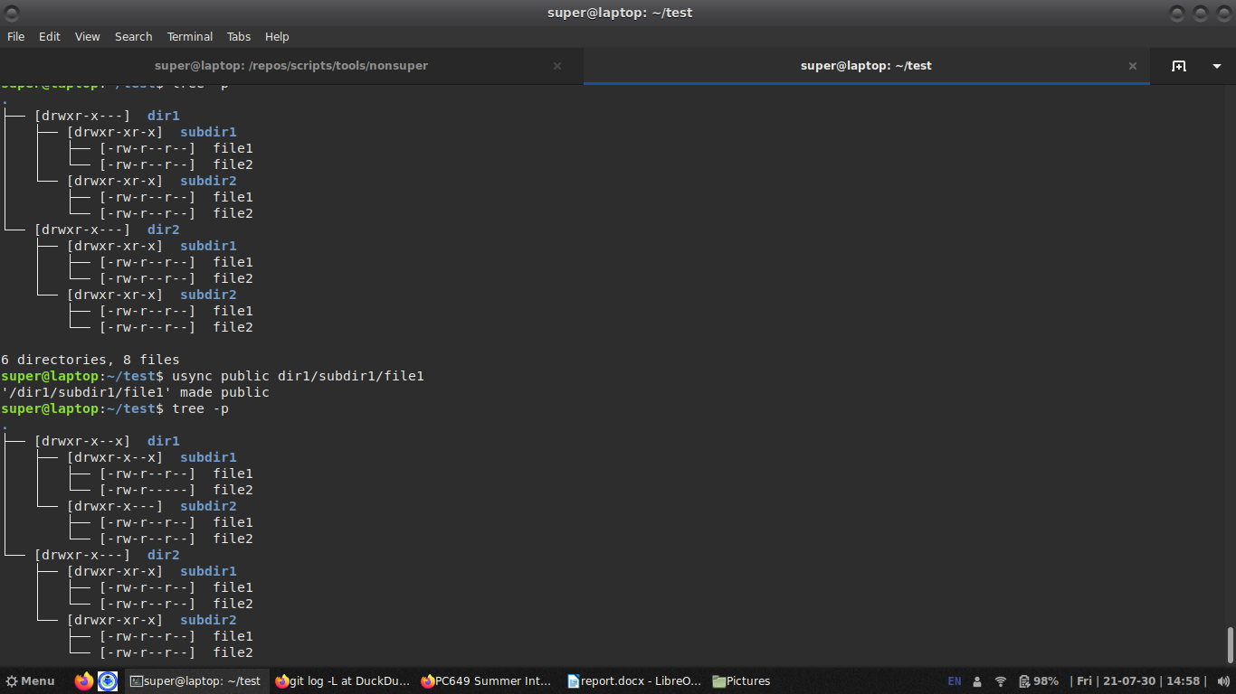

1. after making dir1/subdir1/file1 public



1. after making dir1/subdir1 public

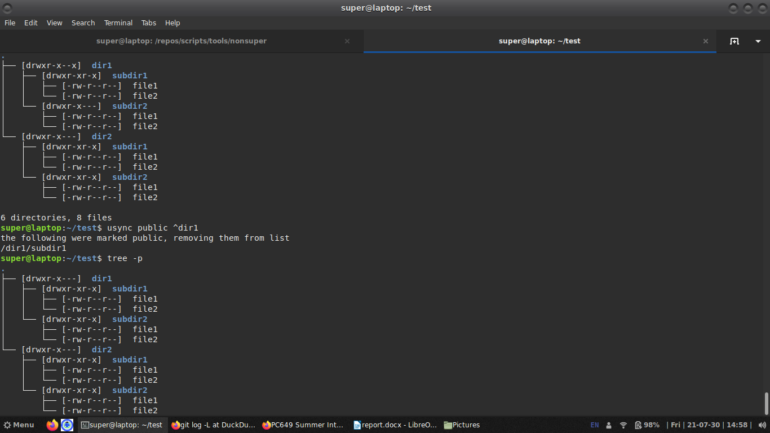

1. after making dir1 private



Limitations:

* This algorithm only works on static file-heirerchy.
* If the tree’s structure is changed then the resulting structure might not be secure and most likely will not be understood by the later runs of the algorithm.
* To circumvent this problem usync provides an option that reapplies all the permissions and make the tree consistent again, but it is a very expensive opperation.