**System Configuration :**

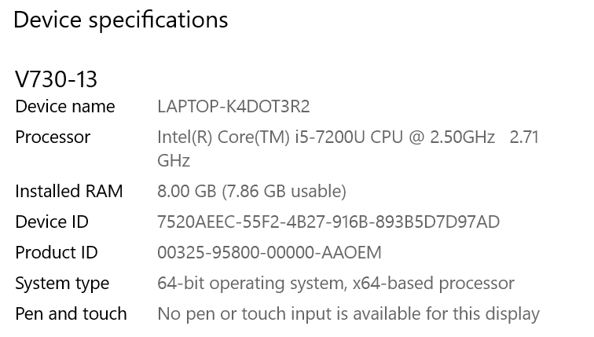

**Observations:**

Varying FileSize with Constant memory

|  |  |  |  |  |  |
| --- | --- | --- | --- | --- | --- |
| Memory Limit(MB) | File Size(MB) | Part1  Phase1 time | Part1  Phase2 time | Part2 4 threads  Phase1 time | Part2 4 threads  Phase2 time |
| 100 | 5 | 0.583 | 0.479(no need) | 0.7 | 0.8 (no need) |
| 100 | 50 | 5.5 | 0.01(no need) | 5.6 | 0.008 (no need) |
| 100 | 500 | 103.91 | 320.06 | 83.09 | 297 |
| 100 | 1024 | 122 | 550 | 133.32 | 494.45 |
| 100 | 2048 | 266 | 873 | 240 | 905 |

* As expected time taken to sort is increasing with memory
* Ideally it should take less time with 4 threads and phase 1 is being read parallelly. Assuming that time is compensated for creation of threads.

Observations:

Varying Memory with Constant fileSize

|  |  |  |  |  |  |
| --- | --- | --- | --- | --- | --- |
| Memory Limit(MB) | File Size(MB) | Part1  Phase1 time | Part1  Phase2 time | Part2 4 threads  Phase1 time | Part2 4 threads  Phase2 time |
| 25 | 500 | 58.80 | 170.11 | 62.85 | 190.61 |
| 100 | 500 | 103.91 | 320.06 | 83.09 | 297 |
| 250 | 500 | 97 | 1089 | 87 | 986 |
| 600 | 500 | 93 | 0.6 no need | 96.5 | 0.53 no need |
| 700 | 500 | 95 | 0.53 no nee | 75 | 0.42 no need |

* With the fixed file size theoretically, whole file is read once and written once in phase 1 then again in phase2. Hence time taken should be 4*No of blocks occupied by file.
* But on performing the experiment. I got the above graph. I am guessing my algorithm to sort is taking extremely large amount of time.
* Once the main mem crosses the file size there is no need for phase 2 hence the sorting is finished in phase 1.