Programme Title: | BSc (Hons) in Computing in IT (4th Yr)
Module Title(s): | Data Exploration & Preparation
Assignment Title: | CA1 Project
Lecturer(s): | Dr. Muhammad Iqbal
Submission  Deadline Date: | 3rd December 2023 11:59pm
Student Name:
Student Email:
Student Number:

CCT College

Contents
Introduction…………………………………………………………………
Report…………………………………………………………………………….

Introduction

Report
a) Identify which variables are categorical, discrete and continuous in the chosen data set and show using some visualization or plot. Explore whether there are missing values for any of the variables.

First, we will have to prepare the data to identify missing and wrong values in our dataset:

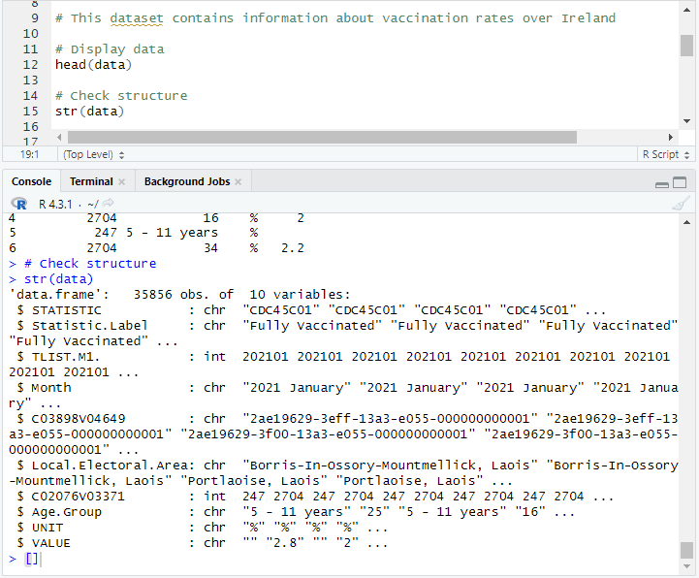
Here we can analyse some wrongness on our dataset, such as ‘Age.Group’ as a char when it should be a numeric value and the range of age is ‘5 – 11 years’ so I will replace that with different ages between 5 and 11 years to make it easier and the ‘VALUE’ also as a char when should be numeric value.

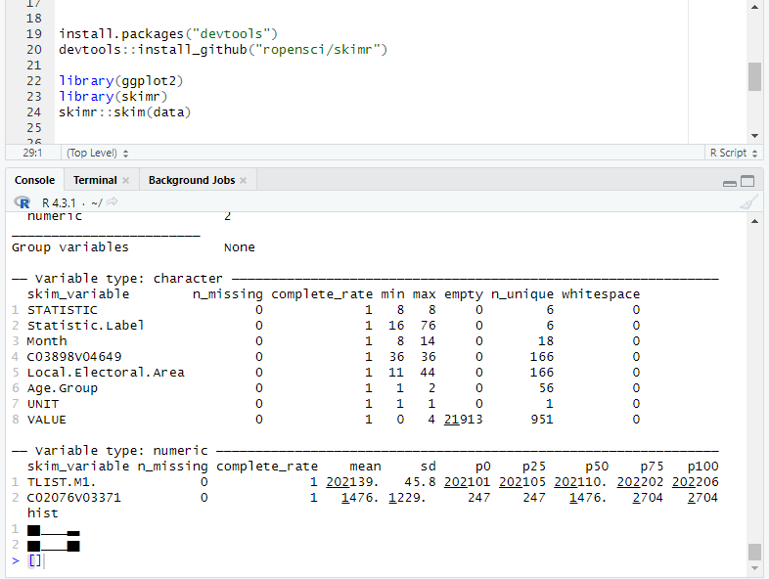
Before transforming into numeric value, I will assign the random ages between 5 and 11 years old where it says ‘5 – 11 years’:
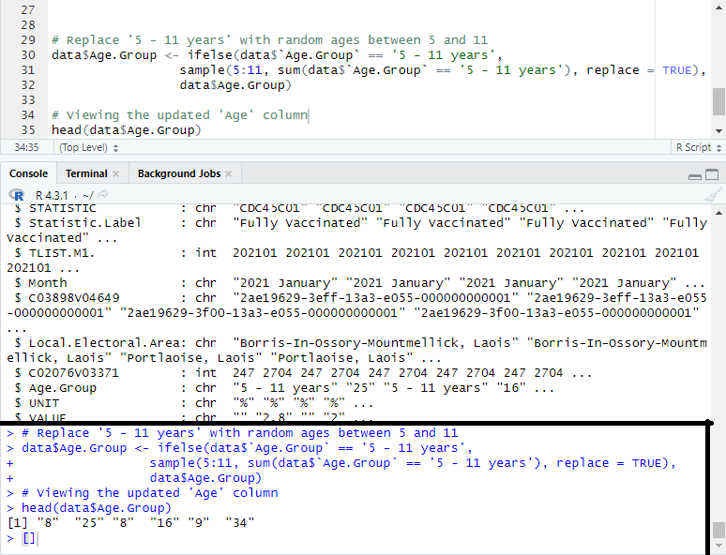
Here we can observe that the ages have been successfully updated. Now we create a new row where we convert the age into numeric value:
Structure of the cleaned and updated dataset:
