EXCLUDING FOOD AND ENERGY

Yiyi

2021-11-30

Table of Contents

rm(list = ls())  
Sys.setlocale("LC_TIME", "English")

## Warning in Sys.setlocale("LC_TIME", "English"): OS reports request to set locale  
## to "English" cannot be honored

## [1] ""

# Weight

The weights data for COICOP level I can find are all yearly frequency. However, from the ONS description, weights barely changed except January of each year. So I regarded annual weights frequency data as monthly frequency data, in this way, I can use monthly inflation of COICOP class data to calculate monthly frequency core inflation.

# CPI

I am not sure whether some classes should be deleted, so I listed them in detail so that you can check again.

17 classes related to food and energy have been removed from the original CPI composed of 85 classes，they are：

n_a_m_e

## # A tibble: 17 × 1  
## name   
## <chr>   
## 1 01.1.1 Bread and cereals   
## 2 01.1.2 Meat   
## 3 01.1.3 Fish   
## 4 01.1.4 Milk, cheese and eggs   
## 5 01.1.5 Oils and fats   
## 6 01.1.6 Fruit   
## 7 01.1.7 Vegetables including potatoes and tubers   
## 8 01.1.8 Sugar, jam, syrups, chocolate and confectionery  
## 9 01.1.9 Food products (nec)   
## 10 01.2.1 Coffee, tea and cocoa   
## 11 01.2.2 Mineral waters, soft drinks and juices   
## 12 04.4.1 Water supply   
## 13 04.5.1 Electricity   
## 14 04.5.2 Gas   
## 15 04.5.3 Liquid fuels   
## 16 04.5.4 Solid fuels   
## 17 07.2.2 Fuels and lubricants

The rest 68 components are listed in the spreadsheet.

# Plot

## Don't know how to automatically pick scale for object of type ts. Defaulting to continuous.

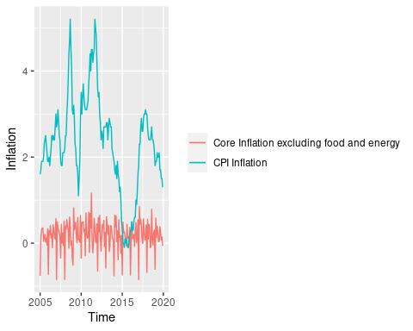

68 classes CPI and core inflation excluding food and energy.