Trimmed Mean

Yiyi

2021-11-21

Table of Contents

DATA 1

CPI weights 1

CPI COICOP index 1

Computes the trimmed means core inflation 1

Plot 2

Conclusion 3

# DATA

At first I wanted the same length of data as the first part of the thesis, with data from 1993-2019. Due to miss data for CPI weights 1997-2004. I can only find CPI weights cover 1988-1996 and 2005-2019. So the computation of the trimmed means core inflation I start from 2005-2019.

In addition, I also tried to be consistent with the previous data in terms of frequency, but I could only find annual data for our 85 classes from 2005-2019. Accordingly, I have replaced the monthly CPI data with annual CPI data, in order to match the weighting data.

## CPI weights

The data I have organized into spreadsheet, please see CPI weight.csv.

## CPI COICOP index

The data I have organized into spreadsheet, please see CPI COICOP index.csv.

# Computes the trimmed means core inflation

Trimming mean requires sorting the CPI indices by trimming the tails of the sample distribution, i.e., the overly volatile part of the indices, and then averaging the remainder. The data of 85 classes are sorted $\left\{x_{1},…,x_{n}\right\}$ and the corresponding weights are sorted in the same way. $\left\{w_{1},…,w_{n}\right\}$. Define cumulative weights as $Wi$, i.e. $Wi≡\sum_{j=1}^{i}{w_{j}}$, $α/100<W_{i}<\left(1-α/100\right)$. The formula is:



Percentage lower and upper tail cut defined as 20%.

## Plot

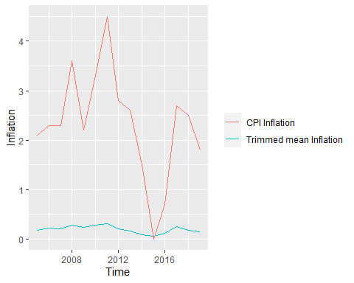

85 classes CPI and Trimmed Mean core inflation.

# 

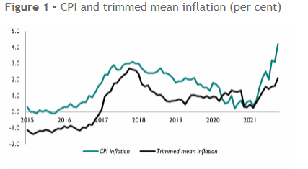

# Conclusion

The figure 1 is Trimmed mean inflation published by National Institute of Economic and Social Research, In contrast, core inflation in the 85 classes appears to be more stable.