**Lab 1: Understanding Logging system in ns3**

There are currently seven levels of log messages of increasing verbosity defined in the system.

• LOG_ERROR — Log error messages (associated macro: NS_LOG_ERROR);

• LOG_WARN — Log warning messages (associated macro: NS_LOG_WARN);

• LOG_DEBUG — Log relatively rare, ad-hoc debugging messages (associated macro: NS_LOG_DEBUG);

• LOG_INFO — Log informational messages about program progress (associated macro: NS_LOG_INFO);

• LOG_FUNCTION — Log a message describing each function called (two associated macros:

NS_LOG_FUNCTION, used for member functions, and NS_LOG_FUNCTION_NOARGS, used for static functions);

• LOG_LOGIC – Log messages describing logical flow within a function (associated macro: NS_LOG_LOGIC);

• LOG_ALL — Log everything mentioned above (no associated macro).

Note: LOG_LEVEL_TYPE = LOG_TYPE + all the levels above it.

1. Disable logging by commenting out the following two lines in myfirst.cc

//LogComponentEnable ("UdpEchoClientApplication", LOG_LEVEL_INFO);

//LogComponentEnable ("UdpEchoServerApplication", LOG_LEVEL_INFO);

$./waf --run scratch/myfirst

No logging massage is printed on the screen.

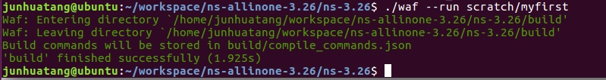

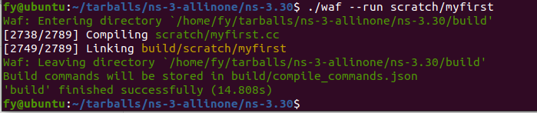

1. Control the logging by setting NS_LOG environment variable

**2.1 Turn on UdpEchoClientApplication**

$export NS_LOG=UdpEchoClientApplication=info

$./waf --run scratch/myfirst

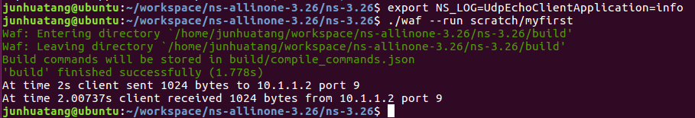

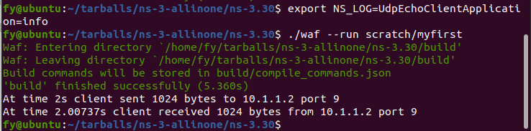

**2.2 Turn on both UdpEchoClientApplication and UdpEchoServerApplication**

$export NS_LOG=UdpEchoClientApplication=info:UdpEchoServerApplication=info

$./waf --run scratch/myfirst

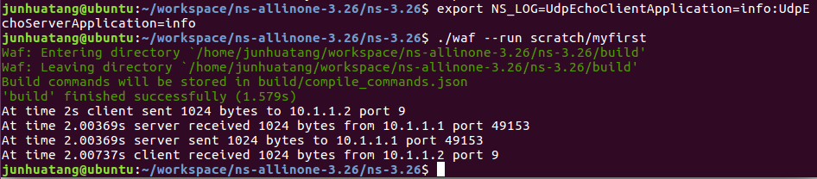

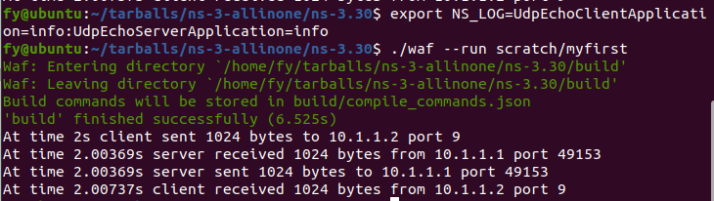

* 1. **Increase the logging level and get more information without changing the script and recompiling**

$export NS_LOG=UdpEchoClientApplication=level_all:UdpEchoServerApplication=level_all

$./waf --run scratch/myfirst

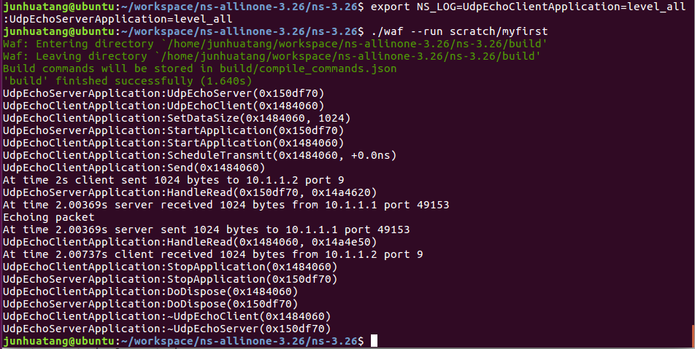

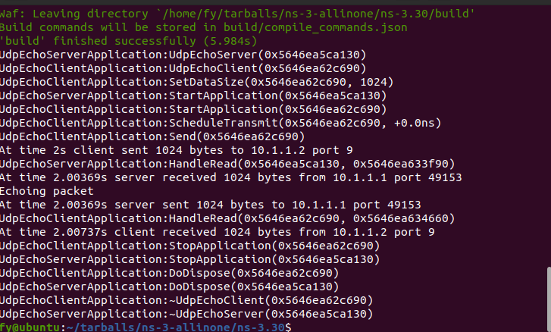

* 1. **Adding the function prefix to logging messages**

$ export 'NS_LOG=UdpEchoClientApplication=level_all|prefix_func'

$./waf --run scratch/myfirst

Note: the quotes (‘ ‘ ) are required since the vertical bar we use to indicate an OR operation is also a Unix pipe connector.

Also note that only UdpEchoClientApplication is turned on.

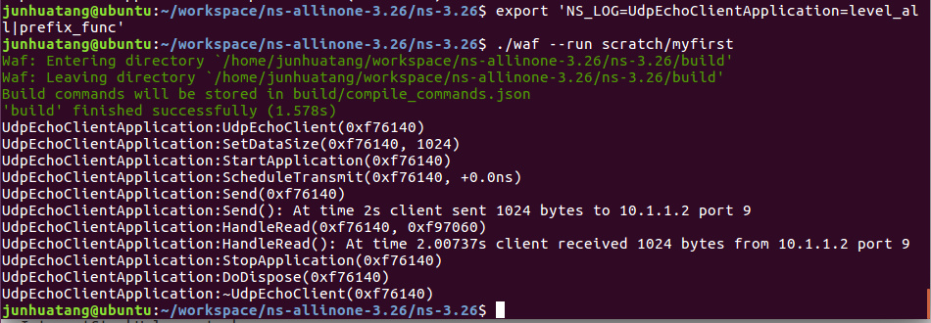

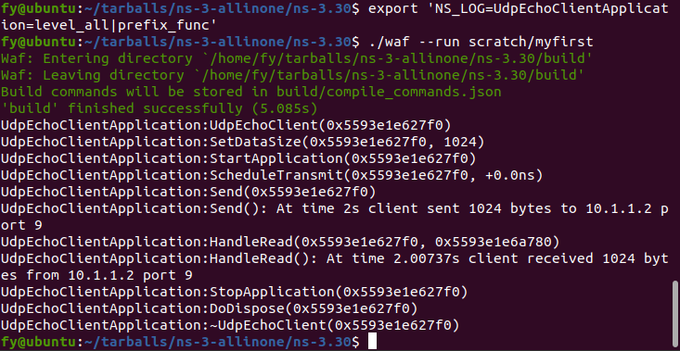

**2.5 Turn on all of the logging components in the system**

$export 'NS_LOG=*=level_all|prefix_func|prefix_time'

$./waf --run scratch/myfirst > log.out 2>&1

（0 stdin，1 stdout，2 stderr，2>&1表示标准错误重定向到标准输出）

Open the file log.out in the ns-3.28 directory and go through the contents

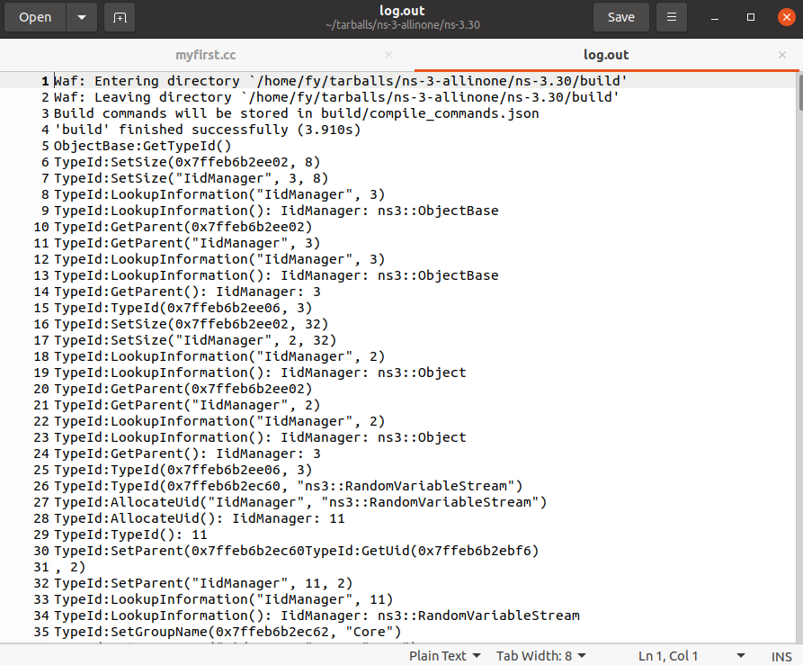

**2.6 Clear NS_LOG settings**

$ export NS_LOG=

$./waf --run scratch/myfirst

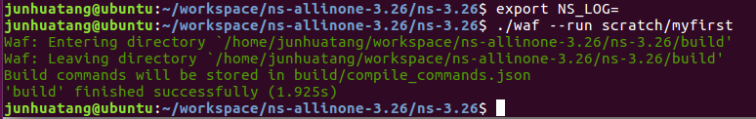

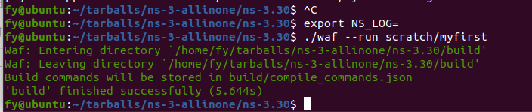

1. **Adding logging to your code**

We have defined a logging component in myfirst.cc by:

NS_LOG_COMPONENT_DEFINE ("FirstScriptExample");

Add the following lines

NS_LOG_UNCOND ("Welcome! Ns3 Simulator! ");

NS_LOG_INFO ("Creating Topology");

right before the lines,

NodeContainer nodes;

nodes.Create (2);

Save the file myfirst.cc, compile and run the script:

$./waf

$export NS_LOG=

$./waf --run scratch/myfirst

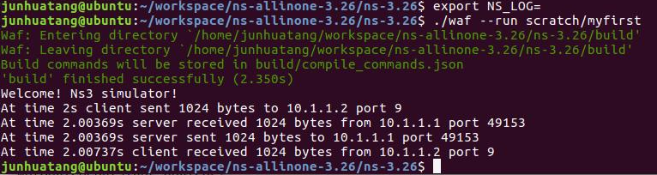

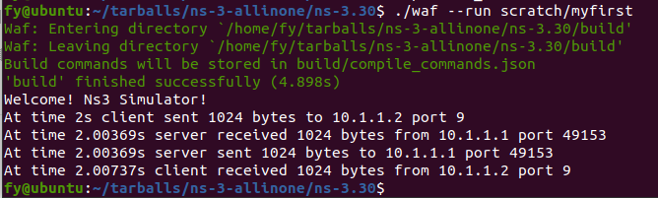

$export NS_LOG=FirstScriptExample=info

$./waf --run scratch/myfirst

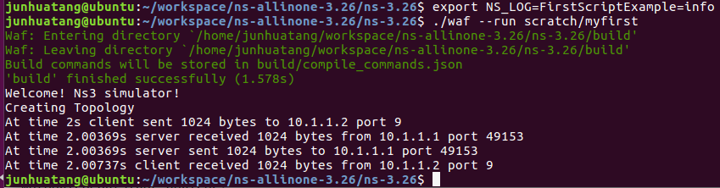

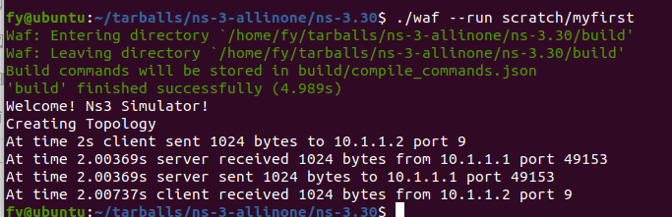

Now go to <https://www.nsnam.org/docs/release/3.28/doxygen/_log_component_list.html> and go through All LogComponents

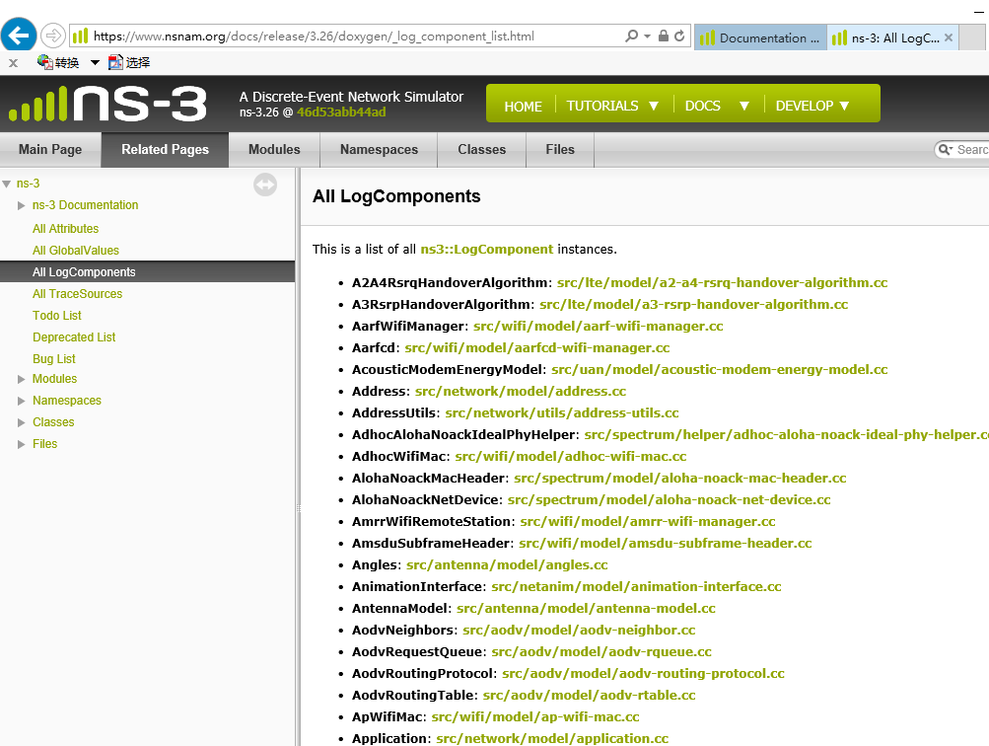

1. **Using Command Line Arguments**

Go ahead and change the scratch/myfirst.cc script to start with the following code,

**int**

main (**int** argc, **char** *argv[])

{

**uint32_t** nPackets = 1;

CommandLine cmd;

cmd.AddValue("nPackets", "Number of packets to echo", nPackets);

cmd.Parse (argc, argv);

...

Scroll down to the point in the script where we set the MaxPackets Attribute and change it so that it is set to the variable nPackets instead of the constant 1 as is shown below.

echoClient.SetAttribute ("MaxPackets", UintegerValue (nPackets));

Now if you run the script and provide the --PrintHelp argument, you should see your new User Argument listed in the help display.

Try,

$./waf

$ ./waf --run "scratch/myfirst --PrintHelp"

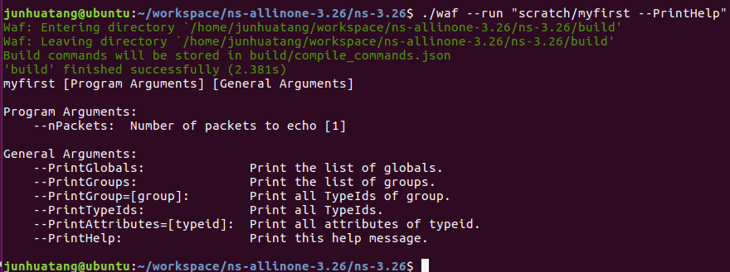

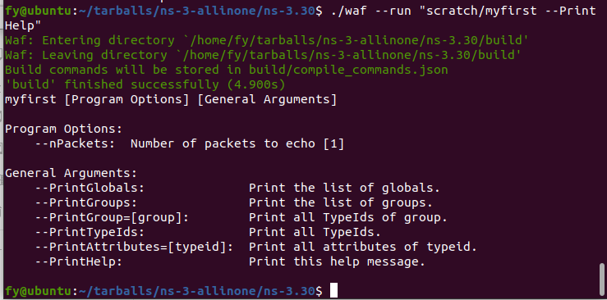

$ ./waf --run "scratch/myfirst --nPackets=2"

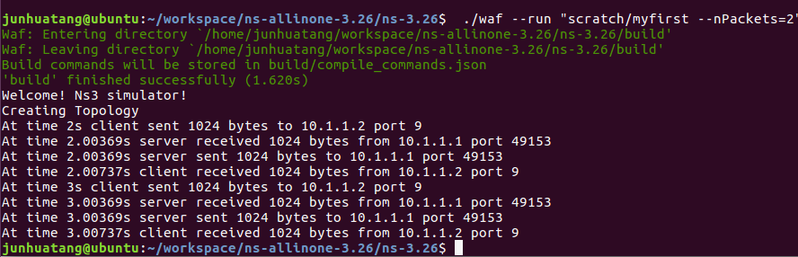

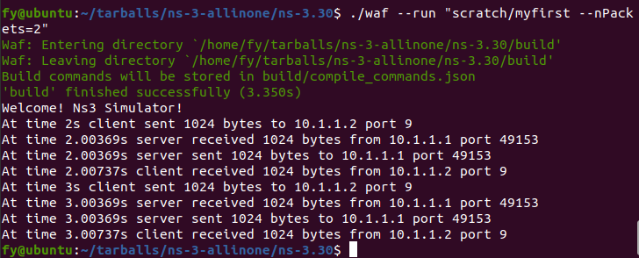

Find out more on general arguments:

$ ./waf --run "scratch/myfirst --PrintGroups"

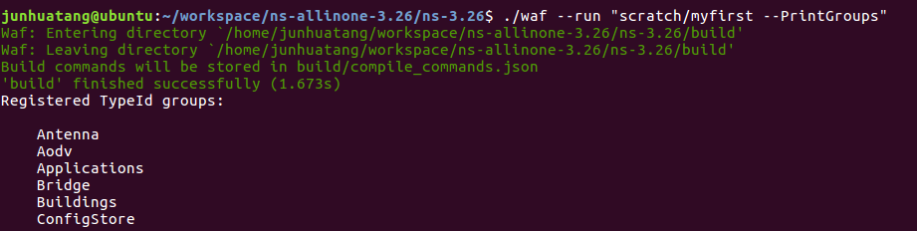

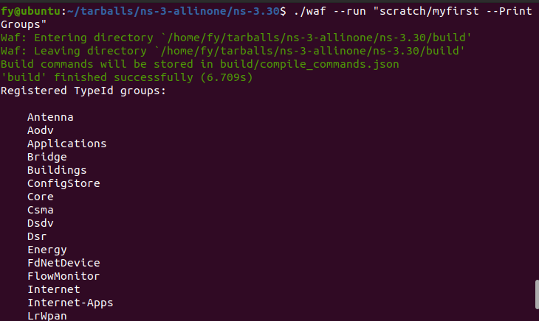

$ ./waf --run "scratch/myfirst --PrintGroup=Applications"

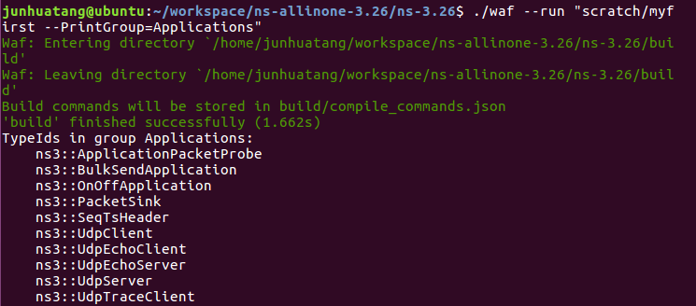

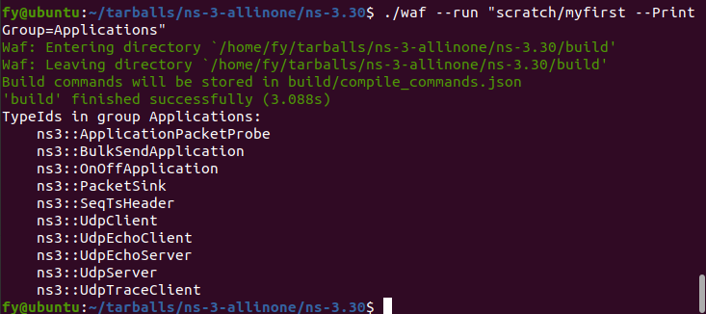

$ ./waf --run "scratch/myfirst --PrintAttributes=ns3::UdpEchoClient"

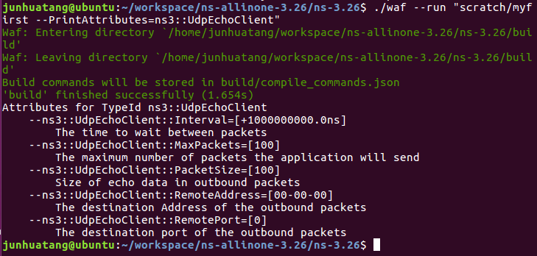

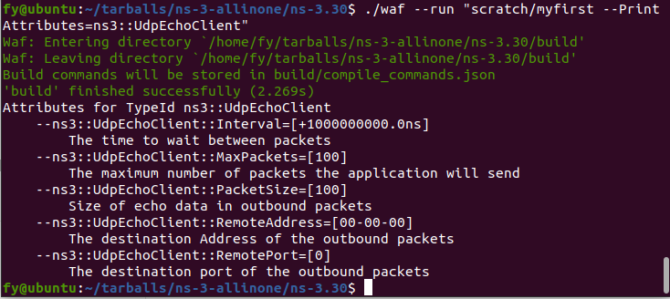

1. **Using the tracing system**

**5.1 ASCII tracing**

Let’s just jump right in and add some ASCII tracing output to our scratch/myfirst.cc script. Right before the call to Simulator::Run (), add the following lines of code:

AsciiTraceHelper ascii;

pointToPoint.EnableAsciiAll (ascii.CreateFileStream ("myfirst.tr"));

The outside call, to EnableAsciiAll(), tells the helper that you want to enable ASCII tracing on all point-to-point devices in your simulation; and you want the (provided) trace sinks to write out information about packet movement in ASCII format.

You can now build the script and run it from the command line:

$ ./waf --run scratch/myfirst

An ASCII trace file myfirst.tr will be created in the directory of ns-3.26, open the file in your favorite editor.

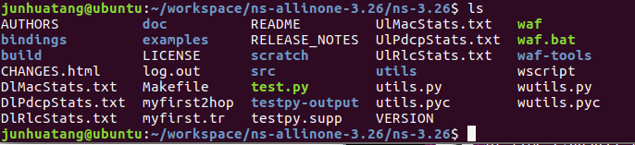

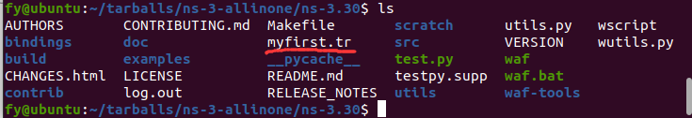

myfirst.tr

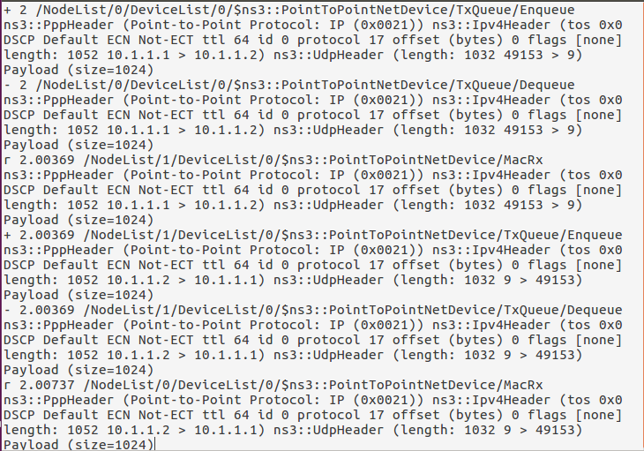

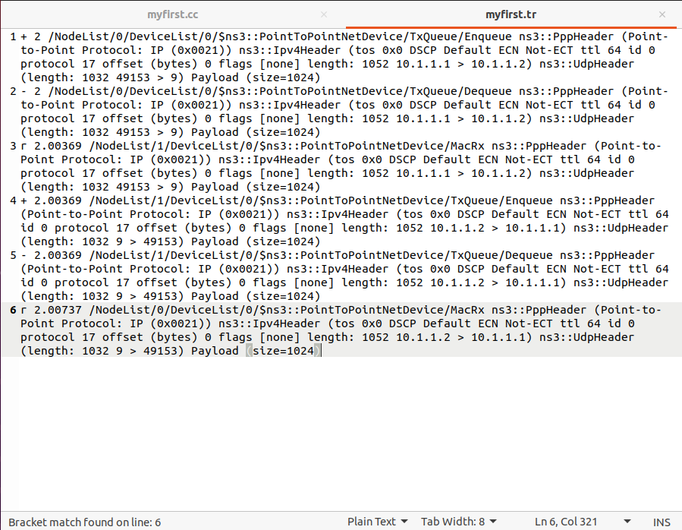

Each line in the file corresponds to a trace event. In this case we are tracing events on the transmit queue present in every point-to-point net device in the simulation. The transmit queue is a queue through which every packet destined for a point-to-point channel must pass. Note that each line in the trace file begins with a lone character (has a space after it). This character will have the following meaning:

+: An enqueue operation occurred on the device queue;

-: A dequeue operation occurred on the device queue;

d: A packet was dropped, typically because the queue was full;

r: A packet was received by the net device.

**5.2 PCAP Tracing**

Go ahead and insert this line of code after the ASCII tracing code we just added to scratch/myfirst.cc.

pointToPoint.EnablePcapAll ("myfirst");

$./waf

$ ./waf --run scratch/myfirst

In our example script, we will eventually see files named “myfirst-0-0.pcap” and “myfirst-1-0.pcap” which are the pcap traces for node 0-device 0 and node 1-device 0, respectively, in the directory of ns-3.26.

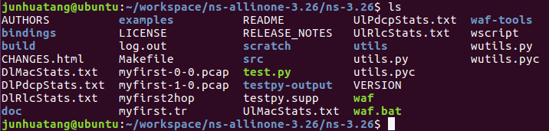

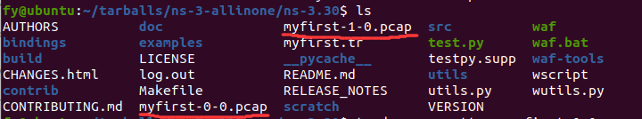

Use tcpdump to look at the pcap files.ls

$ tcpdump -nn -tt -r myfirst-0-0.pcap (trace file for node 0 device 0)



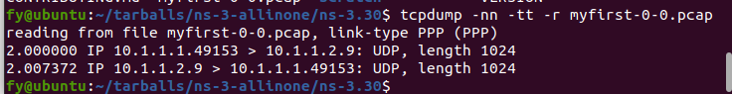

$ tcpdump -nn -tt -r myfirst-1-0.pcap (trace file for node 1 device 0)

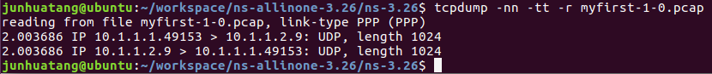

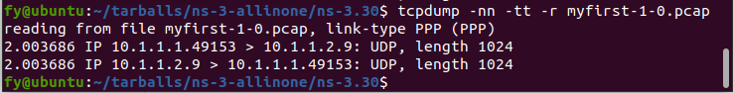

**Lab1 turn in:**

lab1-report.doc (lab1-report.pdf)

1. Draw a time line diagram to show the packet exchanges illustrated by the following two pcap files. Explain how the timestamps are obtained numerically.







