**lab1-report.pdf：**

**费扬 519021910917**

1. Draw a time line diagram to show the packet exchanges illustrated by the following two pcap files. Explain how the timestamps are obtained numerically.

Tcpdump：

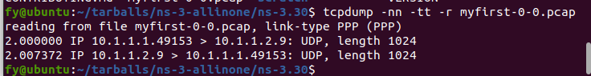

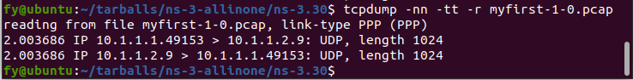

As you can seen in “myfirst.cc”, the rate is 5Mbps and the delay is 2ms. And the client starts at 2s.

And the whole load is 1054 bytes which can be seen in Wireshark. UDP payload takes 1024 bytes inside this packet.

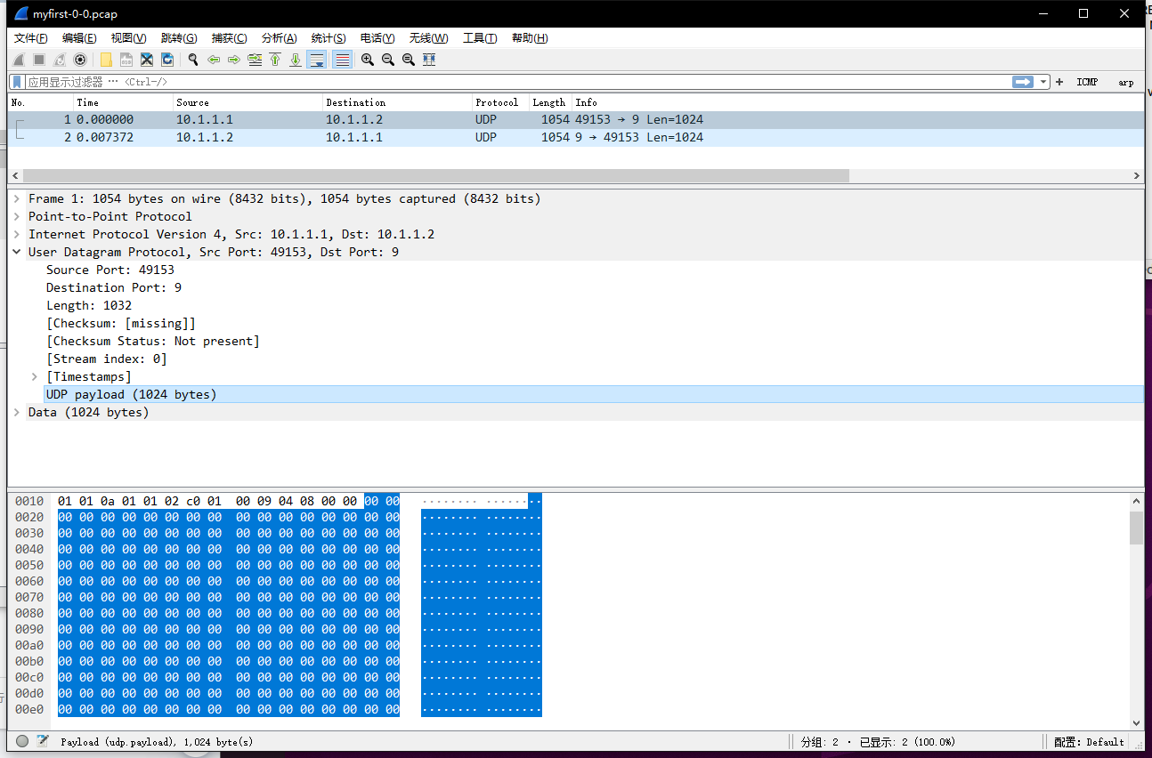

So the whole time can be calculated:

$$\frac{1054*8}{5*{10}^{6}}+2+0.002=2.003686s$$

The whole time is:

$$2*\frac{1054*8}{5*{10}^{6}}+2+0.002*2=2.007372s$$

Here is the time line diagram:

