**数据通信NS3作业-2**

姓名： 费扬 学号： 519021910917 日期： 2022.05.09

1. 实验名称及内容

Lab2：

Build a 2-hop Point-to-Point network as illustrated below,

192.168.10.0 192.168.50.0

n0 ------------------------ n1-------------------------------- n2

point-to-point point-to-point

5Mbps, 2ms 1Mbps, 2ms

* n0 sends a total number of 2000 bytes to n2.
* Use onoff-application (TCP) on n0 with packet size 512, data rate 50kb/s, set the OnTime random variable to 1 and OffTime random variable to 0.
* Use PacketSink (TCP) application on n2 to receive the packets.
* Enable NS_LOG on both onoff-application and PacketSink, turn on pacp tracing on all nodes.
* Use filename: lab2.cc

Hints: For onoff-application and packet-sink application, the source codes are in /home/workspace/ns-allinone-3.28/ns-3.28/src/applications/model. Or go to <https://www.nsnam.org/doxygen/index.html>, click Modules→Applications→OnOffApplication to see a detailed description of the application.

1. 实验过程和结果

程序见压缩包内。本次ns3的版本为3.30。

**Simulation：**

1. $find . -name '*.cc' | xargs grep OnOffApplication | grep example

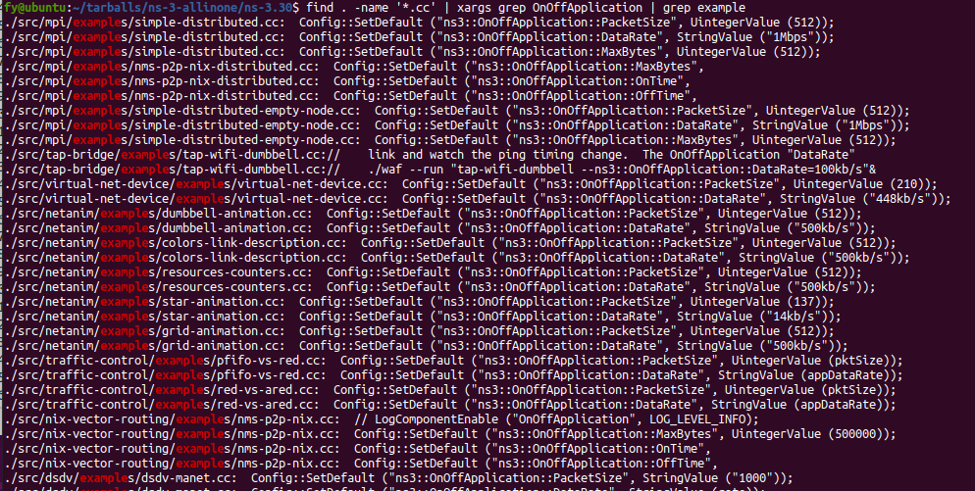

1. $./waf --run "scratch/mysecond --PrintAttributes=ns3::OnOffApplication"

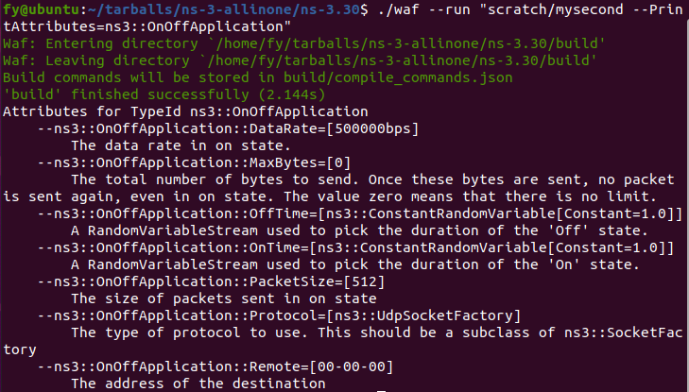

1. $./waf --run scratch/lab2

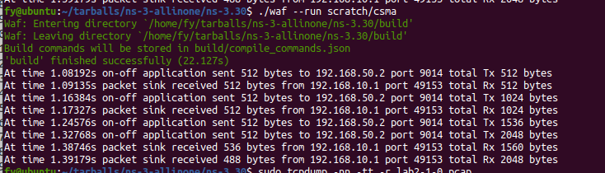

1. pcap file contents to show that packets are delivered to the destination

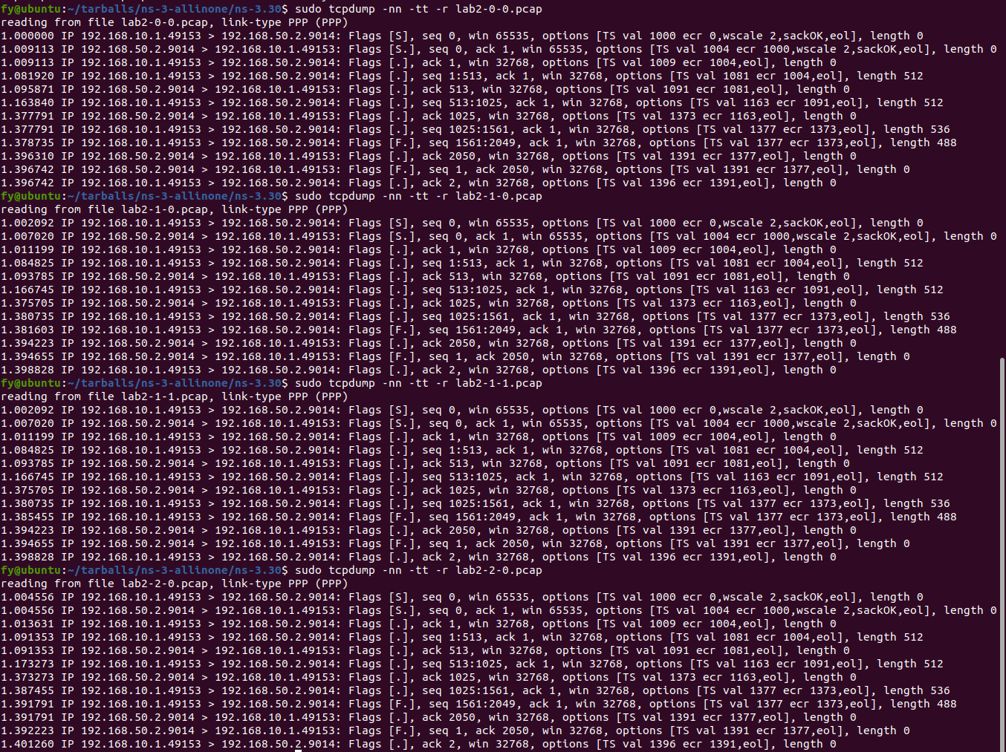

1. Check in Wireshark:

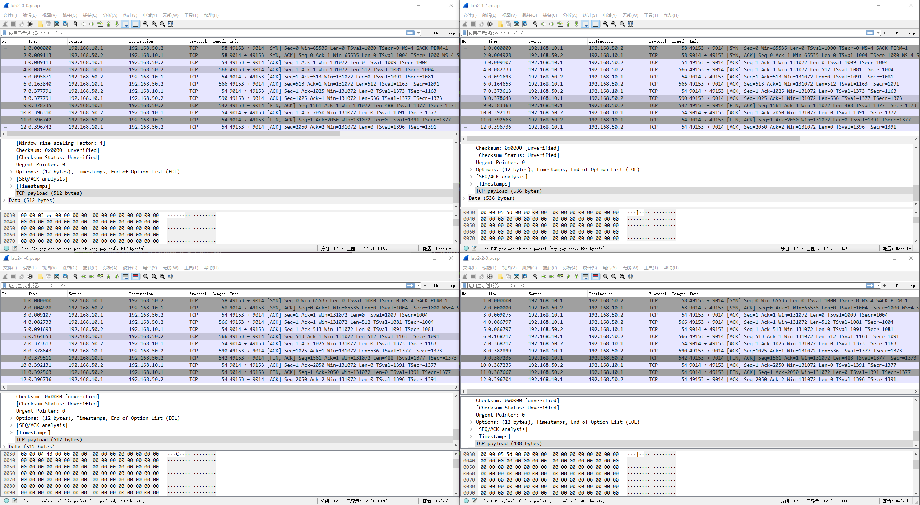

1. 实验思考：

* **关于512分片中出现536和488长度分组的情况：**

分析是由于默认ns-3的TCP分段长度为536，猜测是按断续发送512长度，在最后一段发送时整个发送了1024长度的报文，默认分片成536，剩余488分组。

