**Important point:**

No Developer works on master branch, they create parallel line of development, and work on it. Master branch will have latest production running code.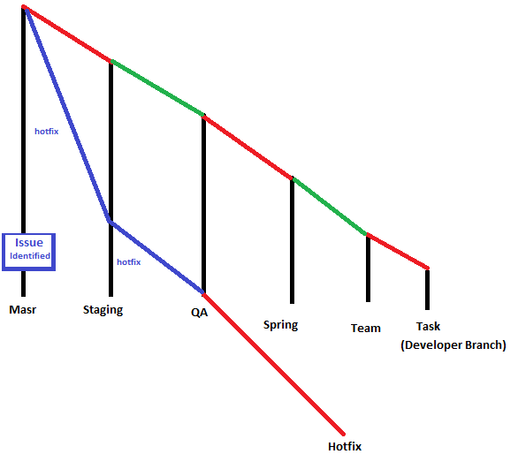



Note: Each developer works on a branch called TASK, then the merge their change to team branch(owned by project manager/team Lead), later those changes are committed to sprint branch.

Setting Java homes: Add java path entry in /etc/environment export JAVA_HOME=/usr/lib/jvm/java-8-openjdk-amd64 echo $JAVA_HOME source /etc/environment // For reloading /etc/environment entry.

Devops is a part of Agile scrum? -> yes

4EC- Eye check, it means your work needs to be reviewed by 2 peers.

Code review- Relevant developer will do code review for each other.

Day build vs Night build: Days build are for developer, and night builds are for deployment.

Code Flow cycle: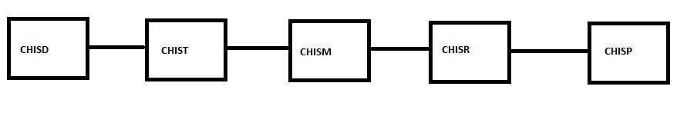

Development project for customer – Below diagram software version 1.1 is released to customer, and production owner is working on continues developer, once version 1.1 is released then all customer will be updated.

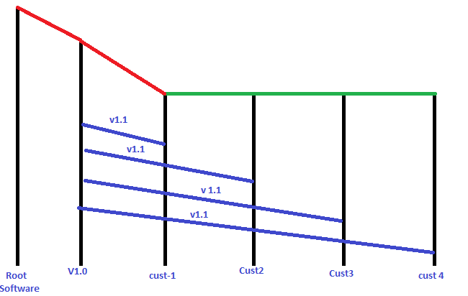

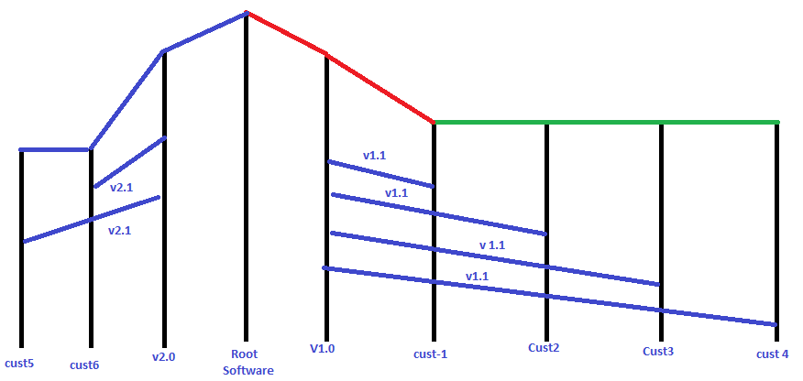

Let’s say oracle is owner of java, so it is having java 7, and java 8. Few customers will be working on java 7, and few on java 8. Here you will have many branches of development.

Cherry fix: Moving particular commit from one branch to another branch.

Active development project: It’s a project where code is not yet deployed to production.

Production support project: it’s project where all the SDLC phase are function, such as maintenance.