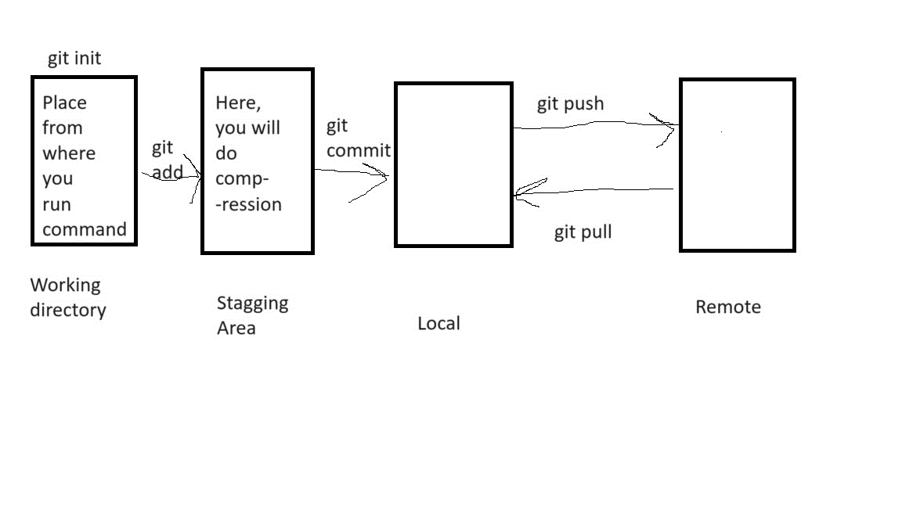

GIT Branching, Merging, rebasing, reset, reverting, stash, GIT commands

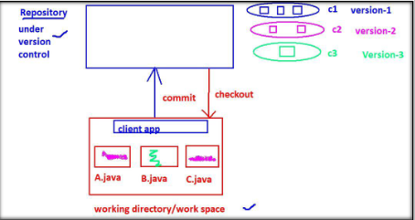

Git commit: GIT commit used to save changes from local to remote

Git checkout: We are pulling the changes

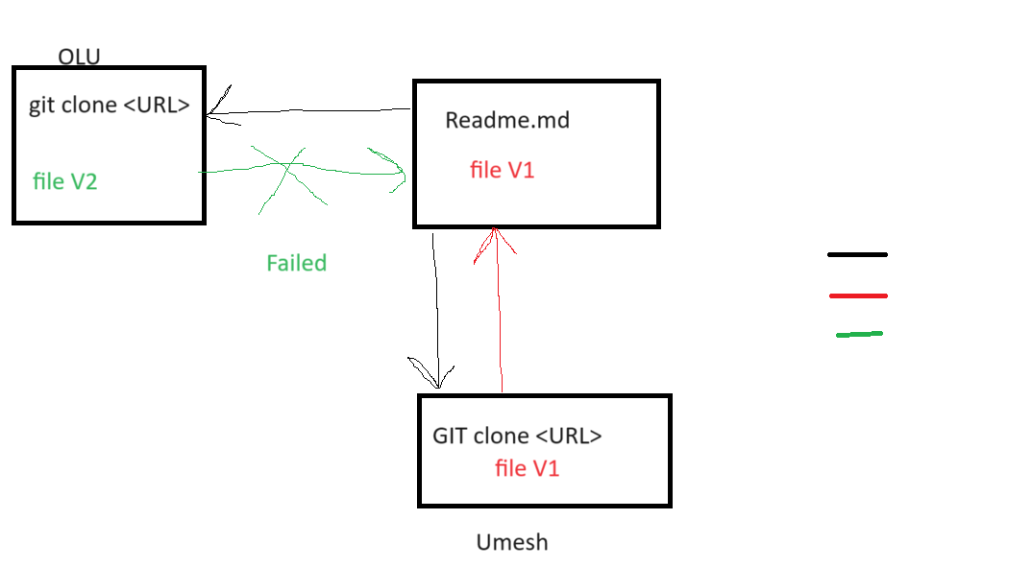

In above diagram two user are their. Umesh and OlU. Iniatially they clone the repo then Umesh push the changes, and now OLU want to push the changes, but he is getting error. Unable to push the changes.

Reason: Master should be source of truth. If any changes push to master then, we need to pull those changes.

Note: If local repository want to push the changes to master, then it must have latest copy of master.

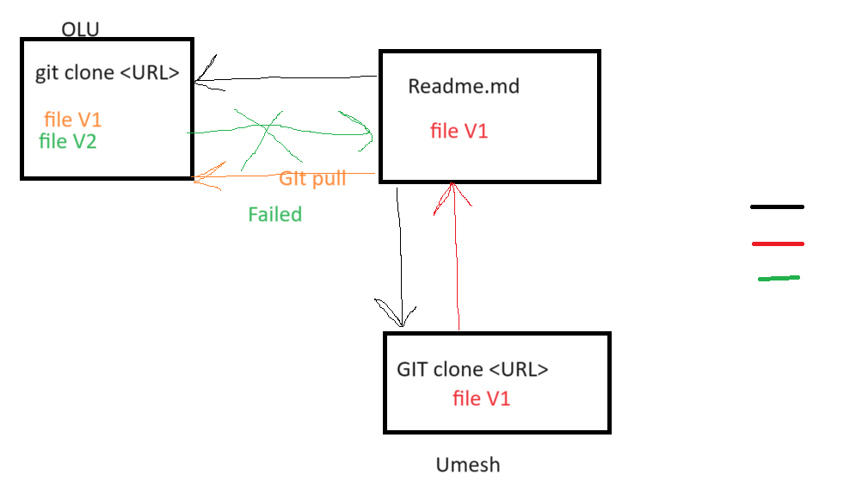

GIT branching:

============

1. Let say my code is running with master branch, and I want to made some modification. So we will make 1 copy of master branch, and do our changes
2. Lets say we want to add new feature to our application, we will take the latest code, then add the feature and merge it.

ubuntu $ git branch

Olu

Test

Umesh

feature1

issu1

\* main

On which branch you are, is pointed by start. Suppose, you want to change the branch

Git checkout <branch-name>

ubuntu $ git checkout Olu

Switched to branch 'Olu'

ubuntu $ git branch

\* Olu

Test

Umesh

feature1

issu1

main

ubuntu $ git checkout Umesh

Switched to branch 'Umesh'

ubuntu $ git branch

Olu

Test

\* Umesh

feature1

issu1

main

Always remember whenever you are doing any changes by linux command it will imapact all the branches. If you want you changes to be applicable to your branch only then you need to use git command.

ubuntu $ git branch

Olu

Test

\* Umesh

feature1

issu1

main

ubuntu $ ls

LICENSE.txt docker-compose.yml gradlew mvnw pom.xml settings.gradle

build.gradle gradle gradlew.bat mvnw.cmd readme.md src

ubuntu $ >docker-compose.yml

ubuntu $ vi docker-compose.yml

ubuntu $ git checkout main

M docker-compose.yml

Switched to branch 'main'

Your branch is up to date with 'origin/main'.

ubuntu $ cat docker-compose.yml

Hello

ubuntu $ git branch

Olu

Test

Umesh

feature1

issu1

\* main

ubuntu $ cat docker-compose.yml

Hello I am main branch

Branch: Creating parallel line of development.

Git rebase:

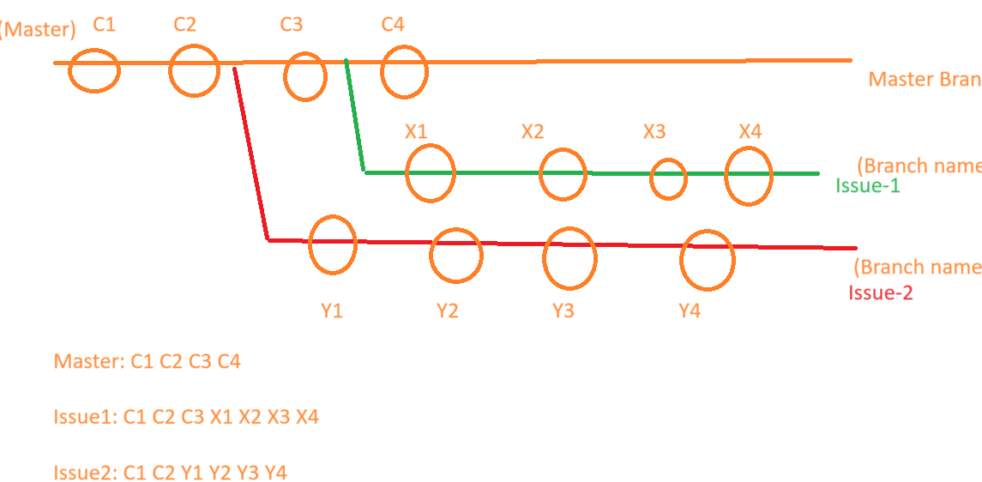

When I want linear history then I will do rebase.

Merging:

2 way merge:

Here, master don’t have any changes. Only branch is having changes.

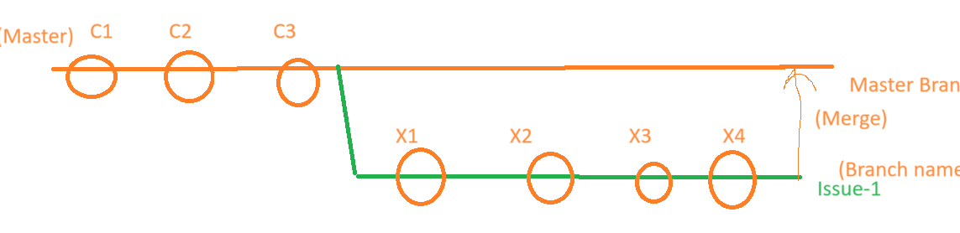

3 way merge:

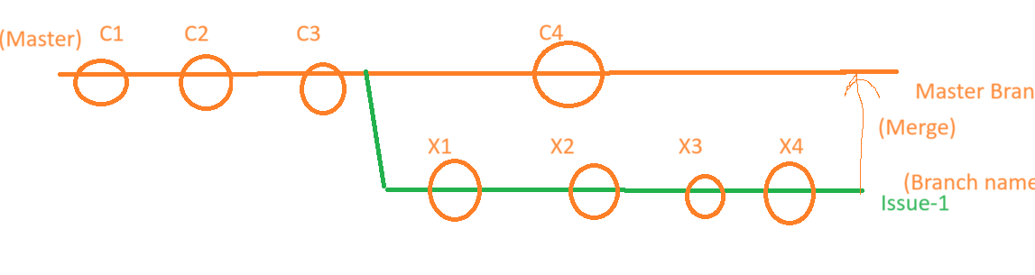

Tomorrow

Practice GIT commands, git reset and git stash