Sebastian Demian
M-PASS Documentation for Final Version

Many people get stuck in the CASH Lanes on the expressways looking for one more quarter to throw in the coin basket, only to realize they don’t have it. This creates a difficult situation not only for the driver, but for the other drivers waiting in line. Others decide to just go through the I-PASS Lanes without having an I-PASS and most likely forget to pay the toll online. The M-Pass application provides a simple solution to this problem. Just install the application, fill in your details, and you are ready to go.

This DEMO version serves as a provisional version with basic functionality. Users can log in, create accounts, modify their accounts, and pay tolls. In the next versions, the GPS matching functionality will be enabled, allowing the system to automatically pay tolls as the user drives through a toll plaza.

The operation contracts and class diagrams displayed below are for illustration purposes and will change as needed together with the development process.

Sample use cases:

Use Case 1: Pay toll

Scope: M-PASS

Level: User goal

Primary Actor: User

Stakeholders and Interests:
User: Wants to pay Toll with minimum hassle.
Illinois Tollway: Wants to receive payment for using the Illinois Tollway.

Pre-conditions:
User is driving a car that is registered in the system
User is registered.
The system is turned on at the time user drives trough a toll.
Credit card on file has enough funds.
Phone has network signal and at least 3G data connection.
User is not engaged in a voice call when passing trough toll.

Post-conditions:
Payment is completed successfully.
User receives confirmation of payment.
Transaction is recorded in system’s database.
System goes back to default state.

Main Scenario:
- User enters car and starts application.
- System turns on GPS, and starts tracking user’s location.
- When passing a Toll, systems connects to Illinois Tollway website.
- System fills out the payment fields on website with user’s information.
- User initializes payment (and fills out Plaza number in the Demo Version).
- System notifies the user that a payment has been made.
- System resumes to default state
Extensions:
*a At any time user initializes a voice call (some carriers do not support voice calls + data transfer at the same time):
1. System remembers most recent GPS coordinates.
2. After ending the voice call, system retrieves current GPS position and calculates if there is a toll plaza between the last and current positions.
3. If there is a toll plaza, system asks for permission to make a payment
4. If user gives permission, system makes payment.

2.a User has several cars under same account:
1. User is asked to select which car he is driving at that time.
4.a System cannot connect to database:
1. System records current GPS coordinates.
2. Notifies the user about the error.
3. Retries the transaction next time the app is started.
Errors:
6.a Credit card on file is declined for lack of funds.
1. User is asked to add new credit card.
4.a Illinois Tollway website is offline.
1. System remembers all details and retries the transaction next time the application is turned on.
2. System send e-mail to owner with a notification that payment was not completed, and a reminder to retry the transaction. E-mail is sent daily until transaction has been completed.

Special Requirements:
None

Technology and Data Variations List:
The toll plaza can be manually inputted into the system.

Frequency of Occurrence:
Average number of transactions is 2 per trip

Open Issues:

What happens if the Illinois Tollway website is down and user forgets to turn the app on for the next 7 days?
One possible solution is to set up the system in such a way that it sends a notification to user’s e-mail reminding him/her to start the application so that the system can complete the payment.
Another solution would be to send notifications via text messaging reminding the user to retry the transaction.

Use Case 2: Make Payment Manually

Scope: M-PASS

Level: User goal

Primary Actor: User

Stakeholders and Interests:
User: Wants to pay Toll through phone with minimum hassle.
Illinois Tollway: Wants to receive payment for using the Illinois Tollway.

Pre-conditions:
User has an unpaid toll.
User is registered in the system.
The system is turned on.
Credit card on file has enough funds.
Phone has network signal and at least 3G data connection.
User is not engaged in a voice call.

Post-conditions:
Payment is completed successfully.
User receives confirmation of payment.
Transaction is recorded in system’s database.

Main Scenario:
- User starts application.
- System turns on GPS
- User initiates manual payment and indicates Plaza location and date.
- System connects to Illinois Tollway website.
- System fills out the payment fields on website with user’s information.
- System initializes payment.
- System notifies the user that a payment has been made.
- System resumes to default state
Extensions:

2.a User has several cars under same account:
1. User is asked to select which car he was driving at that time.
4.a System cannot connect to database:
1. Notifies the user about the error.
2. Retries the transaction next time the app is started.
Errors:
6.a Credit card on file is declined for lack of funds.
1. User is asked to add new credit card.
4.a Illinois Tollway website is offline.
1. System remembers all details and retries the transaction next time the application is turned on.
2. System send e-mail to owner with a notification that payment was not completed, and a reminder to retry the transaction. E-mail is sent daily until transaction has been completed.

Special Requirements:
None

Technology and Data Variations List:
The toll plaza can be manually inputted into the system.

Frequency of Occurrence:
Average number of transactions is 1 per manual payment.

Open Issues:
What happens if the Illinois Tollway website is down and user forgets to turn the app on for the next 7 days?
One possible solution is to set up the system in such a way that it sends a notification to user’s e-mail reminding him/her to start the application so that the system can complete the payment.
Another solution would be to send notifications via text messaging reminding the user to retry the transaction.

Operation Contracts and Interaction Diagrams

- Contract CO1: startApp
- Operation: startApp()
- Cross References: Use Cases: Pay toll
- Preconditions: none
- Postconditions:
    - An application instance was created
    - Driver was associated with Account (Log In)
    - GPS attribute was modified

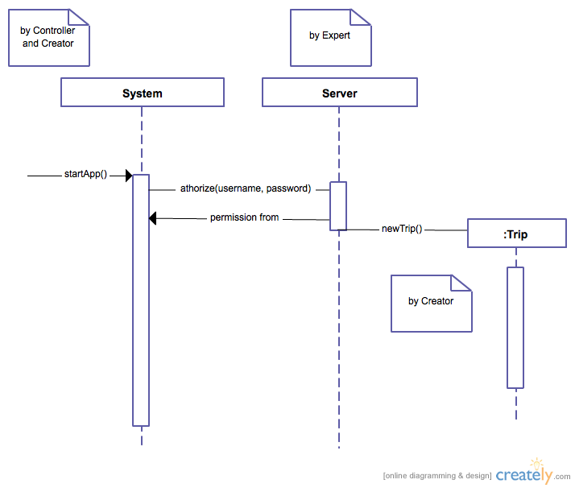

- Contract CO2: startGPS
- Operation: startGPS()
- Cross References: Use Cases: Pay toll
- Preconditions: App is running.
- Postconditions:
    - A GPS instance was created
    - GPS attribute was modified
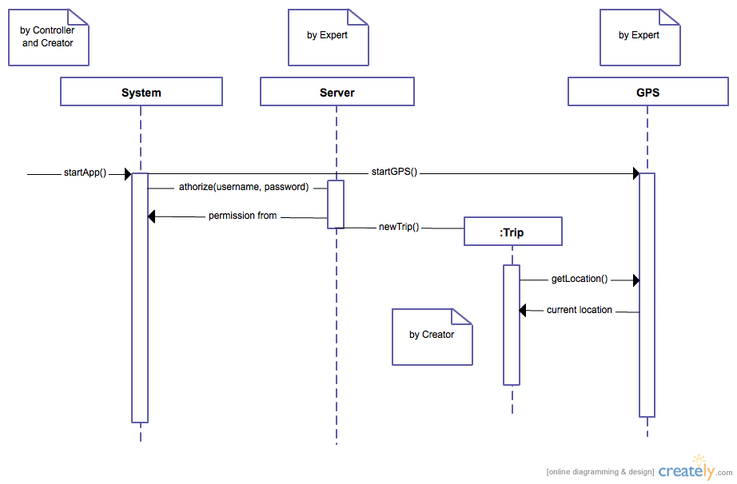

- Contract CO3: addCar
- Operation: addCar(make, model, license plate)
- Cross References: Use Cases: Pay toll
- Preconditions: App is running, user is registered
- Postconditions:
    - Make, model and license plate were associated with Account (association formed).
    - Car instance has been created

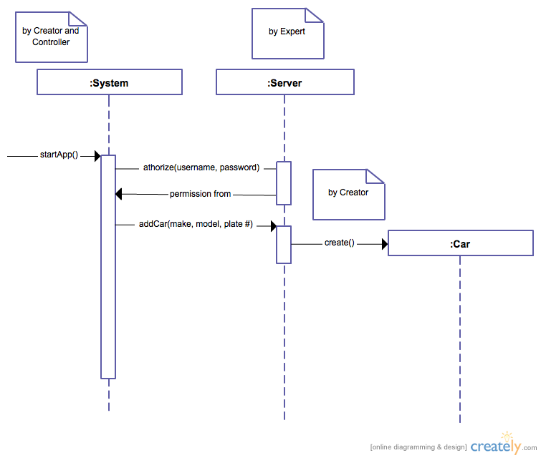

- Contract CO4: selectCar
- Operation: selectCar(number)
- Cross References: Use Cases: Pay toll
- Preconditions: App is started, user is registered.
- Postconditions:
    - Driver was associated with car

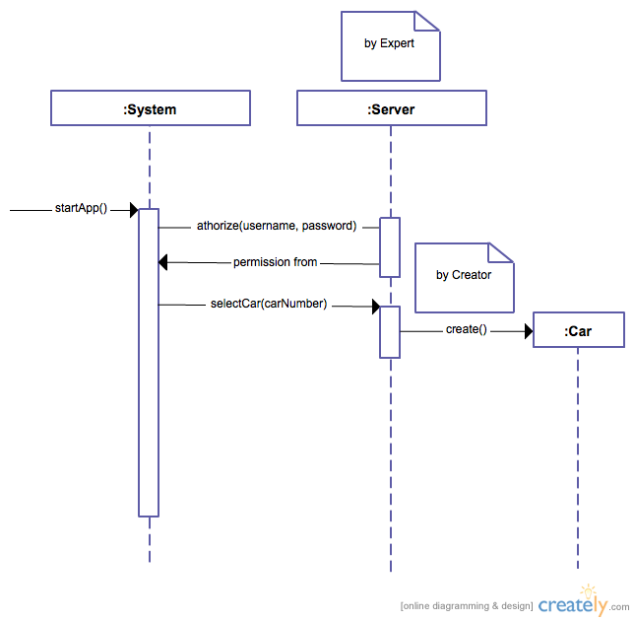

- Contract CO5: startVoiceCall
- Operation: startVoiceCall()
- Cross References: Use Cases: Pay toll
- Preconditions: App is started, user is registered.
- Postconditions:
    - Instance of VoiceCall was created

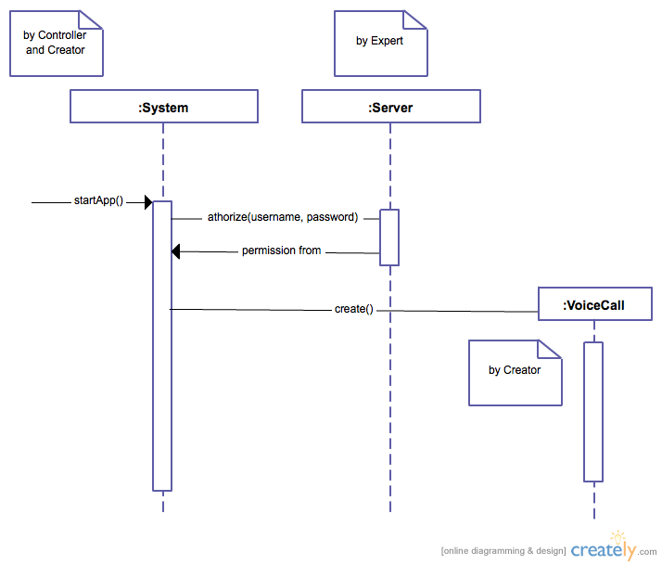

- Contract CO6: stopVoiceCall
- Operation: stopVoiceCall()
- Cross References: Use Cases: Pay toll
- Preconditions: VoiceCall is underway.
- Postconditions:
    - System records current GPS location
    - Instance of VoiceCall was terminated

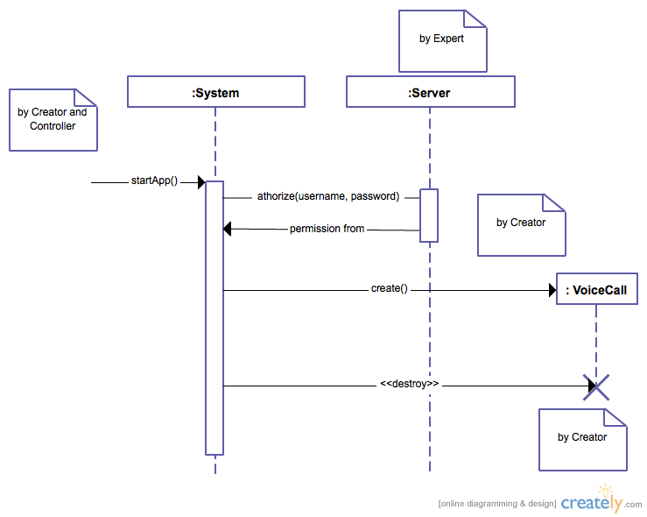

- Contract CO7: endApp
- Operation: endApp()
- Cross References: Use Cases: Pay toll
- Preconditions: App is running.
- Postconditions:
    - The application instance was terminated
    - GPS instance was terminated

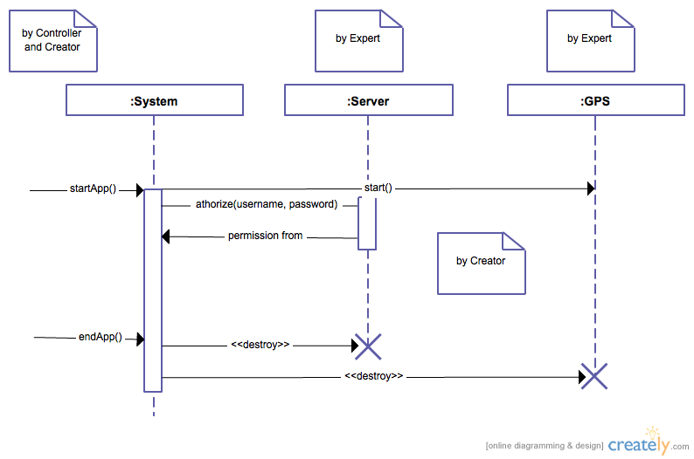

- Contract CO8: calculateToll
- Operation: calculateToll()
- Cross References: Use Cases: Calculate toll
- Preconditions: App is running.
- Postconditions:
    - Total cost of tolls is calculated

