Elsie Park

W1 – Roll a Ball Questions

<https://github.com/2021-01-ITI415/01-roll-a-ball-elsiempk>

1. The unity component used to set the color of objects is materials under assets. A color picker can be used. Smoothness, tiling, emission, offset, UV set are all unfamiliar to me. The rendering mode is familiar along with reflections and specular highlights.
2. The difference between Update() and FixedUpdate() is that Update() runs once per frame while FixedUpdate() runs multiple times, for instance, once, zero, or several times per frame.
3. The difference between Update() and LateUpdate() is that LateUpdate() is called every frame but after Update(). Used when you wish to check and control something after Update() finishes.
4. The unity component that shows the player to be a sphere, the pickUps to be cubes, etc is Rigidbody which has control of an object’s position through the physics simulations.
5. The role of the MainCamera is for the player to have accurate and comfortable view of the world.
6. The problem with making the Main Camera a child object of the Player object is that the player game object rotates like crazy which makes the camera as well rotate like crazy.
7. Directional light is light to represent lighting from the sun.
8. Start() is called once, before any update methods and after Awake(), unlike Awake() it will not be called if the script is disable and the code that is placed in Start() can be delayed. Awake() is called when the script is first loaded, or when an object it is attached to is instantiated. It only gets called once and only after other objects are initialized.
9. If you change the PickUp prefab by selecting the prefab in the project window and changing the scale of the object, within the scene window, all prefabs will follow that change that are connected.
10. The result is an error for the script is case sensitive, I will need to follow exactly what is written.
11. If I change an instance of the PickUp prefab by selecting one prefab on the playfield in the scene window, the behavior is different for not all objects are changed but only that one in particular.
12. Vertical axis: transform.Rotate(new Vector3(0,30,0)\*Time.deltaTime, Space.World);

Forward: transform.Rotate(new Vector3(15,30,45)\*Time.deltaTime);

Sideways: transform.Rotate(0,100\*time.deltaTime,0);

1. 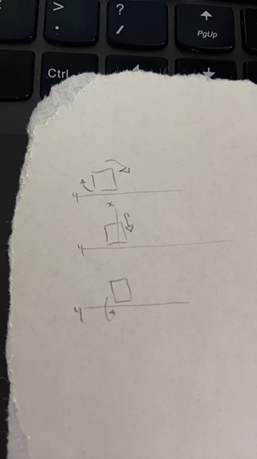
2. There should be two different pick up elements so that the player can easily differentiate why there is a difference in points. Just change the count text script accordingly to how many points you wish each element to be worth.
3. To allow the player to jump, I believe the script should include a jumping script which I am not too certain of but I believe should include a public float variable for jumping force and the equation to be something along the lines of jump = new Vector3(.0f,2.0f,0.0f); and then at the bottom an if statement that states if the player is grounded then add a force to jump and if not grounded then do nothing.
4. A way to place the pickup objects distributed evenly around the perimeter of the circle centered on the player’s start point in the middle of the field is by having the same difference in coordinates within each object to the center player.