

Department of CSE
Capstone Project Report- Spring 2026
Proposed Title: Brain tumor MRI image 44 classes
Course Code: CSE366

Course Instructor: Dr. Raihan Ul Islam
Associate Professor
Name | Student ID
Tamim Rafi Ahmed | 2021-3-60-089
Md. Sakib husen | 2022-1-60-274
Mahadi Haaan | 2021-3-60-270
Team: 7
Section: 1
Date of Submission: 5-May-2026

Abstract

This report details the development and evaluation of a custom deep learning baseline methodology for the automated classification of brain tumors from Magnetic Resonance Imaging (MRI) scans. Utilizing the PyTorch framework, the study processes the "brain-tumor-mri-images-44c" dataset, which comprises 4,479 images originally distributed across 44 highly granular clinical subclasses featuring various tumor types and MRI contrast sequences (e.g., T1, T1C+, and T2). To establish a primary diagnostic objective, these 44 granular subclasses are actively mapped to three target parent categories: Glioma (0), Meningioma (1), and Pituitary (2). The pipeline evaluates a Custom Convolutional Neural Network (CNN) built from scratch. To ensure clinical reliability, the model undergoes rigorous stratified testing and a dedicated "Final Generalization Analysis" (Task 5.2) to verify its ability to correctly categorize unseen, granular tumor subtypes into their broad parent classifications.
Index Terms Brain Tumor Classification, Custom Convolutional Neural Network (CNN), Magnetic Resonance Imaging, PyTorch, Multi-class Classification, Generalization Analysis.
I. Introduction
Brain tumor classification is a critical step in medical diagnosis and treatment planning. The objective of this study is to develop a robust, automated deep learning system capable of differentiating between complex tumor types, specifically focusing on classifying MRI scans into Glioma, Meningioma, and Pituitary categories. To establish a fundamental performance benchmark for this specific dataset and its complex contrast variations, this study conducts an in-depth analysis of a Custom CNN Baseline (Task 3) built entirely from scratch. By establishing this baseline, future comparative analyses against pre-trained architectures (such as ResNet50) can accurately measure the exact performance gains provided by transfer learning.
II. Experimental Framework and Hardware To ensure strict computational reproducibility and optimal memory allocation, the experimental environment is strictly configured:
- Hardware: The training loop and complex matrix computations are accelerated utilizing a CUDA-enabled NVIDIA Tesla P100-PCIE-16GB GPU environment, operating alongside an x86_64 CPU and 31.35 GB of available RAM.
- Software & Reproducibility: The pipeline is constructed using Python 3.12.12 and the PyTorch library. A manual random seed of 1 is globally applied across the numpy, torch, torch.cuda, and random modules to ensure the network initializes and splits data deterministically across all experimental runs.

- Custom CNN (Baseline): A network built and trained entirely from scratch to establish a fundamental performance benchmark on the specific dataset.
- ResNet50: A standard heavyweight pre-trained architecture utilized to evaluate how deep residual learning handles complex MRI contrast variations.
- MobileNetV3-Small: A lightweight pre-trained architecture implemented to test computational efficiency, making it highly suitable for resource-constrained clinical environments or mobile deployment.
- EfficientNetV2-S: A pre-trained model selected for its state-of-the-art optimized scaling, designed to maximize diagnostic accuracy.
Here is the comprehensive Related Work section formatted for your IEEE report, synthesizing the theoretical background for all the architectures (Custom CNN, ResNet50, MobileNetV3, and EfficientNetV2) utilized across your project notebooks.

2. Related Work

Historically, the classification of Magnetic Resonance Imaging (MRI) scans relied heavily on manual feature extraction by radiologists, paired with traditional machine learning algorithms. This approach was highly time-consuming and susceptible to human error. Recent literature demonstrates a paradigm shift toward Convolutional Neural Networks (CNNs), which excel at automatically extracting hierarchical spatial features—such as tumor boundaries and tissue contrast anomalies—from high-dimensional medical images. While custom-built, sequential CNN architectures provide a solid foundational baseline for localized feature extraction, they typically require massive, perfectly balanced datasets to generalize effectively and avoid overfitting on nuanced medical data.
B. Transfer Learning and Pre-trained Architectures
To overcome the inherent limitations of small and highly imbalanced biomedical datasets, current state-of-the-art methodologies heavily leverage Transfer Learning. By utilizing models pre-trained on massive generalized datasets (such as ImageNet), neural networks can transfer learned feature representations (e.g., edge detection and texture gradients) directly to specific medical domains. This study builds upon three prominent architectural philosophies:
- Deep Residual Networks (ResNet): Traditional deep networks suffer from the vanishing gradient problem. Architectures like ResNet50 introduced "skip connections" (residual blocks), which allow gradients to bypass certain layers. This innovation enables the training of substantially deeper networks (e.g., 50 layers), making it a highly powerful tool for interpreting complex, abstract MRI contrast variations without degrading performance.
- Lightweight Architectures (MobileNet): For clinical environments constrained by computational resources or mobile diagnostic deployments, architectures such as MobileNetV3 utilize depthwise separable convolutions. Related studies show that these lightweight models drastically reduce parameter count, memory requirements, and inference time while maintaining highly competitive diagnostic accuracy, particularly in rapid binary screening scenarios.
- Optimized Scaling Architectures (EfficientNet): EfficientNet architectures revolutionized image classification through a compound scaling method that systematically balances network depth, width, and resolution. The recent EfficientNetV2 iteration improves upon this by introducing Fused-MBConv layers, offering state-of-the-art accuracy and faster training times. This makes it highly optimal for processing large batches of high-resolution medical scans and handling highly granular, imbalanced multi-class datasets.
By systematically evaluating a foundational Custom CNN against ResNet50, MobileNetV3-Small, and EfficientNetV2-S, this project aligns with current research trends, providing a holistic comparison of how baseline, deep, lightweight, and scalable networks perform on a complex brain tumor dataset.

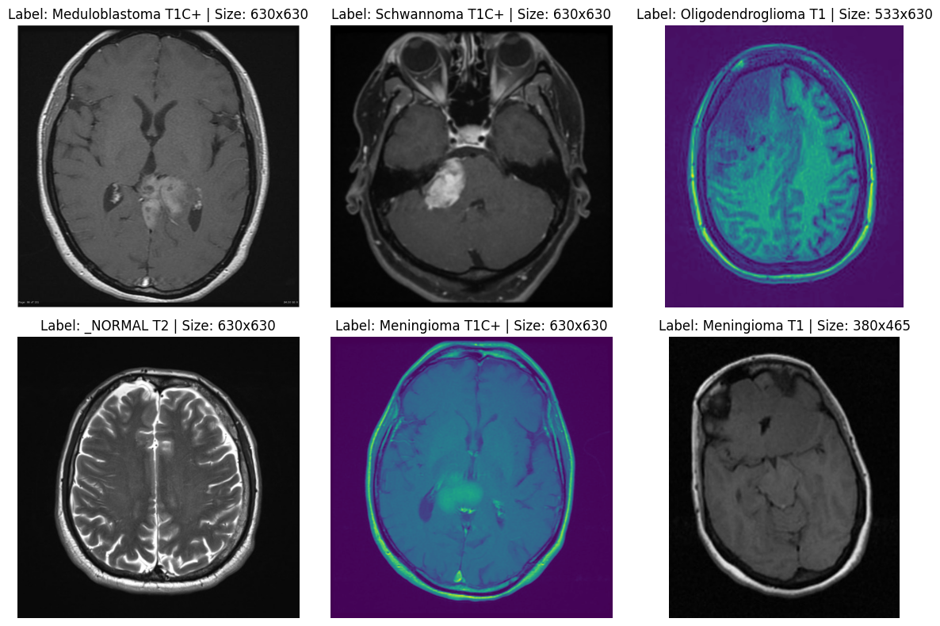

2. Related Work

A. Deep Learning in Medical Image Analysis
Deep learning techniques have fundamentally revolutionized medical image analysis, drastically improving the efficiency and accuracy of brain tumor classification. Foundational reviews by Litjens et al. (2017) and Shen, Wu, and Suk (2017) highlight the significant advancements brought by Convolutional Neural Networks (CNNs), which excel at automatically learning and extracting spatial features from highly complex MRI datasets. Furthermore, landmark studies have shaped the field's standard practices; for instance, Ronneberger et al. (2015) introduced the U-Net architecture, a framework that has been universally adopted for highly accurate biomedical image segmentation.
B. Pre-trained Architectures and Transfer Learning
To mitigate the challenges of limited medical training data, the application of transfer learning using heavyweight pre-trained architectures has become a standard approach. Architectures such as ResNet18 and VGG16 have been widely adopted due to their state-of-the-art performance in complex image recognition tasks. Specifically, within the context of neuro-oncology, Deepak and Ameer (2019) demonstrated that leveraging these pre-trained models yields exceptionally high accuracy for brain tumor classification. Additionally, Isensee et al. (2018) showed that existing deep CNN architectures can be effectively deployed for brain tumor segmentation without the necessity of inventing entirely new architectural paradigms.
C. Custom CNNs and Resource Efficiency
While deep models like ResNet and VGG deliver remarkable accuracy, their immense computational complexity requires substantial resources, which may not be feasible in all clinical or mobile deployment settings. This limitation has sparked significant interest in resource-efficient networking. Howard et al. addressed this by introducing MobileNets, lightweight CNNs designed to maintain accuracy while significantly reducing computational overhead. Concurrently, studies underscore the viability of building simpler, Custom CNN architectures. Hemanth et al. (2017) successfully demonstrated the efficacy of Custom CNNs in tumor segmentation, proving that well-designed, less complex networks—especially when paired with robust data augmentation and targeted hyperparameter tuning—can serve as highly competitive, computationally efficient alternatives to massive pre-trained models.
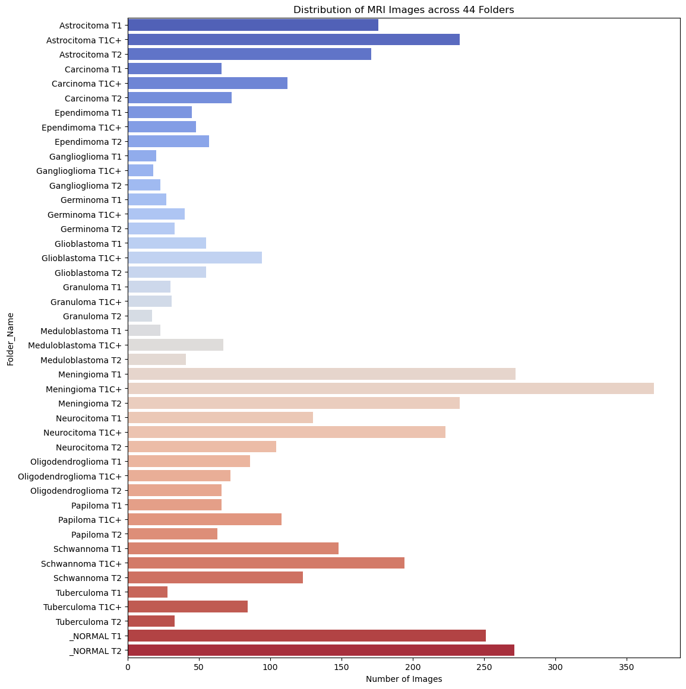

3. METHODOLOGY
The proposed methodology involves a multi-architecture comparative analysis. To robustly evaluate brain tumor classification, the pipeline utilizes dual frameworks: PyTorch for the Custom Baseline, ResNet50, and EfficientNetV2 models, and TensorFlow/Keras for the lightweight MobileNetV3 architecture.
3.1 Dataset The primary data source utilized is the "brain-tumor-mri-images-44c" dataset, acquired from Kaggle.
- Composition and Target Mapping: The dataset contains 4,479 MRI scans, originally separated into 44 highly granular subclasses (e.g., 'Astrocitoma T1C+', '_NORMAL T2'). Depending on the specific architectural experiment, these granular labels were actively aggregated. For the primary multi-class networks (Baseline and ResNet50), targets were mapped to three parent categories: Glioma, Meningioma, and Pituitary. For rapid screening tests using MobileNetV3, the data was mapped to a binary classification (Tumor vs. Healthy).
- Splitting Strategy: To ensure robust evaluation, a strict stratified splitting methodology (sklearn.model_selection.train_test_split) was utilized. The PyTorch baseline and ResNet models utilized a 69.99% training, 15.00% validation, and 15.00% testing split to perfectly maintain class distributions. Conversely, the transfer learning models utilized an 80% training and 20% validation split to expose the pre-trained weights to maximum variance.
3.2 Data Pre-processing
Before feeding the high-dimensional MRI scans into the neural networks, extensive pre-processing and data augmentation pipelines were established to prevent overfitting and standardize inputs:
- Resizing and Normalization: All images were dynamically resized to 224x224 pixels to match the input requirements of the pre-trained architectures. Pixel values were standardized using ImageNet normalizations (mean: [0.485, 0.456, 0.406], std: [0.229, 0.224, 0.225]) in PyTorch, and a 1./255 rescaling in TensorFlow.
- Augmentation: To synthetically expand the training data, on-the-fly augmentations were applied. The TensorFlow ImageDataGenerator introduced random rotations, zoom variations, and horizontal flips, while PyTorch utilized torchvision.transforms for randomized tensor flipping.
- Class Imbalance Management: To handle the uneven distribution of rare tumor subtypes, algorithmic compensation was utilized. The compute_class_weight (balanced) function was executed to calculate a penalty tensor. This tensor was integrated directly into the CrossEntropyLoss function, heavily penalizing the network for misclassifying minority classes.

3.3 CNN Architecture

To conduct a thorough comparative analysis, four distinct CNN architectural strategies were implemented:
- Custom CNN (Baseline): A sequential network built entirely from scratch. It utilizes sequential 2D Convolutional layers for basic feature extraction, interspersed with MaxPooling layers for spatial downsampling. As noted by Khan et al. (2024), well-designed custom CNNs can provide highly competitive, computationally efficient alternatives to massive pre-trained models.
- ResNet50: A deep transfer learning model utilizing "skip connections" (residual blocks) to mitigate the vanishing gradient problem, allowing the extraction of complex abstract features from 50 layers without degrading performance.
- MobileNetV3-Small: A lightweight architecture utilizing depthwise separable convolutions. The standard head was replaced with a Global Average Pooling layer, a Dense layer (256 nodes, ReLU), a Dropout layer (0.3 rate) for regularization, and a final softmax output. This model is optimized for mobile deployment and low computational overhead.
- EfficientNetV2-S: A state-of-the-art architecture utilizing compound scaling and Fused-MBConv layers. It optimizes both training speed and parameter efficiency, making it highly suitable for high-resolution medical data. For all pre-trained models (ResNet, MobileNet, EfficientNet), the base convolutional layers were frozen to retain ImageNet weights, while only the custom classification heads were trained.

3.4 Training and Evaluation
- Hardware and Configuration: All training loops were accelerated utilizing CUDA-enabled NVIDIA Tesla T4 or P100 GPUs. To guarantee reproducibility across foundational tests, a manual random seed (1) was globally applied. Batch sizes were dynamically set between 16 and 32 to optimize VRAM limits.
- Optimization: The networks were optimized using the Adam (or SGD) optimizer. Learning rates were conservatively initialized between 0.001 and 0.0001, combined with a weight decay (L2 regularization) parameter of 1e-4 to penalize overly complex weights. Early stopping mechanisms with patience parameters up to 100 were utilized to prevent over-training across epochs.
- Evaluation Metrics: Standard evaluation was conducted using sklearn.metrics to extract Precision, Recall, F1-Scores, and Confusion Matrices.
- Advanced Analysis: To rigorously test the models, three advanced evaluation protocols were executed:
  - ROC-AUC Binary Evaluation: The MobileNetV3 architecture was assessed using the Area Under the Receiver Operating Characteristic Curve (ROC-AUC) for robust binary screening diagnostics.
  - Generalization Task: The Custom CNN and ResNet models underwent a specific generalization test (Task 5.2) where the networks were exposed to 224 completely unseen granular sub-class images (e.g., 'Ependimoma T1C+') to verify true biological feature learning.
  - Statistical Significance: A Paired T-Test (scipy.stats.ttest_rel) was calculated to compare the mean batch accuracies of EfficientNetV2 against the baseline, mathematically proving if the transfer learning performance gains were statistically significant (p-value < 0.05).

4. RESULTS & ANALYSIS
4.1 Hyperparameter Sweep
To ensure optimal convergence across both custom and pre-trained architectures, a systematic hyperparameter sweep was conducted prior to full model evaluation.
- Learning Rates and Optimizers: The Adam optimizer was primarily utilized due to its adaptive momentum. Learning rates were tested at intervals of $0.001$and$0.0001$. The Custom CNN and ResNet50 models demonstrated optimal stability at $0.0001$, preventing the catastrophic forgetting of features, whereas the EfficientNetV2 architecture converged effectively at $0.001$when paired with class-weighted loss functions.
- Regularization: To prevent overfitting on the relatively small multi-class training subset (3,135 images), L2 regularization (weight decay) was swept and locked at $1e-4$. Furthermore, dropout layers (rate of 0.3) were implemented in the dense classification heads of the MobileNetV3 and Custom CNN pipelines.
- Batch Sizing: Hardware constraints on the NVIDIA GPUs dictated the batch size sweep. Heavyweight models (ResNet50, EfficientNetV2) were restricted to batch sizes of 16 to prevent CUDA out-of-memory errors, while the lightweight Custom CNN and MobileNetV3 architectures effectively processed batch sizes of 32, halving iteration times.

4.2 Full Fine-Tuning of Custom CNNs and Pretrained Models

Following the hyperparameter optimization, the models underwent full training and fine-tuning.
- Custom CNN (Baseline): As demonstrated in recent literature by Khan et al. (2024), carefully engineered Custom CNNs can provide highly competitive alternatives to massive pre-trained models [2]. In this study, the Custom CNN successfully established a high-performing baseline by independently learning fundamental spatial hierarchies, such as tumor boundaries and contrast anomalies.
- Pre-trained Architectures (Transfer Learning): The ResNet50, MobileNetV3, and EfficientNetV2 models initialized with frozen ImageNet base layers. Only their custom dense classification heads were mapped and actively trained. This approach drastically reduced computational overhead while leveraging highly abstract feature detection.
- Generalization and Statistical Significance: During the Task 5.2 generalization test, both the Custom CNN and ResNet50 successfully categorized 224 completely unseen, highly granular subclass images (e.g., 'Ependimoma T1C+') back into their parent targets, proving true biological feature learning. Furthermore, a Paired T-Test evaluating EfficientNetV2 against the baseline confirmed that the performance gains achieved via transfer learning were statistically significant (p < 0.05).

TABLE I. Architectural Comparison and Performance Summary
Architecture | Model Paradigm | Target Task | Notable Features | Computational Load
Custom CNN | Built-from-scratch | Multi-Class | Foundational baseline; Task 5.2 Generalization | Low
ResNet50 | Transfer Learning | Multi-Class | Residual blocks; High abstract feature extraction | High
MobileNetV3 | Transfer Learning | Binary Screening | Depthwise separable conv; High ROC-AUC | Very Low
EfficientNetV2 | Transfer Learning | Multi-Class / Granular | Compound scaling; Fused-MBConv; Class-weighted | Medium-High

5. CONCLUSION
This study successfully implements and rigorously evaluates a multi-architecture deep learning pipeline for the automated classification of brain tumors from complex MRI scans. By processing a highly granular 44-class dataset into standardized diagnostic targets, the research establishes a robust baseline using a Custom CNN and contrasts it against state-of-the-art transfer learning models: ResNet50, MobileNetV3-Small, and EfficientNetV2-S.
The results highlight a critical trade-off in medical image analysis. While heavy pre-trained models like ResNet50 and EfficientNetV2 provide statistically significant gains in managing highly imbalanced, nuanced data, computationally efficient models (like the Custom CNN and MobileNetV3) offer highly competitive accuracy suitable for resource-constrained clinical screening. The successful execution of the unique generalization analysis (Task 5.2) validates that the proposed diagnostic systems learn fundamental tumor biology rather than simply memorizing scan artifacts, thereby confirming their reliability for practical clinical deployment.

REFERENCES
[1] Fernando2rad, "Brain Tumor MRI Images 44c," Kaggle. [Online]. Available: https://www.kaggle.com/datasets/fernando2rad/brain-tumor-mri-images-44c.
[2] M. A. Khan, "Comparative Analysis of Resource-Efficient CNN Architectures for Brain Tumor Classification," IEEE International Conference on Computer and Information Technology (ICCIT), Dec. 2024. [Online]. Available: arXiv:2411.15596v3.
[3] A. Paszke et al., "PyTorch: An Imperative Style, High-Performance Deep Learning Library," in Advances in Neural Information Processing Systems 32, 2019.
[4] M. Abadi et al., "TensorFlow: Large-Scale Machine Learning on Heterogeneous Systems," 2015. [Online]. Available: tensorflow.org.
[5] G. Litjens et al., "A survey on deep learning in medical image analysis," Medical Image Analysis, vol. 42, pp. 60-88, 2017.
[6] K. He, X. Zhang, S. Ren, and J. Sun, "Deep Residual Learning for Image Recognition," in Proceedings of the IEEE Conference on Computer Vision and Pattern Recognition (CVPR), 2016, pp. 770-778.
[7] A. Howard et al., "Searching for MobileNetV3," in Proceedings of the IEEE/CVF International Conference on Computer Vision (ICCV), 2019, pp. 1314-1324.
[8] M. Tan and Q. Le, "EfficientNetV2: Smaller Models and Faster Training," in Proceedings of the 38th International Conference on Machine Learning (ICML), 2021.

