**Lab1 : EEG classification**

**Lab Objective:**

In this lab, you will need to implement simple EEG classification models which are EEGNet, DeepConvNet [1] with BCI competition dataset. Additionally, you need to try different kinds of activation function including ReLU, Leaky ReLU, ELU.

**Important Date:**

1. Experiment Report Submission Deadline: 10/20 (Wed) 12:00 a.m.

2. Demo date: 10/20 (Wed)

**Turn in:**

1. Experiment Report (.pdf)

2. Source code (.py)

**Notice: zip all files in one file and name it like「DLP_LAB1_yourID_name.zip」**

**Requirements:**

1. Implement the EEGNet, DeepConvNet with three kinds of activation function including ReLU, Leaky ReLU, ELU

2. In the experiment results, you have to show the highest accuracy (not loss) of two architectures with three kinds of activation functions.

3. To visualize the accuracy trend, you need to plot each epoch accuracy (not loss) during training phase and testing phase.

**Dataset:**

BCI Competition III - IIIb Cued motor imagery with online feedback (non-stationary classifier) with 2 classes (left hand, right hand) from 3 subjects

[2 classes, 2 bipolar EEG channels]

*Reference:* [*http://www.bbci.de/competition/iii/desc_IIIb.pdf*](http://www.bbci.de/competition/iii/desc_IIIb.pdf)

**Implementation Details:**

* **Prepare Data**

The training data and testing data have been preprocessed and named [S4b_train.npz, X11b_train.npz] and [S4b_test.npz, X11b_test.npz] respectively. Please download the preprocessed data and put it in the same folder. To read the preprocessed data, refer to the “dataloader.py”.

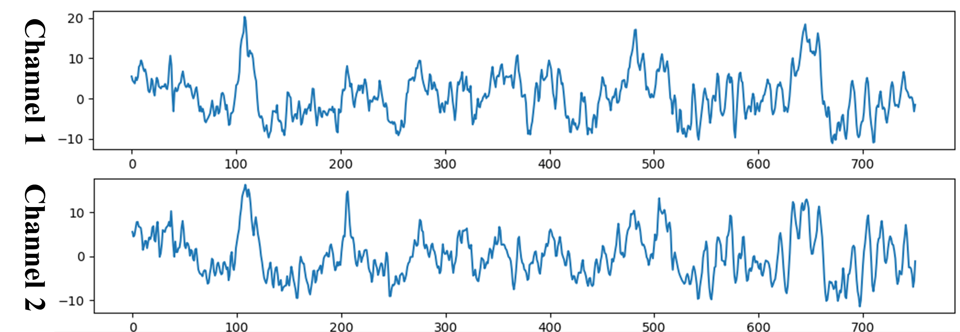

* **Model Architecture**

You need to implement simple EEG classification models which are EEGNet and DeepConvNet.

**EEGNet:**

Overall visualization of the EEGNet architecture

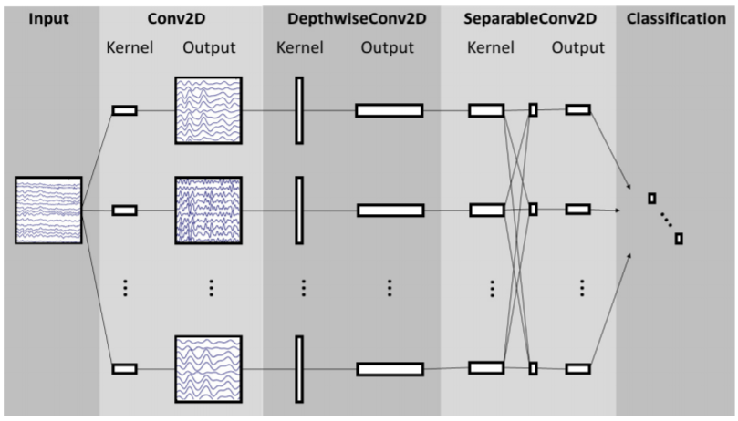

Reference: Depthwise Separable Convolution

<https://towardsdatascience.com/a-basic-introduction-to-separable-convolutionsb99ec3102728>

EEGNet implementation details:

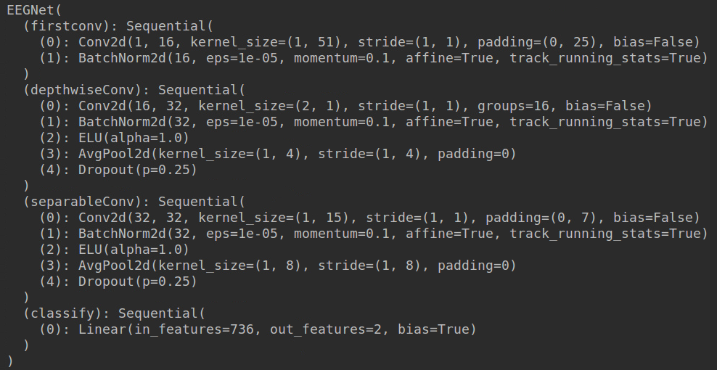

**DeepConvNet:**

You need to implement the DeepConvNet architecture by using the following table, where C =2, T = 750 and N = 2. **The max norm term is ignorable.**

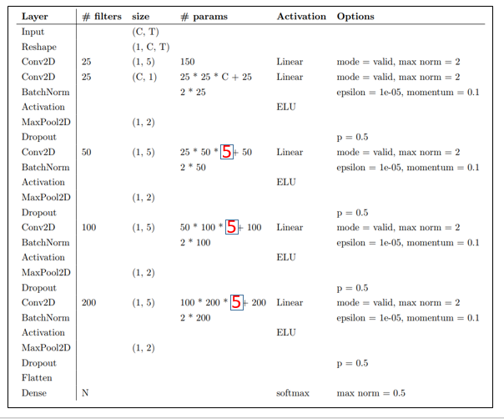

* **Activation Functions**

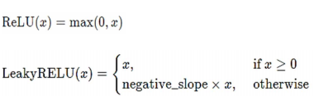

By default, the negative slope = 0.01



The α value for the ELU formulation.Default: 1.0

Reference:

<https://medium.com/tinymind/a-practical-guide-to-relu-b83ca804f1f7>

<https://pytorch.org/docs/stable/nn.html>

In the PyTorch framework, it is easy to implement the activation function. Just typing the following code!



* **Hyper Parameters**

Batch size= 64 Learning rate = 1e-2 Epochs = 300

Optimizer: Adam Loss function: torch.nn.CrossEntropyLoss()

**You can adjust the hyper-parameters according to your own ideas.**

* **Result comparison**

In this part, you can use the matplotlib library to draw the graph.

Reference : <https://matplotlib.org/>

The comparison figure should like the example as below. (EEGNet)

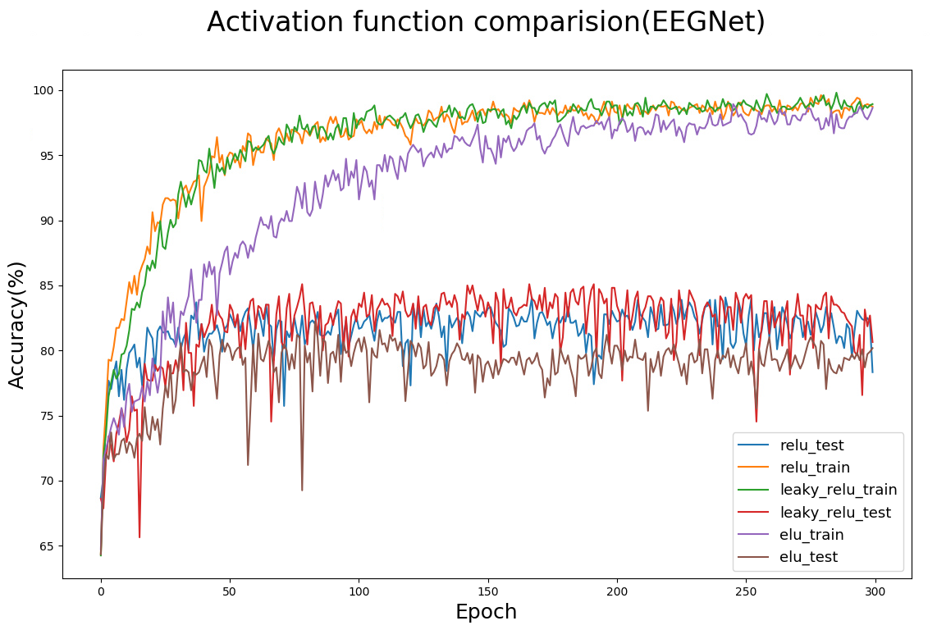

* **Report Spec**

1. Introduction (20%)

2. Experiment set up (30%)

A. The detail of your model

* EEGNet
* DeepConvNet

B. Explain the activation function (ReLU, Leaky ReLU, ELU)

3. Experimental results (30%)

A. The highest testing accuracy

* Screenshot with two models
* anything you want to present

B. Comparison figures

* EEGNet
* DeepConvNet

4. Discussion (20%)

A. Anything you want to share

* **Experimental results**

Accuracy > = 87% = 100 pts

Accuracy 85~87% = 90 pts

Accuracy 80~85% = 80 pts

Accuracy 75~80% = 70 pts

Accuracy < 75% = 60 pts

**Reference:**

[1] EEGNet: A Compact Convolutional Neural Network for EEG-based Brain-Computer Interfaces