HW10 deadline: 2020/06/01

Please find the attached for the Simulink model for the UAV.

The homework is to **design a geometric controller** to track a desired 3d trajectory (e.g., [sin(t); cos(t); 1]).

1. You need to modify “**controller.m**”
2. There is explanation for every function in “**readme.txt**”
3. 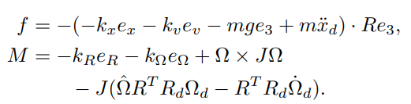Don’t implement this term.
4. You must show $e_{R}$ and $e_{x}$ in **scope** of Simulink.