Comparing Youtube Comments and Tweets about Climate Change with Sentiment

Joyce Simiao
Student At CCT College
Dublin, Ireland
joyce.simiao@gmail.com

Abstract— The study addresses how to qualify using sentiment analysis for feedback and behavior on Youtube and Twitter comments about climate change. Using tools to clean, explore and model the datasets and using SVM and Naive Bayes to explore results and a matrix confusion.
Keywords— Sentiment Analysis, Twitter, Youtube, SVM, Naive Bayes.

Introduction
The growth of social media networks has brought a large amount of data, which is very valuable for companies in a way to measure how the population is behaving and a tool to understand better consumers. That is the moment that Data Science has developed tools to create methods and extract any kind of information and insights from this huge amount of Data, one of these tools is sentiment analysis.
Sentiment Analysis is part of Natural Language Processing (NLP) that develops tools for locating and extracting sentiments from texts. These systems often extract characteristics from sentences recognizing the opinion, subject, and polarity, also possible to recognize emojis and emoticons.

Exploring Datasets

First Stage - Scrapping comments from Youtube
When reading about how the planet is warming, the global average temperature has risen more than 1.6 degrees Fahrenheit in a few years.. The heat is melting sea ice, the numbers of floods are increasing. Rising temperatures create deserts and can kill many animals and plants important for human’s life. Climate experts warn global warming might trigger draughts, water shortages and food production issues. It can cause storms and floods around the world. Addressing climate change involves reducing greenhouse gas emissions, transitioning to renewable energy sources.
According a research from 2020, if existing practices are kept in the future, the globe will become incompatible with the goal of temperatures that are increasing to 1.5 or 2 degrees Celsius over pre-industrial levels.
The research mentioned above shows contrasts on the regulation with NDCs (National Determined Contributions), targets specially the countries voluntarily set when they signed the Paris Agreement to cut their greenhouse gas emissions.
The conclusion of the study updates how much, at least, global greenhouse gas emissions must decrease by 2023, to meet the target established in the Paris agreement.
The aim of this project is to analyse and compare comments about climate change based on twitter and Youtube comments platforms and see how people are reacting to the facts about global warming. The discussion about climate change and global warming is old, scientists have been warning that every year this problem is growing and not much has been done.
As an initial part of the process. I began by extracting and organizing comments from two videos on Youtube platform. Both videos show the changes the world is facing due to climate change.
The first video used was from the channel ClickView video “What is Climate Change? Explore the Causes of Climate Change” and the second video was from the channel DW Documentary, Climate Change - Averting catastrophe. A dataset was created using a concatenate function to make only one dataset with comments of both videos.
In order to get the comments and be able to scrape from Youtube, firstly it was needed 3 pins of authentication provided by Google. These pins are for API service, API version and Developer key, the last one contains 39 digits. The pins are essential for the data extraction and manipulation.
The objective of using scraping on Youtube is to collect data and apply sentiment analysis models capturing expressions within the platforms and measure potential variations of sentiments.

Importing Datasets
The main libraries were imported to use on datasets., such as Pandas, numpy, and a variety of very important libraries to explore sentiment analysis, using textblob, Natural Language Toolkit (NLTK) and for modeling VADER, Support Vector Machine (SVM) and Naive Bayes .

Cleaning Datasets
The first function, and possibly more important, is to clean the text a function was applied to clean. Everything that can interfere with the modeling process will be dealt with by the function “def cleanTxt”. This function is very useful when the text, especially from social media, contains a lot @, Url’s, HTML punctuation, numerals, lower case characters.
I am using the python Textblob library. Other than the processing of textual data, the primary focus of NLP research is on other aspects of language. In addition, it aims to simplify some essential procedures by using the NLTK and Pattern libraries in the background. An important fact about Textblob is that this library just has support in English.
The TextBlob’s ‘sentiment’ attribute was used. This attribute returns a sentiment object with 2 values. The first refers to the polarity of the sentence, which ranges from the most negative (-1) to the most positive (1). The second value refers to the subjectivity of the sentence, which can vary from 0 to 1, and the closer to 1, the more subjective the sentence.
This kind of sentiment analysis is unsupervised, we do not need to pass a base of positive or negative phrases to carry out the classification.
Stop words are phrases, depending on the case, it cannot be irrelevant for the results returned after doing the research on the text.
So when to remove text?
That is a delicate action, in most cases the sentences lose the context when removing words such as for, with or even emotions can be challenging to understand when removing the faces.
There are stop words in every language, and the effectiveness of their removal relies on a number of things, including how well the text is written. Noise may therefore reappear after removal depending on where it was acquired (social networks, for instance). Spacy and nltk are the two primary libraries that provide stop word removal tools.
D. Plotting WordClouds
The graphic representation of the word cloud makes it easier to figure out what is most important and useful in the given situation. Most of the time, the most common words are bigger or darker, while the less common ones are smaller or lighter. On the graph below it was used Wordcloud to catch the most used words in the texts, the first is about Twitter Dataset and second YouTube dataset.
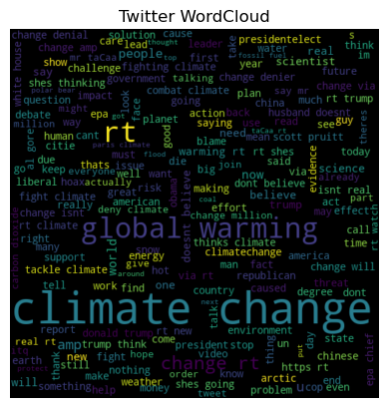

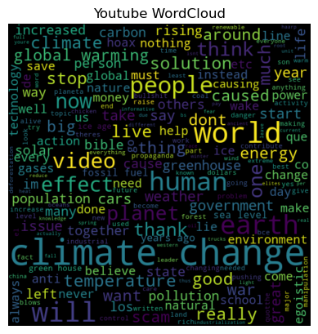

Using WordCloud, It is possible to see in both files the word climate change highlighted, being the most used word but, the file commentsYoutube, even being smaller than Twitter contains words such as world, earth, planet, people, effect more frequently, different of Twitter that contains just global warming most used and highlighted on the graphic.
Python packages like wordcloud and matplotlib give many customisation possibilities. Choosing WordCloud you can get different forms with different shapes mirroring different pictures, color schemes, fonts, and more to meet your needs or aesthetic tastes. WordClouds are easy to create. Create a visually beautiful text data representation with a few lines of code.
Word clouds may be saved as PNG, JPEG, or SVG. This simplifies integration into presentations, reports, webpages, and other publications. They clearly display the most common terms. This is useful for sentiment analysis, subject modeling, and content summarizing contents.
‘Get analysis’ is a function provided for the parameter Score. When the function creates information about positive, negative and neutral comments on both files, with this information.
Using matplotlib I can plot a graph to see the sentiment around both files, as we can see below. The graphs are distributed in three columns: ‘Positive, Neutral and Negative’ and can describe the quality of the texts and information to be transmitted in both platforms.
The indices for neutral and negative in the Twitter text were similar, although with low indices. While the indexes for neutral and positive are near and high on the YouTube graph, the index for negative is low.
This is the issue with this model, many of the positive messages are connected to the video's quality, clarity of the information offered, and explanation about climate change. It does not necessarily mean that there is some positive behavior, feedback or activity transforming and reducing the problems with Climate change.

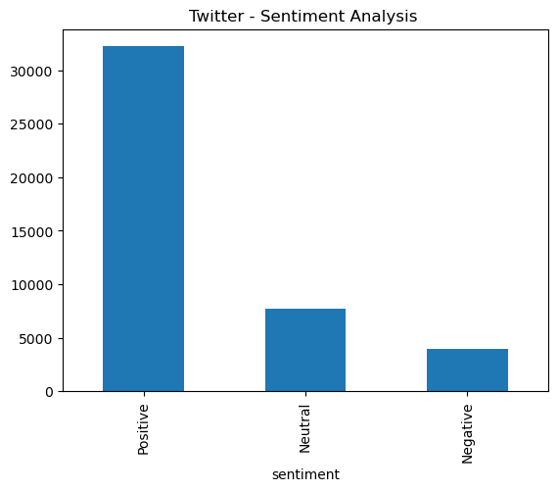

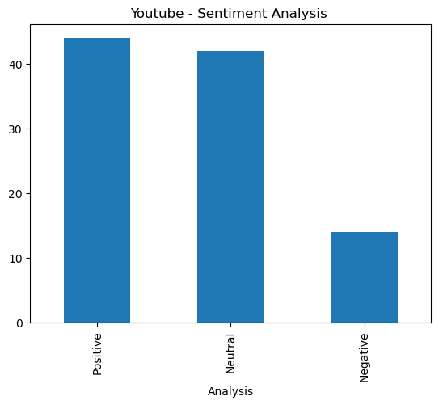

When using a sorted function, I can separate texts from positive ones and make a selection of interesting texts and relevant information. For example, from a positive one, extracted from Youtube, the row 0: “Sea level has been suddenly rising? Sea levels have been rising at the same rate for hundreds of years. It’s easy to find the statistics on NOAA’s website.”
When tokenizing the text with NLTK, it is possible to separate each word. There is one token per line. We can build a tagger that can be used to label new sentences based on this training corpus, and we can use the nltk.chunk.
NLTK (Natural Language Toolkit) is another Python library to interact and develop communication between data and humans. The chunk function extracts meaningful phrases and splits them into a sentence, identifying them as nouns, verbs, foreign words, adjectives, modal etc.There is a list on NLTK documentation that we can check the meaning of the words. From the Jupyter notebook code, I selected 10 first works to see how the library works.

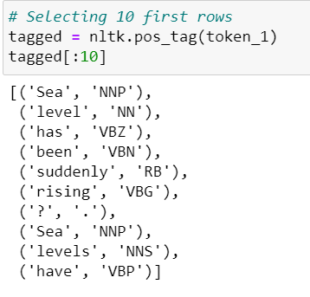.
Information extraction and natural language processing can benefit from NLTK's chunking capabilities, especially if you need to separate nouns, verbs and make a different cluster.

Exploring models for Sentiment Analysis

Another tool used to explore sentiment analyse is Vader, that uses the polarity of the text to be positive, negative or neutral. This is a tool very useful for data mining and exploring and monitoring social media, Brand monitoring, market research, product analysis. It facilitates the gathering and organizing blog posts, comments reviews, tweets and even emojis or emoticons.
VADER sentiment analysis relies on a dictionary that maps lexical features to emotion intensities known as sentiment scores. The sentiment score of a text can be obtained by summing up the intensity of each word in the text. (towardsDataScience).
NLTK’s VADER module optimizes texts from social media, recognizing even slangs, acronyms and peculiarities.
In the graph below we can see the level of sentiment from the Youtube dataset, measuring Negative, Positive, Neutral and compound sentiment.
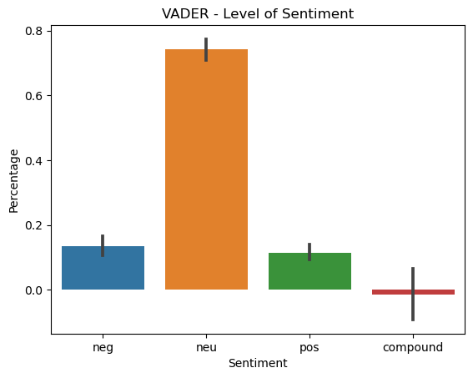

It is a pre-trained model, with a large amount of social media text, from sentiment lexicon, a list of words with sentiment scores. That means, the model can learn and recognize sentiment patterns from the data, and apply the score, being positive, negative and neutral. The compound score is a single number that calculates sentiment by combining word scores. It's used to gauge a text's tone.
When using the same example as before, it is easy to understand the result: ‘Sea levels have been rising at the same rate for hundreds of years. It’s easy to find the statistics on NOAA’s website.':
{'neg': 0.0,
'neu': 0.903,
'pos': 0.097,
'compound': 0.4404}’
but, for example, in the sentence: ‘Great propaganda! 😂': {'neg': 0.313,
'neu': 0.0,
'pos': 0.687,
'compound': 0.5255},

VADER recognizes the sentence above as positive because of the laughing emoji.
E. Train and Test dataset
The train_test_split divides the dataset in two subsets, for training and test, where training is using 80% of the data and testing 20%.
The initialization of the random number generator is done by setting the random_state option to 42. This guarantees that, if the code is executed more than once, the random split will be the same each time.
The TF - IDF ( Term frequency Inverse document Frequency) is applied to transform data in numbers. The TF - IDF works through the algorithm picking words that better describe the content by assigning a value to a term based on its relevance in the document. It is a strong weighting operation used in NLP applications, doing a sentiment categorization.
The idea is to use the Confusion Matrix. The TfidfVectorizer is a class from scikit-learn and used to convert raw documents into a matrix, so then it is possible to apply the TfidfVectorizer on X_train and X_test. As informed before, the file is separated for train and test.
Support Vector Machines are a great machine learning model that can be applied to Natural Language Processing, very useful for text classification problems and can handle high dimensional feature spaces, suitable for a wide range of text.
The other model I used to process the texts is the Naive Bayes classifier, also used for text categorization, learning models input distribution for a class or category. The technique makes fast, reliable predictions by assuming that the input data features are independent of each other in the given file.
Both models are great for sentiment analysis, but SVM can be more affordable and versatile for the task specially for optimizing the dataset features.
Applying the accuracy of the models, SVM has a better result, with a small difference from the Naive Bayes model. SVM with the accuracy of 0.81 and Naive Bayes 0.77.
Applying the confusion matrix model, we can say the performance of the models were positive, from a different perspective, but I would say the SVM model is more precise to get the result due to the power of calculation.

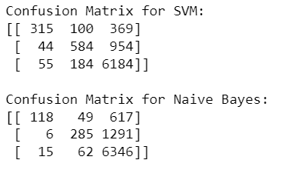
Below you can see a heatmap graphic for the same information above, for the numbers obtained from Confusion Matrix..

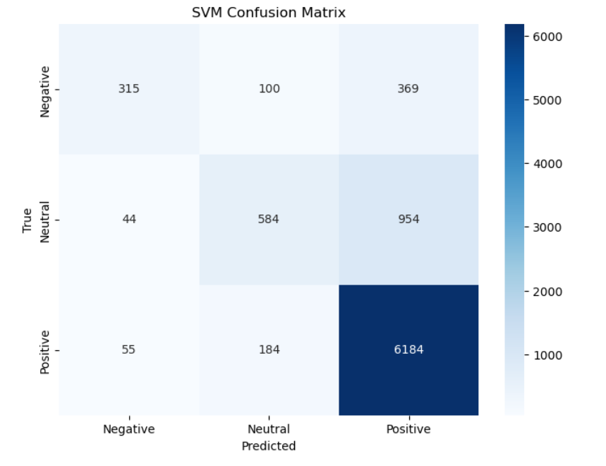

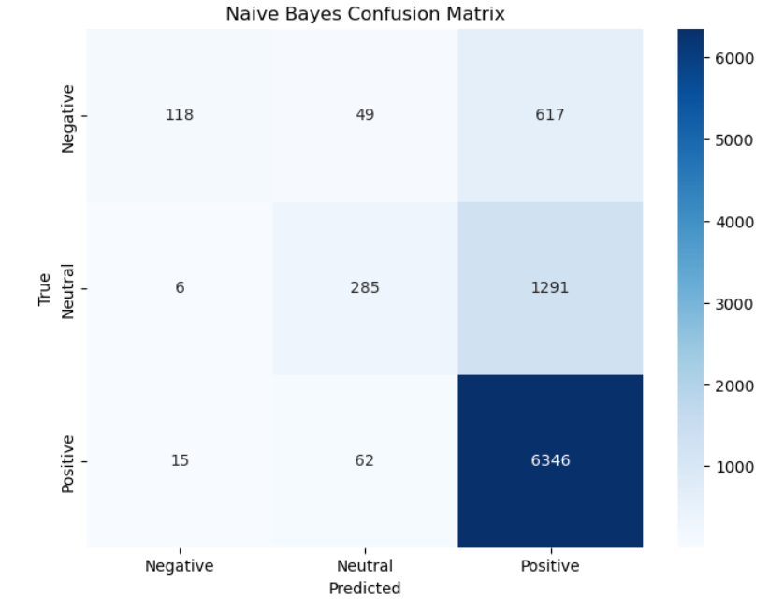
IV. Conclusion

The study explores the field of sentiment analysis from Youtube and Twitter platforms. The idea was to extract people’s feedback and capture what they are saying on social media about climate Change.
For the data extraction a pin authentication was required for the first stage, when scrapping from Youtube videos.
The datasets were cleaned through functions to remove URLs, special characters and punctuation.
Textblob were applied to extract polarity from texts and Wordcloud were used to get visualizations to see the words more common and highlight them in both texts.
Support Vector Machines and Naive Bayes models were used to classify sentiment. SVM proved to be more accurate than Naive Bayes, even though both presented positive and similar results when applied. SVM's effectiveness was confirmed by the Confusion Matrix, which offered more insights into the models' operation.
In conclusion, this project completed the data collecting, preprocessing, sentiment analysis, and model assessment stages effectively. It could gather some knowledge of public opinion and responses to this global problem.

References
(2023) Climate change - averting catastrophe | DW documentary. Available at: https://www.youtube.com/watch?v=pEt6-jA2UE4&t=11s (Accessed: 21 September 2023).
An, X. et al. (2014) Tracking climate change opinions from Twitter data - SCU, Tracking Climate Change Opinions from Twitter Data. Available at: https://www.cse.scu.edu/~yfang/climate-fang.pdf (Accessed: 08 October 2023).
Beri, A. (2020) Sentimental analysis using vader, Medium. Available at: https://towardsdatascience.com/sentimental-analysis-using-vader-a3415fef7664 (Accessed: 05 November 2023).
Choudhary, M. and Choudhary, P.K. (no date) IEEE Xplore: Advanced Search, IEEE Xplore. Available at: https://ieeexplore.ieee.org/search/advanced (Accessed: 02 October 2023).
Dias Baiano, T. (no date) Criando Modelos de machine learning COM pipeline do Scikit-Learn, Tudo sobre o mundo de dados! Available at: https://dadosaocubo.com/criando-modelos-de-machine-learning-com-pipeline-do-scikit-learn/ (Accessed: 01 October 2023).
Effrosynidis, D. et al. (2022) The climate change twitter dataset, Expert Systems with Applications. Available at: https://www.sciencedirect.com/science/article/abs/pii/S0957417422008624 (Accessed: 08 October 2023).
Ewert, N. (2020) Descomplicando Machine Learning: Algoritmos de Classificação - naïve Bayes e árvore de Decisão, Medium. Available at: https://nelson-ewert-oliveira.medium.com/descomplicando-machine-learning-algoritmos-de-classifica%C3%A7%C3%A3o-na%C3%AFve-bayes-e-%C3%A1rvore-de-decis%C3%A3o-940c97cb5227 (Accessed: 01 October 2023).
Getting started with hugging face in 15 minutes | Transformers, pipeline, tokenizer, Models (2022) AssemblyAI. Available at: https://www.youtube.com/watch?v=QEaBAZQCtwE&t=215s (Accessed: 30 September 2023).
Johnson, D. (2023) POS tagging with NLTK and chunking in NLP [examples]. Available at: https://www.guru99.com/pos-tagging-chunking-nltk.html (Accessed: 06 October 2023).
Li, S. (2018) Named entity recognition with NLTK and spacy, Medium. Available at: https://towardsdatascience.com/named-entity-recognition-with-nltk-and-spacy-8c4a7d88e7da (Accessed: 30 September 2023).
Live #6: Análise de Sentimentos utilizando dados do Twitter (Passo a Passo) (2019) YouTube Stack. Available at: https://www.youtube.com/watch?v=Zy5sHkr5W7s&t=2237s (Accessed: 11 October 2023).
Loureiro, M.L. and Allo, M. (2020) Sensing Climate Change and energy issues: Sentiment and emotion analysis with social media in the U.K. and Spain, Sensing climate change and energy issues: Sentiment and emotion analysis with social media in the U.K. and Spain. Available at: https://www.sciencedirect.com/science/article/abs/pii/S0301421520302366 (Accessed: 28 September 2023).
Mahreen, J. (2022) Sentiment analysis using Vader, Analytics Vidhya. Available at: https://www.analyticsvidhya.com/blog/2022/10/sentiment-analysis-using-vader/ (Accessed: 07 October 2023).
Maneja, D. (2021) How TF-IDF Works, How and Why TF-IDF Works. Available at: https://towardsdatascience.com/how-tf-idf-works-3dbf35e568f0 (Accessed: 03 October 2023).
Mucha, N. (2018) Sentiment analysis of global warming using Twitter data, SENTIMENT ANALYSIS OF GLOBAL WARMING USING TWITTER DATA. Available at: https://library.ndsu.edu/ir/bitstream/handle/10365/28166/Sentiment%20Analysis%20of%20Global%20Warming%20Using%20Twitter%20Data.pdf?sequence=1 (Accessed: 11 October 2023).
Mulla, R. (2022) Python sentiment analysis project with NLTK and 🤗 transformers. classify amazon reviews!!, YouTube. Available at: https://www.youtube.com/watch?v=QpzMWQvxXWk (Accessed: 27 September 2023).
Qian, E. (2019) Twitter climate change sentiment dataset, Kaggle. Available at: https://www.kaggle.com/datasets/edqian/twitter-climate-change-sentiment-dataset (Accessed: 21 September 2023).
Redes neurais Para Análise de Sentimentos em Python e Tensorflow (2023) Inteligencia Mil Grau . Available at: https://www.youtube.com/watch?v=qiz8mtlG0G8&t=183s (Accessed: 29 September 2023).
Tabsharani, F. (2023) What is a support vector machine?: Definition from Whatis, Support Vector Machine (SVM) . Available at: https://www.techtarget.com/whatis/definition/support-vector-machine-SVM (Accessed: 02 October 2023).
Twitter sentiment analysis using Python | Machine Learning Project 8 (2022) The AI & DS Channel. Available at: https://www.youtube.com/watch?v=ng6L_wvREB4 (Accessed: 30 September 2023).
What is climate change? explore the causes of climate change (2021) What is Climate Change? Explore the Causes of Climate Change. Available at: https://www.youtube.com/watch?v=EuwMB1Dal-4&t=128s (Accessed: 21 September 2023).

