A Classification Method of Image Feature using Neural Metric Learning for Natural Environment Video
Yukito Seo¹, Rafly Arief Kanza², Nobuya Watanabe³,
Kin Fun Li⁴, Kosuke Takano¹
1 Department of Information and Computer Sciences, Kanagawa Institute of Technology and Address
emails
2 Politeknik Elektronika Negeri Surabaya
3 Chubu Institute for Advanced Studies, Chubu University
4 Department of Electrical and Computer Engineering, Faculty of Engineering, University of Victoria

Abstract. In this study, we propose an image feature classification method that applies a distance learning neural network to image feature vectors extracted from an autoencoder. There is active research on similar image retrieval methods using image feature vectors extracted from neural networks. If the image classification performance is not sufficient, it is possible to further improve the image classification performance by applying a distance learning neural network to convert it into an image feature vector that can obtain appropriate ranking results. In the proposed method, by constructing a model that connects an autoencoder and a distance learning neural network, the reusability of image features extracted from the autoencoder is maintained, and the flexibility of the combination of the autoencoder and distance learning neural network is maintained. It is possible to realize model construction. In the experiment, we evaluate the image classification accuracy using the Geospatial Information Authority of Japan's aerial photo dataset and demonstrate the feasibility of the proposed method.
1 Introduction
Climate change due to global warming, rising sea levels, desertification, and changes in ecosystems are urgent global-scale natural environmental problems that must be solved. For this purpose, data analysis by constantly observing the natural environment and recording visual data such as movies and images to understand natural phenomena over time and to extract similar natural phenomena plays an important role. However, the amount of data required to record video data of observations of the natural environment in various regions of the world is extremely large, and the processing costs required for data analysis are expected to be very high. To solve this problem, we have proposed an image scene retrieval method using low-dimensional image feature vectors extracted by a neural network with images as input[1]. However, when feature vectors are extracted using a neural network with many intermediate layers, such as a VGG convolutional neural network, there are issues such as variations in the properties of the feature vectors obtained depending on the intermediate layers.
In this study, we extend this method and propose an image feature classification method that applies an autoencoder as a network for extracting image features and a distance learning neural network. The reasons for using an autoencoder are that the network structure is not complex and easy to implement, and the number of dimensions of the image feature vectors obtained as the output of the encoder can be easily adjusted. However, since image classification accuracy is not always high even if the image feature vectors are used as they are, we apply a distance learning neural network to perform learning using positive and negative example teacher data. This enables us to improve the accuracy of image classification. In the proposed method, by constructing a model with a structure that connects an autoencoder and a distance learning neural network, it is possible to maintain the reusability of image features extracted from the autoencoder and to realize flexible model construction by combining an autoencoder and a distance learning neural network. In addition, it is possible to realize flexible model construction by combining an autoencoder and a distance learning neural network.
In the experiments, we verify the feasibility of the proposed method using the GSI's aerial photo dataset [6].
2 Related research
Research has been conducted on applying autoencoders as image feature extractors and applying the extracted image feature vectors to image retrieval.
In Reference [2], for the purpose of kaou retrieval, a method is proposed for extracting glyph features from a symbol called kaou, which has a writer's signature function, using a convolutional autoencoder, and the accuracy of the classification is evaluated. Reference [3] proposed a conditional autoencoder with a condition of character type label for handwriting analysis. By training only the image generation part of the decoder with the character type labels, the encoder part extracts the writer's unique writing habits as features from the handwriting image, independent of the character type labels. Reference [4] proposed an autoencoder model that builds a neural network combining a variational autoencoder and triplet loss to learn embedded representations for extracting similarity concepts.
Autoencoders are used as feature extractors for various data other than images, and methods such as [5], which constructs a neural network combining an autoencoder and triplet loss to detect attacks and intrusions from network traffic, have been proposed.

3 Proposed method
The proposed method extracts compressed image features using an autoencoder and converts the image features into a classifiable feature vector by adapting a distance learning neural network. The converted feature vectors are suitable for classification and ranking.
The following describes the implementation procedure of the proposed method.

Step-1: Apply autoencoder to the image set I = { i1, i2, …, in } and train it to create a trained model AE from which image features can be extracted.

Step-2: Extract the image feature vector V = { v1, v2, ..., vn } of the image set from the output of the intermediate layer of the encoder of AE constructed in Step-1 (Figure 1). The mth-order tensor T = ( t1, t2, ..., tm ), which is the output of the convolutional layer, can be used as the image features (Figure 2). where each tx is a multidimensional vector. In this study, we call this mth-order tensor the feature tensor.

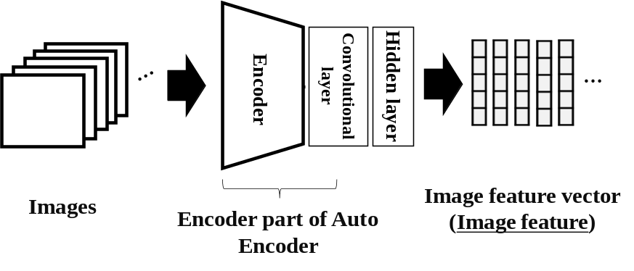
Figure 1 Image feature vector extraction by intermediate layer
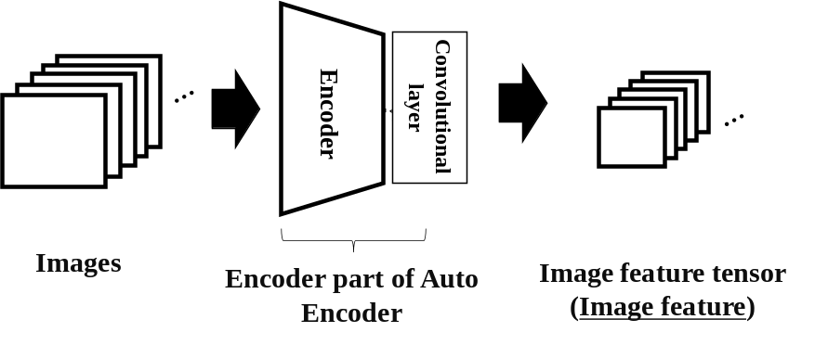
Figure 2 Image feature tensor extraction using convolutional layers

Step-3: Using the distance learning neural network MLNN, transform the image feature vector V or the image feature tensor T into a feature vector V' = { v'1, v'2, ..., v'n } suitable for ranking and classification. ..., v'n } suitable for ranking and classification. Embedding in Figure 3 is a feature vector for which the distance relationship between similar feature vectors has been optimized. The input layer is adapted to the data format of the input image features. For example, an all-join layer is applied in the case of image feature vector format, and a convolution layer is applied in the case of image feature tensor format.

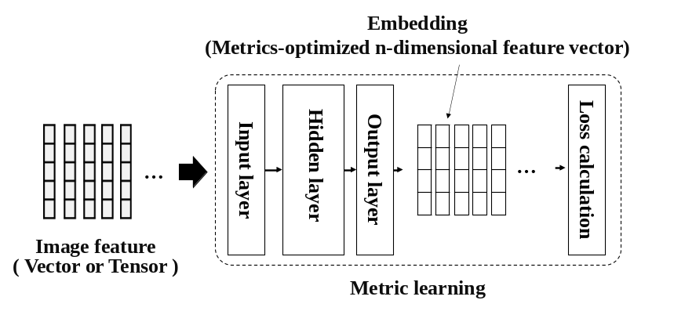
Figure 3 Image feature optimization using distance learning neural networks
4 Experiment
The feasibility of the proposed method is confirmed by the accuracy of image classification using the feature vectors extracted by the proposed method.

4.1 Purpose of the Experiment
The GSI's aerial photograph dataset [6] was used as the image dataset. The dataset consists of 576 aerial photographs, which are classified into four classes: "Fields," "Water Source Areas," "Forests," and "Buildings," with 144 images in each class. An example of image data is shown in Figure 4.
One type of auto encoder AE with a convolutional layer is provided. Two types of distance learning neural networks are used: distance learning NN-1, which has no convolution layer, and distance learning NN-2, which has a convolution layer. Autoencoder AE is trained using 576 aerial photographs. The distance learning neural network is trained using image features (image vectors or image tensors) or image data extracted from the autoencoder AE in a supervised manner.

Class1  fields | 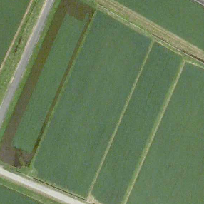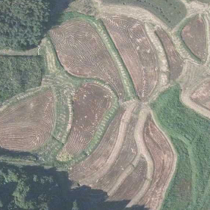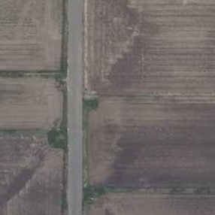
Class2  water source area | 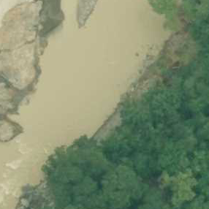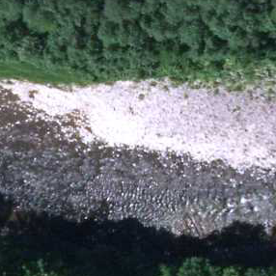
Class3  forest | 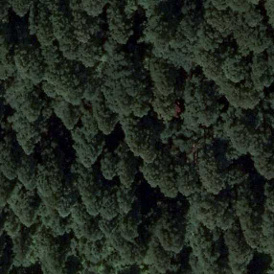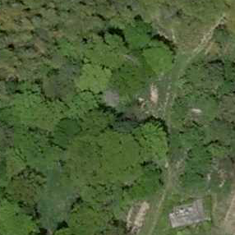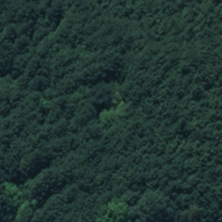
Class4  building | 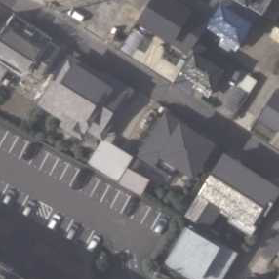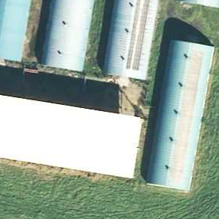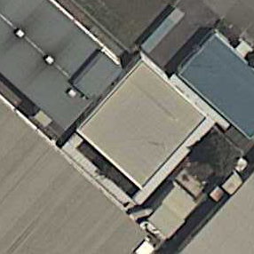
Figure 4 Example of aerial photo data (4 classifications)
4.2 Experimental Environment
Calculate the accuracy of classification by applying k-means for the following six models and compare the results. In each neural network, the dimensions of the intermediate layer of the autoencoder and the output layer of the distance learning neural network are varied by 1000, 500, and 100 dimensions.
M1: Consists of AE only; the output from the encoder of AE is used as the feature vector.
M2: Consists of AE only; the output of the convolutional layer in the encoder of AE is converted into a vector and is used as the feature vector (32*32*64 dimensions).
M3: Consists of AE of M1 and distance learning NN-1; the feature vector is the transformed feature vector extracted from AE of M1 and transformed by distance learning NN-1.
M4: Consists of AEs of M2 and distance learning NN-1; feature vectors are feature vectors extracted from AEs of M1 and transformed by distance learning NN-1.
M5: consists of AEs of M1 and distance learning NN-2; feature vectors are feature tensors (32D, 32D, 64D) extracted from AEs of M1 or convolutional layers in the encoder and transformed by distance learning NN-2.
M6: Consists of distance learning NN-2 only. The image is input as a feature tensor (256D, 256D, 3D), and the transformed feature vector is the one transformed by the distance learning NN-2.

Reproducibility and conformance are calculated by the following equations.
Reproducibility = Number of correct answers / Total number of correct answers (1)
Conformance = Number of Correct Answers / Number of Correct Answers (2)

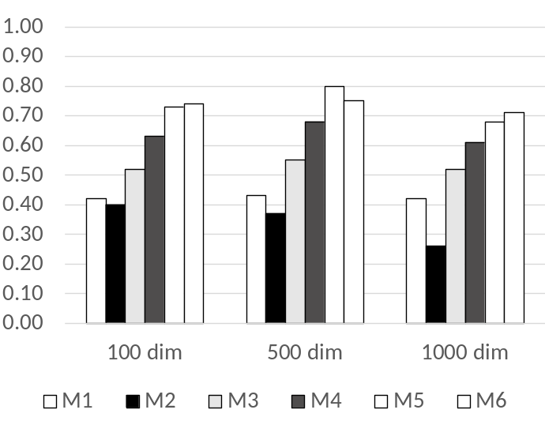
Figure 5 Comparison of recall of each model

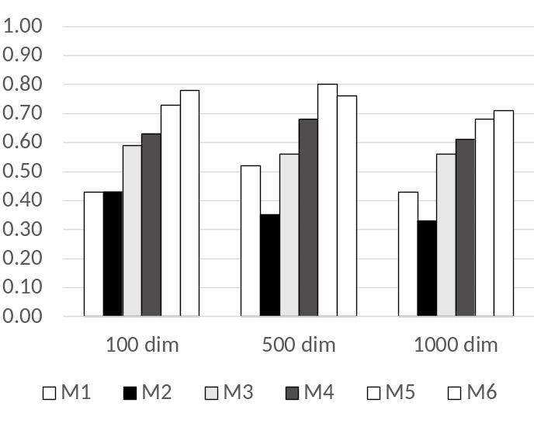
Figure 6 Comparison of precision of each model

Table 1 Comparison of average recall and average precision (M5 and M6)
 | M5 | M6
epochs | 600 | 1000
average recall | 0.736 | 0.733
average precision | 0.736 | 0.750

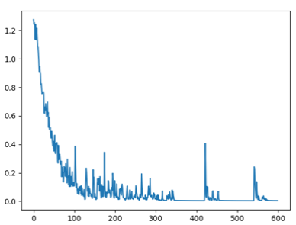 | 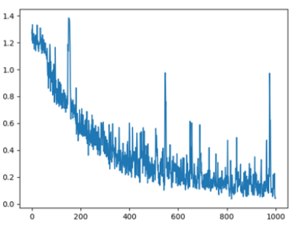
Change in loss value of M5 | Change in loss value of M6
Figure 7 Comparison of loss values ​​in learning

4.3 Results of the Experiment

The experimental results are shown in Figures 5 through 7 and Table 1. Figures 5 and 6 show the comparison results of the reproduction and fit rates for each model. Models M1 and M2 consist of an autoencoder only, while models M3 and M4 consist of an autoencoder and distance learning neural network. Since models M3 and M4 have improved both the reproduction and fit rates, it can be confirmed that the accuracy of image classification can be improved by applying the distance learning neural network.
Model M5, like M3 and M4, consists of an autoencoder and a distance learning neural network, but it has a convolution layer in the distance learning neural network. On the other hand, models M3 and M4 are composed of a distance learning neural network with all coupled layers instead of a convolution layer. The improved reproduction and fit rates of model M5 indicate that using a convolutional layer in the distance learning neural network is more effective in improving classification accuracy in image classification.
Model M6 does not use an autoencoder, but only a distance learning neural network, and uses the image data itself as input instead of extracted image features. The reproduction and fit rates of M6 were improved when the intermediate layer of the autoencoder and the output layer of the distance learning neural network were set to 100 and 1000 dimensions, respectively.
Table 1 and Figure 7 show the results of comparing the average reproducibility and fit rates for models M5 and M6, as well as the change in loss during training (100 dimensions). Table 1 shows that M5 has higher average reproducibility in the 100, 500, and 1000 dimensions, and M6 has a slightly higher average fit rate, but the difference in average fit rate is small at 0.014. The results in Figure 7 also confirm that the learning process is more stable with smaller fluctuations in the loss values for M5. The loss values of M5 and M4 both start at around 1.2 at the time of learning, indicating that the distance relationship is not sufficiently appropriate at the start of learning for both cases using the feature tensor extracted from the autoencoder and the image data. The reason why the number of training epochs for M5 is small is considered to be that the image features appropriate for distance learning have been extracted by training with the autoencoder.
From the results of the comparison of models M5 and M6, it is considered that the separation of the autoencoder and distance learning networks has certain effects in terms of classification accuracy and learning stability.

5 In Conclusion
In this study, we proposed an image classification method that applies an autoencoder and a distance learning neural network as a network for extracting image features. Experiments using aerial photograph data showed that the proposed method can improve the classification accuracy of image features by applying the distance learning neural network, and confirmed the feasibility of the proposed method.
As a future plan, we are considering applying the proposed method to the construction of a video scene analysis system for video data recorded and accumulated from observation cameras installed at different locations in natural environment observation.

Acknowledgments. This research was supported by the Digital Earth Research Collaboration Center for Problem Complexes, FY2023, and by JSPS Grant-in-Aid for Scientific Research 23K11120.
References
1. Baldonado, M., Chang, C.-C.K., Gravano, L., Paepcke, A.: The Stanford Digital Library Metadata Architecture. Int. J. Digit. Libr. 1 (1997) 108–121
2. Bruce, K.B., Cardelli, L., Pierce, B.C.: Comparing Object Encodings. In: Abadi, M., Ito, T. (eds.): Theoretical Aspects of Computer Software. Lecture Notes in Computer Science, Vol. 1281. Springer-Verlag, Berlin Heidelberg New York (1997) 415–438
3. van Leeuwen, J. (ed.): Computer Science Today. Recent Trends and Developments. Lecture Notes in Computer Science, Vol. 1000. Springer-Verlag, Berlin Heidelberg New York (1995)
4. Michalewicz, Z.: Genetic Algorithms + Data Structures = Evolution Programs. 3rd edn. Springer-Verlag, Berlin Heidelberg New York (1996)
1. Hiroki Mimura, Masaya Tahara, Kosuke Takano, Nobuya Watanabe, Kin Fun Li: Video Indexing for Live Nature Camera on Digital Earth, International Conference on Advanced Information Networking and Applications, (2023) 660-667
2. Yosuke Onitsuka, Wataru Ohyama, Taizo Yamada, Sattoshi Inoue, Seichi Uchida: Convolutional Feature Extraction for Kaou Image Retrieval, Proceedings of IPSJ Computers and the Humanities Symposium (Jinmoncon)2018, (2018) 257-262
3. Mariko Hosoe, Tomoki Yamada, Kunihito Kato, Kazuhiko Yamamoto: A Proposal of Method for Extraction of Handwriting Feature Using Conditional AutoEncoder, The 80th National Convention of IPSJ, 2C-06, No. 2, (2018) 37-38
4. Haque Ishfaq, Assaf Hoogi, Daniel Rubin: TVAE: Triplet-Based Variational Autoencoder using Metric Learning, arXiv:1802.04403 [stat.ML], (2018)
5. Giuseppina Andresini, Annalisa Appice, Donato Malerba: Autoencoder-based deep metric learning for network intrusion detection, INFORMATION SCIENCES, Volume 569, (2021) 706-727
6. Geospatial Information Authority of Japan: Teacher image data for paddy field extraction using CNN, Geospatial Information Authority of Japan technical data, H1-No.26 (2023)

