**MEMBERS:**

Earl John O. Luchin

Casandra A. Casicas

Jerlyn Tagopa

**DOCUMENTATION:**

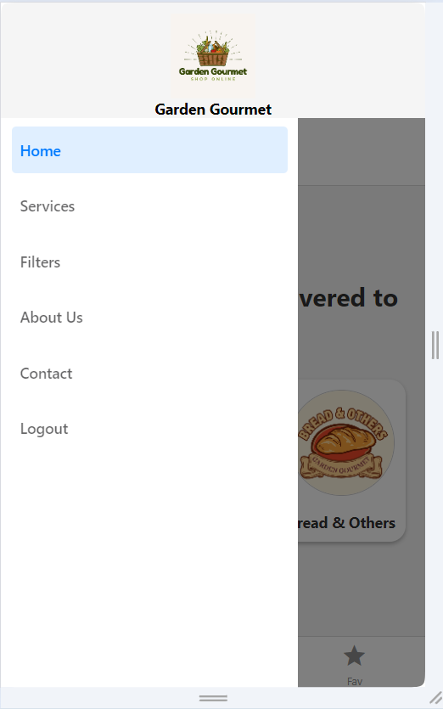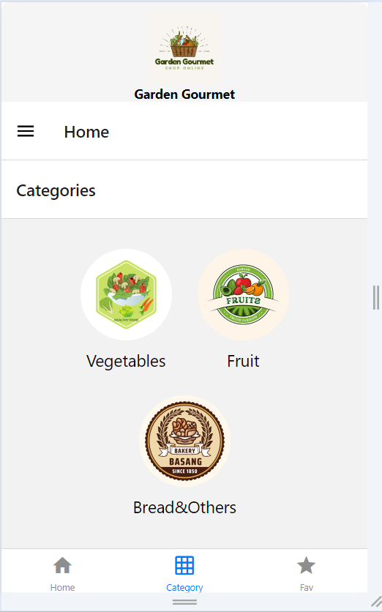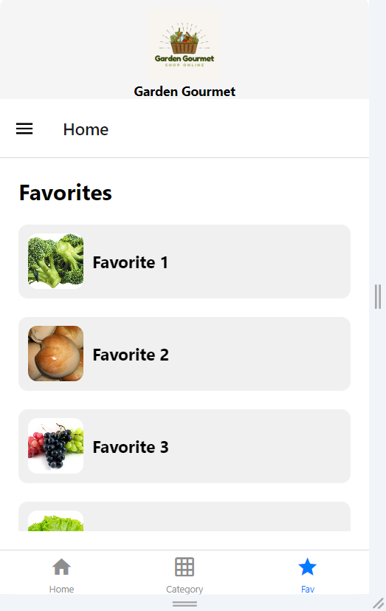**DRAWER NAVIGATION: BOTTOM TAB NAVIGATION: STACK NAVIGATION**

**WITH MULTIPLE SCREENS:**

Feature and Description:

1. Drawer Navigation

Drawer navigation acts as the primary navigation method to access various sections of the app directly. It’s typically used for accessing high-level navigation destinations like Home, Services, Filters, About us, Contact, Products.

2. Bottom Tab Navigation

This navigation pattern allows users to switch between frequently used features quickly. You could set tabs for Home, Categories, and Fav for quick access.

3. Stack Navigation

Stack navigation is used to manage navigation across multiple screens within the same category, such as navigating from the Categories list to Product Details.

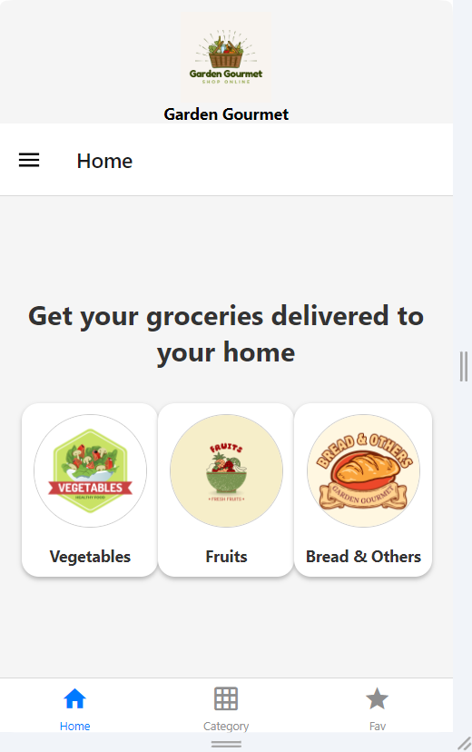**SAMPLES IMAGES OUTPUT:**



