**CASANDRA CASICAS 03/05/2024**

**IT35C IT83**

**TODO Application**

A todo application is a digital tool used to organize tasks and manage to-do lists. It allows users to create, prioritize, categorize, and track their tasks, helping them stay productive and focused on completing their goals.

**Feature Description**

**Create** - Seamlessly add new tasks or academic details with just a few taps. Input course name, description, academic year, and even attach an ID photo for a personalized touch.

**Delete** - Remove tasks or information that are no longer relevant, keeping the list fresh and up to-date.

**Edit** - Mistakes happen, has an edit feature allows the user to quickly correct any information or modify tasks.

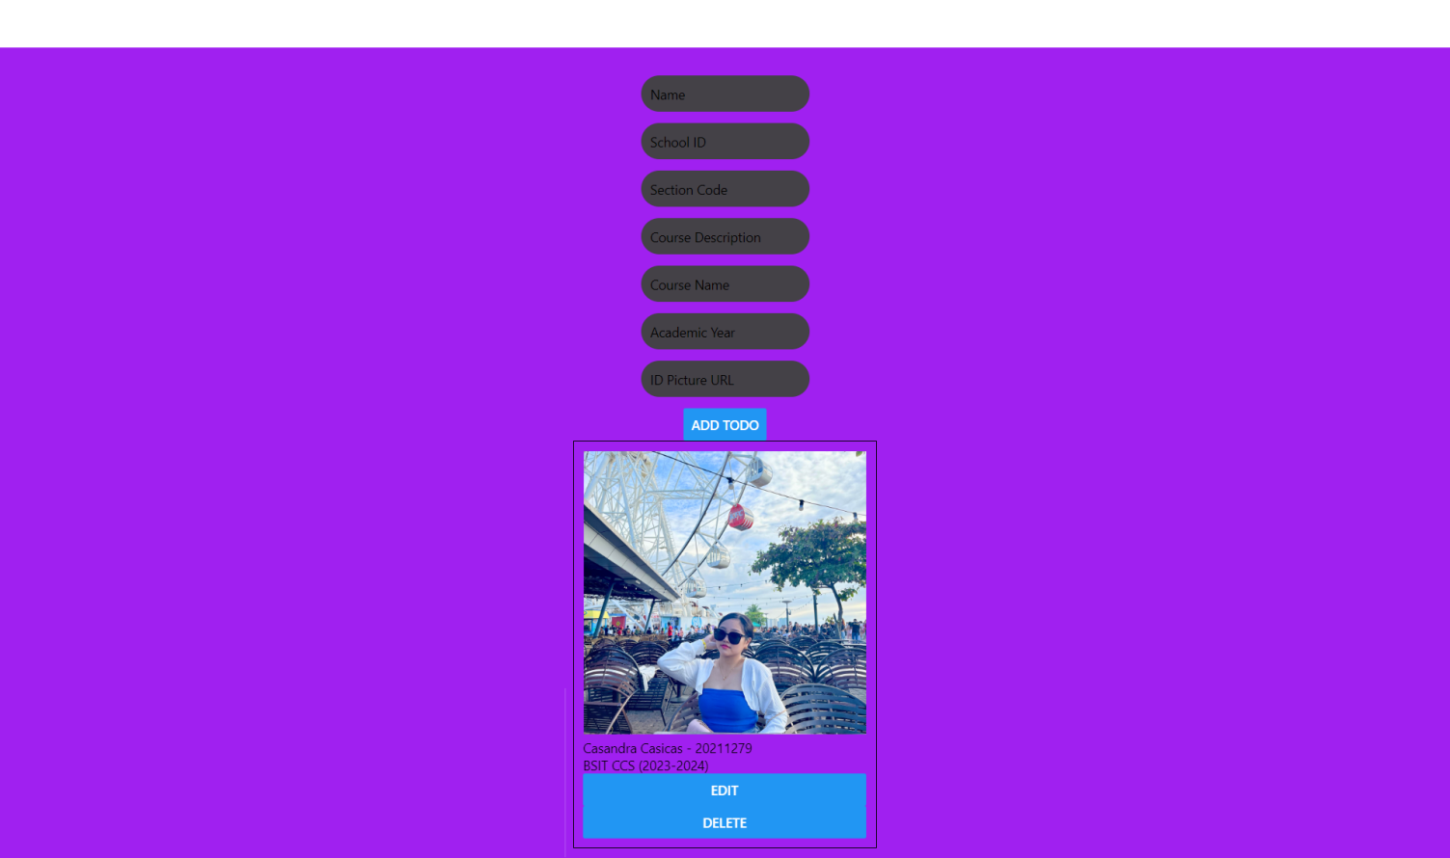**Display** - View tasks and data in a beautifully organized manner. Information displayed includes Name, School ID, Section Code, Course Description, Course Name, Academic Year, and an option to attach an ID Picture/Photo of the user.