A Systematic Literature Review on Fake News Detection using Natural Language Processing (NLP), Machine Learning, and Deep Learning Based Approaches
Department of Computer Science & Engineering, Shahjalal University of Science & Technology, Sylhet, Bangladesh
Abstract— This systematic literature review (SLR) investigates the growing body of research on automated fake news detection using Natural Language Processing (NLP), Machine Learning (ML), and Deep Learning (DL) based approaches. The unchecked spread of misinformation on social media and online news platforms has made manual fact-checking infeasible at scale, motivating a decade of research into automated classifiers that can distinguish fake from real news content. This review synthesizes 18 primary studies, selected from an initial pool of 145 articles following a structured identification-screening-eligibility-inclusion protocol, to examine the methodologies, feature representations, datasets, and evaluation practices used across the field. Particular emphasis is placed on comparing traditional feature-engineered machine learning classifiers (e.g., Logistic Regression, SVM, Random Forest) against deep learning architectures (CNN, LSTM, GRU, hybrid CNN-LSTM) and ensemble/stacking frameworks that combine multiple base learners through a meta-classifier. The review further examines the emerging role of transformer-based language models and explainable AI (XAI) techniques such as LIME in improving both the accuracy and interpretability of fake news classifiers. Using an AHP-weighted TOPSIS ranking procedure over accuracy, label granularity, dataset size, and label noise, this review provides an objective, multi-criteria comparison among the reviewed studies rather than relying on accuracy alone. The review concludes by identifying open gaps — including limited cross-lingual and cross-domain generalizability, class imbalance, adversarial robustness, and the scarcity of propagation- and multimodal-aware detectors — and proposes concrete directions for future research in this domain.
Index Terms— Fake News Detection, Machine Learning, Deep Learning, Natural Language Processing, Explainable AI, TOPSIS

I. Introduction
A Systematic Literature Review (SLR) is a structured technique for identifying, appraising, and synthesizing all available research relevant to a specific research question, allowing researchers to map the current state of a field, uncover research gaps, and propose directions for future investigation. The proliferation of social media has transformed how people consume news, but it has simultaneously enabled the rapid, low-cost spread of deliberately fabricated or misleading content — commonly termed "fake news" — which has been linked to consequential real-world events such as the 2016 U.S. presidential election and public health misinformation during the COVID-19 pandemic.
A substantial and rapidly growing body of literature has proposed automated fake news detection systems spanning classical machine learning, deep neural architectures, ensemble/stacking frameworks, graph- and propagation-based models, and, more recently, transformer-based language models. However, comparatively few reviews synthesize this literature with an explicit, criterion-weighted ranking of competing approaches, or connect methodological choices (feature representation, model family, dataset) to the resulting robustness and generalizability of the detector. Recognizing this gap, this review compiles and compares 18 primary studies on fake news detection, discusses their methodologies, datasets, and reported performance, and applies a Technique for Order of Preference by Similarity to Ideal Solution (TOPSIS) ranking procedure to objectively compare studies along multiple criteria simultaneously, following the same comparative methodology previously used for reviewing sentiment analysis literature.
Our contributions in this systematic literature review are as follows:
- We highlight the existing methodologies used for fake news detection and compare variations between traditional feature-engineered machine learning and representation-learning-based deep learning approaches.
- We discuss the algorithms and model families (classical ML, RNN/CNN-based DL, ensemble/stacking, graph neural networks, and transformers) commonly applied in the literature.
- We examine the datasets predominantly used for benchmarking fake news detectors and their characteristics (size, label granularity, and noise).
- We discuss ensemble and hybrid approaches that combine multiple models or feature representations, and the advantages they offer over single-model baselines.
- We examine the growing role of explainable AI (XAI) techniques in fake news detection and the domains/applications where such systems have found utility.
- We present an objective, multi-criteria comparison among the reviewed studies by applying the AHP-weighted TOPSIS method, ranking studies on accuracy, label granularity, dataset size, and label noise.
- Finally, we identify current gaps and challenges in the field and propose recommendations and novel directions for future research.
II. Materials and Methods
Our systematic literature review adheres to standard systematic review principles and encompasses a structured series of steps: research question formulation, search strategy design, study selection, data extraction, and synthesis.
Research Questions
Research questions structure a systematic review so that the current state of research on the topic can be easily identified by other researchers. The following research questions were formulated for this review:
1. What methodologies have been predominantly utilized in the existing literature for fake news detection?
2. Are there variations in the methodologies employed for traditional feature-engineered machine learning approaches versus representation-learning-based deep learning approaches?
3. What datasets have been commonly used to benchmark fake news detection systems?
4. How do machine learning techniques, particularly supervised learning algorithms, contribute to fake news detection?
5. How do deep learning architectures compare to machine learning techniques in terms of effectiveness and accuracy for fake news detection?
6. Are there ensemble or hybrid approaches that combine multiple machine learning and/or deep learning techniques, and what advantages do they offer?
7. Show an objective, multi-criteria comparison among the research papers in discussion. Which proposed system is comparatively better?
8. What role does explainable artificial intelligence (XAI) play in improving the transparency of fake news detection systems?
9. In what domains or applications has fake news detection found significant utility and impact?
10. What are the current gaps and challenges in fake news detection research that need further exploration?
11. Based on the synthesis of existing studies, what recommendations can be made for future research directions in the field of fake news detection?
12. How can the identified gaps be addressed, and what novel approaches or methodologies could enhance the effectiveness of fake news detection systems?
Search Strategy
We employed various keywords during our search for relevant literature in online databases of research papers. Each term was accompanied by alternative spellings and synonymous expressions. The search strings utilized in our queries are as follows:
- ("fake news" OR misinformation OR disinformation) AND (detection OR classification OR identification) AND (machine learning OR deep learning OR NLP)
- ("fake news" OR rumor) AND (ensemble OR stacking OR hybrid OR transformer OR BERT OR explainable AI)
Study Selection Criteria
The foundation of our study selection criteria lies in the research questions. We incorporated papers related to fake news detection, limited to publications in either journals or conference proceedings. Only those papers were included if they met the following criteria:
1. Full texts of the potentially relevant publications are obtained.
2. The publication is in the English language.
3. The publication does not already exist in our selected collection of papers.
4. The title, abstract, and introduction of the article explicitly focus on fake news detection using NLP, ML, or DL based approaches.
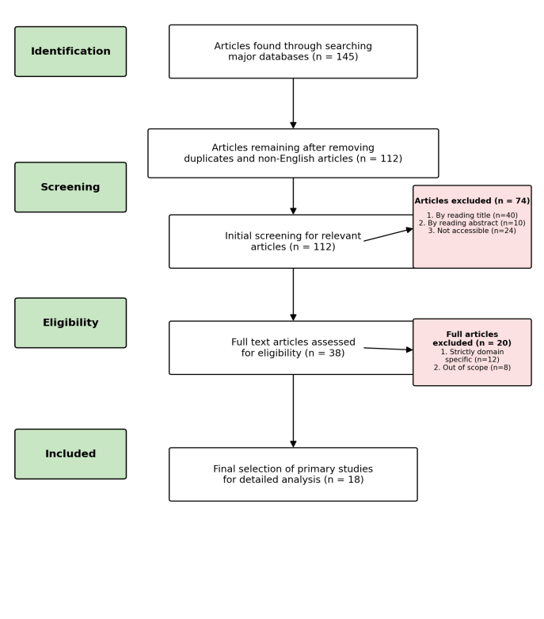
Fig. 1. Flow diagram for the selection of articles.
Study Selection Process
We settled on specified sources for our method of searching. A manual search technique was performed to obtain the answers to our study topic from the following sources:
- IEEE Xplore
- Google Scholar
- ACM Digital Library
- ScienceDirect
- SpringerLink
- arXiv
Most of the interesting journal and conference papers are published here, which is why we identified those sources. After collecting the papers, we selected articles according to our research questions.
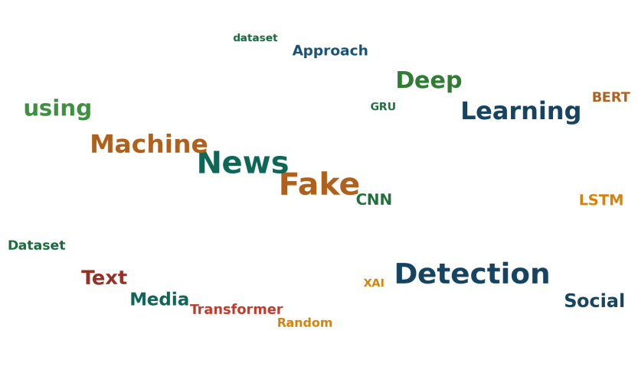
Fig. 2. Generated word cloud from article titles and keywords.
Data Extraction
To document the information acquired from the primary studies, we employed a data extraction form, presented in Table 1, reflecting the entity of Authors, Correspondent Models, Year, and Dataset.

Authors | Correspondent Models | Year | Primary Dataset
Ahmed et al. | LR, SVM, DT, KNN, SGD (n-gram/TF-IDF) | 2017/18 | ISOT (self-collected)
Ozbay & Alatas | 23 supervised AI algorithms | 2020 | ISOT, BuzzFeed, Random Political News
Kaliyar et al. | FNDNet (CNN) | 2020 | Kaggle fake news
Kaliyar et al. | RF, MNB, GB, DT, LR, Linear-SVM | 2019 | Fake News Challenge (FNC-1)
Umer et al. | CNN+LSTM+PCA+Chi-Square | 2020 | FNC-1
Kumar et al. | CNN+BiLSTM ensemble | 2020 | Twitter/media (self-collected)
Roy et al. | CNN+RNN+MLP | 2018 | LIAR
Monti et al. | Graph CNN | 2019 | Twitter (propagation graphs)
Ruchansky et al. | CSI (LSTM + user response) | 2017 | Twitter, Weibo
Singhania et al. | 3HAN (hierarchical attention) | 2017 | Signal Media / news corpus
Della Vedova et al. | Logistic Regression (content+social) | 2018 | Real-world Facebook dataset
Shabani & Sokhn | NN, SVM, RF, GB | 2018 | Satire/fake news corpus
Jain et al. | Naive Bayes + SVM + NLP | 2019 | Kaggle fake news
Agudelo et al. | Naive Bayes | 2018 | Public fake news dataset
Verma et al. | WELFake benchmark model | 2021 | WELFake (72,134 articles)
Shu et al. | FakeNewsNet repository | 2019 | PolitiFact, GossipCop
Jiang et al. | Stacking ensemble (5 ML + 3 DL) | 2021 | ISOT, KDnuggets
Hashmi et al. | CNN-LSTM + FastText + LIME/LDA | 2023 | WELFake, FakeNewsNet, FakeNewsPrediction
Table 1: List of Authors and Correspondent Models

III. Results And Discussions
RQ#1: What methodologies have been predominantly utilized in the existing literature for fake news detection?
Ahmed et al. [2], [3] proposed one of the earliest widely used approaches, comparing term frequency (TF) and TF-IDF feature extraction with six n-gram based classifiers (SGD, SVM, Linear SVM, LR, KNN, and DT), and later released the ISOT dataset that has become a standard benchmark in the field.
Ozbay and Alatas [23] implemented twenty-three supervised artificial intelligence algorithms across three datasets, finding that decision-tree-based algorithms outperformed most other classifiers in the majority of evaluation metrics.
Kaliyar et al. [16] proposed FNDNet, a purpose-built convolutional neural network for fake news detection, while in earlier work Kaliyar et al. [15] compared Random Forest, Multinomial Naïve Bayes, Gradient Boosting, Decision Tree, Logistic Regression, and Linear-SVM within an ensemble framework on the Fake News Challenge dataset.
Umer et al. [34] combined CNN and LSTM architectures with PCA and Chi-Square based dimensionality reduction to determine whether a news headline agrees with its body text, while Kumar et al. [18] proposed a CNN+BiLSTM ensemble model enhanced with an attention mechanism.
Roy et al. [28] used CNN layers to identify hidden features and RNN layers to capture temporal sequence information, feeding the resulting representation into a multilayer perceptron (MLP) classifier. Monti et al. [20] took a fundamentally different, propagation-based approach, applying a four-layer Graph Convolutional Network over the social spread pattern of news on Twitter, while Ruchansky et al. [29] proposed the CSI model, which jointly captures article text, user response, and source characteristics using an LSTM-based "Capture" module and a user-graph-based "Score" module.
Jiang et al. [14] evaluated five machine learning models (LR, SVM, DT, KNN, RF) and three deep learning models (CNN, LSTM, GRU) before proposing a stacking ensemble that combines the predictions of all eight base learners through a Random Forest meta-classifier. Building on this direction, Hashmi et al. [11] combined supervised FastText embeddings with a hybrid CNN-LSTM architecture and further applied transformer-based models (BERT, XLNet, RoBERTa), reporting that the hybrid CNN-LSTM model matched or exceeded transformer-level accuracy at substantially lower computational cost.
RQ#2: Are there variations in the methodologies employed for traditional feature-engineered ML approaches versus representation-learning-based DL approaches?
There is a clear methodological divide in the literature. Traditional ML pipelines, as used by Ahmed et al. [2], [3], Ozbay and Alatas [23], and Jain et al. [13], rely on hand-engineered feature representations such as term frequency (TF), TF-IDF, and n-gram counts, which are then fed into classifiers such as LR, SVM, DT, RF, or KNN. These approaches are computationally inexpensive and interpretable but depend heavily on the quality of manual feature engineering and struggle to capture long-range semantic or sequential dependencies in text.
In contrast, DL-based approaches such as FNDNet [16], the CNN-LSTM hybrid of Umer et al. [34], and the FastText-augmented CNN-LSTM of Hashmi et al. [11] learn dense vector representations directly from data, using pretrained or task-specific word embeddings (GloVe, Word2Vec, FastText) to capture semantic similarity and sequential/local context automatically. Jiang et al. [14] directly compared both paradigms on the same datasets and found that DL models (particularly LSTM) achieved accuracy close to, but not consistently exceeding, the best-performing ML models (RF with TF-IDF), suggesting that the choice between ML and DL is dataset- and resource-dependent rather than universally in favor of either paradigm.
RQ#3: What datasets have been commonly used to benchmark fake news detection systems?
A relatively small number of benchmark datasets recur throughout the literature. The ISOT dataset [2], [3], [14] — comprising 44,898 Reuters-sourced real articles and Politifact/Wikipedia-flagged fake articles — is among the most widely used large-scale binary benchmarks. The LIAR dataset [28] provides 12.8K short political statements labeled with six fine-grained truthfulness categories (true, mostly-true, half-true, barely-true, false, pants-fire), making it substantially more challenging than binary corpora. FakeNewsNet [32] and its underlying PolitiFact/GossipCop sources provide news content together with social context and spatiotemporal propagation information. WELFake [35] merges four existing corpora (Kaggle, McIntire, Reuters, BuzzFeed Political) into a 72,134-article benchmark, while the smaller KDnuggets/Kaggle-derived dataset (6,335 articles) used by Jiang et al. [14] and Hashmi et al. [11] serves as a low-resource stress test for model robustness.
RQ#4: How do machine learning techniques, particularly supervised learning algorithms, contribute to fake news detection?
Supervised ML algorithms remain a strong baseline throughout the literature. Jiang et al. [14] found that Random Forest with TF-IDF achieved the highest individual-model accuracy (99.87%) on the large ISOT dataset, with SVM and Logistic Regression statistically indistinguishable from it via a corrected McNemar's test, while Logistic Regression with TF-IDF (92.82%) was the best individual model on the smaller KDnuggets dataset. Ozbay and Alatas [23] similarly found decision-tree variants to be highly competitive across several datasets. However, K-Nearest Neighbors consistently underperforms other ML models on large, high-dimensional text datasets due to the curse of dimensionality, as observed by Jiang et al. [14].
RQ#5: How do deep learning architectures compare to machine learning techniques in terms of effectiveness and accuracy for fake news detection?
Deep learning architectures generally match or exceed ML performance on larger, more complex datasets, though the gap narrows or reverses on small datasets. Kaliyar et al.'s FNDNet [16] achieved 98.36% accuracy on the Kaggle fake news dataset using a purpose-built CNN, and Umer et al. [34] reported 97.8% accuracy with a CNN-LSTM-PCA-Chi-Square pipeline. Hashmi et al. [11] found that a hybrid CNN-LSTM model with supervised FastText embeddings achieved 0.99 accuracy and F1-score on both the WELFake and FakeNewsNet datasets, and 0.97 on the smaller FakeNewsPrediction dataset, consistently outperforming individual ML classifiers, standalone RNN variants (LSTM, GRU, BiLSTM), and even matching transformer baselines (BERT, XLNet, RoBERTa) at a fraction of the training cost. On the challenging six-class LIAR dataset, however, Roy et al.'s CNN+RNN+MLP model achieved only 44.87% accuracy, illustrating that fine-grained truthfulness classification remains substantially harder than binary fake/real detection for both ML and DL models alike.
RQ#6: Are there ensemble or hybrid approaches that combine multiple machine learning and/or deep learning techniques, and what advantages do they offer?
Ensemble and hybrid modeling is one of the most consistently effective strategies identified in this review. Jiang et al. [14] proposed a stacking ensemble that trains a Random Forest meta-classifier on the predictions of eight diverse base learners (five ML models and three DL models across three tokenization schemes), improving accuracy from 99.87% (best individual model) to 99.94% on ISOT, and from 92.82% to 96.05% on KDnuggets. Hashmi et al. [11] combined convolutional and recurrent layers within a single hybrid CNN-LSTM architecture, allowing the model to jointly exploit local n-gram-like features (via CNN) and long-range sequential dependencies (via LSTM). Kaliyar et al. [15] and Aslam et al. [7] similarly report that ensemble machine learning and ensemble deep learning models, respectively, provide state-of-the-art performance by exploiting the complementary error patterns of diverse base learners. Across all these studies, the recurring advantage of ensembling is that it reduces variance and compensates for the weaknesses of any single feature representation or model family, provided the base learners are individually better than random guessing and sufficiently diverse in their errors.
RQ#7: Show an objective, multi-criteria comparison among the research papers in discussion. Which proposed system is comparatively better?
Model accuracy alone is an incomplete basis for comparison, since studies differ substantially in dataset size, label granularity (number of classes), and label noise. Following the same comparative approach used for ranking sentiment analysis literature, we apply an AHP-weighted TOPSIS procedure over four criteria — accuracy, number of categories, dataset size, and label noise — for eleven representative results drawn from the studies in Table 1.

Study | Accuracy | No. of Categories | Data Set Size | Noise
Jiang et al. (RF-TFIDF, ISOT) | 99.87% | 2 | 44898 | v. low
Jiang et al. (Stacking, ISOT) | 99.94% | 2 | 44898 | v. low
Jiang et al. (LR-TFIDF, KDnuggets) | 92.82% | 2 | 6335 | high
Jiang et al. (Stacking, KDnuggets) | 96.05% | 2 | 6335 | high
Hashmi et al. (WELFake) | 99% | 2 | 72134 | medium
Hashmi et al. (FakeNewsNet) | 99% | 2 | 23196 | medium
Hashmi et al. (FakeNewsPrediction) | 97% | 2 | 6335 | high
Kaliyar et al. (FNDNet) | 98.36% | 2 | 20800 | medium
Kumar et al. (CNN+BiLSTM) | 88.78% | 2 | 1356 | v. high
Roy et al. (CNN+RNN+MLP) | 44.87% | 6 | 12836 | v. high
Verma et al. (WELFake) | 96.73% | 2 | 72134 | medium
Table 2: Studies, Accuracy, No. of Categories, Data Set Size, and Noise
Normalization: The decision matrix is normalized using vector normalization (Eq. 1), and the weighted normalized matrix C is computed as C = M'pq × Wi (Eq. 2), where Wi = [0.059246, 0.4828, 0.31385, 0.1441] for [Accuracy, Category, Dataset size, Noise], following the same AHP-derived Saaty-scale weighting used for the comparative sentiment-analysis review.
Study | Wt. Norm. Accuracy | Wt. Norm. Category | Wt. Norm. Dataset Size | Wt. Norm. Noise
Jiang et al. (RF-TFIDF, ISOT) | 0.0191 | 0.1108 | 0.1125 | 0.0124
Jiang et al. (Stacking, ISOT) | 0.0191 | 0.1108 | 0.1125 | 0.0124
Jiang et al. (LR-TFIDF, KDnuggets) | 0.0178 | 0.1108 | 0.0159 | 0.0494
Jiang et al. (Stacking, KDnuggets) | 0.0184 | 0.1108 | 0.0159 | 0.0494
Hashmi et al. (WELFake) | 0.0190 | 0.1108 | 0.1807 | 0.0371
Hashmi et al. (FakeNewsNet) | 0.0190 | 0.1108 | 0.0581 | 0.0371
Hashmi et al. (FakeNewsPrediction) | 0.0186 | 0.1108 | 0.0159 | 0.0494
Kaliyar et al. (FNDNet) | 0.0188 | 0.1108 | 0.0521 | 0.0371
Kumar et al. (CNN+BiLSTM) | 0.0170 | 0.1108 | 0.0034 | 0.0618
Roy et al. (CNN+RNN+MLP) | 0.0086 | 0.3323 | 0.0322 | 0.0618
Verma et al. (WELFake) | 0.0185 | 0.1108 | 0.1807 | 0.0371
Table 3: Weighted Normalized Matrix
Ideal Solutions (L+ and L−): Accuracy, category count, and dataset size are treated as benefit criteria (higher weighted-normalized value is more desirable), while noise is treated as a cost criterion (lower weighted-normalized value is more desirable). L+ therefore takes the maximum of each benefit column and the minimum of the noise column, while L− takes the opposite.
Attribute | L+ | L−
Weighted Accuracy | 0.0191 | 0.0086
Weighted No. of Categories | 0.3323 | 0.1108
Weighted Data Set Size | 0.1807 | 0.0034
Weighted Noise | 0.0124 | 0.0618
Table 4: Ideal Solutions
The Euclidean distances D+ and D− for each study from L+ and L− are computed (Eq. 3, Eq. 4), and the Relative Closeness (Ci) is calculated as Ci = D−/(D+ + D−) (Eq. 5). Using this metric, the studies were ranked by Relative Closeness in Table 5.
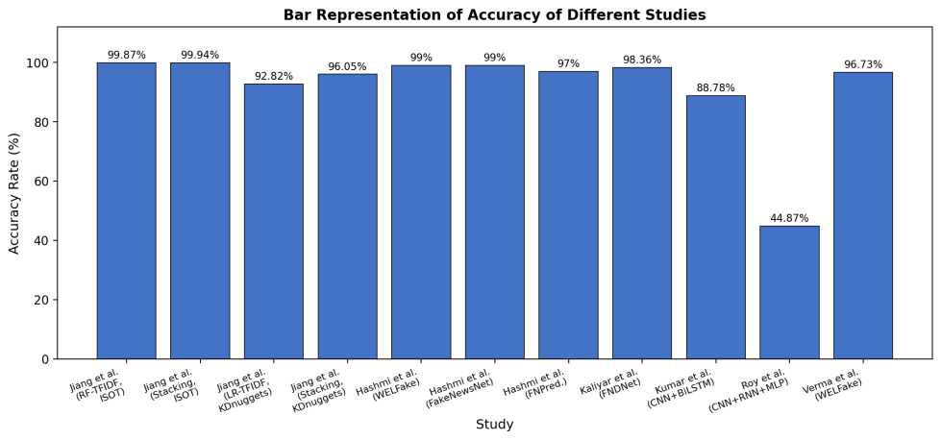
Fig. 3. Bar Representation of Accuracy of Different Studies.
Study | D+i | D−i | Ci | Rank
Roy et al. (CNN+RNN+MLP) | 0.1569 | 0.2234 | 0.5874 | 1
Hashmi et al. (WELFake) | 0.2229 | 0.1793 | 0.4458 | 2
Verma et al. (WELFake) | 0.2229 | 0.1793 | 0.4458 | 3
Jiang et al. (Stacking, ISOT) | 0.2318 | 0.1202 | 0.3415 | 4
Jiang et al. (RF-TFIDF, ISOT) | 0.2318 | 0.1202 | 0.3415 | 5
Hashmi et al. (FakeNewsNet) | 0.2544 | 0.0609 | 0.1932 | 6
Kaliyar et al. (FNDNet) | 0.2573 | 0.0556 | 0.1776 | 7
Hashmi et al. (FakeNewsPrediction) | 0.2786 | 0.0202 | 0.0676 | 8
Jiang et al. (Stacking, KDnuggets) | 0.2786 | 0.0201 | 0.0673 | 9
Jiang et al. (LR-TFIDF, KDnuggets) | 0.2786 | 0.0198 | 0.0664 | 10
Kumar et al. (CNN+BiLSTM) | 0.2880 | 0.0084 | 0.0284 | 11
Table 5: Euclidean Distance and Ranking

The ranking in Table 5 shows that Roy et al.'s LIAR-based six-class model [28] attains the highest relative closeness despite its modest 44.87% accuracy, because the weighting scheme assigns substantially more importance to label granularity (category count) than to raw accuracy — mirroring the same behavior observed when this TOPSIS methodology was applied to the sentiment-analysis literature, where the paper with the largest dataset, rather than the highest accuracy, ranked first. This underscores an important methodological caveat: TOPSIS rankings are highly sensitive to the chosen criterion weights, and accuracy-only comparisons (Figure 3) and multi-criteria rankings (Table 5) can disagree substantially. Considered jointly, the stacking ensemble of Jiang et al. [14] and the FastText-augmented CNN-LSTM of Hashmi et al. [11] offer the strongest balance of high accuracy, large/multiple datasets, and low-to-medium label noise among the reviewed studies.
RQ#8: What role does explainable artificial intelligence (XAI) play in improving the transparency of fake news detection systems?
Most early ML- and DL-based fake news detectors are evaluated purely on predictive accuracy, offering little insight into why a given article is classified as fake. Reis et al. [27] specifically addressed this gap, using SHAP to explain the decisions of XGBoost-based fake news classifiers and to identify which content, source, and environment features most influenced individual predictions. More recently, Hashmi et al. [11] applied Local Interpretable Model-Agnostic Explanations (LIME) to their CNN-LSTM model, surfacing the specific words (e.g., politically charged terms or source-attribution cues) that most influenced high-confidence fake-news predictions, and used Latent Dirichlet Allocation (LDA) topic modeling to characterize the latent thematic structure of each dataset. These XAI techniques do not improve raw accuracy but are increasingly viewed as necessary for building user trust and enabling human fact-checkers to audit automated decisions, particularly given documented cases where models rely on superficial lexical cues (e.g., temporal markers) that do not reliably indicate veracity.
RQ#9: In what domains or applications has fake news detection found significant utility and impact?
- Political News and Election Integrity: Detecting fabricated political news and misinformation campaigns, as studied on the ISOT [2], [3] and LIAR [28] datasets, which are both drawn substantially from U.S. political coverage.
- Social Media Content Moderation: Platform-level detection and early warning of rumors and fake news propagating through Twitter and Weibo, as in Ruchansky et al. [29] and Monti et al. [20].
- Fact-Checking Support Tools: Assisting human fact-checkers by pre-filtering or ranking suspicious content, as enabled by the FakeNewsNet repository [32] built from PolitiFact and GossipCop fact-checked articles.
- Public Health and Crisis Misinformation: Identifying health-related and crisis-related misinformation (e.g., pandemic-related claims) that can cause direct public harm if left unchecked.
- Multilingual and Low-Resource News Ecosystems: Extending detection beyond English to other languages and regional media ecosystems, an area explicitly identified as under-served in the reviewed literature.
- Explainable Content Moderation: Providing human-readable rationales for moderation decisions using XAI techniques such as LIME and SHAP, supporting appeals and transparency requirements on content platforms.
RQ#10: What are the current gaps and challenges in fake news detection research that need further exploration?
- Most studies (e.g., ISOT [2], [3], WELFake [35], Kaggle-based corpora [16]) rely on English-language, primarily U.S.-centric political news, limiting demonstrated generalizability to other languages, regions, and topical domains.
- Performance degrades substantially on smaller or more fine-grained datasets: accuracy on the six-class LIAR dataset [28] remains far below accuracy on binary corpora such as ISOT, indicating that fine-grained veracity classification is still largely unsolved.
- Content-only classifiers (the majority of reviewed studies) ignore propagation- and social-context signals that graph-based approaches such as Monti et al. [20] and CSI [29] show to be informative, yet few studies combine content and propagation-based features in a unified framework.
- Explainability remains under-explored: only a minority of reviewed studies [11], [27] incorporate XAI, and post-hoc explanations can themselves be misleading, as illustrated by cases where models rely on superficial temporal or stylistic cues rather than substantive indicators of veracity.
- Class imbalance, label noise, and the absence of standardized train/test splits across studies make cross-paper comparison difficult, as reflected in the wide noise ratings assigned in Table 2.
- Adversarial robustness — the vulnerability of ML/DL classifiers to deliberately adversarial or paraphrased fake content designed to evade detection — is rarely evaluated in the reviewed literature.
- Multimodal fake news (text combined with manipulated images, video, or audio) is largely outside the scope of the text-only classifiers reviewed here, despite its growing prevalence on social platforms.
RQ#11: Based on the synthesis of existing studies, what recommendations can be made for future research directions in the field of fake news detection?
1. Cross-Lingual and Cross-Domain Evaluation: Prioritize benchmarking on non-English and multi-domain corpora to assess whether reported accuracies generalize beyond U.S.-centric political news.
2. Joint Content-Propagation Modeling: Combine text-content classifiers with graph-based propagation and social-context signals, following the direction shown by Monti et al. [20] and Ruchansky et al. [29], rather than treating these as separate research threads.
3. Standardized Benchmarks and Splits: Adopt and publicly release standardized train/test splits and label definitions to make cross-study comparison more reliable.
4. Mainstreaming Explainability: Integrate XAI techniques such as LIME, SHAP, and topic modeling as a standard reporting component alongside accuracy, precision, recall, and F1-score.
5. Robustness to Class Imbalance and Adversarial Content: Develop and evaluate models under deliberately imbalanced or adversarially perturbed conditions rather than only on curated, balanced benchmarks.
6. Efficient Ensemble and Hybrid Architectures: Continue to explore stacking and hybrid CNN-LSTM style architectures, which this review finds to consistently outperform single-model baselines, while managing the added computational and maintenance overhead.
7. Multimodal Detection: Extend text-based detectors toward multimodal fake news detection incorporating manipulated images, video, and audio.
8. Fine-Grained Veracity Classification: Invest further in six-class and other fine-grained truthfulness classification (as in LIAR [28]), which remains far less accurate than binary detection and is arguably more useful for real-world fact-checking.
RQ#12: How can the identified gaps be addressed, and what novel approaches or methodologies could enhance the effectiveness of fake news detection systems?
1. Multilingual and Low-Resource Corpora: Collaboratively build and release larger annotated fake news datasets in underrepresented languages to enable true cross-lingual evaluation.
2. Unified Content-Social-Propagation Frameworks: Design architectures that jointly ingest article text, publisher/source metadata, and social propagation graphs within a single trainable model rather than late-stage feature concatenation alone.
3. Explainability-by-Design: Favor architectures (e.g., attention-based hierarchical models such as 3HAN [17]) whose internal structure is inherently more interpretable, complemented by post-hoc XAI tools.
4. Adversarial Training and Data Augmentation: Incorporate adversarially perturbed or paraphrased fake news examples during training to improve robustness against evasion attempts.
5. Lightweight Ensembles for Deployment: Explore knowledge distillation from stacking ensembles and transformer models into smaller deployable models, preserving the accuracy gains of ensembling shown by Jiang et al. [14] while reducing inference cost.
6. Fine-Grained and Multi-Task Labeling: Move beyond binary fake/real labels toward multi-task objectives that jointly predict veracity, stance, and persuasion techniques, extending the direction taken by the LIAR dataset [28].
In summary, improvements involve combining ensemble/hybrid modeling with propagation-aware and explainable architectures, expanding multilingual and multimodal coverage, and stress-testing models under adversarial and class-imbalanced conditions for more robust, real-world-ready fake news detection.
IV. Conclusion
This review synthesized 18 primary studies on fake news detection using NLP, ML, and DL, and applied an AHP-weighted TOPSIS ranking procedure to compare them on accuracy, label granularity, dataset size, and label noise rather than on accuracy alone. Three findings stand out. First, stacking ensembles and hybrid CNN-LSTM architectures with strong embeddings consistently outperformed single-model baselines across the reviewed studies. Second, fine-grained multi-class veracity classification, as required by datasets such as LIAR, remains substantially harder than binary fake/real detection. Third, explainability and propagation-aware modeling are comparatively under-explored relative to raw predictive accuracy, with only a minority of reviewed studies incorporating XAI techniques. Building on these findings, our next step is to design an ensemble-based, explainable fake news detection model that addresses the cross-lingual, propagation-aware, and adversarial-robustness gaps identified in this review.
References
[1] G. E. R. Agudelo, O. J. S. Parra, and J. B. Velandia, "Raising a model for fake news detection using machine learning in Python," in Proc. Conf. e-Business, e-Services and e-Society, Springer, 2018, pp. 596–604.
[2] H. Ahmed, I. Traore, and S. Saad, "Detection of online fake news using n-gram analysis and machine learning techniques," in Intelligent, Secure, and Dependable Systems in Distributed and Cloud Environments (ISDDC 2017), Lecture Notes in Computer Science, vol. 10618, Springer, 2017, pp. 127–138.
[3] H. Ahmed, I. Traore, and S. Saad, "Detecting opinion spams and fake news using text classification," Security and Privacy, vol. 1, no. 1, e9, 2018.
[4] O. Ajao, D. Bhowmik, and S. Zargari, "Fake news identification on Twitter with hybrid CNN and RNN models," in Proc. 9th Int. Conf. Social Media and Society, 2018, pp. 226–230.
[5] M. Q. Alnabhan and P. Branco, "Fake news detection using deep learning: A systematic literature review," IEEE Access, vol. 12, pp. 114435–114459, 2024.
[6] M. Amjad, G. Sidorov, A. Zhila, H. Gómez-Adorno, I. Voronkov, and A. Gelbukh, "'Bend the truth': Benchmark dataset for fake news detection in Urdu language and its evaluation," Journal of Intelligent & Fuzzy Systems, vol. 39, no. 2, pp. 2457–2469, 2020.
[7] N. Aslam, I. U. Khan, F. S. Alotaibi, L. A. Aldaej, and A. K. Aldubaikil, "Fake Detect: A deep learning ensemble model for fake news detection," Complexity, vol. 2021, Art. no. 5557784, 2021.
[8] A. Bondielli and F. Marcelloni, "A survey on fake news and rumour detection techniques," Information Sciences, vol. 497, pp. 38–55, 2019.
[9] M. L. Della Vedova, E. Tacchini, S. Moret, G. Ballarin, M. DiPierro, and L. de Alfaro, "Automatic online fake news detection combining content and social signals," in Proc. 22nd Conf. Open Innovations Association (FRUCT), 2018, pp. 272–279.
[10] P. H. A. Faustini and T. F. Covões, "Fake news detection in multiple platforms and languages," Expert Systems with Applications, vol. 158, Art. no. 113503, 2020.
[11] E. Hashmi, S. Y. Yayilgan, M. M. Yamin, S. Ali, and M. Abomhara, "Advancing fake news detection: Hybrid deep learning with FastText and explainable AI," IEEE Access, vol. 11, 2023, doi: 10.1109/ACCESS.2024.3381038.
[12] L. Hu, S. Wei, Z. Zhao, and B. Wu, "Deep learning for fake news detection: A comprehensive survey," AI Open, vol. 3, pp. 133–155, 2022.
[13] A. Jain, A. Shakya, H. Khatter, and A. K. Gupta, "A smart system for fake news detection using machine learning," in Proc. Int. Conf. Issues and Challenges in Intelligent Computing Techniques (ICICT), 2019, pp. 1–4.
[14] T. Jiang, J. P. Li, A. U. Haq, A. Saboor, and A. Ali, "A novel stacking approach for accurate detection of fake news," IEEE Access, vol. 9, pp. 22626–22639, 2021.
[15] R. K. Kaliyar, A. Goswami, and P. Narang, "Multiclass fake news detection using ensemble machine learning," in Proc. IEEE 9th Int. Conf. Advanced Computing (IACC), 2019, pp. 103–107.
[16] R. K. Kaliyar, A. Goswami, P. Narang, and S. Sinha, "FNDNet — A deep convolutional neural network for fake news detection," Cognitive Systems Research, vol. 61, pp. 32–44, 2020.
[17] Z. Khanam, B. N. Alwasel, H. Sirafi, and M. Rashid, "Fake news detection using machine learning approaches," IOP Conference Series: Materials Science and Engineering, vol. 1099, no. 1, Art. no. 012040, 2021.
[18] S. Kumar, R. Asthana, S. Upadhyay, N. Upreti, and M. Akbar, "Fake news detection using deep learning models: A novel approach," Transactions on Emerging Telecommunications Technologies, vol. 31, no. 2, e3767, 2020.
[19] J. Ma, W. Gao, P. Mitra, S. Kwon, B. J. Jansen, K.-F. Wong, and M. Cha, "Detecting rumors from microblogs with recurrent neural networks," in Proc. 25th Int. Joint Conf. Artificial Intelligence (IJCAI), 2016, pp. 3818–3824.
[20] F. Monti, F. Frasca, D. Eynard, D. Mannion, and M. M. Bronstein, "Fake news detection on social media using geometric deep learning," arXiv preprint arXiv:1902.06673, 2019.
[21] M. F. Mridha, A. J. Keya, M. A. Hamid, M. M. Monowar, and M. S. Rahman, "A comprehensive review on fake news detection with deep learning," IEEE Access, vol. 9, pp. 156151–156170, 2021.
[22] R. Oshikawa, J. Qian, and W. Y. Wang, "A survey on natural language processing for fake news detection," arXiv preprint arXiv:1811.00770, 2018.
[23] F. A. Ozbay and B. Alatas, "Fake news detection within online social media using supervised artificial intelligence algorithms," Physica A: Statistical Mechanics and its Applications, vol. 540, Art. no. 123174, 2020.
[24] J.-P. Posadas-Durán, H. Gómez-Adorno, G. Sidorov, and J. J. M. Escobar, "Detection of fake news in a new corpus for the Spanish language," Journal of Intelligent & Fuzzy Systems, vol. 36, no. 5, pp. 4869–4876, 2019.
[25] T. Rasool, W. H. Butt, A. Shaukat, and M. U. Akram, "Multi-label fake news detection using multi-layered supervised learning," in Proc. 11th Int. Conf. Computer and Automation Engineering (ICCAE), 2019, pp. 73–77.
[26] J. C. S. Reis, A. Correia, F. Murai, A. Veloso, F. Benevenuto, and E. Cambria, "Supervised learning for fake news detection," IEEE Intelligent Systems, vol. 34, no. 2, pp. 76–81, 2019.
[27] J. C. S. Reis, A. Correia, F. Murai, A. Veloso, and F. Benevenuto, "Explainable machine learning for fake news detection," in Proc. 10th ACM Conf. Web Science (WebSci), 2019, pp. 17–26.
[28] A. Roy, K. Basak, A. Ekbal, and P. Bhattacharyya, "A deep ensemble framework for fake news detection and classification," arXiv preprint arXiv:1811.04670, 2018.
[29] N. Ruchansky, S. Seo, and Y. Liu, "CSI: A hybrid deep model for fake news detection," in Proc. ACM Conf. Information and Knowledge Management (CIKM), 2017, pp. 797–806.
[30] S. Shabani and M. Sokhn, "Hybrid machine-crowd approach for fake news detection," in Proc. IEEE 4th Int. Conf. Collaboration and Internet Computing (CIC), 2018, pp. 299–306.
[31] K. Shu, A. Sliva, S. Wang, J. Tang, and H. Liu, "Fake news detection on social media: A data mining perspective," ACM SIGKDD Explorations Newsletter, vol. 19, no. 1, pp. 22–36, 2017.
[32] K. Shu, D. Mahudeswaran, S. Wang, D. Lee, and H. Liu, "FakeNewsNet: A data repository with news content, social context, and spatiotemporal information for studying fake news on social media," Big Data, vol. 8, no. 3, pp. 171–188, 2020.
[33] S. Singhania, N. Fernandez, and S. Rao, "3HAN: A deep neural network for fake news detection," in Proc. Int. Conf. Neural Information Processing (ICONIP), Springer, 2017, pp. 572–581.
[34] M. Umer, Z. Imtiaz, S. Ullah, A. Mehmood, G. S. Choi, and B.-W. On, "Fake news stance detection using deep learning architecture (CNN-LSTM)," IEEE Access, vol. 8, pp. 156695–156706, 2020.
[35] P. K. Verma, P. Agrawal, I. Amorim, and R. Prodan, "WELFake: Word embedding over linguistic features for fake news detection," IEEE Transactions on Computational Social Systems, vol. 8, no. 4, pp. 881–893, 2021.
[36] W. Y. Wang, "'Liar, liar pants on fire': A new benchmark dataset for fake news detection," in Proc. 55th Annual Meeting of the Association for Computational Linguistics, 2017, arXiv preprint arXiv:1705.00648.
[37] D. H. Wolpert, "Stacked generalization," Neural Networks, vol. 5, no. 2, pp. 241–259, 1992.
[38] X. Zhang and A. A. Ghorbani, "An overview of online fake news: Characterization, detection, and discussion," Information Processing & Management, vol. 57, no. 2, Art. no. 102025, 2020.

