

Department of Electronics and Electrical Engineering

IIT Guwahati

EE - 625 Computer Vision Project

Development of a Novel Method for PCBs Fault Detection

|  |  |
| --- | --- |
| Name | Roll No. |
| Rahul Ghosh | 120108027 |
| Ashima Jain | 120108051 |

**Introduction**

With the boost in Electronics industry, the demand for Printed Circuit Boards (PCBs) has soared high. PCBs being cheap, reliable and easy to mount ICs on, have become an important component of the industry. Further, with the increasing miniaturization of the circuits, the intricacies of the PCBs also increases. In such cases, defects in the circuit boards are bound to occur. However, before they can be used in the electronic components, they must be defect free whether pseudo or true. Manual detection of such faults is tiresome and subject to errors. Hence, the need of the hour is a novel automated method for detection of such faults. There are various types of defects such as dust, oxidation, contamination, open, short, surface defect. Examples of some of these defects are shown in Figure 1. In this work, we have used samples from ok level, dust and oxidation because of unavailability of enough data of other faults. The approach includes using SIFT features for classification using a support vector machine (SVM).

**Literature Review**

A number of techniques have been proposed before to automatically detect and classify faults in printed circuit boards. Sikka et al. [1] have proposed a method for detection and classification of true vs pseudo defects. PCBs with true defects such as bump, broken, short, etc. cannot be further used while the ones having pseudo defects that is, dust or rust on the metallic part are temporary. In the presented approach, the authors applied discrete wavalet transform (DWT) upto two levels to segment the image. Statistical features such as mean and standard deviation are extracted from the approximation and detail sub-bands of one, two and three level decomposed images. Based on these features, an SVM with a Gaussian kernel was trained to give the final classified result, ie., true or pseudo defect.

In [2], the copper and non-copper part have first been separated. Edges in the copper part were detected using canny edge detector. Hough transform was then used to find to circles from the copper edges detected earlier. The authors next trained a 1vr SVM to find the defect of copper. For the non-copper part, the 3D color histogram is made and the training and classification is done using an SVM with a polynomial kernel of degree 4. The results of the two are then logically combined to obtain the defect in the PCB.

**Adopted Methodology**

For defect classification, we first need to extract certain features based on the information available due to the shape, colour etc. of the defects. This problem statement belongs to Content based image retrieval (CBIR) which is still an active research field. Various approaches are available to retrieve visual data from large databases. All these approaches have Image digestion as their first step. Image digestion is describing an image using low level features such as colour, shape, and texture while removing unimportant details. Bag-Of-Feature (BoF) is a kind of visual feature descriptor which can be used in CBIR applications. For this we need to extract a feature from the image using any feature extractor such as SIFT (Scale Invariant Feature Transform), SURF (Speeded Up Robust Features), and LBP (Local Binary Patterns), etc. In this classification of PCB defects we are using the SIFT features. A brief description of SIFT, BOF and SVM are given below:

**SIFT - Scale Invariant Feature Transform**

It is one of the most popular feature extraction and description algorithms, which extracts blob like feature points and describe them with a scale, illumination, and rotational invariant descriptor. SIFT detects blob like features from the image and describe each and every point with a descriptor that contains 128 numbers. As the output, it gives an array of point descriptors.

CBIR needs a global descriptor in order to match with visual data in a database or retrieve the semantic concept out of a visual content. We can use the array of point descriptors that yields from the SIFT algorithm for obtaining a global descriptor which gives an overall impression of visual data for CBIR applications. There are several methods available to obtain that global descriptor from SIFT feature point descriptors, and BoF is one general method that can be used to do the task

.

**Bag-Of-Feature (BoF) Descriptor**

BoF is one of the popular visual descriptors used for visual data classification which is essentially inspired by a concept called Bag of Words used in document classification. A bag of words is a a sparse histogram over the vocabulary that stores the occurrence counts of words in the document. In computer vision, a bag of visual words of features is a sparse vector of occurrence counts of a vocabulary of local image features.

BoF typically involves in two main steps. First step is obtaining the set of bags of features. This step is actually offline process. We can obtain set of bags for particular features and then use them for creating BoF descriptor. The second step is we cluster the set of given features into the set of bags that we created in first step and then create the histogram taking the bags as the bins. This histogram can be used to classify the image or video frame.

**SVM – Support Vector Machine**

A Support Vector Machine (SVM) is a discriminative classifier which basically works by modelling a separating hyperplane. Given a labelled training data, the algorithm outputs an optimal hyperplane which categorizes new examples

The following equations formally define a hyperplane:

$$f\left(x\right)=β_{0}+β^{T}x$$

Where, β is known as the *weight vector* and β0 as the *bias*.

There are infinite methods of representation of the optimal hyperplane. Among all the possible representations of the hyperplane, the one chosen is

$$\left|β_{0}+β^{T}x\right|=1$$

Where, $x$  symbolizes the training examples closest to the hyperplane. This is also called the canonical hyperplane.

The training samples that are closest to the hyperplane are called support vectors. The following distance function is used to find the distance between a point $x$  and a hyperplane represented by $\left(β,β_{0}\right)$:

$$distance=\frac{\left|β_{0}+β^{T}x\right|}{\left\|β\right\|}$$

For the canonical hyperplane the above equation evaluates out to be:

$${distance}_{{support}_{vectors}}=\frac{\left|β_{0}+β^{T}x\right|}{\left\|β\right\|}=\frac{1}{\left\|β\right\|}$$

Let us define a margin denoted as $M$  which is twice the distance to the closest examples:

$$M=\frac{2}{\left\|β\right\|}$$

Finally, the problem of maximizing $M$  is equivalent to the problem of minimizing a function $L\left(β\right)$  subject to some constraints. The constraints help in modelling the hyperplane that correctly classifies all the samples. The following equation shows the constraints used:

$$\min_{β,β_{0}}L\left(β\right)=\frac{1}{2}{\left\|β\right\|}^{2}subjecty_{i}\left(β_{0}+β^{T}x_{i}\right)≥1∀i$$

Where, $y_{i}$  represents each of the labels of the training examples. This Lagrangian optimization problem can be solved to obtain the *weight vector* β and *bias* β0 of the optimal hyperplane.

After the classification, the fault area is marked on the images. In dust, the image under coax illumination is dark whereas the defect region is very bright in side.

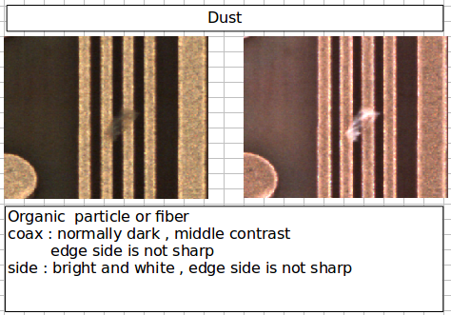

The c0 and c1 images of the PCB for which dust is detect are subtracted and turned into greyscale. It is then converted into binary image by thresholding. The resultant image contains thin edges and the fault area. The noise portion is removed by first removing the components connected by less than certain fixed number of pixels following which the image is opened.The remaining white region is the fault area.

Oxidation on the other hand is a little complex as in both the illumination, the fault region is dark. The c0 and c1 components of the PCB are both added and subtracted and their grayscale counterparts obtained. By threshloding, both the images are coverted into binary and then XORed. Following this, the smaller components are removed and finally, the image is opened.

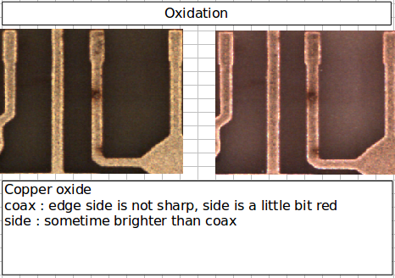

**Results**

The dataset has 146 instances PCBs having faults that belong to the dust category, 26 that belong to the oxidation category and finally 20 instances of PCBs that do not have any fault. Moreover for each PCB we have two images belonging to two different illuminating conditions differentiated as c0 and c1. We used the c0 images for feature extracting and classification. Following are the results obtained:

|  |  |  |
| --- | --- | --- |
| Class | Correct | Incorrect |
| Dust | 52 | 21 |
| Oxidation | 10 | 3 |
| Ok | 8 | 2 |

The following figure shows the coax, side illumoination and the detected defect area in the PCB.

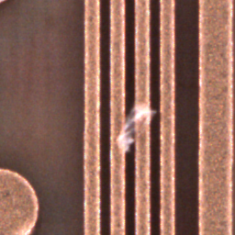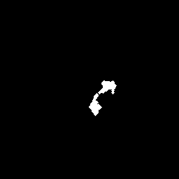

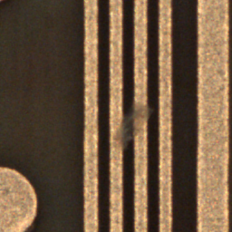

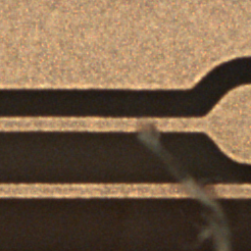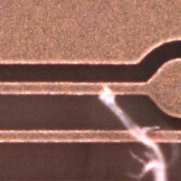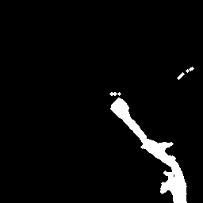

Figue: PCB image: Coax illumination, Side illumination, Detected fault area

**Conclusions**

In this work, we have proposed an automated syaytem of PCB fault detection and classification using SIFT features along with SVM as a classifier. The techniques gives good results on dust and oxidation and can be extended to other types of PCB faults.

**Bibliography**

[1] Sikka, S., Sikka, K., Bhuyan, M.K. and Iwahori, Y., 2013. Pseudo vs. True Defect Classification in Printed Circuits Boards using Wavelet Features.*arXiv preprint arXiv:1310.6654*.

[2] Kumar, S., wahori, Y., and Bhuyan, M.K., 2016, PCB Defect Classification Using Logical Combination of Segmented Copper and Non-Copper Part

[3] Inoue, H., Iwahori, Y., Kijsirikul, B. and Bhuyan, M.K., 2015. SVM Based Defect Classification of Electronic Board Using Bag of Keypoints. *ITC-CSCC 2015*, pp.31-34.

[4] Nakagawa, T., Iwahori, Y. and Bhuyan, M.K., 2014. Reduction of Defect Misclassification of Electronic Board Using Multiple SVM Classifiers.*International Journal of Software Innovation (IJSI)*, *2*(1), pp.25-36.