**Team:** CompEdu

**Architecture Design:**

For designing the architecture of memento we designed a Layered architecture.The main reason we decided to design memento using a layered architecture was due primaryly to the fact that the layered architecture is easy to change and is highly portable.Having the flexibility to edit layers while not effecting other layers will be integral in scaling memento as well as adjusting it to meet the shifting demands of users.

**Architecture Design Diagram:**

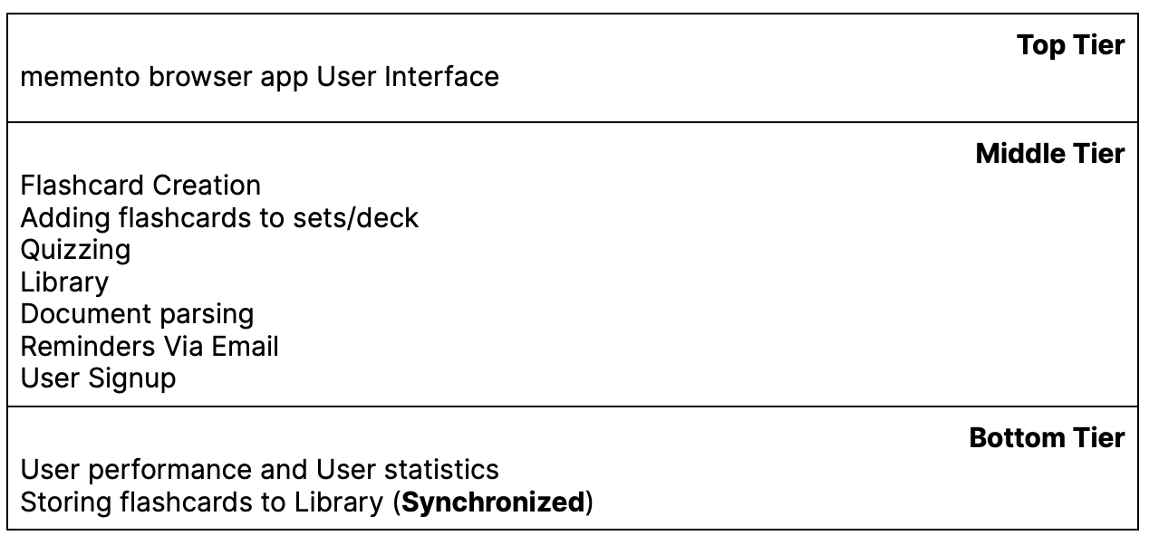

**Design Description:**

The architectural pattern of the memento app consists of three layers, the top layer, the middle layer and the bottom layer.

The Top tier of the memento app handles the user interface of the web application. This is mostly handled by React and CSS. The top tier is where the UI of memento will be displayed as well as showing components and data for users.

The Top tier is also responsible for getting input from users so that such requests are handled and that proper functionally can provided to the user as per their request. ***<List here any other libraries or packages you plan to use at the view layer>***

The middle layer is where the majority of memento’s application functionaily is handled, Everything from adding a flashcard to importing documents for text parsing or even enabling email reminders. To illustrate, when a request is detected from the top tier to add data to a flashcard, the flashcard object takes input from the user and stores temporarily within the user’s browser. The stored data can then be accessed and modified by the user in real time. Using the indexedDB api in React will allow for browser storage on such data while also making possible to implement the flashcard download feature.

The bottom tier is where data storage and OS compatibility for the memento app is handled. Here the memento app stores user specific flashcard and flashcard sets as well as memento’s application storage. To illustrate, when users decide to add their specific flashcard to their user specific library,the temporary data in user’s browser is called and stored within the user specific library object allowing for access of such data on multiple devices such data can be updated, deleted or modified by the user at any time.***<List here any other libraries or packages you plan to use at the controller layer>***