**Inactive Vendor’s Logic**:   
The “inactive vendor” logic is handled inside the **GET /vendors** function. After fetching all vendors from the database, the code compares each vendor’s lastActive date with the current time (now). By subtracting the two dates, it calculates how many days have passed since the vendor was last active. If that difference is greater than 3 days, the vendor is labeled as "Inactive"; otherwise, they’re marked as "Active". This check ensures the system automatically reflects a vendor’s status without needing manual updates.

The approach uses map() to loop through each vendor and return a new object that includes all the original vendor details (via v.toObject()) plus a dynamically computed status field. This way, the frontend or API consumer gets real-time information on vendor activity, making the system more responsive and automated in tracking engagement.

**Website improvement:**  
I find that in the Cibos website, it is taking time load the data. So I think that lazy loading will help us to resolve the problem.  
In the UI:  
Ill change mobile UI for the website. It is responsive but it is better if we change that, it will help us to engage more audience.  
I think that we can have different background. White only but a type of grid. I think that it will help the customer to have a better to view to the products.

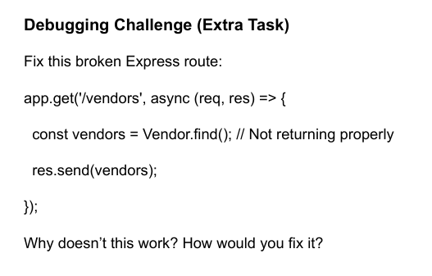

The problem here is that Vendor.find() is **asynchronous** — it returns a **Promise**, not the actual list of vendors. In your current code, you’re directly sending that unresolved Promise back in res.send(vendors), which is why it doesn’t return the data properly.

To fix this, you need to **await** the result of Vendor.find() so that it resolves before sending the response. Since the route handler is already marked async, you can use await inside it.