**Lab-06**

Modeling Class Diagram and Activity Diagram (Point of Sale System)

**Name:** Stavan Ravisaheb

**ID:** 202201436

1. **Use Case Descriptions:**
2. **Process Sale**:  
   **Actors**: Cashier, Catalog System, Inventory System  
   **Description**: A cashier initiates a sale when a customer presents items. The barcode of each item is scanned to retrieve details like price and name from the Catalog System. The Inventory System updates to reflect stock deduction. Once all items are scanned, the customer chooses a payment method (cash, credit card), and a receipt is printed.
3. **Handle Returns**:  
   **Actors**: Cashier  
   **Description**: The cashier processes the return of items based on a previous purchase. The system updates the inventory and potentially adjusts the customer’s payment (e.g., issuing a refund or store credit).

**2. Entity/Boundary Control Objects**

**Entity Objects:**

Product: Represents an item in the sale, with attributes like name, price, and stock quantity.

Sale Transaction: Captures details of the sale (e.g., items, total price, discounts applied).

Inventory: Manages stock levels for products.

**Boundary Objects:**

POS Interface: Interacts with the cashier and customer.

Catalog System Interface: Retrieves item information.

Inventory System Interface: Manages updates to stock levels.

**Control Objects:**

Sale Controller: Manages the process of scanning items, applying discounts, and handling payments.

Return Controller: Manages the process of handling returns, updating inventory, and managing refunds.

**3. Sequence Diagrams**

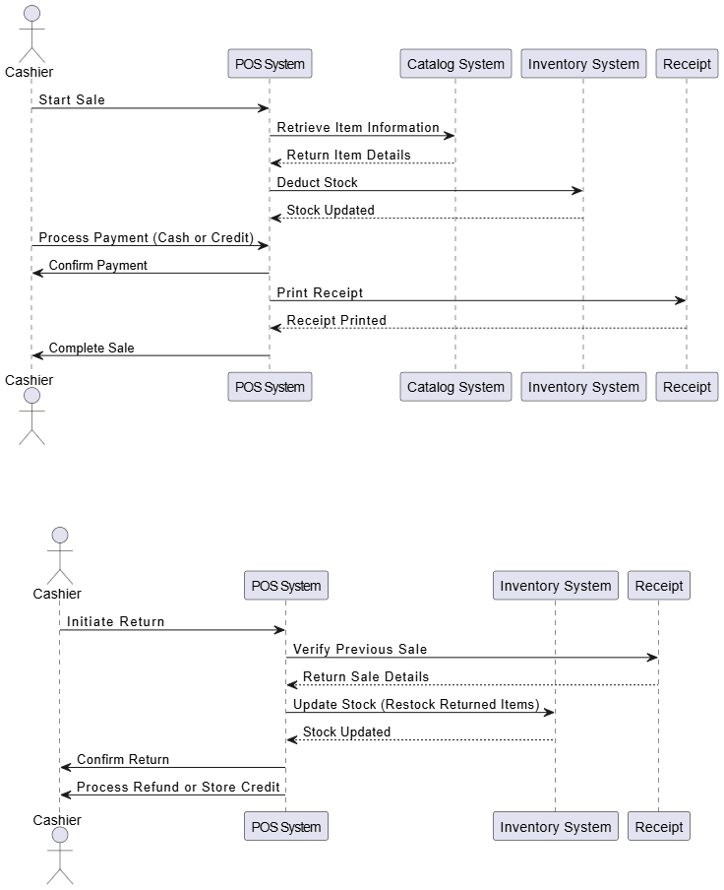

**4. Activity Diagrams**

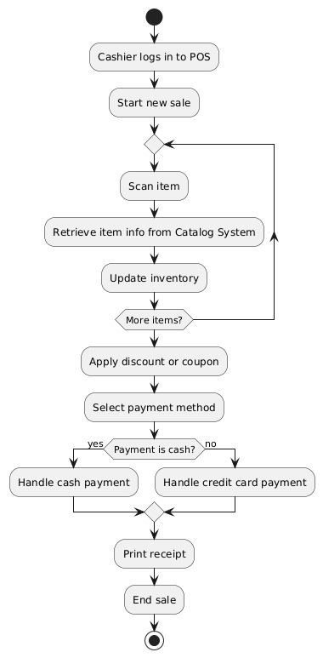

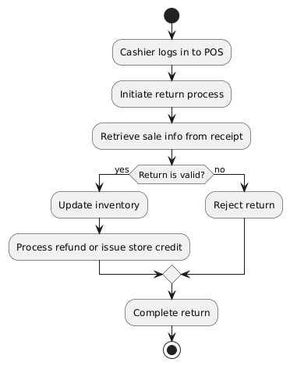

**5. Analysis Domain Models**

