Opportunities for CS Students - Research Report
Course: CS251 - Intro to Software Engineering University: Cairo University - Faculty of Computers and AI Student: Alaa eldin Abdullah Hassan Ali ID: 20220930 Section: S12 TA: Basma Mukhtar Hussain Date: April 2026

1. Government Training Initiative

Mahara-Tech - Frontend Development Courses
Mahara-Tech is the official e-learning platform run by ITI and MCIT. It offers free courses in both Arabic and English covering programming, data analysis, cybersecurity, UI/UX, and more. The Frontend Development track includes courses like Learn HTML and CSS, JavaScript, Modern JavaScript ES6 and Beyond, and TypeScript Fundamentals - all completely free with over 200,000 total enrollments.
Website: https://maharatech.gov.eg/course/index.php?categoryid=13
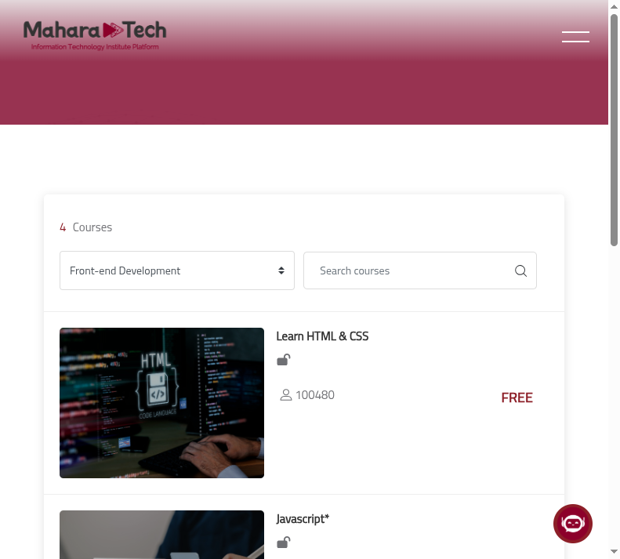
Mahara-Tech Courses

2. Software Engineering Job + Freelancing

Software Engineer Intern at Blink22
A backend/frontend developer role. Responsibilities include building software solutions, working with OOP, data structures, and web technologies.
Freelancing: Backend and frontend developers can offer API development, database design, and website building as freelance services on Upwork, Fiverr, and Mostaql.
Link: https://www.linkedin.com/jobs/view/4377830329/
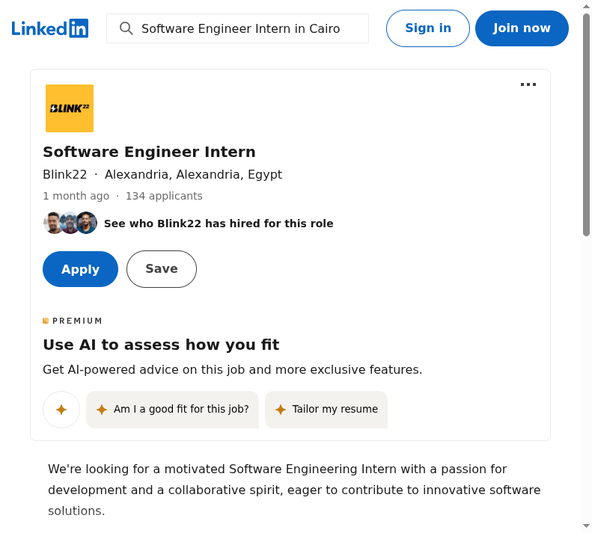
Blink22 Job

3. Internship Opportunity

IT Internship at Bayantech - Cairo
On-site internship supporting corporate IT operations including network maintenance, user account management, and troubleshooting hardware and software issues.
Link: https://www.linkedin.com/jobs/view/4397261608/
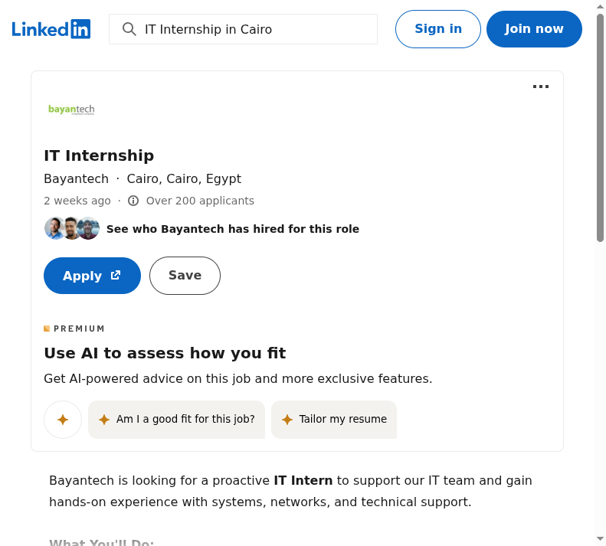
Bayantech Internship

