Software Design Specifications - Personal Budgeting Software
Course: CS251 - Intro to Software Engineering University: Cairo University - Faculty of Computers and AI Section: S12 TA: Basma Mukhtar Hussain Version: 1.0 Date: April 2026
Team Members:
Name: Alaa eldin Abdullah Hassan Ali ID: 20220930

Table of Contents
- System Architecture
- Technology Stack
- View Layer
- Controller Layer
- Model Layer
- Component Diagram
- Database Schema (ERD)
- Data Flow Examples
- Package Diagram
- Class Diagram
- Sequence Diagrams
- Class-Sequence Usage Table
- State Diagrams
- SOLID Principles
- Design Patterns
- Diagrams Index

1. System Architecture
We went with the MVC (Model-View-Controller) pattern for this project. The idea is to keep the UI, the logic, and the data separate from each other.
The three main parts are:
- View - the frontend built with Alpine.js and Bootstrap, what the user sees in the browser
- Controller - Node.js with Express, handles API requests and coordinates between the view and model
- Model - the database layer, PostgreSQL, where all the data is stored and managed
This pattern is widely used and makes the code much easier to maintain and test.
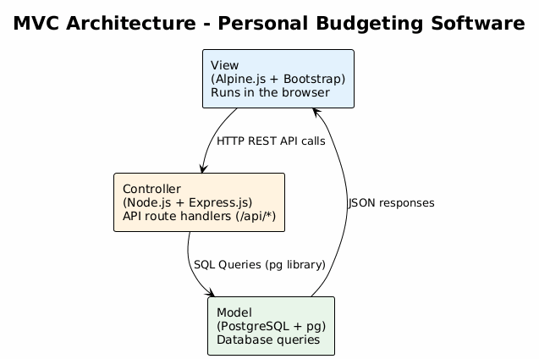
MVC Architecture

2. Technology Stack
Frontend: - HTML5 for page structure - Alpine.js for client-side reactivity and API calls - Bootstrap for styling and responsive layout
Backend: - Node.js as the runtime environment - Express.js as the web framework for API routes - pg (node-postgres) for connecting to PostgreSQL
Database: - PostgreSQL for all data storage

3. View Layer
The view layer is basically all the pages the user sees in the browser. We have:
- Dashboard - the main screen that shows balance, recent transactions, and a quick summary
- Transactions - where the user can add, edit, or delete income and expense entries
- Budgets - for creating and tracking monthly budgets per category
- Goals - lets the user set savings goals and track progress
- Reports - shows charts for income vs expenses by category
- Auth - login and sign up pages
- Settings - profile editing and preferences
- Notifications - alerts when a budget limit is reached
- Export - lets the user download data as CSV or PDF

4. Controller Layer
The controller layer runs on Node.js with Express. Each controller is a set of API route handlers:
- Auth Controller (/api/auth) - handles sign up and login
- Transaction Controller (/api/transactions) - manages income and expenses
- Budget Controller (/api/budgets) - creates budgets and checks limits
- Goal Controller (/api/goals) - manages savings goals
- Report Controller (/api/reports) - generates chart data
- Category Controller (/api/categories) - manages categories
- Dashboard Controller (/api/dashboard) - overview data
- User Controller (/api/users) - profile and settings
- Export Controller (/api/export) - CSV and PDF generation

5. Model Layer
The model layer is PostgreSQL with the pg library handling the connection:
- users - user accounts and login credentials
- categories - income and expense categories
- transactions - every income or expense record
- budgets - monthly spending limits per category
- goals - savings targets and progress
- notifications - budget alerts

6. Component Diagram
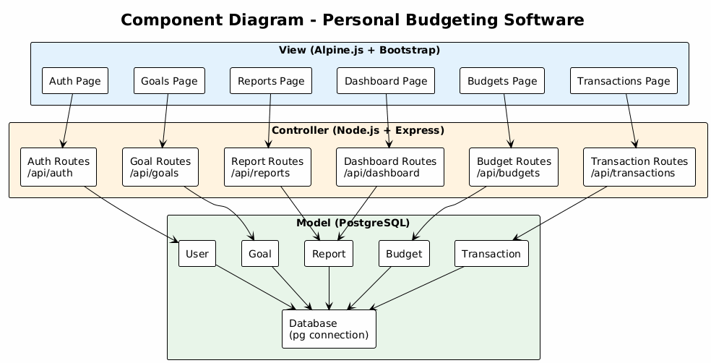
Component Diagram

7. Database Schema (ERD)
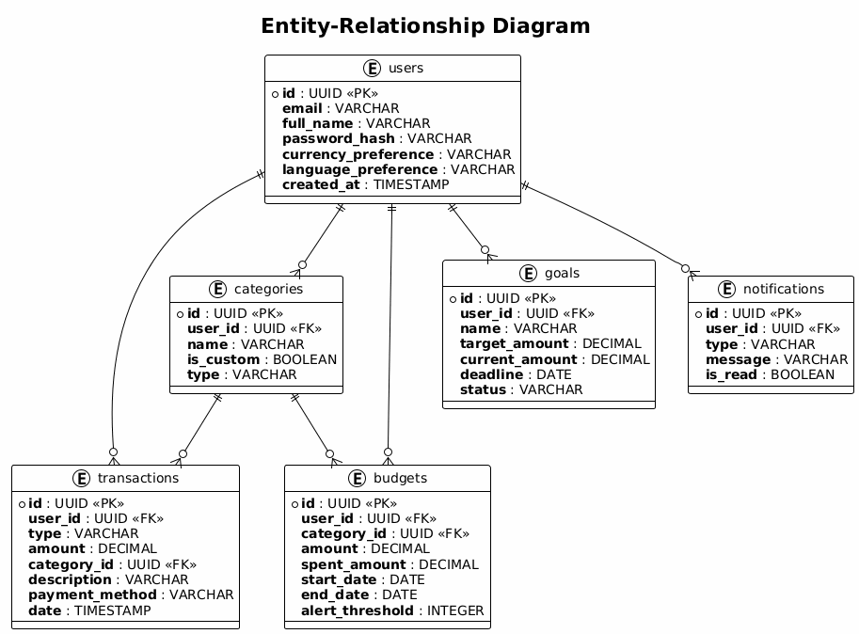
ERD Diagram
We have 6 tables. A user can have multiple transactions, budgets, goals, categories, and notifications. Each transaction and budget is linked to a category.

8. Data Flow Examples

8.1 User Authentication
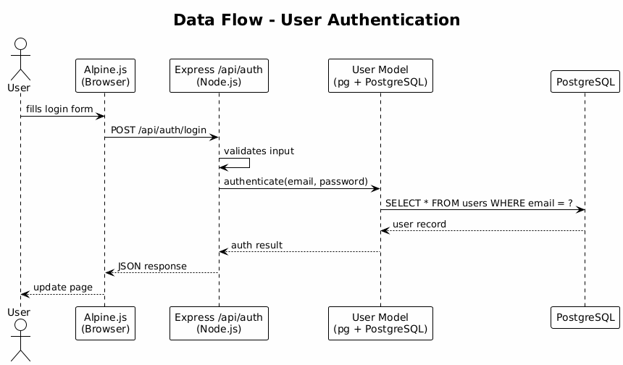
Data Flow - Auth

8.2 Add Transaction
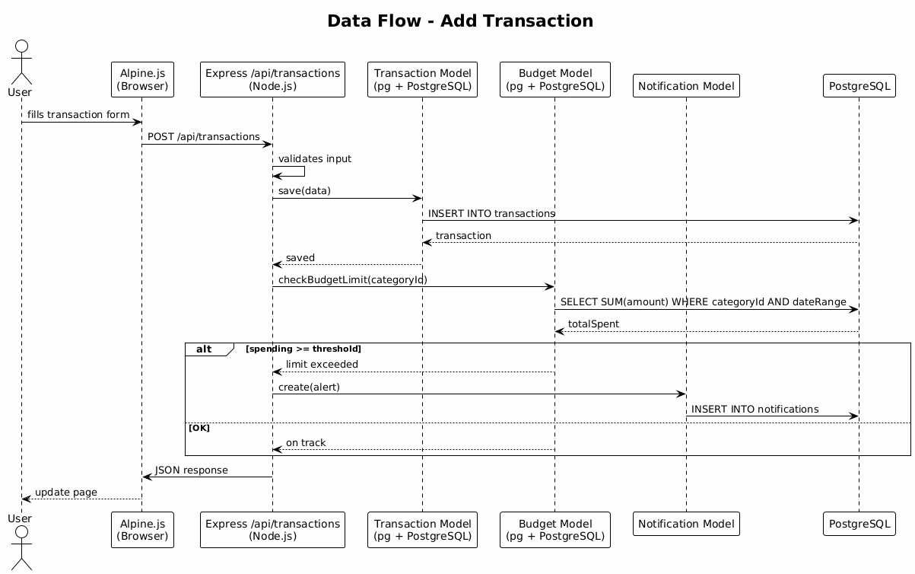
Data Flow - Add Transaction

8.3 View Reports
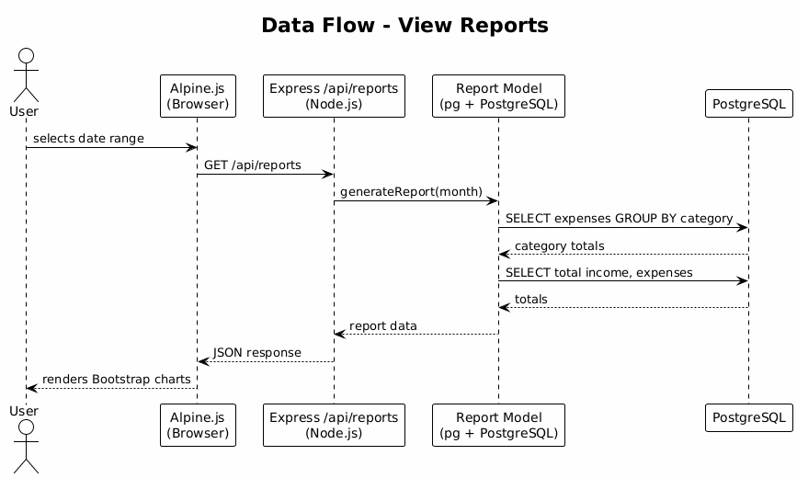
Data Flow - Reports

9. Package Diagram
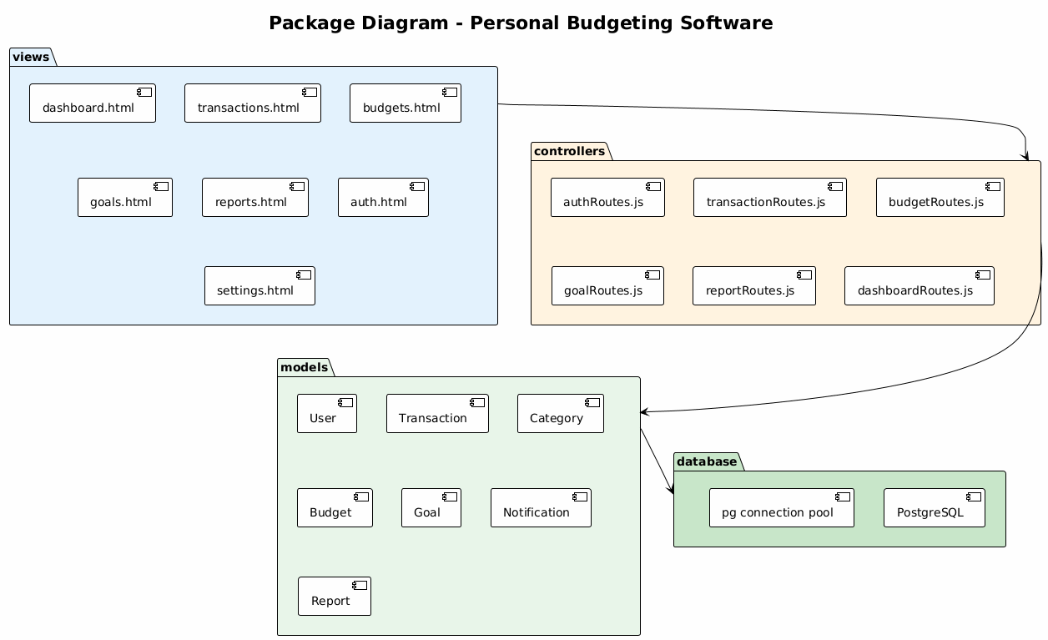
Package Diagram
The code is organized into 4 packages:
- views - HTML pages with Alpine.js and Bootstrap
- controllers - Express route handlers in Node.js
- models - database query functions using pg
- database - the PostgreSQL connection setup

10. Class Diagram
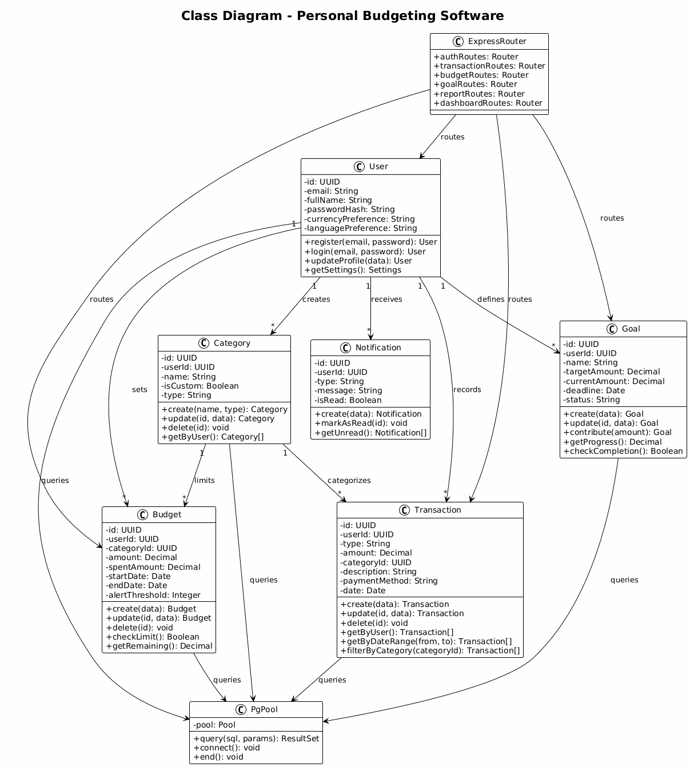
Class Diagram
We have model classes that map directly to our database tables: User, Transaction, Category, Budget, Goal, and Notification. Each class has its own attributes (matching the columns in the ERD) and methods for the operations we need to do on it.
On the backend side, ExpressRouter holds all the API route handlers. PgPool manages the PostgreSQL connection pool that all models share to run their queries.
The relationships between the classes match what we have in the ERD. For example, a User has many Transactions, a Category has many Transactions, and a Category has many Budgets.

11. Sequence Diagrams

11.1 User Sign Up (US#1)
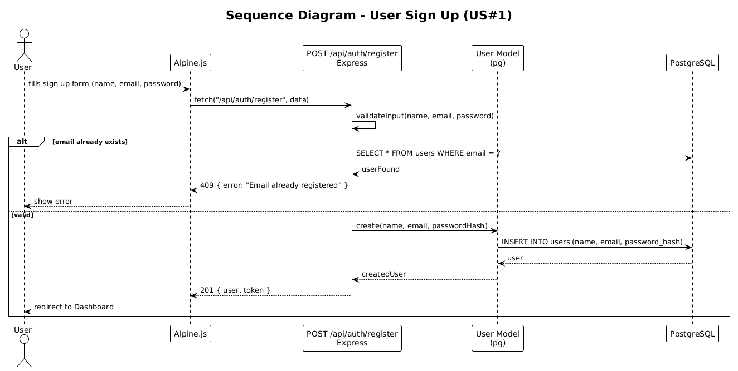
Sequence - Sign Up
- The user fills the sign up form with name, email, and password
- Alpine.js sends a POST to /api/auth/register
- The Express route validates the input
- It checks PostgreSQL to see if the email already exists
- If it does, a 409 error is returned
- If not, the User Model creates a new user and returns 201 with a token
- Alpine.js redirects the user to the Dashboard

11.2 User Login (US#2)
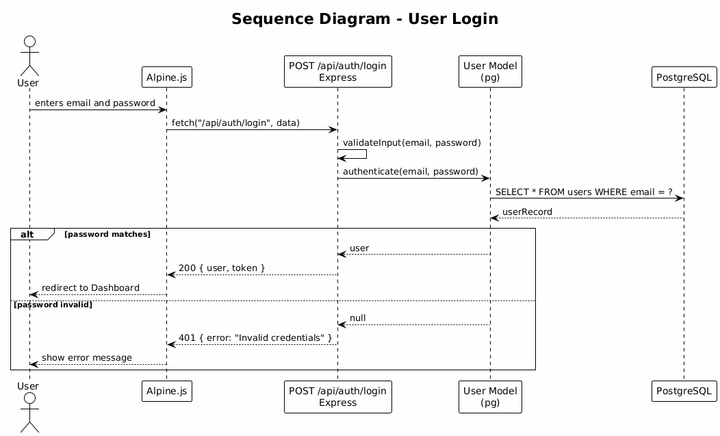
Sequence - Login
- The user enters their email and password on the login page
- Alpine.js sends a POST request to /api/auth/login
- The Express route validates the input
- It calls the User Model which queries PostgreSQL to find the user by email
- If the password matches, a 200 is returned with the user data and token, and Alpine.js redirects to the Dashboard
- If the password is wrong, a 401 is returned and an error message is shown

11.3 Add Transaction (US#3)
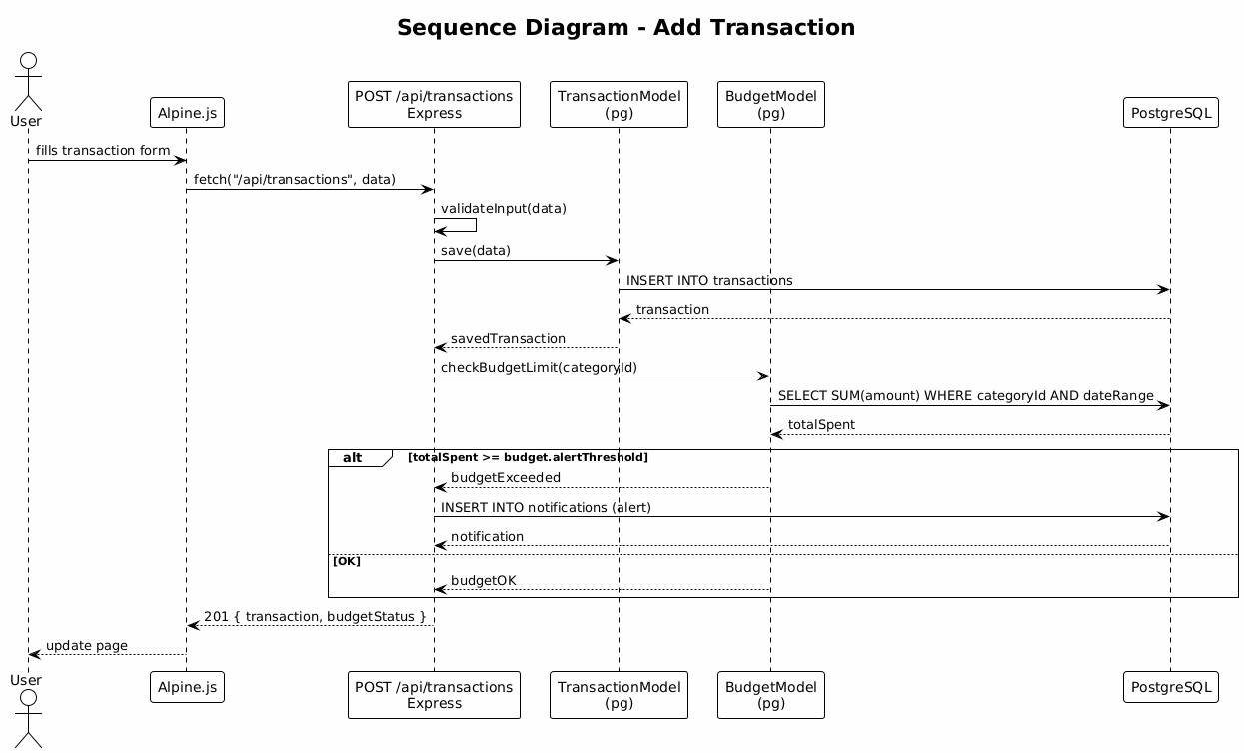
Sequence - Add Transaction
This is the most complex flow because it involves checking the budget after saving:
- The user fills in the transaction form
- Alpine.js sends a POST to /api/transactions
- The Express route validates the input and calls the Transaction Model to insert into PostgreSQL
- After saving, it checks the Budget Model to see if the limit has been reached
- The Budget Model calculates the total spent in that category for the month
- If spending crossed the alert threshold, a notification is inserted
- The route returns the transaction and budget status as JSON

11.4 Create Budget (US#4)
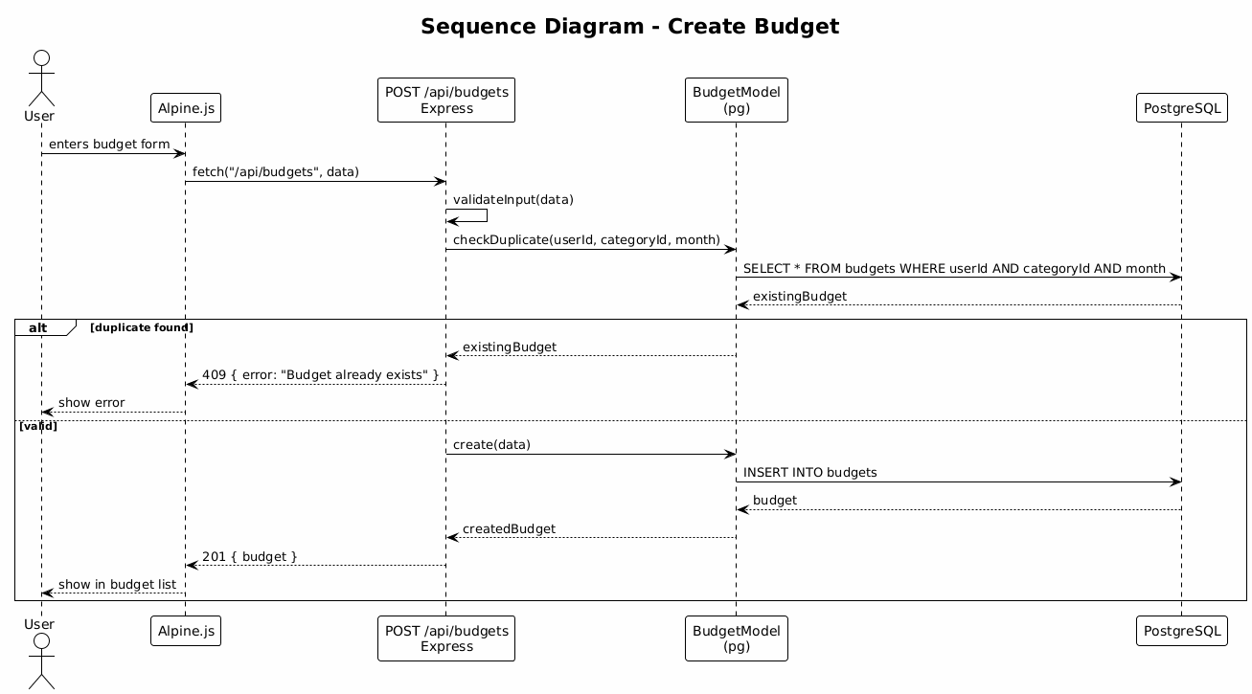
Sequence - Create Budget
- The user fills in the budget form (category, amount, month)
- Alpine.js sends a POST to /api/budgets
- The route first checks if a budget for that category already exists for the same month
- If it does, a 409 conflict error is returned
- If not, the Budget Model creates the new budget in PostgreSQL

11.5 Budget Over-Limit Alert (US#5)
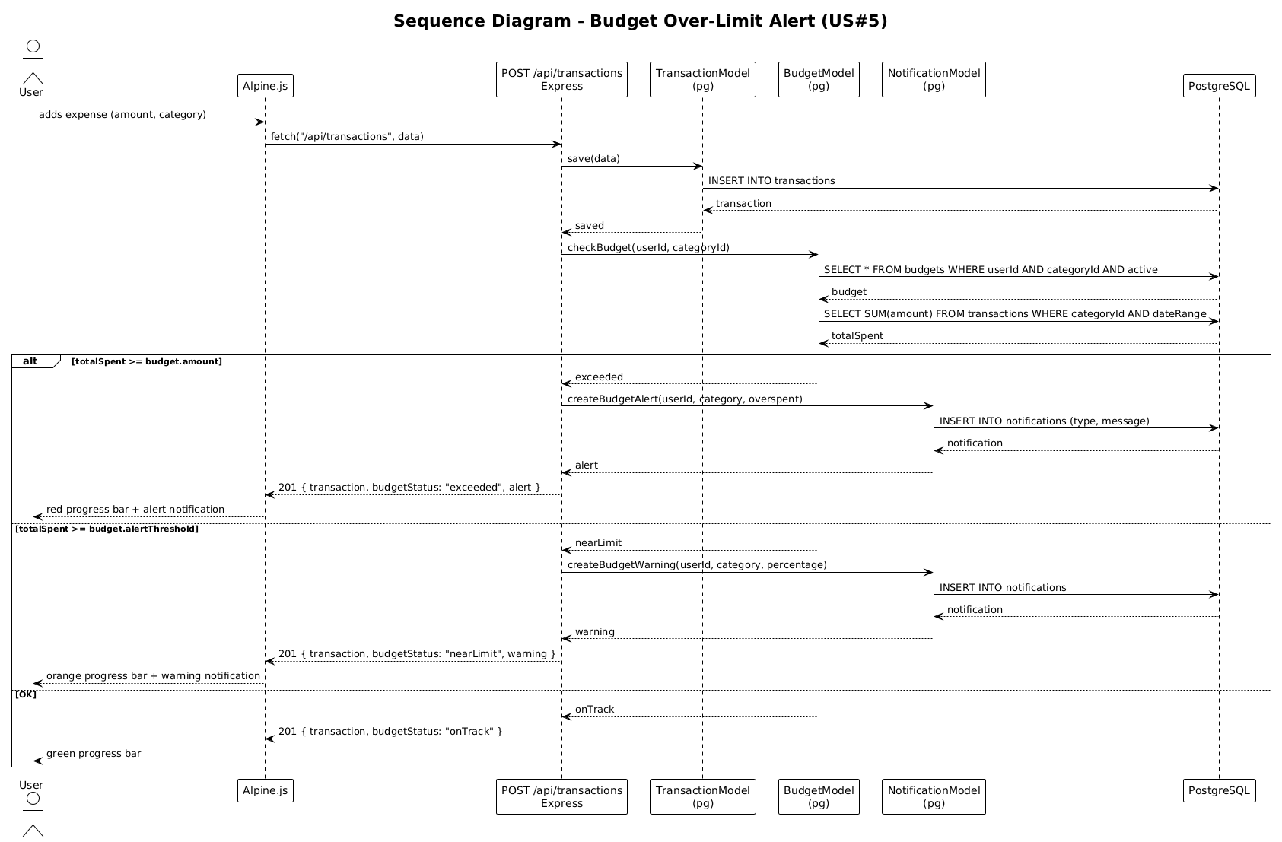
Sequence - Budget Alert
This flow happens automatically when a transaction is saved:
- After saving a transaction, the controller asks the Budget Model to check the budget for that category
- The Budget Model fetches the budget and calculates total spending for the month
- If spending exceeded the budget, a red alert notification is created in PostgreSQL
- If spending reached the warning threshold, an orange warning notification is created
- If everything is fine, the progress bar stays green
- The frontend gets back the transaction plus the budget status and shows the right color

11.6 Set and Track Financial Goals (US#6)
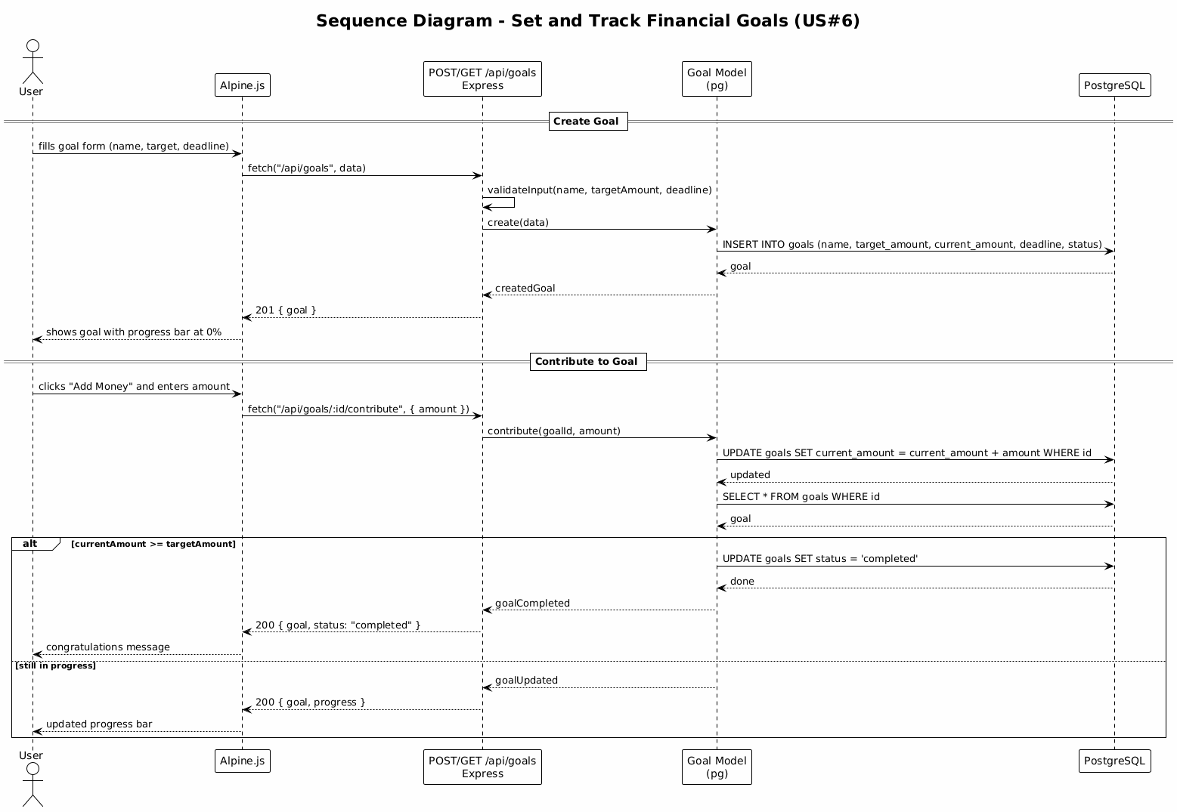
Sequence - Goals
Creating a goal:
- The user fills the goal form (name, target amount, deadline)
- Alpine.js sends a POST to /api/goals
- The Goal Model inserts it into PostgreSQL and returns it with a 0% progress bar
Contributing to a goal:
- The user clicks “Add Money” and enters an amount
- Alpine.js sends a request to /api/goals/:id/contribute
- The Goal Model updates the current amount in PostgreSQL
- If the target is reached, the goal status changes to “completed” and a congratulations message is shown
- Otherwise, the progress bar updates normally

11.7 View Reports and Analytics (US#7)
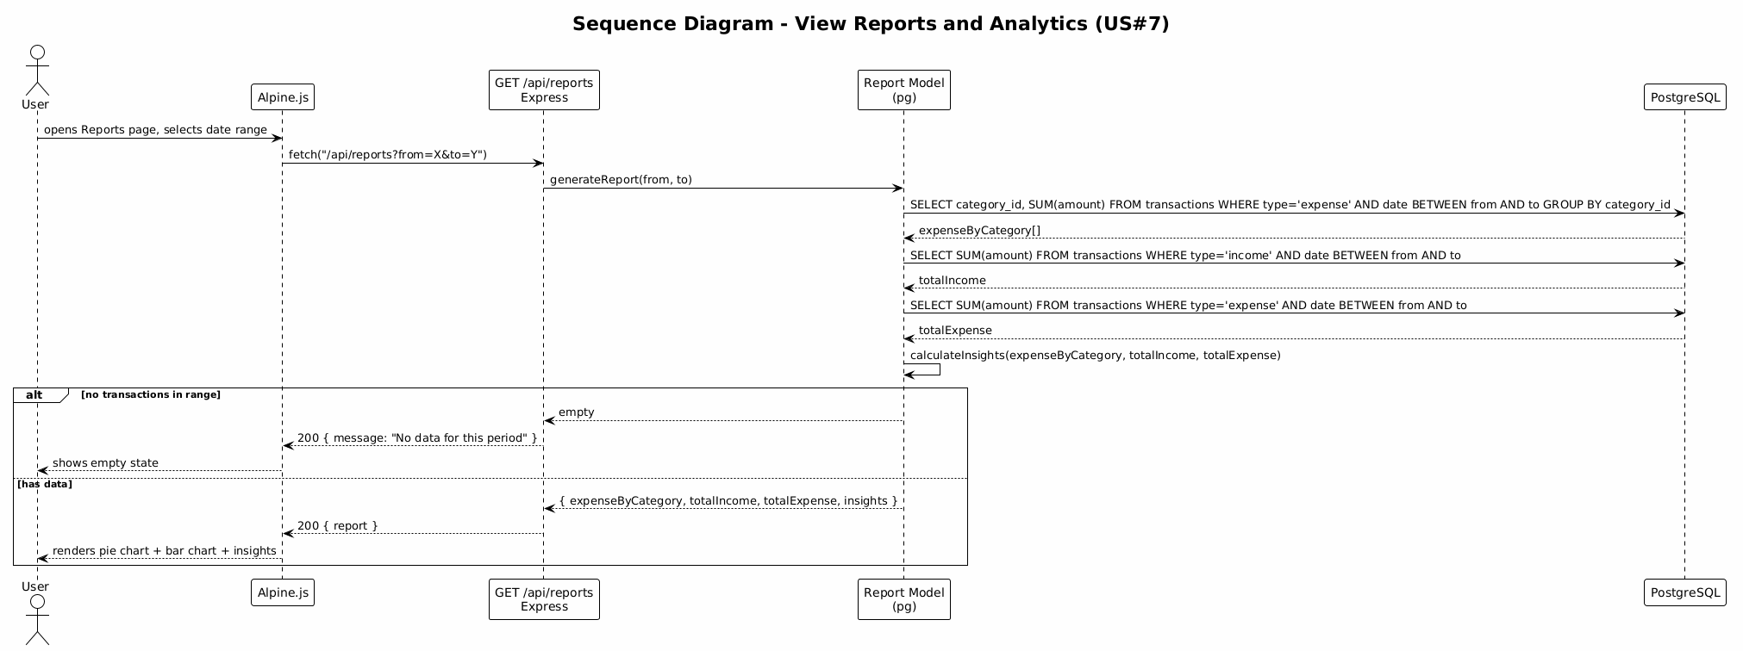
Sequence - Reports
- The user opens the Reports page and selects a date range
- Alpine.js sends a GET to /api/reports with the date range
- The Report Model runs three queries on PostgreSQL: expenses by category, total income, total expenses
- It calculates insights from the raw data (like which category the user spends the most on)
- If there is no data for the period, an empty state is shown
- Otherwise the frontend renders pie charts, bar charts, and the insights

12. Class-Sequence Usage Table
This table maps each class to the sequence diagrams where it appears. This helps trace which classes participate in each user story.
Class Name | US#1 Sign Up | US#2 Login | US#3 Add Transaction | US#4 Create Budget | US#5 Budget Alert | US#6 Goals | US#7 Reports
User | Yes | Yes | - | - | - | - | -
Transaction | - | - | Yes | - | - | - | -
Category | - | - | Yes | Yes | Yes | - | Yes
Budget | - | - | - | Yes | Yes | - | -
Goal | - | - | - | - | - | Yes | -
Notification | - | - | - | - | Yes | - | -
ExpressRouter | Yes | Yes | Yes | Yes | Yes | Yes | Yes
PgPool | Yes | Yes | Yes | Yes | Yes | Yes | Yes

13. State Diagrams

13.1 Budget Lifecycle
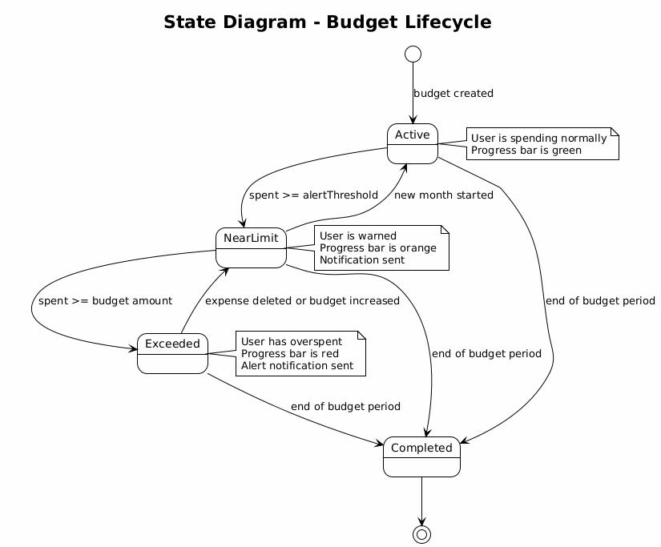
State - Budget
- Active - the budget was just created, progress bar is green
- NearLimit - spending reached the alert threshold, progress bar turns orange, warning notification sent
- Exceeded - spending went over the budget, progress bar turns red, alert notification sent
- Completed - the budget period ended

13.2 Goal Lifecycle
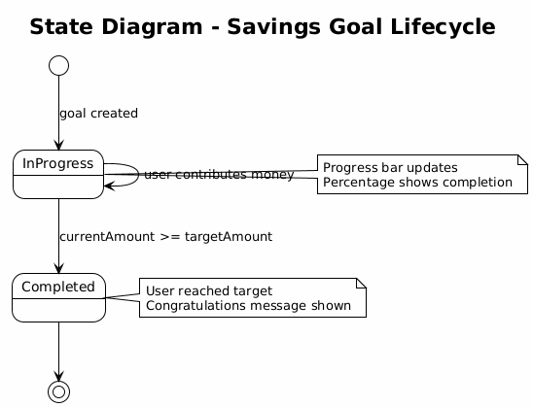
State - Goal
- InProgress - the goal is active, progress bar updates as the user contributes money
- Completed - the current amount reached the target

13.3 User Session
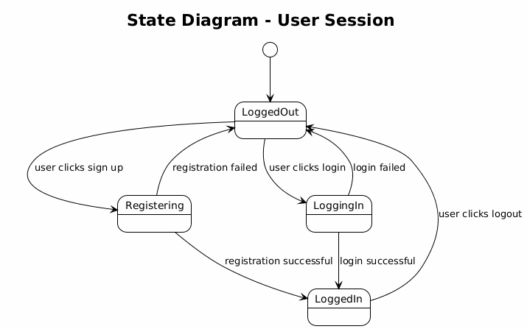
State - Session
- LoggedOut - the user is on the login/signup page
- LoggedIn - the user has access to all features
- Registering and LoggingIn are intermediate states that either succeed or fail

14. SOLID Principles

14.1 Single Responsibility Principle
Each Express route file handles one thing. authRoutes.js only deals with login and signup. transactionRoutes.js only deals with CRUD on transactions. This way if something breaks we know exactly which file to look at.

14.2 Open/Closed Principle
If we want to add a new report type or a new notification type, we can add it without changing the existing code. We just add a new function in the appropriate route file or model.

14.3 Liskov Substitution Principle
We did not use inheritance in this project since our models represent different database tables. But if we add admin functionality later, an AdminUser could extend the User class and be used anywhere a User is expected.

14.4 Interface Segregation Principle
Each Express route handler only receives the data it needs. The auth routes do not need to know about budgets or transactions. This keeps the API endpoints clean and focused.

14.5 Dependency Inversion Principle
All models depend on the PgPool abstraction, not on PostgreSQL directly. If we ever need to switch to a different database, we only change the connection setup. The route handlers and models stay the same.

15. Design Patterns

15.1 MVC Pattern
This is the main pattern of the whole system. The views (Alpine.js + Bootstrap), the controllers (Express routes), and the models (pg queries) are cleanly separated.

15.2 Observer Pattern
Used for budget alerts. When a transaction is saved, the route checks if any budget limit is reached and creates a notification. The Alpine.js frontend can poll for new notifications or use Alpine.js reactivity to display them.

15.3 Singleton Pattern
The PostgreSQL connection pool is a singleton. One pool instance is created when the server starts and shared across all route handlers. This avoids opening too many connections.

15.4 Strategy Pattern
Report generation uses different query strategies depending on the report type (monthly, by category, income vs expense). Each strategy is a separate function in the Report Model.

15.5 Middleware Pattern
Express middleware is used for common tasks like authentication (checking JWT tokens) and input validation. This keeps the individual route handlers clean since they do not need to repeat the same checks.

16. Diagrams Index
- MVC Architecture: layered-architecture.puml
- Component Diagram: component-diagram.puml
- ERD: erd.puml
- Package Diagram: package-diagram.puml
- Data Flow - Auth: dataflow-auth.puml
- Data Flow - Add Transaction: dataflow-add-transaction.puml
- Data Flow - Reports: dataflow-reports.puml
- Class Diagram: class-diagram.puml
- Sequence - Sign Up: sequence-signup.puml
- Sequence - Login: sequence-login.puml
- Sequence - Add Transaction: sequence-add-transaction.puml
- Sequence - Create Budget: sequence-create-budget.puml
- Sequence - Budget Alert: sequence-budget-alert.puml
- Sequence - Goals: sequence-goals.puml
- Sequence - Reports: sequence-reports.puml
- State - Budget: state-diagram-budget.puml
- State - Goal: state-diagram-goal.puml
- State - Session: state-diagram-session.puml

17. Application Screenshots

17.1 Login Page
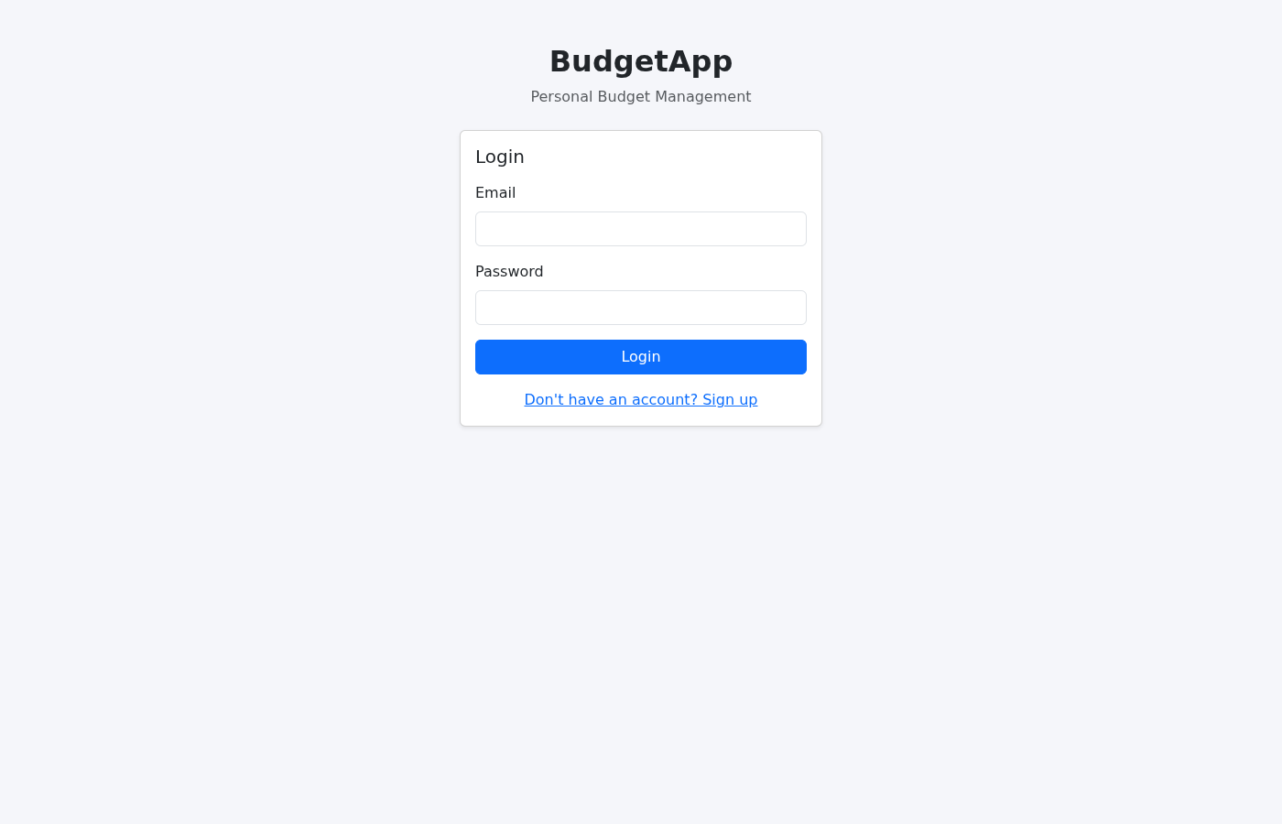
Login Page

17.2 Login Filled
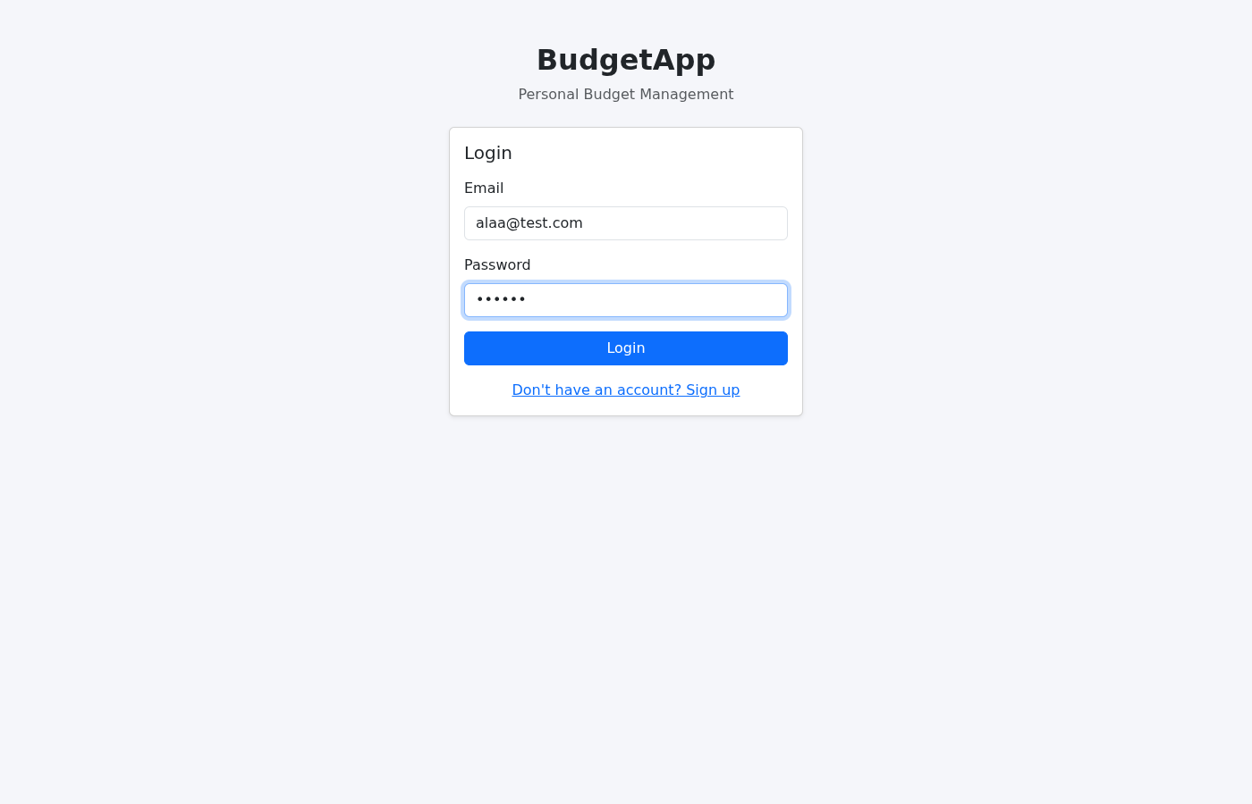
Login Filled

17.3 Dashboard
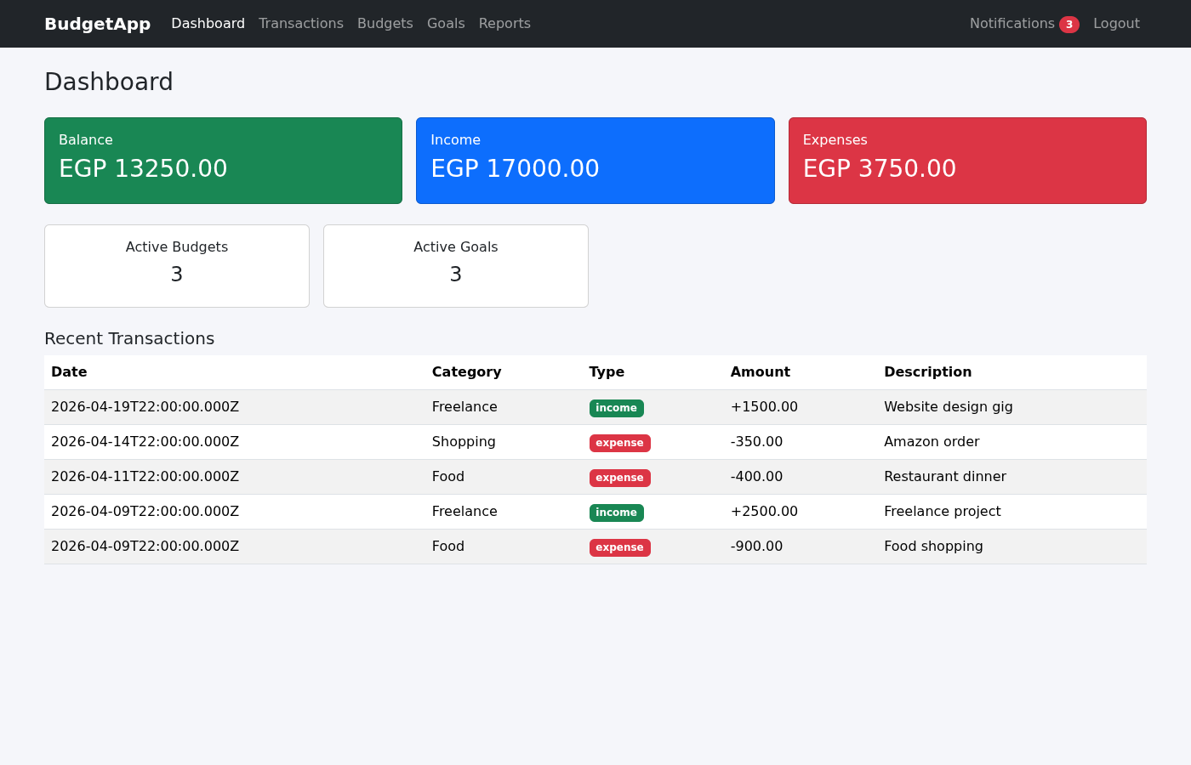
Dashboard
The dashboard shows the user’s balance, total income, total expenses, active budgets, active goals, and the 5 most recent transactions.

17.4 Transactions List
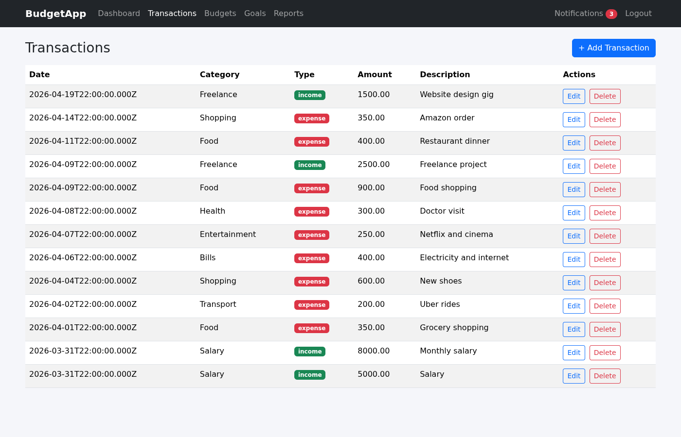
Transactions
All income and expense transactions are displayed in a table with date, category, type, amount, and description. Users can edit or delete any transaction.

17.5 Add Transaction Form
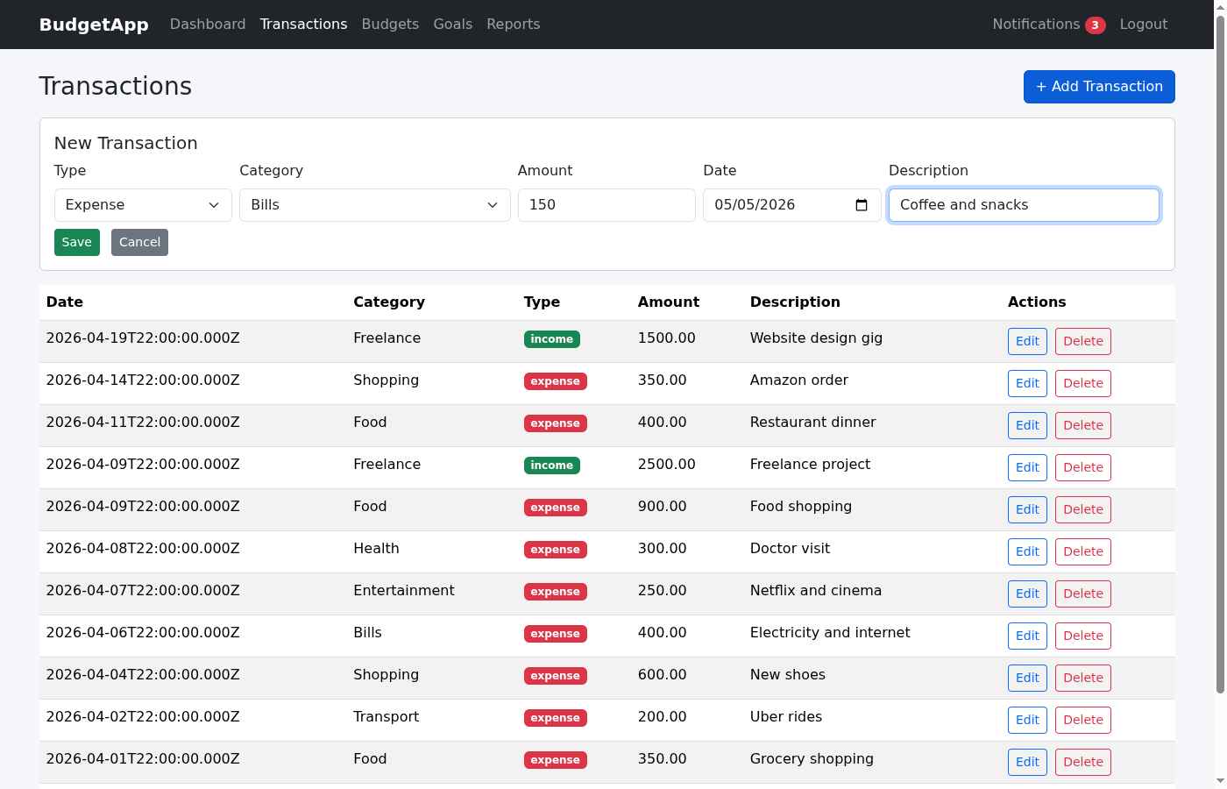
Add Transaction Form
The form allows selecting type (income/expense), category, amount, date, and description. When adding an expense, the system automatically checks the budget for that category.

17.6 Budgets
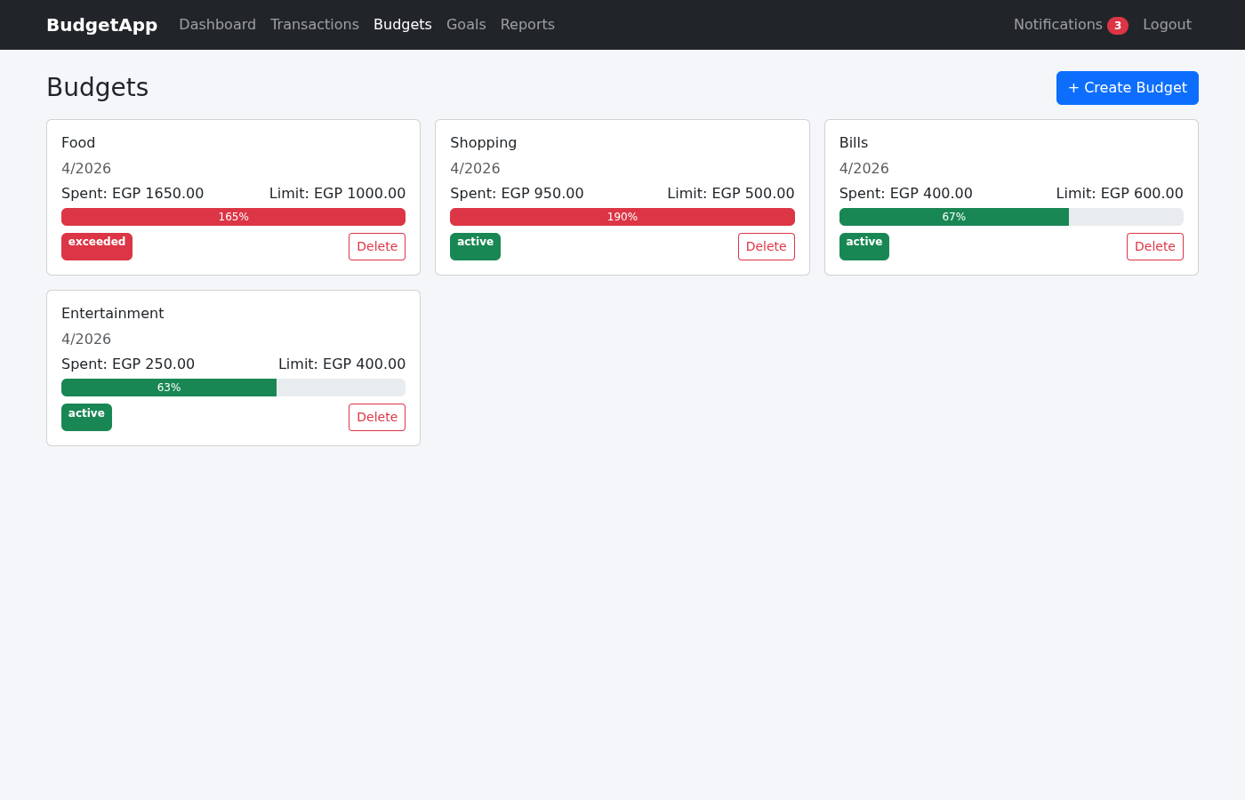
Budgets
Each budget shows a progress bar that changes color based on spending: green (under control), orange (nearing limit), red (exceeded). The percentage and status badge are displayed.

17.7 Create Budget Form
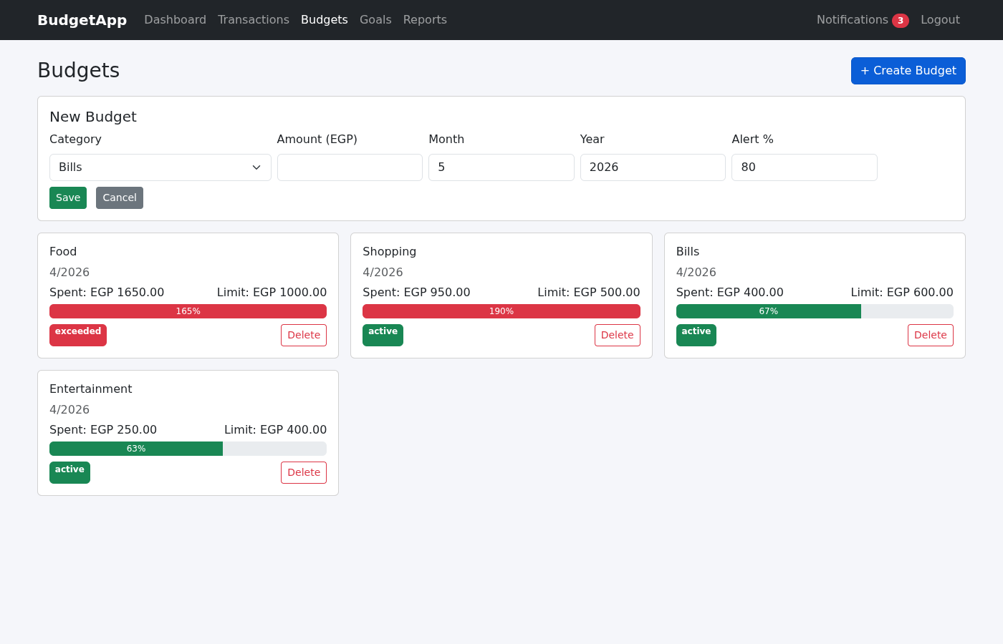
Create Budget Form
Users set a spending limit per category per month with a customizable alert threshold percentage.

17.8 Goals
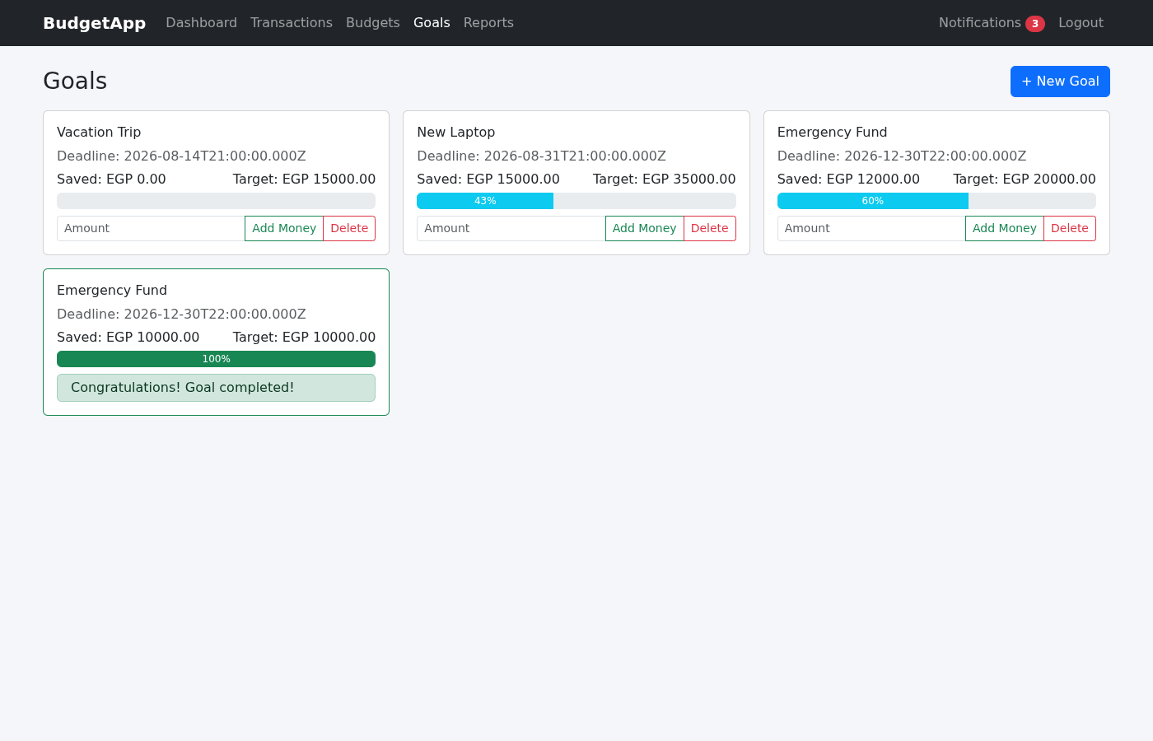
Goals
Savings goals show progress bars. Users can contribute money using the “Add Money” button. When the target is reached, the goal is marked as completed with a congratulations message.

17.9 Reports
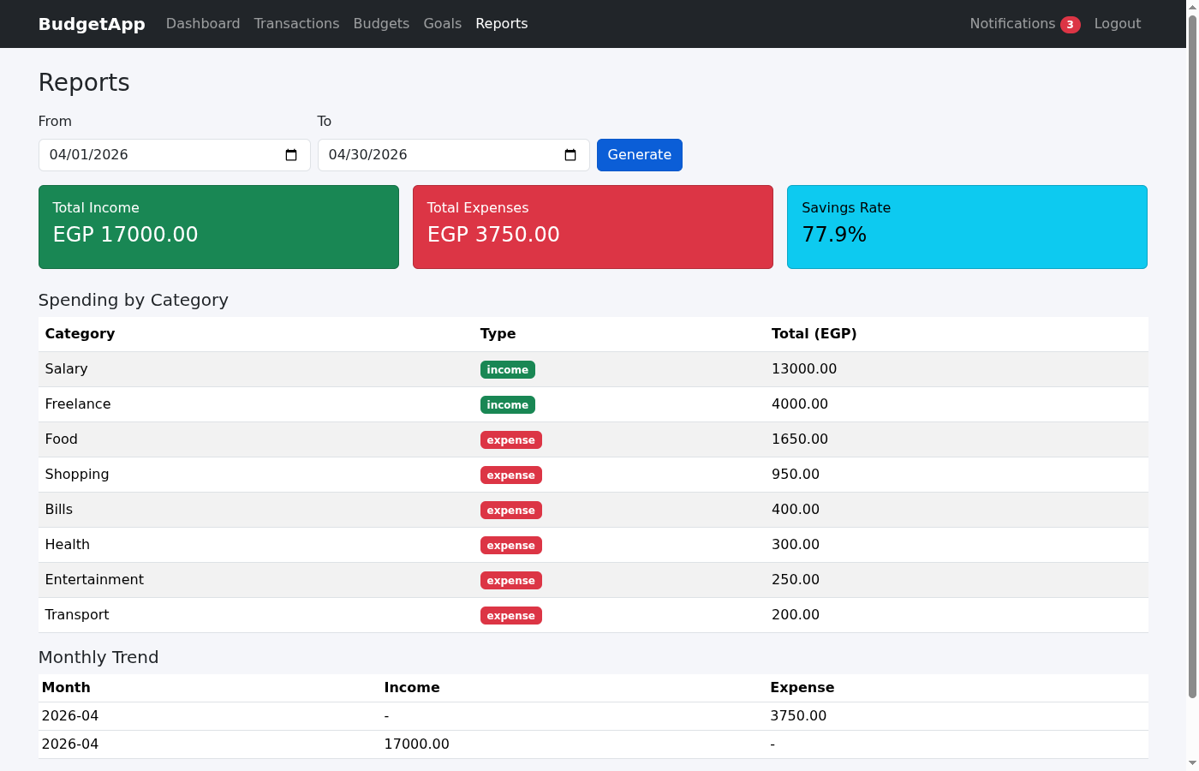
Reports
Reports show total income, total expenses, savings rate, spending by category, and monthly trends. Users can filter by date range.

17.10 Notifications
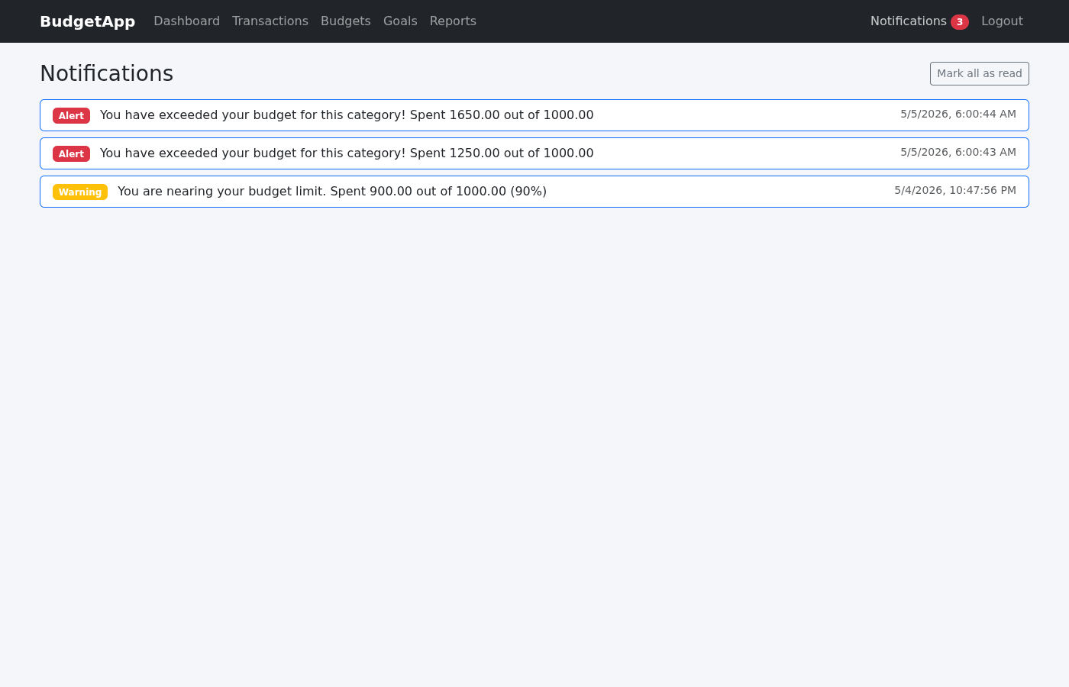
Notifications
Budget alerts appear automatically when spending nears or exceeds the set limit. Each notification shows the type (warning or alert) and the timestamp.

