PRIMERA PARTE DEL EXAMEN
Inicializo todas las variables definidas en variables.tf según lo que pide el enunciado, y edito los <placeholders> por los valores necesarios en cada caso. Ejecutamos los siguientes comandos:
PS C:\Users\sofin\Desktop\4 iMAT\Tecnologías para la Digitalización\Laboratorio\EXAMEN\td-exam-2026-alumni\terraform> terraform init
Initializing the backend...
Initializing provider plugins...
- Finding hashicorp/google versions matching "6.5.0"...
- Installing hashicorp/google v6.5.0...
- Installed hashicorp/google v6.5.0 (signed by HashiCorp)
Terraform has created a lock file .terraform.lock.hcl to record the provider
selections it made above. Include this file in your version control repository
so that Terraform can guarantee to make the same selections by default when
you run "terraform init" in the future.

Terraform has been successfully initialized!

You may now begin working with Terraform. Try running "terraform plan" to see
any changes that are required for your infrastructure. All Terraform commands
should now work.

If you ever set or change modules or backend configuration for Terraform,
rerun this command to reinitialize your working directory. If you forget, other

PS C:\Users\sofin\Desktop\4 iMAT\Tecnologías para la Digitalización\Laboratorio\EXAMEN\td-exam-2026-alumni\terraform> terraform plan

Terraform used the selected providers to generate the following execution plan. Resource actions are indicated with the following symbols:
+ create

Terraform will perform the following actions:

# google_container_cluster.primary will be created
+ resource "google_container_cluster" "primary" {
+ cluster_ipv4_cidr = (known after apply)
+ datapath_provider = (known after apply)
+ default_max_pods_per_node = (known after apply)
+ deletion_protection = false
+ effective_labels = {
+ "goog-terraform-provisioned" = "true"
}
+ enable_cilium_clusterwide_network_policy = false
+ enable_intranode_visibility = (known after apply)
+ enable_kubernetes_alpha = false
+ enable_l4_ilb_subsetting = false
+ enable_legacy_abac = false
+ enable_multi_networking = false
+ enable_shielded_nodes = true
+ endpoint = (known after apply)
+ id = (known after apply)
+ initial_node_count = 1
+ label_fingerprint = (known after apply)
+ location = "europe-west4-a"
+ logging_service = (known after apply)
+ master_version = (known after apply)
+ monitoring_service = (known after apply)
+ name = "sofianegueruela-td2026"
+ network = "default"
+ networking_mode = (known after apply)
+ node_locations = (known after apply)
+ node_version = (known after apply)
+ operation = (known after apply)
+ private_ipv6_google_access = (known after apply)
+ project = (known after apply)
+ remove_default_node_pool = true
+ self_link = (known after apply)
+ services_ipv4_cidr = (known after apply)
+ subnetwork = "default"
+ terraform_labels = {
+ "goog-terraform-provisioned" = "true"
}
+ tpu_ipv4_cidr_block = (known after apply)

+ addons_config (known after apply)

+ authenticator_groups_config (known after apply)

+ cluster_autoscaling (known after apply)

+ confidential_nodes (known after apply)

+ cost_management_config (known after apply)

+ database_encryption (known after apply)

+ default_snat_status (known after apply)

+ gateway_api_config (known after apply)

+ identity_service_config (known after apply)

+ ip_allocation_policy (known after apply)

+ logging_config (known after apply)

+ master_auth (known after apply)

+ master_authorized_networks_config (known after apply)

+ mesh_certificates (known after apply)

+ monitoring_config (known after apply)

+ node_config (known after apply)

+ node_pool (known after apply)

+ node_pool_auto_config (known after apply)

+ node_pool_defaults (known after apply)

+ notification_config (known after apply)

+ release_channel (known after apply)

+ security_posture_config (known after apply)

+ service_external_ips_config (known after apply)

+ vertical_pod_autoscaling (known after apply)

+ workload_identity_config (known after apply)
}

# google_container_node_pool.primary_nodes will be created
+ resource "google_container_node_pool" "primary_nodes" {
+ cluster = "sofianegueruela-td2026"
+ id = (known after apply)
+ initial_node_count = (known after apply)
+ instance_group_urls = (known after apply)
+ location = "europe-west4-a"
+ managed_instance_group_urls = (known after apply)
+ max_pods_per_node = (known after apply)
+ name = "td-lab-494513-node-pool"
+ name_prefix = (known after apply)
+ node_count = 2
+ node_locations = (known after apply)
+ operation = (known after apply)
+ project = "td-lab-494513"
+ version = (known after apply)

+ management (known after apply)

+ network_config (known after apply)

+ node_config {
+ disk_size_gb = 20
+ disk_type = (known after apply)
+ effective_taints = (known after apply)
+ image_type = (known after apply)
+ labels = (known after apply)
+ local_ssd_count = (known after apply)
+ logging_variant = (known after apply)
+ machine_type = "e2-small"
+ metadata = (known after apply)
+ min_cpu_platform = (known after apply)
+ oauth_scopes = [
+ "https://www.googleapis.com/auth/cloud-platform",
]
+ preemptible = false
+ service_account = (known after apply)
+ spot = false

+ confidential_nodes (known after apply)

+ gcfs_config (known after apply)

+ guest_accelerator (known after apply)

+ shielded_instance_config (known after apply)

+ workload_metadata_config (known after apply)
}

+ upgrade_settings (known after apply)
}

Plan: 2 to add, 0 to change, 0 to destroy.

Changes to Outputs:
+ gcp-cluster-name = "sofianegueruela-td2026"
+ kubernetes_endpoint = (known after apply)

───────────────────────────────────────────────────────────────────────────────────────────────────────────────────────────────────────────────────────────────

Note: You didn't use the -out option to save this plan, so Terraform can't guarantee to take exactly these actions if you run "terraform apply" now.

PS C:\Users\sofin\Desktop\4 iMAT\Tecnologías para la Digitalización\Laboratorio\EXAMEN\td-exam-2026-alumni\terraform> terraform apply

Terraform used the selected providers to generate the following execution plan. Resource actions are indicated with the following symbols:
+ create

Terraform will perform the following actions:

# google_container_cluster.primary will be created
+ resource "google_container_cluster" "primary" {
+ cluster_ipv4_cidr = (known after apply)
+ datapath_provider = (known after apply)
+ default_max_pods_per_node = (known after apply)
+ deletion_protection = false
+ effective_labels = {
+ "goog-terraform-provisioned" = "true"
}
+ enable_cilium_clusterwide_network_policy = false
+ enable_intranode_visibility = (known after apply)
+ enable_kubernetes_alpha = false
+ enable_l4_ilb_subsetting = false
+ enable_legacy_abac = false
+ enable_multi_networking = false
+ enable_shielded_nodes = true
+ endpoint = (known after apply)
+ id = (known after apply)
+ initial_node_count = 1
+ label_fingerprint = (known after apply)
+ location = "europe-west4-a"
+ logging_service = (known after apply)
+ master_version = (known after apply)
+ monitoring_service = (known after apply)
+ name = "sofianegueruela-td2026"
+ network = "default"
+ networking_mode = (known after apply)
+ node_locations = (known after apply)
+ node_version = (known after apply)
+ operation = (known after apply)
+ private_ipv6_google_access = (known after apply)
+ project = (known after apply)
+ remove_default_node_pool = true
+ self_link = (known after apply)
+ services_ipv4_cidr = (known after apply)
+ subnetwork = "default"
+ terraform_labels = {
+ "goog-terraform-provisioned" = "true"
}
+ tpu_ipv4_cidr_block = (known after apply)

+ addons_config (known after apply)

+ authenticator_groups_config (known after apply)

+ cluster_autoscaling (known after apply)

+ confidential_nodes (known after apply)

+ cost_management_config (known after apply)

+ database_encryption (known after apply)

+ default_snat_status (known after apply)

+ gateway_api_config (known after apply)

+ identity_service_config (known after apply)

+ ip_allocation_policy (known after apply)

+ logging_config (known after apply)

+ master_auth (known after apply)

+ master_authorized_networks_config (known after apply)

+ mesh_certificates (known after apply)

+ monitoring_config (known after apply)

+ node_config (known after apply)

+ node_pool (known after apply)

+ node_pool_auto_config (known after apply)

+ node_pool_defaults (known after apply)

+ notification_config (known after apply)

+ release_channel (known after apply)

+ security_posture_config (known after apply)

+ service_external_ips_config (known after apply)

+ vertical_pod_autoscaling (known after apply)

+ workload_identity_config (known after apply)
}

# google_container_node_pool.primary_nodes will be created
+ resource "google_container_node_pool" "primary_nodes" {
+ cluster = "sofianegueruela-td2026"
+ id = (known after apply)
+ initial_node_count = (known after apply)
+ instance_group_urls = (known after apply)
+ location = "europe-west4-a"
+ managed_instance_group_urls = (known after apply)
+ max_pods_per_node = (known after apply)
+ name = "td-lab-494513-node-pool"
+ name_prefix = (known after apply)
+ node_count = 2
+ node_locations = (known after apply)
+ operation = (known after apply)
+ project = "td-lab-494513"
+ version = (known after apply)

+ management (known after apply)

+ network_config (known after apply)

+ node_config {
+ disk_size_gb = 20
+ disk_type = (known after apply)
+ effective_taints = (known after apply)
+ image_type = (known after apply)
+ labels = (known after apply)
+ local_ssd_count = (known after apply)
+ logging_variant = (known after apply)
+ machine_type = "e2-small"
+ metadata = (known after apply)
+ min_cpu_platform = (known after apply)
+ oauth_scopes = [
+ "https://www.googleapis.com/auth/cloud-platform",
]
+ preemptible = false
+ service_account = (known after apply)
+ spot = false

+ confidential_nodes (known after apply)

+ gcfs_config (known after apply)

+ guest_accelerator (known after apply)

+ shielded_instance_config (known after apply)

+ workload_metadata_config (known after apply)
}

+ upgrade_settings (known after apply)
}

Plan: 2 to add, 0 to change, 0 to destroy.

Changes to Outputs:
+ gcp-cluster-name = "sofianegueruela-td2026"
+ kubernetes_endpoint = (known after apply)

Do you want to perform these actions?
Terraform will perform the actions described above.
Only 'yes' will be accepted to approve.

Enter a value: yes

google_container_cluster.primary: Creating...
google_container_cluster.primary: Still creating... [00m10s elapsed]
google_container_cluster.primary: Still creating... [00m20s elapsed]
google_container_cluster.primary: Still creating... [00m30s elapsed]
google_container_cluster.primary: Still creating... [00m40s elapsed]
google_container_cluster.primary: Still creating... [00m50s elapsed]
google_container_cluster.primary: Still creating... [01m00s elapsed]
google_container_cluster.primary: Still creating... [01m10s elapsed]
google_container_cluster.primary: Still creating... [01m20s elapsed]
google_container_cluster.primary: Still creating... [01m30s elapsed]
google_container_cluster.primary: Still creating... [01m40s elapsed]
google_container_cluster.primary: Still creating... [01m50s elapsed]
google_container_cluster.primary: Still creating... [02m00s elapsed]
google_container_cluster.primary: Still creating... [02m10s elapsed]
google_container_cluster.primary: Still creating... [02m20s elapsed]
google_container_cluster.primary: Still creating... [02m30s elapsed]
google_container_cluster.primary: Still creating... [02m40s elapsed]
google_container_cluster.primary: Still creating... [02m50s elapsed]
google_container_cluster.primary: Still creating... [03m00s elapsed]
google_container_cluster.primary: Still creating... [03m10s elapsed]
google_container_cluster.primary: Still creating... [03m20s elapsed]
google_container_cluster.primary: Still creating... [03m30s elapsed]
google_container_cluster.primary: Still creating... [03m40s elapsed]
google_container_cluster.primary: Still creating... [03m50s elapsed]
google_container_cluster.primary: Still creating... [04m00s elapsed]
google_container_cluster.primary: Still creating... [04m10s elapsed]
google_container_cluster.primary: Still creating... [04m20s elapsed]
google_container_cluster.primary: Still creating... [04m30s elapsed]
google_container_cluster.primary: Still creating... [04m40s elapsed]
google_container_cluster.primary: Still creating... [04m50s elapsed]
google_container_cluster.primary: Still creating... [05m00s elapsed]
google_container_cluster.primary: Still creating... [05m10s elapsed]
google_container_cluster.primary: Still creating... [05m20s elapsed]
google_container_cluster.primary: Still creating... [05m30s elapsed]
google_container_cluster.primary: Still creating... [05m40s elapsed]
google_container_cluster.primary: Still creating... [05m50s elapsed]
google_container_cluster.primary: Still creating... [06m00s elapsed]
google_container_cluster.primary: Still creating... [06m10s elapsed]
google_container_cluster.primary: Still creating... [06m20s elapsed]
google_container_cluster.primary: Creation complete after 6m29s [id=projects/td-lab-494513/locations/europe-west4-a/clusters/sofianegueruela-td2026]
google_container_node_pool.primary_nodes: Creating...
google_container_node_pool.primary_nodes: Still creating... [00m10s elapsed]
google_container_node_pool.primary_nodes: Still creating... [00m20s elapsed]
google_container_node_pool.primary_nodes: Still creating... [00m30s elapsed]
google_container_node_pool.primary_nodes: Still creating... [00m40s elapsed]
google_container_node_pool.primary_nodes: Still creating... [00m50s elapsed]
google_container_node_pool.primary_nodes: Still creating... [01m00s elapsed]
google_container_node_pool.primary_nodes: Creation complete after 1m2s [id=projects/td-lab-494513/locations/europe-west4-a/clusters/sofianegueruela-td2026/nodePools/td-lab-494513-node-pool]

Apply complete! Resources: 2 added, 0 changed, 0 destroyed.

Outputs:

gcp-cluster-name = "sofianegueruela-td2026"
kubernetes_endpoint = "34.12.239.246"
Podemos comprobar que se ha creado el cluster correctamente:
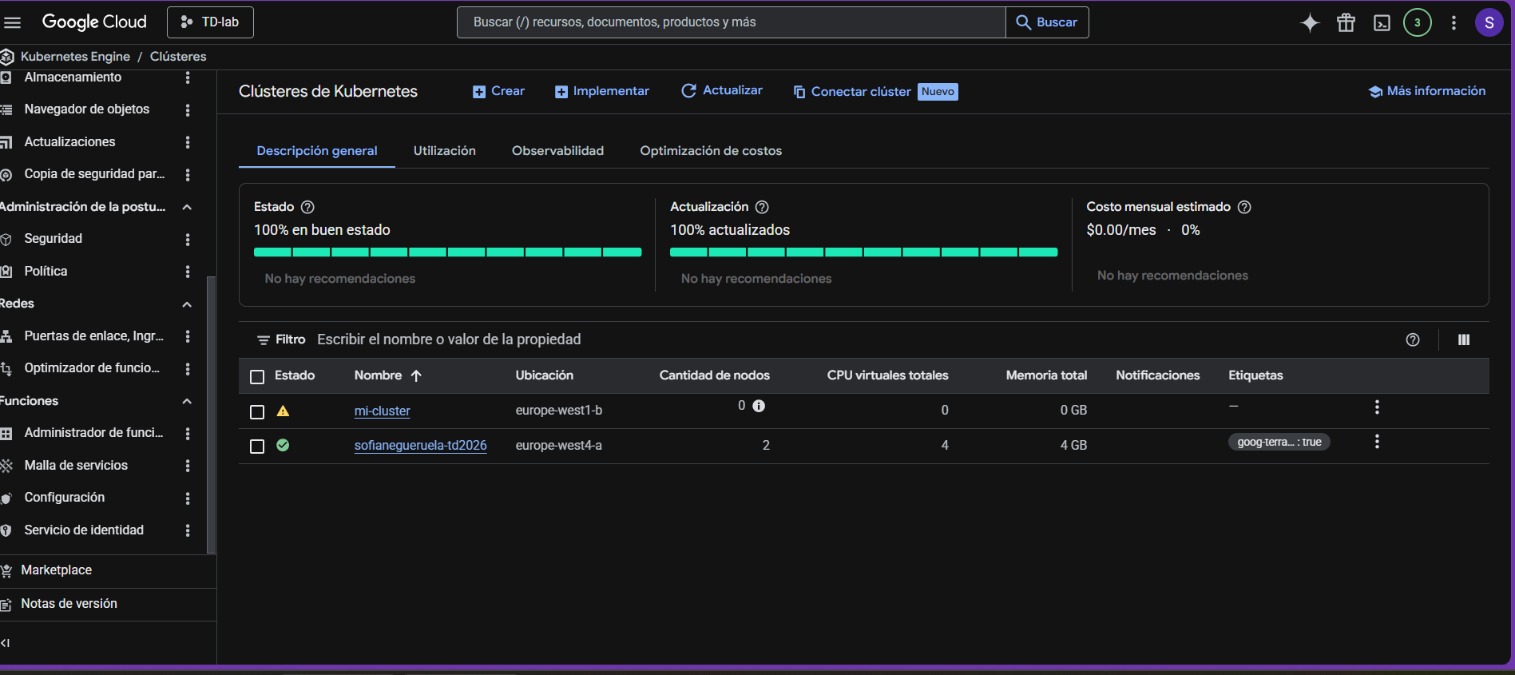
DESPLIEGUE APLICACIÓN CON GITHUB ACTIONS
Definimos los secretos y variables en Github Actions:
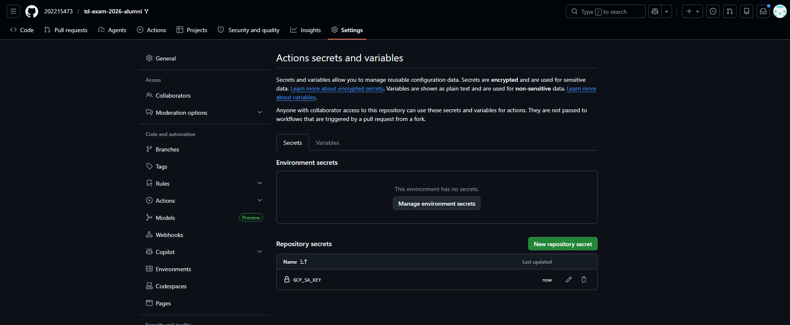
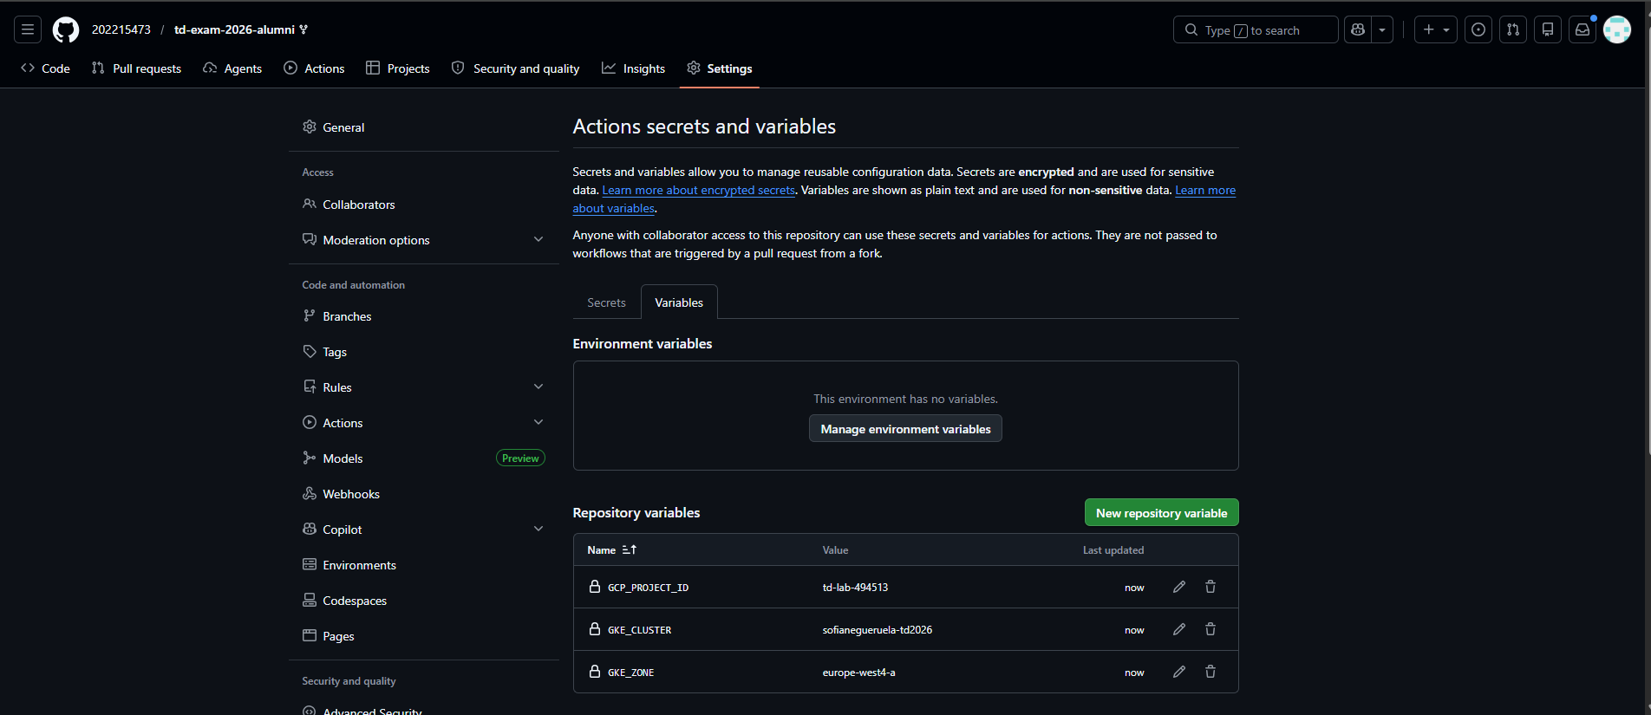
Finalmente, tras arreglar los nombres de las variables por los valores añadidos como secretos y variables en Actions, he conseguido desplegar la primera aplicación:
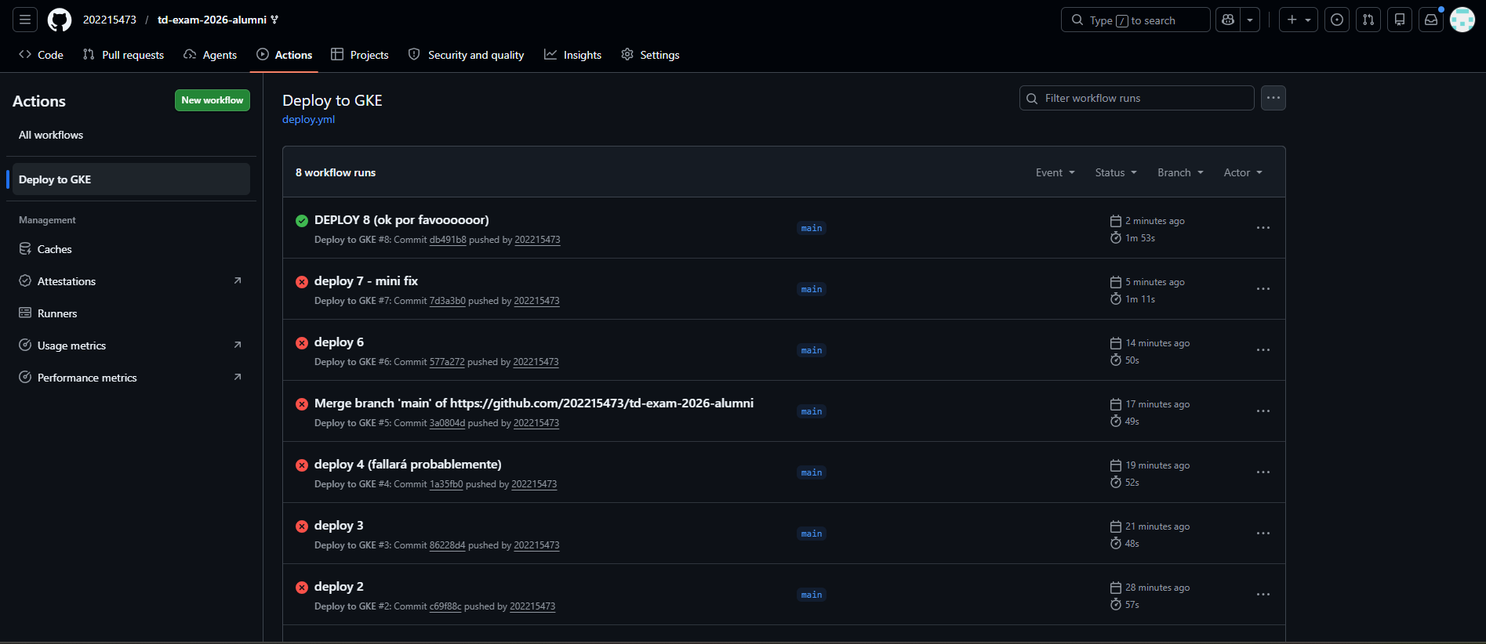
A la hora de comprobar que todo estaba desplegado correctamente desde la cloud Shell, me encontré con un pequeño problema: como yo tenía de antes un cluster creado, no era capaz de encontrar la IP externa de svc-api. En la siguiente captura se ve claramente esto y cómo accedo a la IP externa (y compruebo que las tres aplicaciones existen y funcionan bien). Soy consciente de que podría haber listado las tres aplicaciones directamente con un solo comando, pero preferí ir una a una comprobando que todo estaba bien.
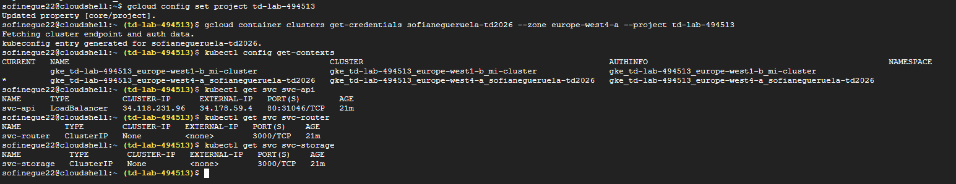
Finalmente, ejecuto los comandos que he dejado almacenados en el repositorio, en el archivo test.txt, y se observa que todo funciona correctamente:
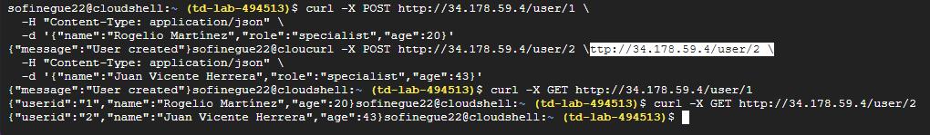
A continuación, incluyo el texto de las dos últimas imágenes:
sofinegue22@cloudshell:~$ gcloud config set project td-lab-494513
Updated property [core/project].
sofinegue22@cloudshell:~ (td-lab-494513)$ gcloud container clusters get-credentials sofianegueruela-td2026 --zone europe-west4-a --project td-lab-494513
Fetching cluster endpoint and auth data.
kubeconfig entry generated for sofianegueruela-td2026.
sofinegue22@cloudshell:~ (td-lab-494513)$ kubectl config get-contexts
CURRENT NAME CLUSTER AUTHINFO NAMESPACE
gke_td-lab-494513_europe-west1-b_mi-cluster gke_td-lab-494513_europe-west1-b_mi-cluster gke_td-lab-494513_europe-west1-b_mi-cluster
* gke_td-lab-494513_europe-west4-a_sofianegueruela-td2026 gke_td-lab-494513_europe-west4-a_sofianegueruela-td2026 gke_td-lab-494513_europe-west4-a_sofianegueruela-td2026
sofinegue22@cloudshell:~ (td-lab-494513)$ kubectl get svc svc-api
NAME TYPE CLUSTER-IP EXTERNAL-IP PORT(S) AGE
svc-api LoadBalancer 34.118.231.96 34.178.59.4 80:31046/TCP 21m
sofinegue22@cloudshell:~ (td-lab-494513)$ kubectl get svc svc-router
NAME TYPE CLUSTER-IP EXTERNAL-IP PORT(S) AGE
svc-router ClusterIP None <none> 3000/TCP 21m
sofinegue22@cloudshell:~ (td-lab-494513)$ kubectl get svc svc-storage
NAME TYPE CLUSTER-IP EXTERNAL-IP PORT(S) AGE
svc-storage ClusterIP None <none> 3000/TCP 21m
sofinegue22@cloudshell:~ (td-lab-494513)$ ^C
sofinegue22@cloudshell:~ (td-lab-494513)$ curl -X POST http://34.178.59.4/user/1 \
-H "Content-Type: application/json" \
-d '{"name":"Rogelio Martínez","role":"specialist","age":20}'
{"message":"User created"}sofinegue22@cloucurl -X POST http://34.178.59.4/user/2 \ttp://34.178.59.4/user/2 \
-H "Content-Type: application/json" \
-d '{"name":"Juan Vicente Herrera","role":"specialist","age":43}'
{"message":"User created"}sofinegue22@cloudshell:~ (td-lab-494513)$ curl -X GET http://34.178.59.4/user/1
{"userid":"1","name":"Rogelio Martínez","age":20}sofinegue22@cloudshell:~ (td-lab-494513)$ curl -X GET http://34.178.59.4/user/2
{"userid":"2","name":"Juan Vicente Herrera","age":43}sofinegue22@cloudshell:~ (td-lab-494513)$

SEGUNDA PARTE DEL EXAMEN
Igual que antes, las variables y secretos de github actions quedan así:
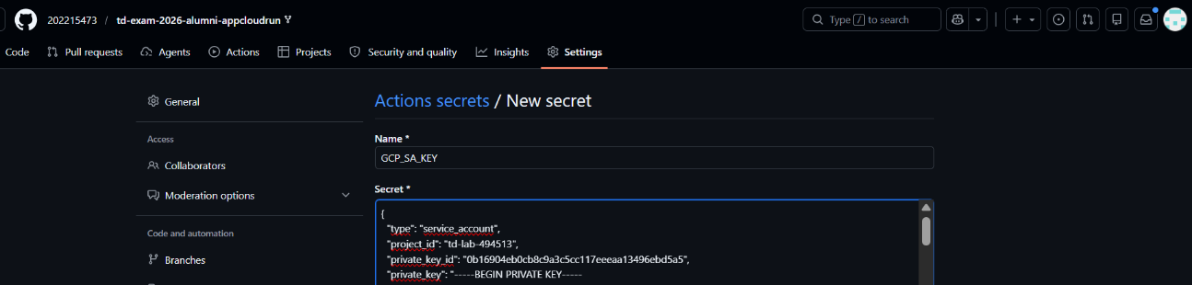
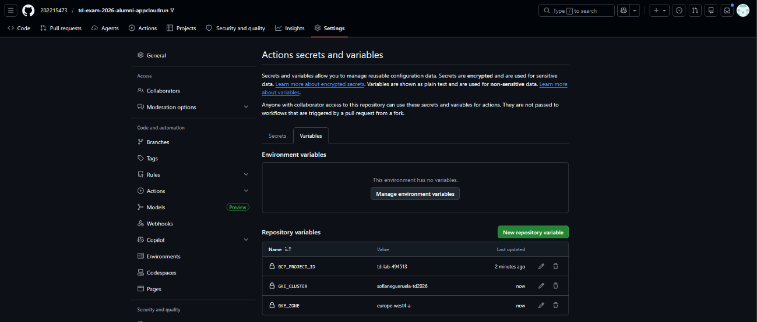
Y, tras editar el fichero del workflow con la configuración necesaria y resolver pequeñas erratas, he logrado desplegar la aplicación:
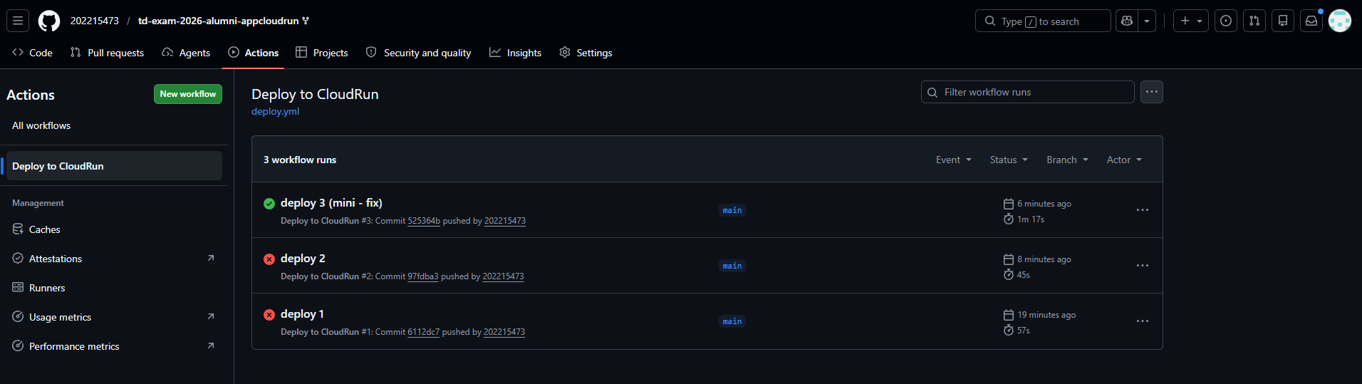
En la CLI de Google Cloud, comprobamos que está desplegada:
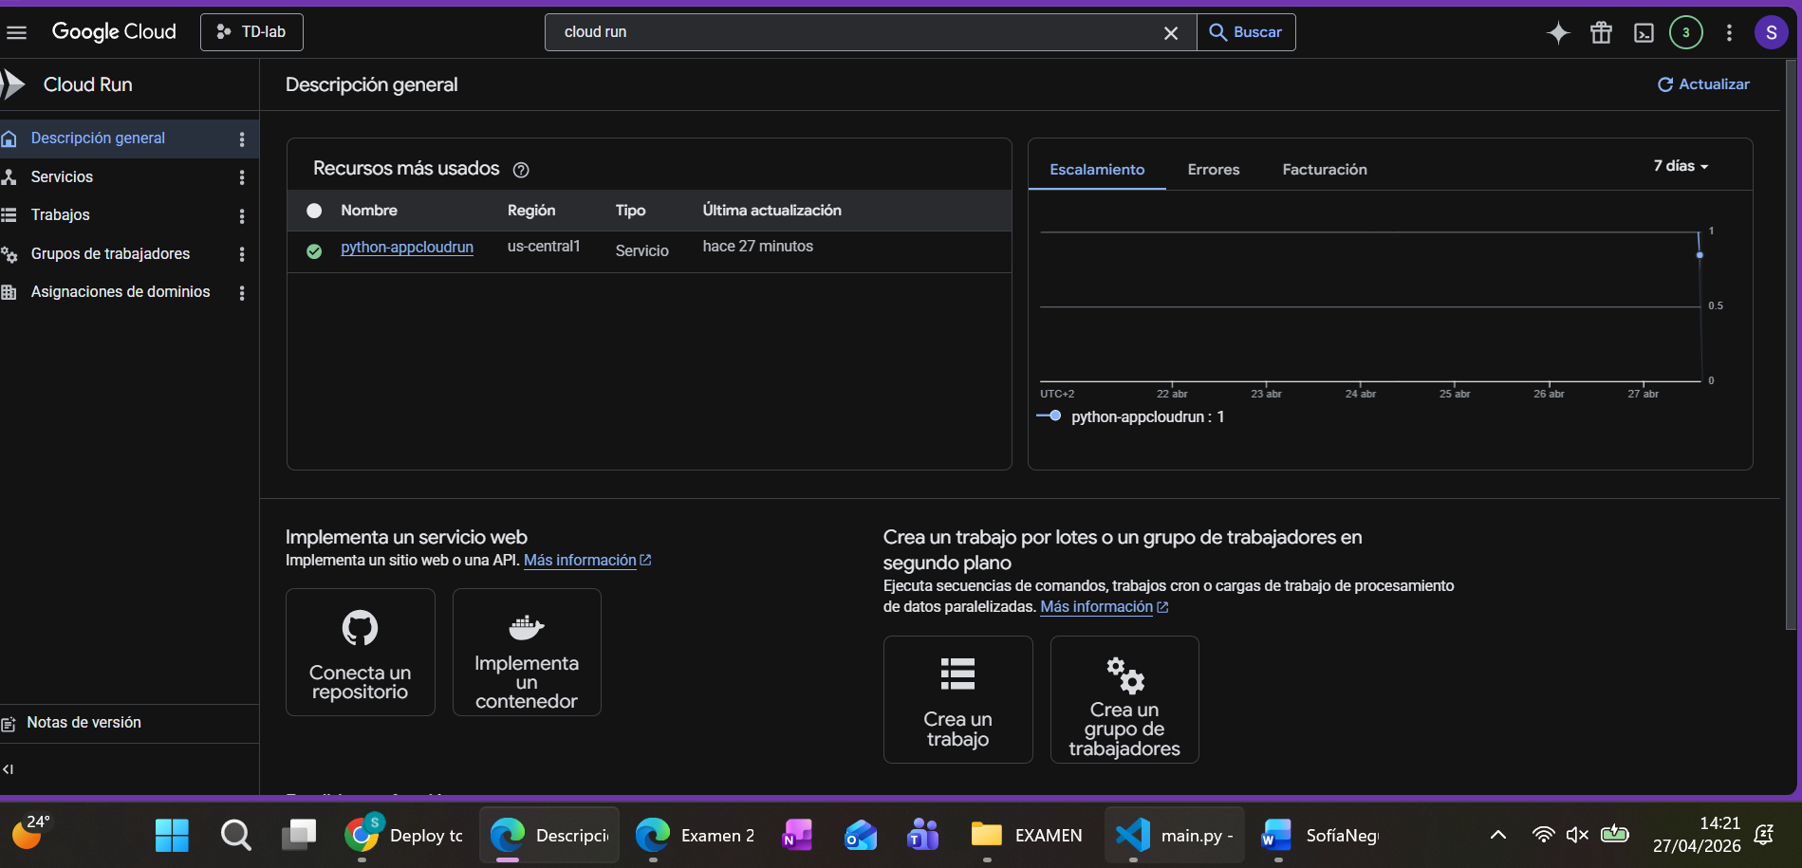
Efectivamente, cuando entramos en la url, todo funciona correctamente (los datos que se muestran también son correctos):
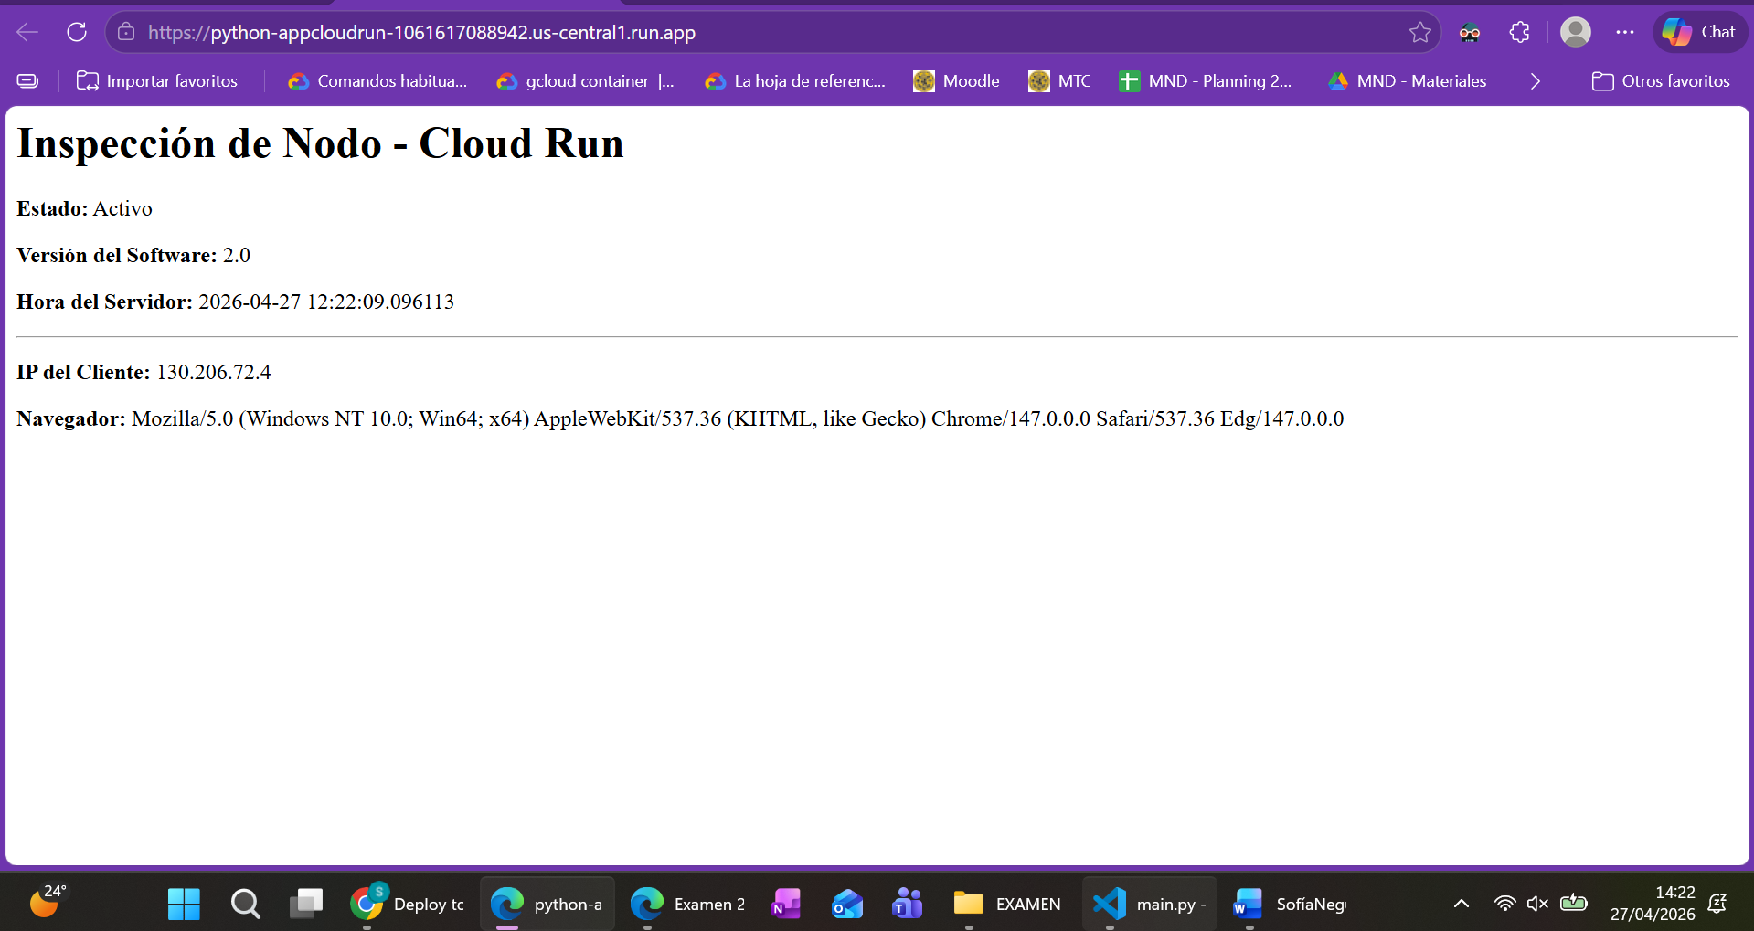
Y para el endpoint api/status:
