Service Now Dashboard

BITS ZC229T: Design Project
By
Himanshu
202217b3231

B.Sc. Design and Computing

Design Project work carried out at

HCL Tech, Noida



WORK INTEGRATED LEARNING PROGRAMMES DIVISION (WILPD),
BIRLA INSTITUTE OF TECHNOLOGY & SCIENCE
PILANI (RAJASTHAN)

March 2025

Certificate
This is to certify that the Design Project entitled Service Now Dashboard and submitted by Himanshu having BITS ID No. 202217B3231 for the fulfilment of the requirements of the B.Sc. (Design and Computing) degree program of BITS, embodies the bona fide work done by him under my supervision.

Signature of the Mentor
Rajesh Kumar Saini
Reporting Manager
HCL Technologies Ltd
Noida | +91-8675433333

ACKNOWLEDGMENT
I am deeply grateful to everyone who contributed to the successful completion of the project ‘ServiceNow Dashboard’. First and foremost, I extend my heartfelt thanks to my supervisor, Rajesh Kumar Saini, whose guidance and expertise were invaluable throughout the project. Their insights and constructive feedback significantly enhanced the quality of the work.
I also wish to acknowledge the support of my additional examiner, Dhruv Bhatnagar, whose collaboration and dedication were crucial in achieving the project's goals. Furthermore, I extend my sincere thanks to HCL Technologies for providing the necessary resources and a conducive environment for the project's execution.
Special appreciation goes to the faculty and my classmates in the COHORT at BITS Pilani. Your unwavering support and understanding during the project's demanding phases were greatly appreciated.
This project would not have been possible without the collective effort and support of all those mentioned above. Thank you for being an integral part of this endeavor.

ABSTRACT
Project Title: ServiceNow Dashboard Chrome Extension
Broad Academic Area of Work: Browser Extension Development & data fetching Integration
Technologies Used: React.js, Vite, JavaScript, ServiceNow, Tailwind CSS, Chrome Extension APIs
The project focuses on building a ServiceNow dashboard Chrome extension that enhances the user experience by providing a seamless way to fetch and manage ServiceNow data. It addresses UI/UX challenges and technical issues like CORS restrictions while ensuring optimal performance and usability.
Through this project, I have gained hands-on experience in front-end development, API integration, and handling data efficiently in a real-world application. The implementation has helped improve ServiceNow data accessibility and usability, benefiting users in managing their workflows effectively.
I extend my sincere appreciation to everyone who contributed to the successful completion of this project. Thank you for your guidance, support, and encouragement throughout this endeavor.
Name of Student: Himanshu

Signature of the Student
Name of Mentor: Rajesh Kumar Saini

Signature of the Mentor
Date: 2025-03-08
Place: Noida

TABLE OF CONTENTS
Section No. | Section Name | Page No.
1 | Introduction | 4
1.1 | About the project | 4
1.2 | Objective | 4
2 | Technologies Involved | 4
3 | Screenshots Of Various Steps | 5
4 | Conclusion | 6
5 | Future Plan | 6
6 | Checklist & Declaration | 7

1. INTRODUCTION

1.1 About the Project
The mid-semester project focuses on developing a ServiceNow dashboard Chrome extension to enhance data visualization and streamline user interactions. The extension provides a user-friendly interface for fetching and displaying ServiceNow data efficiently. The project aims to improve workflow management and data accessibility for users interacting with ServiceNow.

1.2 OBJECTIVE
The primary objective of this project is to develop a robust and intuitive ServiceNow dashboard Chrome extension. The key goals include:
- Fetching real-time data from ServiceNow.
- Addressing UI/UX issues to improve usability.
- Enhancing user interaction with a dynamic form and table component.
- Resolving CORS issues while fetching data.
- Ensuring efficient data handling and display.

2. TECHNOLOGIES INVOLVED
The project is developed using the following technologies:
- React.js: For building the front-end UI components.
- Vite: For a fast and optimized development environment.
- JavaScript (ES6+): For handling logic and API requests.
- CSS & Tailwind CSS: For styling and enhancing UI design.
- Browser Storage & State Management: For handling user preferences and session data.
- Chrome Extension APIs: For enabling integration with the browser and ServiceNow.

3. SCREENSHOTS OF VARIOUS STEPS
Dashboard page
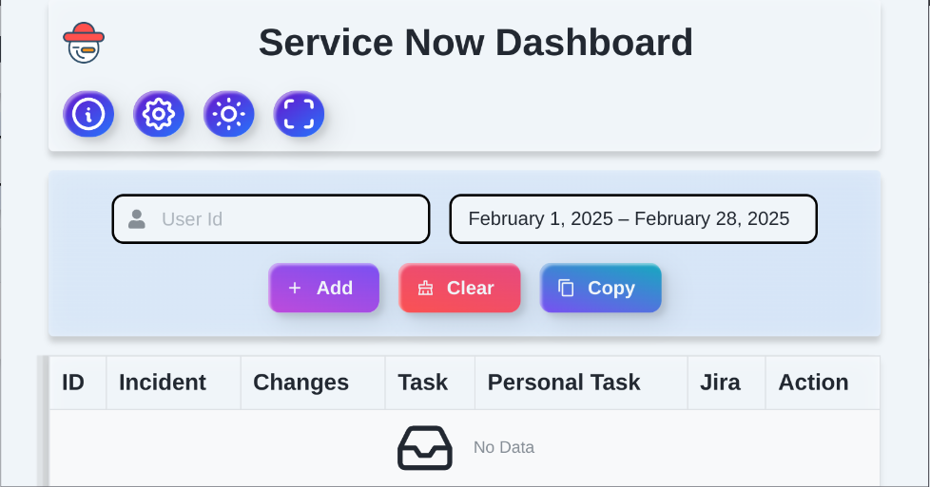
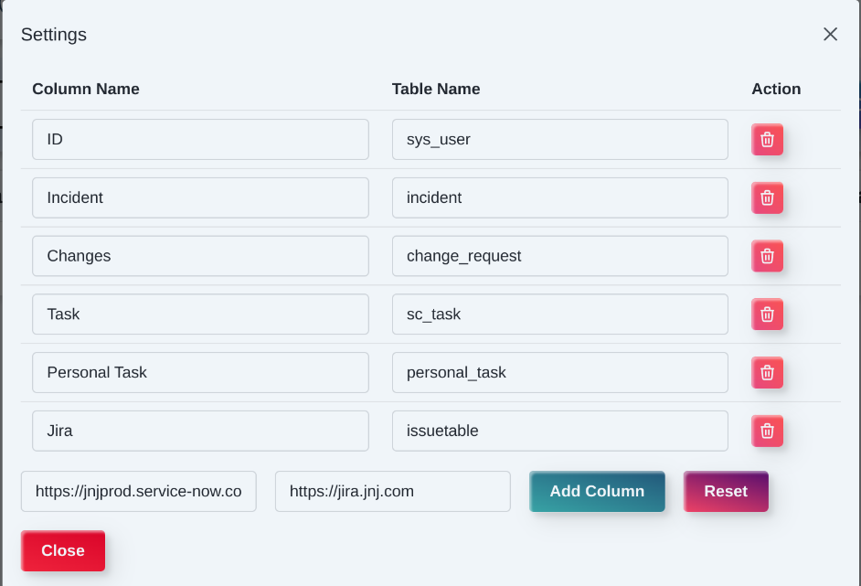
Settings Page
About Page
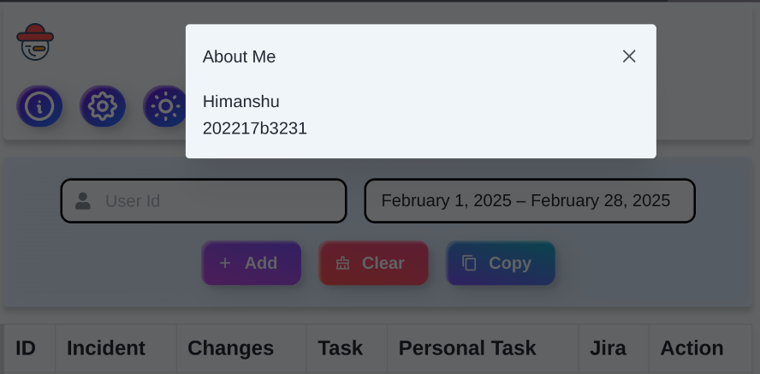

Full screen & Dark Mode

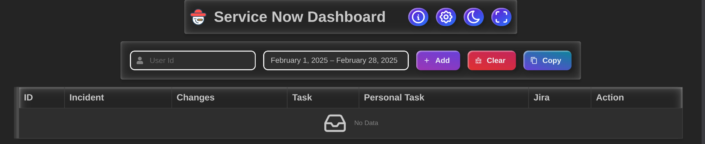
Fetched data
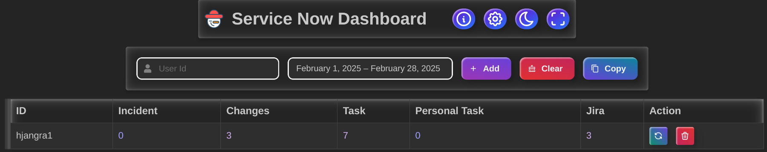

4. CONCLUSION
The ServiceNow dashboard Chrome extension successfully integrates with the ServiceNow, providing a seamless user experience for managing and visualizing data. The project has significantly improved UI/UX, enhanced data accessibility, and resolved technical challenges like CORS issues. The implementation ensures that users can efficiently fetch and analyze ServiceNow data.

5. FUTURE PLAN
- Enhancing the filtering mechanism for more advanced data querying.
- Implementing role-based access control to secure data visibility.
- Adding export functionality for data extraction in multiple formats.
- Integrating additional Service Now modules for expanded functionality.

6. Declaration
I, Himanshu, hereby declare that this project report is a result of my work and the information provided is accurate to the best of my knowledge. No part of this work has been copied or reproduced from unauthorized sources.
Student Name: Himanshu
BITS ID: 202217b3231
Date: 8 March 2025

