**An Industry Oriented Mini Project Report  
on   
SIGNATURE FORGERY DETECTION USING DEEP LEARNING**

**Submitted in partial fulfillment of the requirements for the  
award of the degree of B.Tech**

**BACHELOR OF TECHNOLOGY**

**IN**

**COMPUTER SCIENCE AND ENGINEERING**

**Submitted by**

**20EG105639 -A DEVIKA**

**20EG105704 - P AKHIL**

**20EG105712 - M HARSHITH VARMA**

**20EG105717 - N SUJEETH KUMAR**



**Under the guidance of**

**MR K SADANANDAM M.Tech PhD**

**Assistant Professor**

# DEPARTMENT OF COMPUTER SCIENCE AND ENGINEERING

# Anurag University

# VENKATAPUR– 500088

# TELANGANA

# Year 2023-24

**An Industry Oriented Mini Project Report**

**On SIGNATURE FORGERY DETECTION USING DEEP LEARNING**

**DECLARATION**

I hereby declare that the Report entitled “**SIGNATURE FORGERY DETECTION USING DEEP LEARNING**” submitted for the award of Bachelor of technology Degree is my original work and the Report has not formed the basis for the award of any degree, diploma, associate ship or fellowship of similar other titles. It has not been submitted to any other University or Institution for the award of any degree or diploma.

Place:

20EG105639: A Devika

20EG105704: P Akhil

20EG105712: M Harshith Varma

20EG105717: N Sujeeth Kumar

Date:

**CERTIFICATE**

This is to certify that the Report/dissertation entitled for An Industry Oriented Mini Project Report “**SIGNATURE FORGERY DETECTION USING DEEP LEARNING**” that is being submitted by A Devika (20EG105639), P Akhil (20EG105704), M Harshith Varma (20EG105712), N Sujeeth Kumar (20EG105717) in partial fulfillment for the award of B.Tech in Anurag University is a record of bonafide work carried out by him / her under my/our guidance and supervision. The results embodied in this Report have not been submitted to any other University or Institute for the award of any degree or diploma.

**Signature of Supervisor Dean, CSE**

MR K SADANANDAM

M.Tech, PhD

Assistant Professor

**TABLE OF CONTENTS**

|  |
| --- |
| S.NO CHAPTERS PAGE NO. |
| 1. **ABSTRACT AND ACKNOWLEDGEMENT** **1-2** |
| 1.1 ACKNOWLEDGEMENT 1 |
| 1.2 ABSTRACT 2 |
| 2. **INTRODUCTION 3-4** |
| 2.1 CHARACTERISTICS 3 |
| 2.1.1 Importance of Signature Authentication 3 |
| 2.1.2 Signature Characteristics 3 |
| 2.1.3 Role of Deep Learning 3 |
| 2.1.4 Feature Extraction 4 |
| 2.1.5 Database for Storing Features 4 |
| 2.1.6 Signature Comparison 4 |
| 2.2.1 EXISTING SYSTEM 4 |
| 2.2.2 PROPOSED SYSTEMS 4-5 |
| 3. **LITERATURE REVIEW 5** |
| 4. **SYSTEM REQUIREMENTS 6** |
| 4.1 SOFTWARE REQUIREMENTS 6 |
| 4.2 HARDWARE REQUIREMENTS 6 |
| 5. **SYSTEM ARCHITECTURE 7** |
| 5.1 Convolutional Neural Network (CNN) 7 |
| 6. **REQUIREMENTS 8-9** |
| 6.1 **Functional Requirements** 8 |
| 6.1.1 Image Upload and Processing 8 |
| 6.1.2 Signature Forgery Detection 8 |
| 6.1.3 Model Persistence 8 |
| 6.1.4 Web Interface 8 |
| 6.1.5 User Feedback 8 |
| 6.1.6 Security Measures 8 |
| 6.2 **Non-Functional Requirements 9** |
| 6.2.1 Performance 9 |
| 6.2.2 Accuracy 9 |
| 6.2.3 User Experience 9 |
| 6.2.4 Security 9 |
| 6.2.5 Scalability 9 |
| 6.2.6 Model Persistence 9 |
| 6.2.7 Compatibility 9 |
| S.NO CHAPTERS PAGE NO. |
| 6.2.9 Documentation 9 |
| 6.2.10 Training and Education 9 |
| 7. **SYSTEM DESIGN 10-12** |
| 7.1.1 Convolutional Neural Network (CNN) 10 |
| 7.1.2 Data Acquisition and Preprocessing 10 |
| 7.1.3 Feature Extraction 11 |
| 7.1.4 Convolution Layer 11 |
| 7.1.5 ReLU Layer 11 |
| 7.1.6 Pooling Layer 11 |
| 7.1.7 Fully Connected Layer 11 |
| 7.1.8 Training and Neural Network 11 |
| 7.1.9 Performance Evaluation 11 |
| 7.1.10 Testing 11 |
| 7.2 ACTIVITY DIAGRAM 12 |
| 7.2.1 Dataset 12 |
| 7.2.2 Image Processing 12 |
| 7.2.3 Data Augmentation 12 |
| 7.2.4 Neural Network Training 12 |
| 7.2.5 Testing trained model with Evaluation Data 12 |
| 8 **DATA SET 13** |
| 9 **OVERVIEW OF TECHNOLOGY 14** |
| 9.1 PYTHON 14 |
| 10 **IMPLEMENTATION 15-16** |
| 10.1.1 NumPy 15 |
| 10.1.2 Pandas 15 |
| 10.1.3 Matplotlib 15 |
| 10.1.4 Flask 16 |
| 10.1.5 Pillow (PIL) 16 |
| 10.1.6 PyTorch 16 |
| 11. **Requirements Installation 17-22** |
| 11.1 Coding Snapshots 18 |
| 11.1.1 app.py 18 |
| 11.1.2 data.py 19 |
| 11.1.3 utils.py 20 |
| 11.2 TRAINING AND TESTING 21-22 |
| 11.2.1 getDataStats.py 21 |
| 11.2.2 model.py 22 |
| 12. **Conclusion 23-24** |
| 12.1 Future Enhancements 23 |
| 13. **References 24** |

1. **ABSTRACT AND ACKNOWLEDGEMENT**

# ACKNOWLEDGEMENT

It is our privilege and pleasure to express my profound sense of respect, gratitude and indebtedness to our guide **Mr. K. Sadanandam,** Assistant Professor**,** Department of Computer Science And Engineering, Anurag University, Ghatkesar, for her indefatigable inspiration, guidance, cogent, discussion, encouragement and valuable advice throughout the dissertation work.

We would like to express our sincere thanks to **Dr. G. Vishnu Murthy,** Professor and Head, Department of Computer Science And Engineering, Anurag University, Ghatkesar, whose motivation in the field of software development has made us to overcome all hardships during the course of study and successful completion of the project.

We extend our sincere thanks to **Dr. G. Vijaya Kumar**, Dean School of Engineering, Anurag University, Venkatapur (V), Ghatkesar (M), Medchal Dist., for their encouragement and constant help.

Finally, we would like to express our heartfelt thanks to our parents who were very supportive both financially and mentally and for their encouragement to achieve our set goals.

* 1. **ABSTRACT**

A handwritten signature plays a crucial role in security by serving as a means of authentication and verification. Its uniqueness stems from factors such as stroke patterns, length, continuity, and thickness, which can even vary when produced by the same individual. This inherent variability makes detecting forged signatures challenging.

To authenticate a signature, an image of it serves as input for a recognition system. This system learns from the image by extracting distinct features, which are then stored in a database. Convolutional neural networks (CNNs) come into play for comparing the signature against the original, helping determine its authenticity. Techniques like gray scale conversion and binarization are commonly employed during feature extraction. However, the accuracy of this model hinges on meticulous training.

Central to this process is the extraction of features, accomplished through a CNN algorithm. The accurate recognition and extraction of signature characteristics are pivotal for generating dependable results. In-depth feature identification and extraction are imperative for a comprehensive verification process.

1. **INTRODUCTION**

This project is about **Signature forgery detection using deep learning** algorithm. A handwritten signature plays a crucial role in **authenticating a person’s identity**. The characteristics of signature include various factors such as **stroke patterns, length, continuity and thickness**, which can even vary when produced by the same individual. This requires a person’s **identification skills** to his best, which cannot be determined. To authenticate a signature, an **image** of it serves as a **input** for the python program. This system learns from the image extracting distinct features, which are stored in the database. In this scenario the Convolutional Neural Networks (CNNs) come into play for comparing the signature against the original, which will be helping to determine the authenticity.

We have used techniques like **grayscale conversion** and **binarization** for the feature extraction. However, the accuracy of this model hinges on meticulous training.

* 1. **Characteristics**
     1. **Importance of Signature Authentication:** A person's handwritten signature is a widely accepted form of authentication, commonly used in financial transactions, legal documents, and various other applications. Ensuring the authenticity of signatures is crucial in preventing identity fraud and maintaining security.
     2. **Signature Characteristics:** Signatures exhibit a wide range of characteristics, including stroke patterns, length, continuity, thickness, and even variations in signatures produced by the same individual. These characteristics make it challenging to develop a reliable method for signature verification.
     3. **Role of Deep Learning:** To tackle the complexities of signature forgery detection, deep learning techniques, particularly Convolutional Neural Networks (CNNs), are employed. CNNs are well-suited for image-based tasks and can extract valuable features from signature images.
     4. **Feature Extraction:** Feature extraction is a critical step in this process. Grayscale conversion and binarization are used to preprocess signature images. Grayscale conversion simplifies the image to shades of gray, making it easier for the model to analyze. Binarization further simplifies the image by converting it into a binary format, typically black and white. These techniques help reduce noise and enhance the salient features of the signature.
     5. **Database for Storing Features:** Extracted features from the signature images are stored in a database. These features could include information about the shape and distribution of strokes, pixel values, and other relevant data that the model uses for comparison.
     6. **Signature Comparison:** The crux of the system lies in the comparison of the submitted signature with an original or reference signature. CNNs are used to compare these signatures. They analyze the stored features and the features of the submitted signature to determine whether the signature is authentic or a forgery.
     7. **Existing System:** In the absence of our proposed signature forgery detection system, existing methods for identifying forged signatures primarily rely on traditional machine learning models and manual examination by forensic experts or document examiners. These traditional models analyze features such as stroke patterns, continuity, length, and thickness to determine the authenticity of a signature. While these models have been valuable tools, they often face limitations in achieving high accuracy and objectivity. The traditional machine learning models may struggle to capture intricate patterns in signatures and can have difficulty distinguishing genuine signatures from forgeries with a high degree of confidence. Additionally, the manual examination process is labor-intensive and can lead to subjective results, making it challenging to meet the demands of real-time or high-throughput signature verification scenarios. These limitations highlight the need for an automated, more accurate, and highly confident signature forgery detection system, which is the primary motivation behind our proposed system.
     8. **Proposed System:** Our proposed "Signature Forgery Detection using CNN" system represents a significant advancement over the existing system, particularly in the realm of model sophistication. While the existing system relies on traditional machine learning models, our system leverages state-of-the-art deep learning techniques, specifically Convolutional Neural Networks (CNN). Deep learning allows for a more intricate analysis of signature features, offering higher accuracy and a superior level of confidence in the forgery detection process. With deep learning, our system can identify subtle patterns and distinctions in signatures that were previously challenging to capture accurately. The proposed system introduces a user-friendly web interface built using Flask, allowing users to seamlessly upload two signature images, one genuine and one suspected forged. The integration of CNN-based deep learning models results in real-time classification outcomes that exhibit a high degree of confidence. This system's ability to provide not only binary outcomes but also a confidence score adds a new level of assurance for users, making it ideal for critical applications where trust and accuracy are paramount. Additionally, the proposed system is designed for scalability, enhanced security, and regulatory compliance, setting new standards in automated signature forgery detection.

**3. LITERATURE REVIEW**

**“Analysis on Identification and Detection of Forgery in Handwritten Signature Using CNN” by T. Vasudeva Reddy, D. Harikrishna, V. Hindumathi, P. Asha Rani & T. Keerthi**: This research work introduces an advanced deep learning mechanism for signature forgery detection using CNN. The authors argue that conventional models like genetic algorithms, Random forest optimization, Xboosting machine learning, and supporting vector machines cannot provide proper solutions to forgery-related signatures. The proposed CNN model achieved an average accuracy of about 83.3%, sensitivity 99.2, recall 98.24, F score 97.23, and throughput 98.911.

**“Signature Forgery Detection Using Machine Learning” by Ms. Manjula Subramanian :**This paper focuses on developing a system for detecting whether a signature is real or fake from a dataset of signatures using CNN and Deep learning. The authors argue that signatures change over a period of time based on multiple behavioral changes such as age, state of mind, physical health etc., and hence a system that can learn from multiple training datasets and increase its accuracy of detection is required2.

**“Digital Signature Forgery Detection using CNN” by an unknown author3:** This paper presents an investigation of using Convolutional Neural Network (CNN) for Writer-Dependent models in signature verification. Random distortions were generated in genuine images using an Auto-Encoder to get forged signatures, which were passed to the classifier during training.

**“Signature Forgery Detection Using Convolutional Neural Network” by an unknown author:** This paper proposes a Convolutional Neural Network (CNN) based solution where the model is trained on a dataset of signatures and predictions are produced as to whether a given signature is real or forged4.

1. **SYSTEM REQUIREMENTS**
   1. **SOFTWARE REQUIREMENTS**

Operating System : Windows 7, 8.1, 10 or higher

Programming Language : Python 3.9.5

Browser : Google Chrome

IDE : Visual Studio Code (VS Code)

* 1. **HARDWARE REQUIREMENTS**

System : Intel Core 2 Duo or above

RAM : 8 GB or above

SSD : 256 GB or above

Output Device : Monitor or PC

GPU : RTX 3060 (6GB VRAM)

1. **SYSTEM ARCHITECTURE**
   1. **Convolutional Neural Network (CNN):** A Convolutional Neural Network (CNN) is a type of artificial neural network that is especially effective for image processing, pattern recognition, and other tasks that can benefit from considering the spatial relationships between pixels.

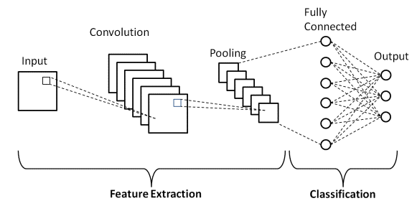

**Fig**

CNN architecture consists of several building blocks, including:

* Convolution layers
* Pooling layers
* Fully connected layers

A typical CNN architecture consists of:

* A stack of several convolution layers
* A pooling layer
* One or more fully connected layers

CNNs transform 3-dimensional image volumes into 3-dimensional output volumes. They extract features from images and convert them into lower dimensions without losing their characteristics.

1. **REQUIREMENTS**
   1. **Functional Requirements:**
      1. **Image Upload and Processing:**

The system shall allow users to upload two signature images, one genuine and one suspected forged, for analysis. It shall process the uploaded images to prepare them for model inference, including resizing, normalization, and format conversion.

* + 1. **Signature Forgery Detection:**

The system shall utilize a deep learning model to perform signature forgery detection based on stroke patterns, length, continuity, and thickness. It shall provide real-time classification results, indicating whether the signatures are genuine or forged.

* + 1. **Model Persistence:**

The system shall support the saving and loading of model weights, allowing for model persistence across multiple sessions.

* + 1. **Web Interface:**

The system shall provide a user-friendly web interface using the Flask framework, enabling users to interact with the model.

* + 1. **User Feedback:**

It shall include features for users to provide feedback on the model's predictions, contributing to continuous model improvement.

* + 1. **Security Measures:**

The system shall ensure secure handling of uploaded images and model weights, protecting user data and system integrity.

* 1. **Non-Functional Requirements:**
     1. **Performance:** The system shall demonstrate high performance, including real-time signature forgery detection to ensure responsiveness.
     2. **Accuracy:** The model shall achieve a high accuracy score in signature forgery detection, exceeding a predefined threshold from the existing proposition.
     3. **User Experience:** The web interface shall be user-friendly, ensuring an intuitive and smooth user experience.
     4. **Security:** The system shall implement robust security measures to protect user data and system integrity, meeting industry-standard security practices.
     5. **Scalability:** The system shall be designed for scalability, with optimizations to handle a growing number of users and image verifications.
     6. **Model Persistence:** The system shall provide reliable model persistence features, ensuring that saved models can be loaded without issues.
     7. **Compatibility:** The system shall be compatible with various platforms and browsers, ensuring broad accessibility for users.
     8. **Regulatory Compliance:** The system shall adhere to relevant data protection and privacy regulations, ensuring legal compliance in handling sensitive user data.
     9. **Documentation:** The project shall include comprehensive documentation covering system architecture, usage guidelines, and development notes for future maintenance and improvement.
     10. **Training and Education:** The system shall include educational materials and support for users to understand and effectively use the signature forgery detection system.

These functional and non-functional requirements provide a comprehensive framework for the design, development, and deployment of a signature forgery detection system, ensuring that it meets user needs while maintaining high standards of performance, security, and compliance.

1. **SYSTEM DESIGN**
   * 1. **Convolutional Neural Network (CNN):** A Convolutional Neural Network (CNN) is a type of artificial neural network that is especially effective for image processing, pattern recognition, and other tasks that can benefit from considering the spatial relationships between pixels.

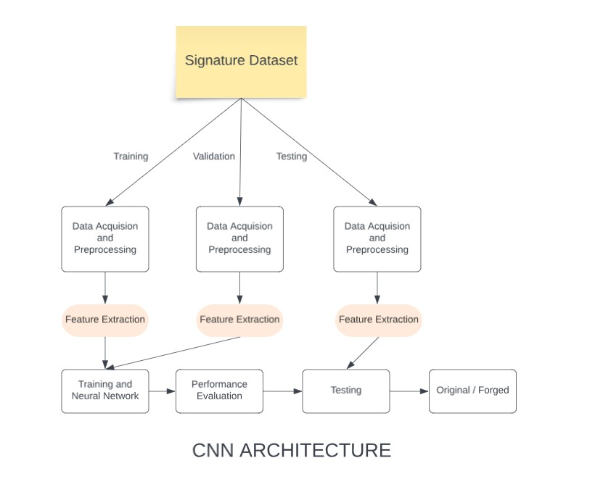

**Fig**

* + 1. **Data Acquisition and Preprocessing:** This is the first step where the signature dataset is collected. The data might need to be preprocessed to make it suitable for the CNN. Preprocessing could involve resizing the images, converting them to grayscale, or normalizing them.
    2. **Feature Extraction:** In this step, the CNN begins to extract features from the preprocessed images. The features could be various aspects of the signatures such as stroke patterns, length, continuity, and thickness.
    3. **Convolution Layer:** The convolution layer applies various filters to the input image to create a feature map. This helps in preserving the spatial relationship between pixels.
    4. **ReLU Layer:** The Rectified Linear Unit (ReLU) layer applies the non-linear function max (0,x) to all inputs. This introduces non-linearity to the CNN, allowing it to learn from the complex patterns in data.
    5. **Pooling Layer:** The pooling layer reduces the spatial size of the feature map, keeping the most important information intact. This helps in reducing computational complexity and controlling over fitting.
    6. **Fully Connected Layer:** In this layer, neurons have full connections to all activations in the previous layer. It’s used for learning non-linear combinations of high-level features as represented by the output of the convolutional layer and max-pooling layer.
    7. **Training and Neural Network:** The CNN is trained using back propagation and a suitable optimization algorithm like Adam or SGD. The aim is to adjust the weights in the network to minimize the difference between the predicted and actual outputs.
    8. **Performance Evaluation:** After training, the performance of the model is evaluated using suitable metrics like accuracy, precision, recall, or F1-score.
    9. **Testing:** Finally, the trained model is tested on unseen data. If it performs well, it can be deployed for real-world signature forgery detection.

**7.2 ACTIVITY DIAGRAM**

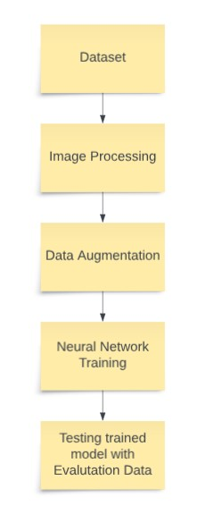

**Fig**

The steps involved in the machine learning process as depicted in the figure:

* + 1. **Dataset:** This is the first step where you gather a dataset of images that will be used to train the model. The dataset should be diverse and representative of the problem you’re trying to solve.
    2. **Image Processing:** The images in the dataset are processed to make them suitable for the model. This could involve resizing the images, converting them to grayscale, or normalizing them.
    3. **Data Augmentation:** The dataset is augmented to increase the number of images and improve the model’s performance. Data augmentation techniques can include rotation, scaling, flipping, or cropping of images.
    4. **Neural Network Training:** The model is trained using a neural network. This involves feeding the processed and augmented images through the network, adjusting the network’s weights based on the error of its predictions, and repeating this process for a number of iterations.
    5. **Testing trained model with Evaluation Data:** The final step is to test the trained model with evaluation data that it has never seen before. This gives an indication of how well the model will perform on real-world data.

1. **DATA SET:**

The CEDAR Signature Dataset is a database of offline signatures used for signature verification. Here are some key details about this dataset:

- The dataset consists of signatures from **55 individuals**.

- Each individual contributed **24 genuine signatures, creating a total of 1,320 genuine signatures**.

- Some individuals were asked to forge three other writers’ signatures, eight times per subject, thus creating **1,320 forgeries**.

- Each signature was scanned at **300 dpi grayscale** and binarized using a grayscale histogram.

- Salt pepper noise removal and slant normalization were two steps involved in image preprocessing.

- The database has **24 genuine and 24 forged signatures** available for each writer.

This dataset is widely used in research for developing and benchmarking signature verification algorithms. It provides a diverse set of genuine and forged signatures, making it suitable for training robust machine learning models for signature verification.

Source/github links for the dataset:

1. CEDAR Signature Dataset:  
   <https://paperswithcode.com/dataset/cedar-signature>
2. CEDAR Signature Verification - University at Buffalo. <https://cedar.buffalo.edu/signature/>
3. **OVERVIEW OF TECHNOLOGY**

The following are the python modules, we used during the development of our project to detect signature forgery.

* 1. **PYTHON**

Python is an interpreted, object-oriented, high-level programming language with dynamic semantics. Its high-level built-in data structures, combined with dynamic typing and dynamic binding, make it very attractive for Rapid Application Development, as well as for use as a scripting or glue language to connect existing components together. Python's simple, easy to learn syntax emphasizes readability and therefore reduces the cost of program maintenance. Python supports modules and packages, which encourages program modularity and code reuse. The Python interpreter and the extensive standard library are available in source or binary form without charge for all major platforms, and can be freely distributed.

Often, programmers fall in love with Python because of the increased productivity it provides. Since there is no compilation step, the edit-test-debug cycle is incredibly fast. Debugging Python programs is easy: a bug or bad input will never cause a segmentation fault. Instead, when the interpreter discovers an error, it raises an exception. When the program doesn't catch the exception, the interpreter prints a stack trace. A source level debugger allows inspection of local and global variables, evaluation of arbitrary expressions, setting breakpoints, stepping through the code a line at a time, and so on. The debugger is written in Python itself, testifying to Python's introspective power. On the other hand, often the quickest way to debug a program is to add a few print statements to the source: the fast edit-test debug cycle makes this simple approach very effective.

Python has various libraries to help people working on these aspects such as MDP, a collection of supervised and unsupervised learning algorithms. Some of the other libraries include imply, scikit learn, Tensor flow, Keras.

1. **IMPLEMENTATION**

The main aim of our project is Signature forgery detection .Signature forgery detection is a critical application in various fields, such as document verification, financial transactions, and access control, where the authenticity of a person’s signature plays a crucial role. Convolutional Neural Networks (CNNs), a subset of deep learning, have shown remarkable capabilities in image classification tasks, making them a suitable choice for signature forgery detection. This essay outlines the key steps involved in the implementation of a signature forgery detection system using CNNs.

There are six packages from python programming which are used in this project they are:

* + 1. **NumPy:**

NumPy is a Python package which stands for 'Numerical Python'. It is a library consisting of multidimensional array objects and a collection of routines for processing of arrays.

* + 1. **Pandas:**

Fast and efficient Data Frame object with default and customized indexing. Tools for loading data into in-memory data objects from different file formats. Data alignment and integrated handling of missing data. Reshaping and pivoting of date sets.

* + 1. **Matplotlib:**

This package is used for the mathematical operation in python

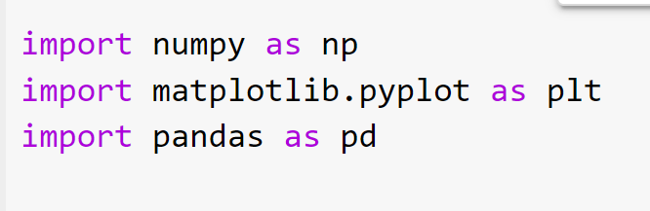

Fig

* + 1. **Flask**:

Flask is a Python web framework that can be used to build web applications, including those with machine learning models. You can use Flask to create a web-based user interface for your signature forgery detection system.

* + 1. **Pillow (PIL):**

Pillow is a Python Imaging Library that allows you to work with images, making it a valuable tool for image preprocessing and handling in your project.

* + 1. **PyTorch**:

PyTorch is a deep learning framework that can be used to train, load, and run deep neural networks, including your CNN-based signature forgery detection model.

1. **Requirements Installation:**

We have included a file “requirements.txt” which can be used to install all the pre-requisites with a single command “pip install -r requirements.txt”

Flask==3.0.0

Matplotlib==3.6.3

Numpy==1.24.1

Pandas==1.5.2

Pillow==8.4.0

Pillow==10.1.0

Torch==2.0.1

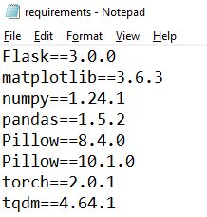

**Fig**



**Fig**

* 1. **Coding Snapshots:**

The following code snapshots showcases the implementation of a web-based signature forgery detection system using Flask, Pillow, and PyTorch. The system allows users to upload two signature images, one genuine and one suspected to be forged, and provides real time classification result.

* + 1. **app.py**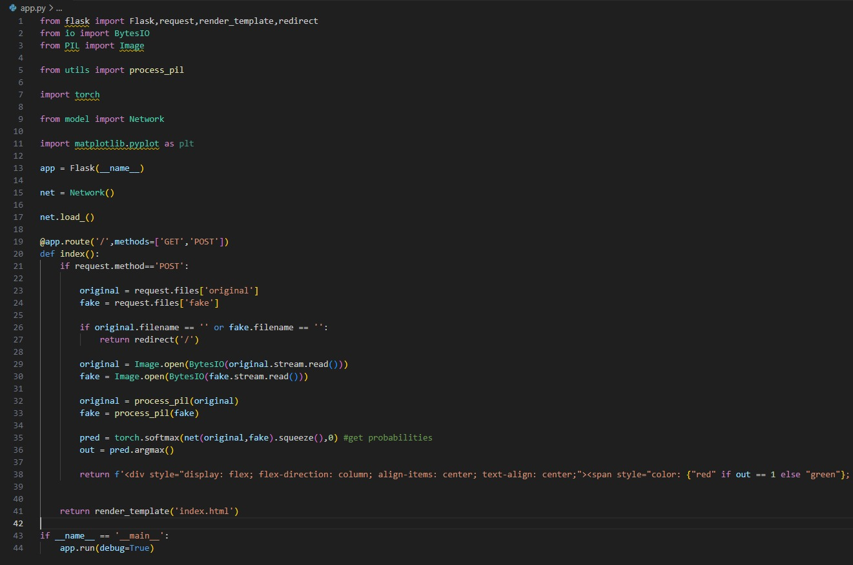

**Fig**

This code snapshot showcases the implementation of a web-based signature forgery detection system using Flask, Pillow, and PyTorch. The system allows users to upload two signature images, one genuine and one suspected to be forged, and provides a real-time classification result, below is the HTML Output.

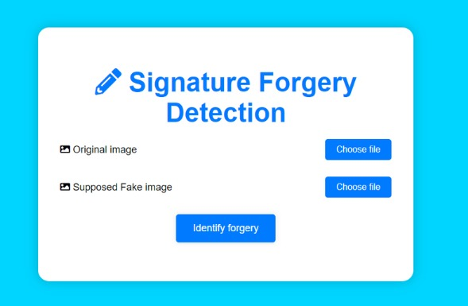

* + 1. **data.py**

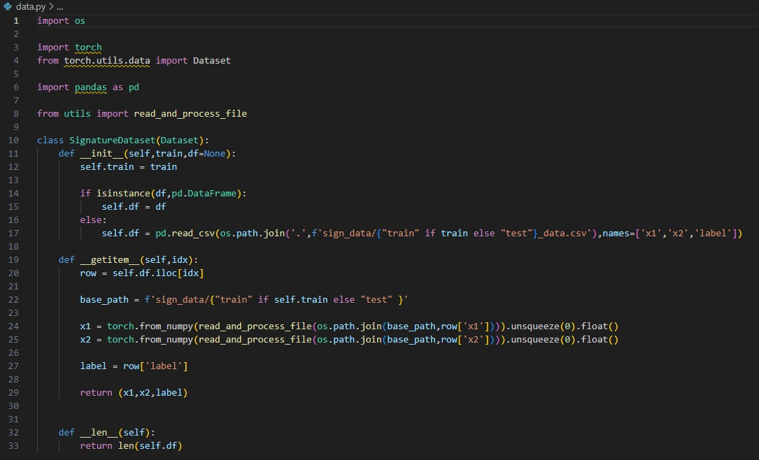

**Fig**

The Signature Dataset class plays a pivotal role in the "Signature Forgery Detection using CNN" project by providing a structured and efficient way to manage and access the signature data. This custom dataset class is designed for both training and testing phases, offering flexibility and versatility. It seamlessly handles the loading of signature pairs and their corresponding labels from CSV files, providing data in a format suitable for feeding into the neural network. In doing so, it ensures that the CNN model receives properly preprocessed image data, allowing for effective signature forgery detection. This dataset class serves as a critical bridge between the raw data and the machine learning model, contributing significantly to the success of the project.

* + 1. **utils.py**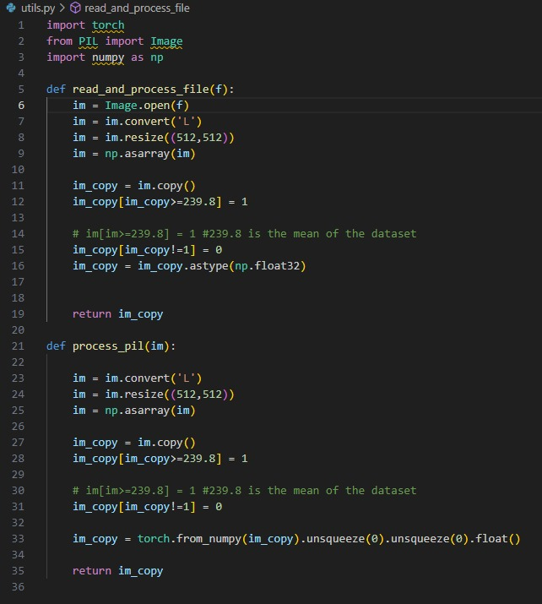

**Fig**

To run the application run the app.py which will activate flask and run the backend using command prompt or the windows shell and prompt you with a IP address which will redirect you to the application

* 1. **TRAINING AND TESTING:**
     1. **getDataStats.py**

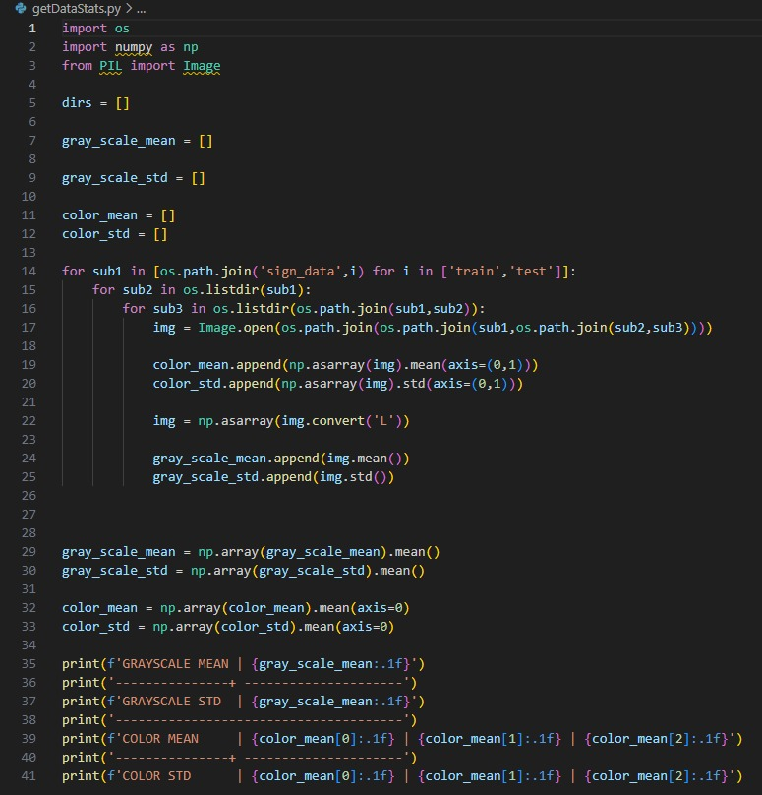

**Fig**

It gives you the stats of the model color conversion rate as below:

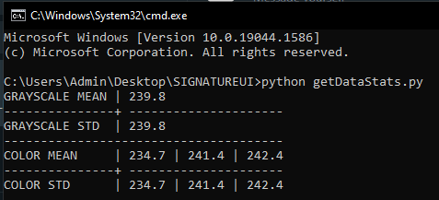

* + 1. **model.py**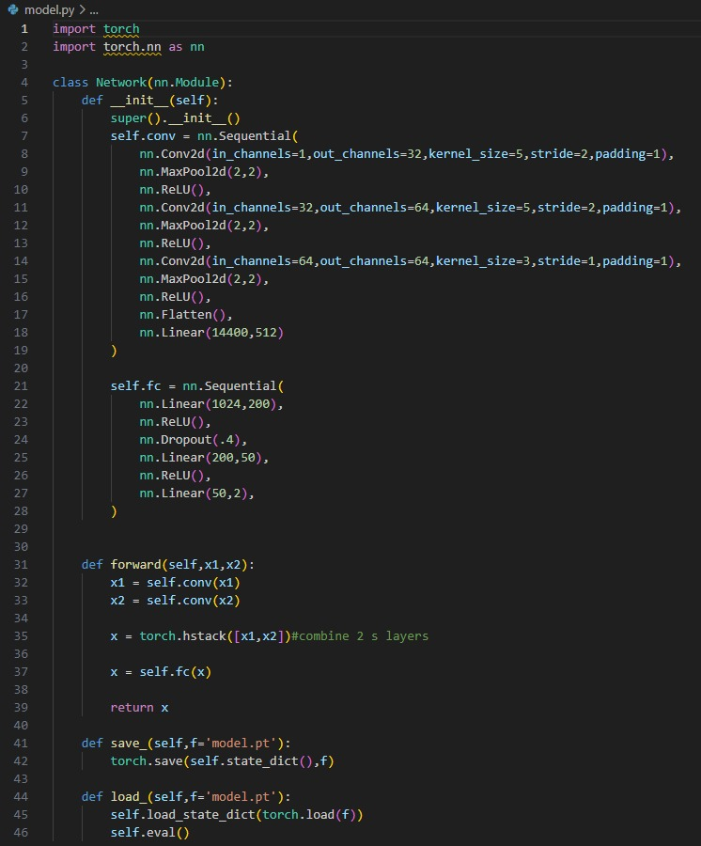

**Fig**

**12. Conclusion**

In this documentation, we have presented a comprehensive overview of our project, "Signature Forgery Detection using Convolutional Neural Networks (CNN)." The project aims to provide an automated and reliable solution for distinguishing between genuine and forged signatures based on stroke patterns, length, continuity, and thickness. By integrating the Flask web framework, Pillow for image processing, and PyTorch for deep learning, we have developed a functional system that allows users to upload signature images and receive real-time classification results.

**12.1 Future Enhancements:**

In mapping out the future of our 'Signature Forgery Detection using CNN' project, we envisage several key enhancements that will bolster its capabilities and relevance. First and foremost, we are considering the implementation of a more interactive and user-friendly web interface. This interface will serve as a user portal, facilitating seamless interactions for individuals seeking to verify signatures, such as banking professionals, legal experts, or document reviewers. It will offer intuitive features for uploading, analyzing, and receiving instant forgery detection results, enhancing the overall user experience.

To further refine the system's capabilities, we are exploring a move towards decentralized governance. This shift from a single admin entity to a decentralized model will enable multiple authorized entities to collectively manage access and control over the system. This enhancement will not only improve security but also distribute responsibilities, reducing potential risks associated with a centralized control point.

In terms of bolstering security and verification, we are considering the integration of advanced identity verification methods, such as biometric verification or multi-factor authentication. By adding these layers of authentication, we can enhance the confidence in the system's signature forgery detection capabilities, making it more robust in various real-world applications.

Additionally, we are researching options to extend the system's functionality by offering multi-modal verification. This approach would enable the system to verify signatures through various means, such as comparing them with a pre-registered reference signature, enhancing the adaptability of the system in different contexts.

Ensuring scalability is a paramount concern. As we anticipate the system's use in various applications, we are exploring optimizations in the underlying architecture and algorithms to ensure that the system can handle a growing volume of signature verifications without compromising performance.

Lastly, we are considering the implementation of comprehensive user education programs. These programs will aim to provide users, including signature analysts, forensic experts, and document examiners, with the necessary training and support to maximize the system's potential and to ensure its effective integration into their workflow.

These envisioned enhancements collectively represent our commitment to advancing the system's functionality, usability, and security, aligning it with evolving technological trends and user expectations in the field of signature forgery detection.

**13. References**

[1] L. &. R. D. &. S. R. &. G. E. &. M. P. Batista, "State of the art in offline signature verification," Pattern Recognition Technologies and Applications: Recent Advances,

[2] P. K. Y. K. R. K. B. V. K. R. a. P. L. M. Ramachandra A C, "CrossValidation for Graph Matching based Offline Signature Verification," India Conference INDICON 2008, 2008.

[3] B. S. K. T. a. B. D., "Features Extraction and Verification of Signature Image using Clustering Technique," International Journal of Smart Home, pp. 113-116, 2010.

[4] B. H. a. P. N. 2001, "A new signature verification technique based on a two-staged neural network classifier," Engineering Applications of Artificial Intelligence.

[5] E. &. Ş. T. &. K. M. Özgündüz, "Offline Signature Verification and Recognition by Support Vector Machine,".

[6] H. B. ,. &. d. P. J. Coetzer J., "Off-line signature verification using the discrete radon transform and a hidden Markov model," URASIP Journal on Applied Signal Processing, 2004.

[7] N. W. S. S. S. M. J. C. Kyle Martin, "A Convolutional Siamese Network for Developing Similarity Knowledge in the Self BACK Dataset," ICCBR 2017, 2017.

[8] Y. Q. B. R.Hunt, "Signature verification using global and grid features," Pattern Recognition, pp. 1621-1629, 1994.

[9] A. D. J. I. T. S. K. J. L. U. P. Sounak Deya, "SigNet: Convolutional Siamese Network for Writer Independent Offline Signature Verification," Pattern Recognition Letters, 2017.

[10] A. A. S. Shruti Jadon, "Siamese Networks for One Shot Learning using Kernel Based Activation functions," Easy Chair Preprint, 2019.

[11] L. B. B. L. Alexander Hermans, "In Defense of the Triplet Loss for Person Re-Identification," Computer Vision and Pattern Recognition, 2017.

[12] D. K. J. P. Florian Schroff, "FaceNet: A Unified Embedding for Face Recognition and Clustering," IEEE Conference on Computer Vision and Pattern Recognition (CVPR), 2015.