Shell script 프로그래밍

학번 : 20223068 이름 : 김지유

# ex3-0.sh

(코드)

#!/bin/bash

echo hello world

exit 0

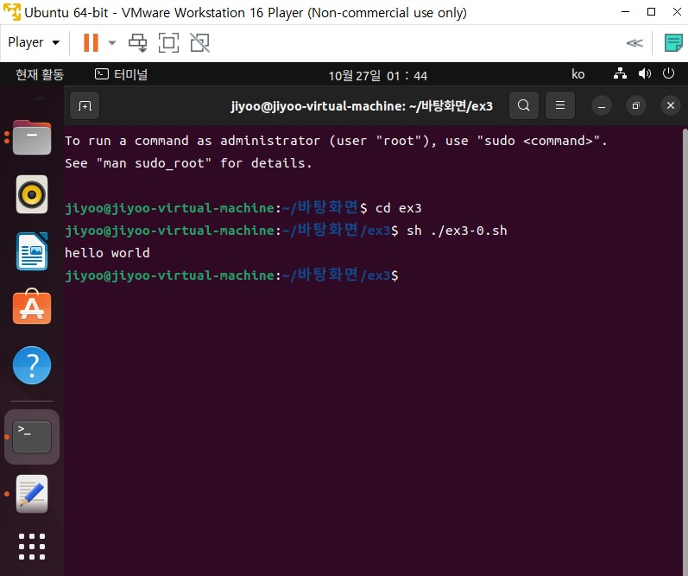

# ex3-1.sh

(코드)

#!/bin/sh

time=$1

i=0

while [ "$i" -lt "$time" ]

do

i=$(expr $i + 1)

echo "hello world"

done

exit 0

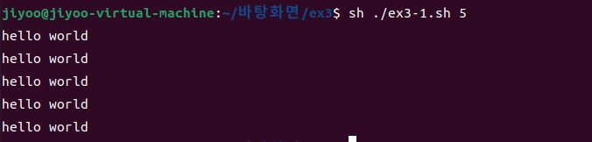

# ex3-2.sh

(코드)

#!/bin/sh

x=$1

op=$2

y=$3

cal=`expr $x $op $y`

echo $cal

exit 0

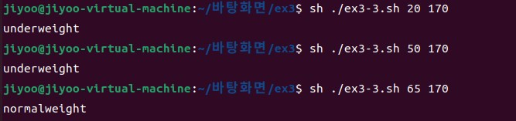

# ex3-3.sh

(코드)

#1/bin/sh

w=$1

h=$2

hh=$( echo "scale=1; $h / 100" |bc )

bmi=$( echo "scale=1; $w / $hh / $hh" |bc )

if [ `echo "$bmi < 18.5" | bc` -eq 1 ]

then

echo "underweight"

else

if [ `echo "$bmi <= 23" | bc` -eq 1 ]

then

echo "normalweight"

else

echo "overweight"

fi

fi

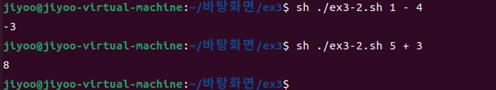

# ex3-4.sh

(코드)

#!/bin/sh

echo "linux is fun? (yes/no)"

read answer

case $answer in

yes | y | Y | Yes | YES)

echo "yes" ;;

[Nn]*)

echo "no" ;;

*)

echo "enter yes or no"

exit 1 ;;

esac

exit 0

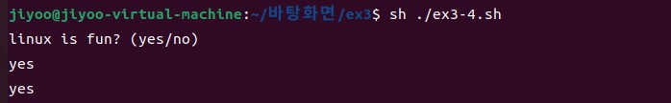

# ex3-5.sh

(코드)

#!/bin/sh

echo "start program"

func(){

echo "entered the func"

if [ $# -eq 1 ]

then

$1

else

$1 $2

fi

return

}

if [ $# -eq 0 ]

then

func ls

else

func ls $1

fi

echo "exit the program"

exit 0

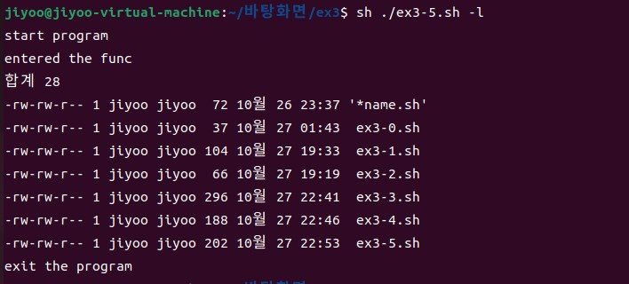

# ex3-6.sh

(코드)

#!/bin/sh

t=$1

echo "file0.txt file1.txt file2.txt file3.txt file4.txt files.tar"

echo "file0.txt"

echo "file1.txt"

echo "file2.txt"

echo "file3.txt"

echo "file4.txt"

eval mkdir $t

eval touch file0.txt

eval touch file1.txt

eval touch file2.txt

eval touch file3.txt

eval touch file4.txt

tar -cvf files.tar $t

mv files.tar $t

mv file0.txt $t

mv file1.txt $t

mv file2.txt $t

mv file3.txt $t

mv file4.txt $t

exit 0

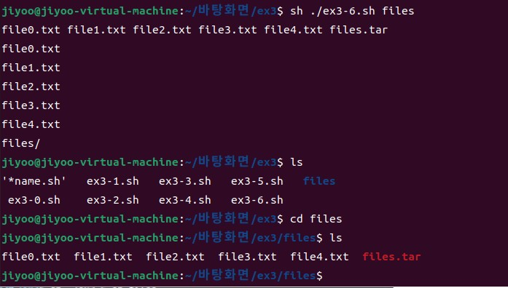

# ex3-7.sh

(코드)

#!/bin/sh

if [ ! -d $1 ]

then

mkdir $1

fi

for i in 0 1 2 3 4

do

mkdir $1/file$i

touch $1/file$i.txt

ln -s file$i.txt $1/file$i/file$i.txt

done

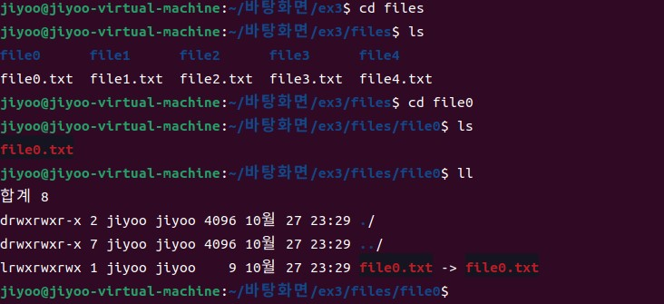

# ex3-8.sh

(코드)

#!/bin/sh

echo "$1 $2" >> DB.txt

exit 0

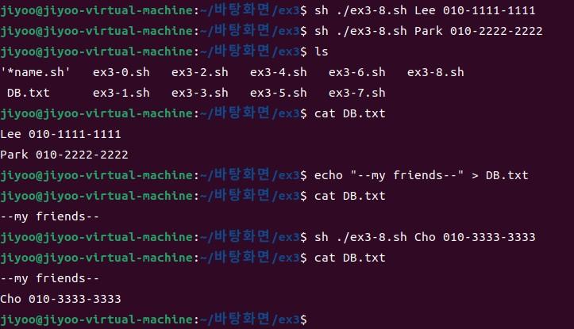

# ex3-9.sh

(코드)

#!/bin/sh

grep -r $1 ./DB.txt

exit 0

