Predicting CO₂ Emissions from Cattle-Driven Deforestation in the Amazon Rainforest Using Machine Learning

Carlos Daniel Ambrosio & Suelen Rocha

A Report Submitted in Partial Fulfilment
of the requirements for the
Degree of
BSc in Computing in IT (4th year)



May 2026

Supervisor: Muhammad

Table of Contents
Terminology 6
Introduction 7
1.CRISP-DM stage one – business understanding 8
1.1 Business objectives 8
1.1.1 Objectives 8
1.1.2 Who would use our system? 8
1.1.3 why 8
1.2 Project Plan 9
1.3 Business Success Criteria 9
1.4 What competitive advantage it gives 9
2. Assess Situation 10
2.1 Inventory of Resources 10
2.2 External Factors using PEST Analysis 10
2.2.1 Pest Analysis 10
2.2.2 Political Factors 10
2.2.3 Economic Factors 11
2.2.4 Social Factors 12
2.2.5 Technological Factors 12
2.3 Requirements, Assumptions and Constraints 13
2.4 Risks and Contingencies 13
2.6 Costs and benefits 13
3.Data mining/ Machine Learning goals 14
2 .CRISP-DM stage two – data understanding 14
2.1 Dataset Formats and problems encountered 14
2.2 Data description report 15
2.2.3 Other surface features 15
2.3 Data exploration report 16
2.4 Data Quality Report 20
3. CRISP-DM stage three – data preparation 21
3.1 – Data Cleaning 21
3.1.1 – Missing Values 21
3.1.2 – Invalid Entries 22
3.1.3- Removing Unnecessary columns 22
3.1.4 – Label encoding 22
4. CRISP-DM stage four – Modelling 23
4.1 – Modelling Technique 23
4.2 - Test design 23
4.3 – Build Model 24
4.3.1 - K-Nearest Neighbours Regressor (KNN) 24
4.3.2 - Random Forest Regressor 25
4.3.3 – Partial Least Squares Regressor(PLS) 26
4.4 Model Assessment and Parameter Settings 26
5. CRISP-DM stage five – Evaluation 27
5.1 – Evaluate Results 27
5.1.1 – Metrics 27
5.1.2 Comparing Results 28
5.2 Evaluation of Initial Business Objectives 30
5.3 Final Model Selection 30
6. CRISP-DM stage six – Deployment 31
6. References 33

Table of Figures
Figure 1-Filtering the dataset to include only Amazon biome records. 16
Figure 2-Shape of the filtered beef dataset containing 839,727 rows and 26 columns. 16
Figure 3-Description of the variables and units included in the beef dataset. 17
Figure 4-Histograms showing the distribution of numerical variables in the beef_amazon dataset. 18
Figure 5-Boxplots showing the spread and potential extreme values of the numerical variables in the beef dataset. 19
Figure 6-Scatter plot matrix showing relationships between the main numerical variables in the beef dataset. 20
Figure 7-Aggregated yearly FOB values and net CO₂ emissions from cattle-driven deforestation in the beef dataset. 21
Figure 8-Missing values in the beef dataset. 23
Figure 9-Cleaning invalid characters from the importer column. 24
Figure 10-Removing unnecessary columns from the beef dataset before modelling. 24
Figure 11-Formula for Euclidean distance (GeeksforGeeks, 2020) 26
Figure 12-Formula for Manhattan distance 27
Figure 13-Formula for Minkowski distance 27
Figure 14- Formula for the R² score used to evaluate model performance. 30
Figure 15-Formula for Mean Absolute Error (MAE) used to measure prediction error 30

Terminology
ANPD – National Data Protection Authority
CO2 – Carbon Dioxide
CSRD – Corporate Sustainability Reporting Directive
DETER – Real-Time Deforestation Detection System
DETEX – Selective Logged Area
EDA – Exploratory Data Analysis
ESG – Environmental, Social, and Governance
EUDR – European Union Deforestation Regulation
GDPR – General Data Protection Regulation
GIS – Geographic Information Systems
IBAMA – Brazilian Institute of Environment and Renewable Natural Resources
IBGE – Brazilian Institute of Geography and Statistics
ICMBio – Chico Mendes Institute for Biodiversity Conservation
INPE – National Institute for Space Research
IQR – Interquartile Range
JBS – José Batista Sobrinho – Brazilian multinational meat company
KNN – K-Nearest Neighbors
MAE – Mean Absolute Error
MCTI – Ministry of Science, Technology and Innovation
NFT – Non-Fungible Token
PEST – Political, Economical, Social and Technological
PLSR – Partial Least Squares Regression
PRODES – Program for the Calculation of Deforestation in the Legal Amazon
RF – Random Forest
TRASE – Transparency for Sustainable Economies
UAVs – Unmanned Aerial Vehicles

Introduction
Deforestation has become a major environmental issue worldwide, especially in the Amazon Rainforest, which is known as one of the world’s largest carbon sinks. This region has been significantly impacted by cattle farming, contributing to increased CO₂ emissions and land degradation. As Brazil is one of the world’s largest beef producers and exporters, the environmental impact of livestock production has attracted increasing attention from organisations, governments, and sustainability analysts.
This project aims to analyse the relationship between cattle farming, deforestation, and CO₂ emissions in the Amazon using Machine Learning techniques. Using the CRISP-DM framework, the project explored each stage of the process, starting with business understanding, followed by data understanding, data preparation, modelling, evaluation, and deployment.
During the exploratory data analysis phase, the dataset was analysed using histograms, scatter plots, boxplots, and correlation analysis to better understand the distribution of the variables, identify outliers, examine relationships between features, and detect issues such as skewness and multicollinearity. The analysis showed that the dataset contains highly skewed distributions, extreme values, correlated variables, and missing data, which required careful preprocessing before modelling.
Numerous data preparation techniques were applied, including missing value handling, removal of invalid entries, label encoding, and removal of unnecessary columns. Three different approaches for handling missing values were tested: dropping missing values, median imputation, and model-based imputation.
Four machine learning models were developed and compared: K-Nearest Neighbours Regressor (KNN), Random Forest Regressor, Partial Least Squares Regressor (PLS) and Linear Regression. Feature scaling and PCA were applied to some models. Different hyperparameters were tested using GridSearchCV, and the models were evaluated using metrics such as R² score, Mean Absolute Error (MAE), and cross-validation. Particular attention was given to how correlated features and preprocessing techniques affected model performance and generalisation.

1. CRISP-DM stage one – business understanding

1.1 Business objectives

1.1.1 Objectives
This project aims to analyse livestock farming, Amazon deforestation, and CO₂ emissions by developing a predictive model using Machine Learning that estimates the environmental impact of meat production in the Amazon.
Due to climate change, the world is experiencing severe environmental impacts, including flooding, melting ice caps, rising temperatures, land degradation, and the loss of wildlife and biodiversity.
The Amazon Rainforest is the largest tropical forest and one of the most biodiverse ecosystems. It plays a vital role in absorbing around 200+ billion tons of carbon, regulating the climate, and maintaining global rainfall patterns. (WWF, 2024). Due to deforestation in the Amazon, driven by activities such as livestock farming, mining, and soy production, the region is experiencing significant carbon loss. In particular, meat production contributes heavily to this impact, leading to substantial CO₂ emissions and accelerating climate change.
Below are the main questions this project aims to answer:
- How does cattle farming contribute to deforestation in the Amazon?
- What is the relationship between deforestation and CO₂ emissions?
- Can predictive models help organisations anticipate environmental risks?

How accurately can regression models predict CO2 emissions from cattle-driven deforestation in the Amazon rainforest?
Which machine learning model provides the most reliable predictions for CO₂ emissions in the Amazon region?

1.1.2 Who would use our system?
The system would be used by Investors, ESG (Environment, Social and Governance) Analysts, Government agencies, Policymakers, Researchers, Sustainability Analysts and Supply chain Companies. (ESG, 2025)

1.1.3 Why?
The System would be used to understand and predict CO2 emissions caused by cattle-driven deforestation. Enabling understanding of how livestock growth affects the Amazon Forest, resulting in better decision-making for sustainability planning and environmental monitoring.

1.2 Project Plan
- Business Understanding: Define the business goals, assess the current situation, and data mining goals.
- Data Understanding: Data collection from TerraBrasilis, TRASE, and INPE
- Data Preparation: Data cleaning and preprocessing, Data integration from multiple sources (if necessary).
- Modelling: Design a machine learning model for predicting CO2 emissions caused by cattle production.
- Evaluation: Evaluate the model’s performance by measuring prediction correctness and validating whether the results are reliable and useful for decision-making.
- Deployment: Deploy a model that presents results to stakeholders for sustainable decision-making.

Tools and Techniques
- Jupyter Notebook, Python
- Python Libraries (pandas, NumPy, matplotlib, scikit-learn, seaborn, plotly, geopandas)
- Machine Learning (Linear Regression, K-Nearest Neighbour regressor, Random Forest regressor, Partial Least Squares regressor)

1.3 Business Success Criteria
The model should demonstrate accurate predictions of CO₂ emissions based on livestock and deforestation data, provide useful insights for policymakers, ESG analysts, and organisations, support compliance with environmental regulations such as EUDR, and improve understanding of environmental risks in supply chains.

1.4 What competitive advantage does it give?
This section highlights the solution’s competitive advantage. It explains how this predictive model can enable better risk management, compliance, and sustainability decisions compared to existing tools.
Environmental regulations and sustainability standards highlight the importance of monitoring land-use impacts and the need for predictive analytics tools to evaluate risks in livestock supply chains. The advantage of this system compared to existing monitoring tools is its predictive capability. While many current technologies mainly detect deforestation after it occurs, this system focuses on predicting CO₂ emissions linked to cattle-driven deforestation. By analysing these emissions, the system helps organisations understand risks and make more informed decisions about their supply chains and sustainability strategies. This solution would help organisations identify risks earlier, stay aligned with regulations and market expectations, and avoid penalties or trade restrictions while protecting their reputation. Businesses can improve sustainability reporting, demonstrate responsible practices to investors and regulators, and maintain access to international markets while reducing compliance costs. (Aljohani, 2023)

2. Assess Situation

2.1 Inventory of Resources
This project has been developed by Carlos and Suelen using the Beef Amazon dataset, the Python programming language and the use of its libraries. Using personal computers to handle datasets and train models.

2.2 External Factors using PEST Analysis

2.2.1 Pest Analysis
PEST is a business approach that evaluates 4 different factors: Political, Economic, Social and Technological. Using PEST helps identify and anticipate external factors that may affect the company's long-term performance and align strategies. (Jim Makos, 2020) (Ranjan, 2025) For this project, PEST helps assess the external pressures affecting livestock production and deforestation in the Amazon. These factors highlight the growing need for analytical tools to predict CO₂ emissions from cattle-driven deforestation.

2.2.2 Political Factors
The governance of the Amazon Rainforest is influenced by political factors at both national and international levels. Due to its role in climate regulation and biodiversity conservation, the Amazon has become a central issue in global environmental politics. As a result, governments in Amazon countries face increasing international pressure to reduce deforestation and protect the ecosystem. These pressures can create tensions between global environmental concerns and countries wanting to control natural resources. As a result, regional cooperation and international agreements have been created to coordinate environmental policies in the Amazon. (Paes, 2022).
Furthermore, increasing regulatory pressure, such as the European Union Deforestation Regulation (EUDR), requires companies to ensure that products like beef are not linked to deforestation. Businesses must provide evidence that their supply chains are deforestation-free before exporting products to certain markets (European Commission, 2023).
In addition, companies must improve transparency by tracking the origin of commodities and providing geographic information showing that products were not produced on deforested land. (O’Brien, 2025). Environmental reporting policies such as the Corporate Sustainability Reporting Directive (CSRD) also require businesses to disclose environmental impact, including climate-related risks and greenhouse gas emissions. (Duvernay, 2025)

2.2.3 Economic Factors
The increase in global meat consumption affects cattle production by placing pressure on businesses to expand livestock operations. Consequently, this increases pressure in the Amazon. Higher levels of production result in greater deforestation risks, which lead to increased CO₂ emissions.
Livestock production represents an important sector in Brazil. The country has a cattle herd exceeding 200 million animals, making cattle farming a key component of the Brazilian economy and a significant source of employment in rural areas. In addition, Brazil is one of the world’s largest beef producers and exporters, accounting for approximately 27.7% of the global beef export market (Izquierdo and Menghi, 2024). International demand plays a role in the expansion of Brazil’s livestock industry. China, for example, has become the largest importer of Brazilian beef, accounting for 51.3% of the country’s beef exports in 2024. This demand has increased Brazil’s beef export revenues, which reached approximately $11.4 billion between January and September 2024. (Watanabe, 2025)
Companies involved in the livestock supply chain may face financial risks if their operations are linked to deforestation. These companies could lose access to international markets due to environmental regulations. For example, in 2024, JBS, the largest Brazilian meat producer, was fined $64 million due to its involvement in cattle linked to deforestation. Such situations can damage a company’s reputation and create significant financial costs associated with non-compliance. (Jackson, 2025)
Investors evaluate companies based on environmental, social, and governance (ESG) performances in industries linked to climate change and deforestation. (Pinzón et al., 2024) In livestock supply chains, this has increased attention toward companies that operate in the Amazon and created pressure to improve sustainability and transparency. (Berg, 2023)

2.2.4 Social Factors
Brazil has 213.4 million people, according to the Brazilian Institute of Geography and Statistics (IBGE, 2023). Within this population, around 30 million people live in the Amazon region, including approximately 1.5 million Indigenous people. These communities depend on the Amazon forest for food, medicine, shelter, and traditional economic activities such as fishing and agriculture. Indigenous populations lived in the Amazon before the Portuguese arrived in Brazil, developing a strong cultural and environmental connection with the forest. Due to this historical relationship, Indigenous communities play a role in environmental preservation and protection. (Guitarrara, 2022)
However, increasing levels of deforestation have threatened both the economic survival and the cultural traditions of these communities, creating social conflicts related to land use and rural development. Large-scale cattle farming and illegal land occupation have contributed to disputes between farmers, Indigenous and riverine communities, and environmental groups. Consequently, the expansion of livestock production in the Amazon is not only an environmental issue but also a social challenge that affects local populations and community stability. (Amazon Anonymous Society, 2023). The Amazon Rainforest plays a critical role in the global climate system, acting as one of the largest carbon sinks, which affects Brazilian communities and the global population (Chambers, 2023).

2.2.5 Technological Factors
The Amazon Rainforest, covering 6.7 million km² across nine countries, is monitored using advanced technologies due to its environmental importance. 61.8% of the forest is in Brazil, in the region known as “Amazônia Legal”, which includes nine states and 772 municipalities. The National Institute for Space Research (INPE), linked to the Ministry of Science, Technology and Innovation (MCTI), operates satellite-based systems such as PRODES, DETER, DEGRAD, and DETEX to monitor deforestation, forest degradation, and illegal activities. Geographic Information Systems (GIS) enable real-time tracking of forest loss, land-use changes, and carbon storage (Fundo Amazônia, 2024).
Drones (UAVs) are used by agencies like IBAMA and ICMBio to capture high-resolution images, detect illegal deforestation, and monitor fires. Bioacoustics sensors and camera traps help track wildlife and identify illegal activities, while artificial intelligence (AI) analyses satellite and drone data for faster and more accurate detection of deforestation and environmental threats. (WWF Brasil, 2024).
Blockchain technology improves supply chain transparency. The startup Btracer developed the Hope Green NFT to track trees and restoration projects, providing secure, real-time records of carbon sequestration and forest conservation efforts. (Observatório Blockchain, 2025). Blockchain also supports compliance with the EU Deforestation Regulation (EUDR) by verifying product origins and ensuring deforestation-free sourcing through immutable records. (Astrakode, 2024)
Despite these technologies, monitoring remains limited in remote areas due to poor infrastructure and high costs, creating challenges for smaller producers implementing sustainable practices and forest surveillance.

2.3 Requirements, Assumptions and Constraints
Requirements:
- Respect data licensing, permission agreements and terms of use
- Compliance with legal and environmental regulations
- The model must produce accurate results
- The project must be completed by May 29th
Assumptions:
- The datasets used are accurate and up-to-date
- There is a measurable relationship between cattle farming, deforestation, and CO₂ emissions
- The data sources are compatible and can be integrated successfully
Constraints:
- Integrating the three datasets
- Data quality issues
- Computational processing complexity

2.4 Risks and Contingencies
Risk 1: Bias in the dataset
Contingency plan: Apply data validation and preprocessing techniques to identify and reduce bias
Risk 2: Difficulty integrating multiple datasets
Contingency plan: To address integration challenges, data preprocessing and standardisation techniques will be applied to ensure consistency across datasets.

2.6 Costs and benefits
There are no direct financial costs associated with this project, as it is conducted for academic purposes. However, indirect costs include time investment, computational resources, and effort required to develop this project.

3. Data mining/ Machine Learning goals
Model success criteria: The model will be considered successful if it minimises prediction error (loss), generalises well to unseen data, and captures key relationships between variables, resulting in accurate and reliable predictions of CO₂ emissions.

2 . CRISP-DM stage two – data understanding
To develop the model, three datasets were initially collected to explore the relationship between deforestation and CO₂ emissions. The data was obtained from publicly available sources, including TerraBrasilis for deforestation monitoring (TerraBrasilis, n.d.), TRASE for livestock production (zu Ermgassen et al., 2023), and INPE for CO₂ emissions data (Crispim and Bezerra, 2019). An exploratory data analysis (EDA) was conducted on all datasets; however, integrating them was not suitable for the scope of this project.
The primary objective is to predict CO₂ emissions specifically associated with meat production. While the deforestation and CO₂ datasets provide aggregate values from multiple sources, they do not isolate emissions or deforestation caused by cattle-related activities. Including these variables would introduce noise and reduce the relevance of the model. In contrast, the Beef_amazon dataset contains targeted features directly linked to cattle-driven deforestation and emissions. Therefore, only this dataset was selected for further analysis.

2.1 Dataset Formats and Problems Encountered
1- The beef_amazon dataset was provided in CSV format. For this project, the dataset was filtered to include only records from the Amazon region, as this is the focus of the analysis.
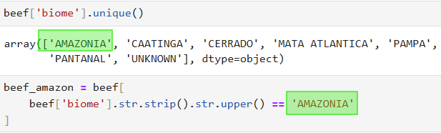

Figure 1-Filtering the dataset to include only Amazon biome records.

2.2 Data description report

Number of records
The number of records in the beef_amazon dataset is 839,727 rows and 26 columns.
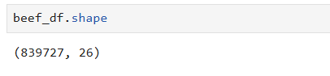

Figure 2-Shape of the filtered beef dataset containing 839,727 rows and 26 columns.

Identity of the fields
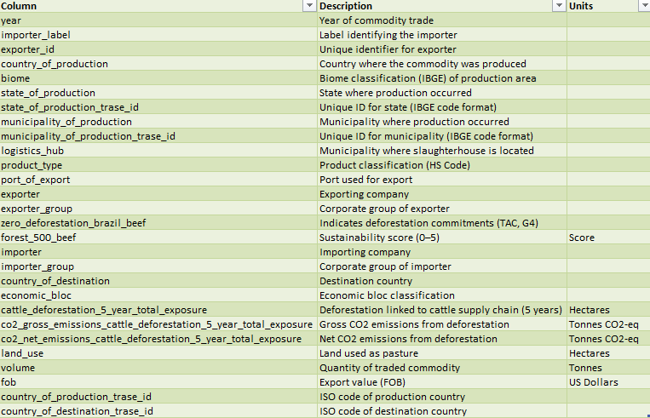
The beef_amazon dataset includes variables related to production, trade, and environmental impact. It contains geographic, economic, and sustainability fields, with a strong focus on deforestation and CO₂ emissions linked to meat production.
Figure 3-Description of the variables and units included in the beef dataset.

2.2.3 Other surface features
Other surface features of the beef_amazon dataset include a combination of numeric and categorical variables, with most fields stored as categorical (object) types and key variables such as deforestation exposure and CO₂ emissions represented as numeric (float64) values.

2.3 Data exploration report

Distribution of the Data
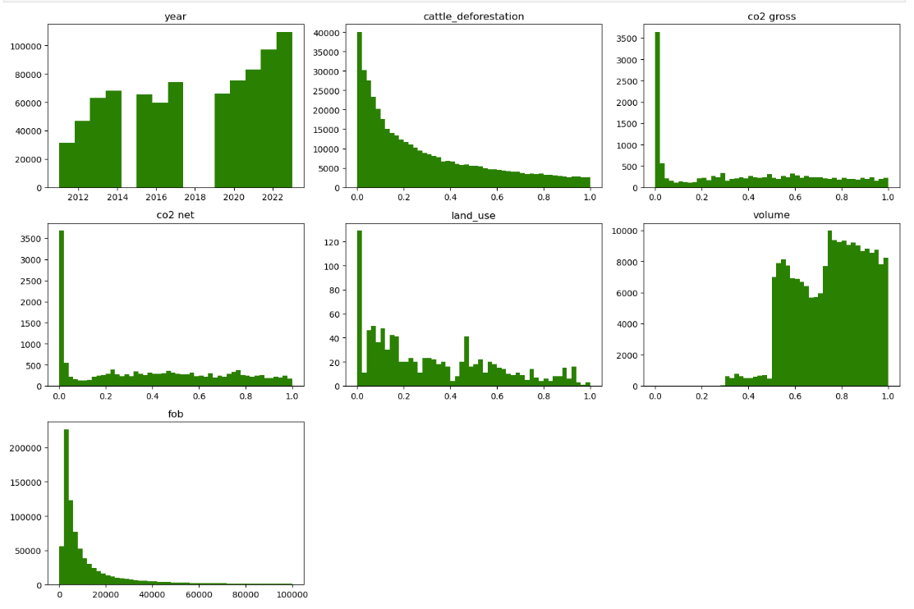
Histograms were used to examine the distribution of numerical variables in the beef_amazon dataset. Most variables, including CO₂ emissions, cattle deforestation, land use, and FOB values, exhibit strong right-skewness, with most observations concentrated at lower values and a long tail extending toward higher values. Scatter plots further showed that while most observations are grouped near lower values, a smaller number of observations are spread far from the main cluster, suggesting high variability and potential extreme values within the dataset. The year variable shows a more distributed pattern across different years, while volume contains most observations between 0.5 and 1. In contrast, variables such as cattle_deforestation, co2 gross, co2 net, land_use, and fob are highly right-skewed, with most values concentrated near zero and a smaller number of higher values. Overall, these patterns indicate significant skewness within the dataset, which should be considered during preprocessing and modelling.
Figure 4-Histograms showing the distribution of numerical variables in the beef_amazon dataset.

Checking for outliers
Boxplots were used to analyse the spread of numeric variables in the beef_amazon dataset. Most observations are concentrated near zero, while a small number of values extend to very high ranges. These extreme values are particularly noticeable for FOB (above 15 million), CO₂ emissions (above 4 million). This large gap between typical values and extreme observations indicates strong skewness and the presence of significant outliers in the dataset, which may impact the modelling phase, but some models are resistant to outliers, and others may need feature scaling.
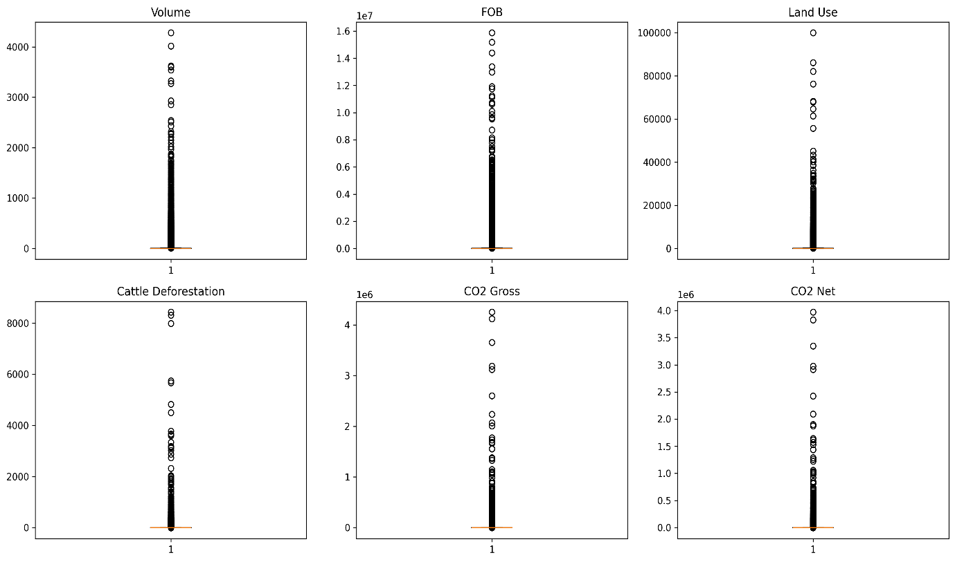
Figure 5-Boxplots showing the spread and potential extreme values of the numerical variables in the beef dataset.

Relationship between variables
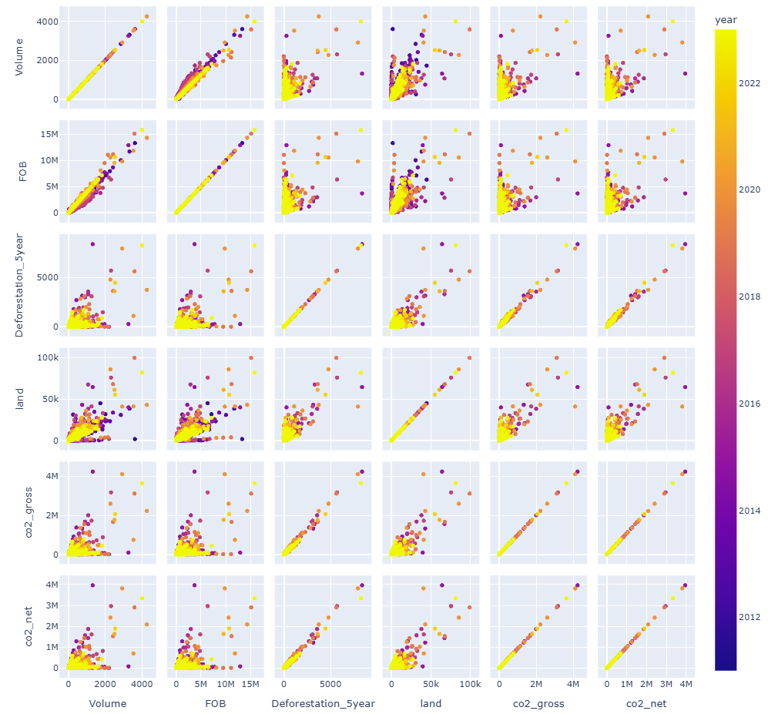
The scatter matrix reveals a strong linear relationship between CO₂ gross and CO₂ net emissions, indicating a high level of correlation between these variables. This suggests potential redundancy and may introduce multicollinearity (Fatima, 2024). FOB and Volume show a strong positive correlation with a clear linear trend, while the other variables are more scattered, suggesting weaker relationships between them. This graph helps in selecting appropriate algorithms, since some models are affected by correlated features, while others can handle them without issues.
Figure 6-Scatter plot matrix showing relationships between the main numerical variables in the beef dataset.

Simple aggregations
Simple aggregations were used to analyse trends over time in the Beef_amazon dataset. FOB values show an overall increase, rising from approximately 730 million in 2011 to over 2.7 billion in 2023, indicating significant economic growth. CO₂ net emissions also increased over time, particularly after 2015, reaching values above 120 million. In contrast, emissions were zero in earlier years, suggesting missing or unreported data rather than an actual absence of emissions.

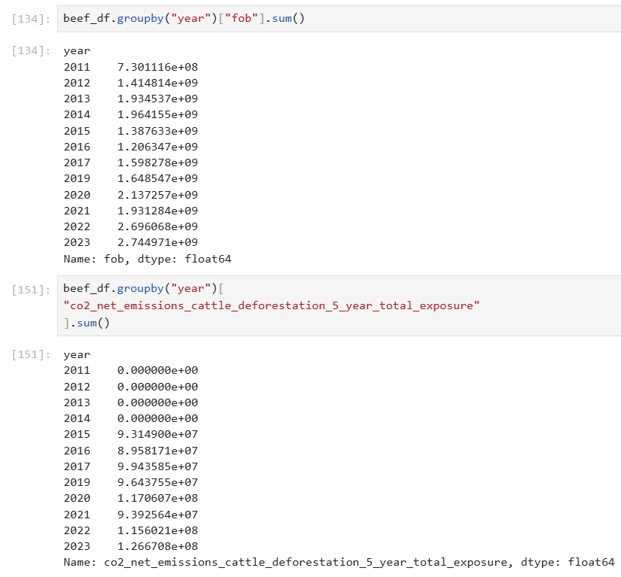
Figure 7-Aggregated yearly FOB values and net CO₂ emissions from cattle-driven deforestation in the beef dataset.

2.4 Data Quality Report

Missing values

During the analysis, we identified that four features contain missing values. The land use variable has approximately 3.75% missing data, which is relatively low and unlikely to significantly impact the analysis. On the other hand, the variables related to deforestation exposure and CO₂ emissions contain a much higher proportion of 24.92% missing values, which may negatively affect the reliability of the results and should be carefully handled in later stages.

Outliers

From our analysis, we observed that the dataset contains significant outliers, with most values concentrated near zero and a few extreme values in variables such as FOB and CO₂ emissions. These outliers contribute to strong skewness and may affect data interpretation and model performance.

Duplicates

We also examined the dataset for duplicate records and found no duplicates. This indicates that each observation represents a unique entry, ensuring data integrity and consistency. The absence of duplicates is important, as it prevents bias caused by repeated records and ensures that the analysis and model training are based on accurate and non-redundant data.

Possible solutions
To address the identified data quality issues, we considered several approaches. Missing values may be handled using imputation techniques, including simple methods such as median imputation, as well as model-based imputation to better estimate missing values and reduce bias. Alternatively, the removal of rows with missing values may be considered, depending on their impact on the dataset.
Regarding outliers, we decided that these values should be kept, as they represent real observations and may provide valuable insights. However, their impact on model performance should be considered, and techniques such as feature scaling may be applied depending on the requirements of the selected machine learning models.

3. CRISP-DM stage three – data preparation

3.1 – Data Cleaning
For the data cleaning phase, three different techniques were applied to handle missing values in order to evaluate which approach would be most suitable for the model. In addition, invalid entries were identified and corrected, unnecessary columns were removed, and label encoding was implemented. The following approaches were considered:

3.1.1 – Missing Values

Dropping Missing Values
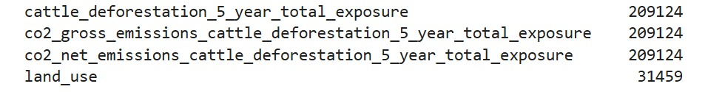
The first approach involved removing all missing values from the dataset using the dropna() function.(pandas.pydata.org, n.d.)
Figure 8-Missing values in the beef dataset.

Median Imputation
The second approach involved median imputation, where the median value of each column was calculated and used to replace any missing values with fillna().median method. (GeeksforGeeks, 2025)

Model-Based Imputation
The third approach involved model-based imputation, which uses machine learning techniques to predict missing values (GeeksforGeeks, 2025). In this study, Linear Regression was first applied to estimate missing values in the land_use variable using fob and volume as predictors, as these features showed a strong correlation (Cambridge Spark, 2019). Subsequently, a Random Forest model was used to predict cattle_deforestation_5_year_total_exposure based on volume, fob, and land_use (GeeksforGeeks, 2024). Finally, Linear Regression was applied again to estimate missing values in co2_gross_emissions_cattle_deforestation_5_year_total_exposure and co2_net_emissions_cattle_deforestation_5_year_total_exposure, using the remaining numerical features as input variables. This study by (Foschi et al., 2025) showed that using this strategy improved prediction results, particularly because the dataset contained missing values.

3.1.2 – Invalid Entries
The dataset had invalid entries such as &# and special characters like quotation marks (“ ”). To fix this, the column was converted to a string using astype(), and the unwanted characters were removed using the replace() function. (pandas.pydata.org, n.d.)
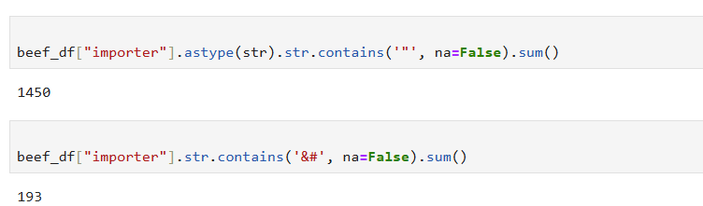
Figure 9-Cleaning invalid characters from the importer column.

3.1.3- Removing Unnecessary columns
The following columns were removed because some contained IDs that are not useful for the analysis. Since the project focuses only on Brazil, columns like country and biome (Amazon) were also removed. The importer_group column was removed because it contains the same information as importer.
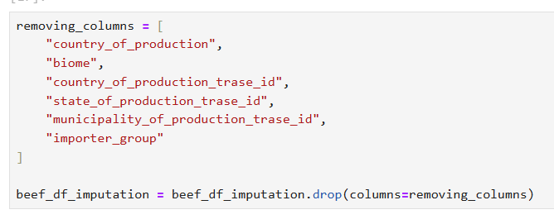
Figure 10-Removing unnecessary columns from the beef dataset before modelling.

3.1.4 – Label encoding
Label encoding was applied to convert non-numeric features into numerical values, as some machine learning models cannot work with string data. (Scikit-learn, 2019). Using other encoding methods, such as one-hot encoding, would increase the complexity and require more computational resources, making them less feasible for this project.

