Table of contents

Question 1: Implementation of Blockchain in Insurance 2

Purpose and Definition of Blockchain Technology 2

Potential Applications of Blockchain in the Insurance Sector 2

Comparative Advantages Over Traditional Systems 3

Limitations and Adoption Challenges 3

Social, Ethical, and Legal Implications 4

Question 2: Smart Contracts for Travel Insurance 4

Design Principles 4

Application in Travel Insurance 5

Contract Features 5

Question 3: Blockchain in Insurance: Privacy, Security, and Compliance Challenges 5

Diagram Overview 6

Table Overview 6

References: 8

CA 2 – Distributed Digital Transactions

# Question 1: Implementation of Blockchain in Insurance

## Purpose and Definition of Blockchain Technology

Blockchain is a distributed ledger technology that records transactions in interconnected and cryptographically protected blocks. Its decentralized design eliminates the need for intermediaries, ensuring security, transparency, and immutability. This makes it a key tool for sectors like insurance, where trust and traceability are fundamental (Brophy, 2020).  
In the insurance sector, Blockchain enables real-time recording of transactional data, improving efficiency and eliminating duplication of efforts. Additionally, reducing intermediaries lowers operational costs and reinforces customer trust by ensuring transparent processes (Javaid et al., 2022).

## Potential Applications of Blockchain in the Insurance Sector

1. **Claims Automation**:  
   Blockchain, combined with smart contracts, automates claims by executing contract terms when specific conditions are met. For example, a travel insurance policy can automatically process a refund if an oracle validates a flight delay (Brophy, 2020).
2. **Fraud Prevention**:  
   Its ability to permanently and auditably record transactions significantly reduces fraud risks in claims and improper payments. According to PwC (2022), Blockchain could reduce fraud cases by up to 50%, improving operational integrity.
3. **Identity Management and Regulatory Compliance**:  
   Blockchain can manage customers’ digital identities, facilitating compliance with regulations such as GDPR without compromising privacy. Tools like **zk-SNARKs** ensure that sensitive data remains protected while being verified (Javaid et al., 2022).
4. **Policy Management**:  
   Blockchain offers instant and transparent access to policy conditions, reducing disputes and improving customer satisfaction. Its traceability is especially useful in reinsurance, where multiple parties need to verify the information (Brophy, 2020).

## Comparative Advantages Over Traditional Systems

* **Transparency and Trust**:  
  Blockchain allows insurers and customers to directly access reliable information, eliminating the opacity inherent in traditional systems (Frolov et al., 2024).
* **Cost Reduction**:  
  Process automation and the elimination of intermediaries reduce operational costs by up to 30%, according to Deloitte (2021). This makes insurance services more affordable for customers.
* **Enhanced Security**:  
  Thanks to advanced encryption and immutability, Blockchain is resistant to tampering and cyberattacks, protecting data for both insurers and customers (Brophy, 2020).

## Limitations and Adoption Challenges

1. **Scalability**:  
   Blockchain networks, such as Ethereum, face challenges in efficiently processing large volumes of transactions, which can limit its use in high-volume operations (Brophy, 2020).
2. **Energy Costs**:  
   The Proof of Work (PoW) consensus model consumes significant amounts of energy, raising environmental concerns. The transition to Proof of Stake (PoS) could mitigate this problem (Javaid et al., 2022).
3. **Fragmented Regulation**:  
   The lack of global regulatory uniformity hinders widespread Blockchain adoption. Additionally, compliance with regulations like GDPR requires technological adjustments that balance transparency and privacy (Goldin, 2024).

## Social, Ethical, and Legal Implications

1. **Customer Privacy**:  
   While Blockchain enhances transparency, it also poses challenges in protecting sensitive data. Insurers must implement controlled access systems and advanced encryption to ensure regulatory compliance (Brophy, 2020).
2. **Financial Inclusion**:  
   By reducing operational costs, Blockchain makes insurance more accessible, benefiting underserved communities and promoting equity (Goldin, 2024).
3. **Ethics and Accountability**:  
   Blockchain increases insurers’ accountability by making all interactions on the network traceable. However, companies must ensure that this transparency does not compromise individual rights, such as privacy (Goldin, 2024).

# Question 2: Smart Contracts for Travel Insurance

## Design Principles

Smart contracts are self-executing programs on the Blockchain that operate according to predefined conditions. Their key principles are:

* **Self-Execution**: Automatically execute contract terms, reducing the need for intermediaries.
* **Immutability**: Once deployed, they cannot be altered, ensuring trust.
* **Transparency**: All transactions are publicly auditable.
* **Efficiency**: They streamline processes such as claims and reimbursements.  
  In travel insurance, smart contracts automate compensation for delays, baggage loss, and other inconveniences, enhancing customer experience and reducing costs.

## Application in Travel Insurance

This smart contract addresses key needs:

1. **Claims Automation**: Automatically compensates passengers in case of delays by validating data through oracles.
2. **Partial Refunds**: Allows airlines to issue flexible refunds for cancellations.
3. **Baggage Loss Coverage**: Provides direct compensation for lost baggage.
4. **Missed Flight Assistance**: Offers customer support, such as flight rescheduling or service vouchers.
5. **Penalties and Incentives for Airlines**: Penalizes non-compliance and rewards exemplary practices.

## Contract Features

The contract enables:

* **Policy Purchase**: Passengers acquire insurance policies by sending ETH to the contract.
* **Claims Processing**: Payments are automatically executed if predefined conditions are met.
* **Financial Management**: Includes penalties, incentives, and refunds managed by the insurer and the airline.

## Presentation of Smart Contract Execution

1. **Contract Deployment**



# 

The contract was deployed using the insurer's account. The airline's address was provided in the constructor as part of the deployment process. The deployment transaction was confirmed on the Ganache network.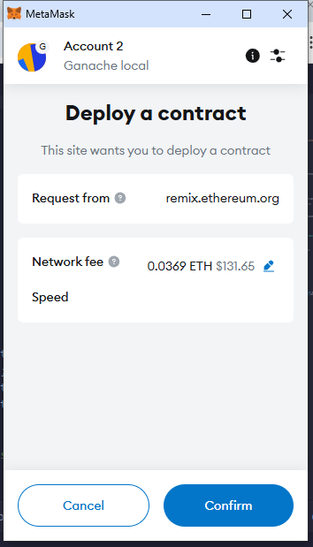

1. **Funding the Contract**

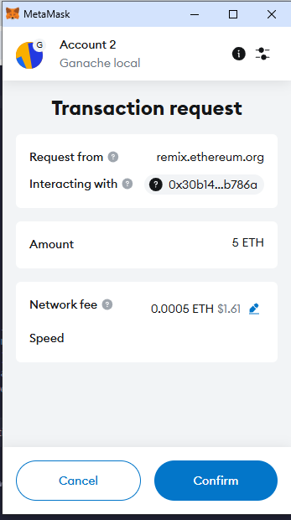

The insurer funded the contract with 5 ETH to ensure sufficient liquidity for processing client claims. The balance was verified using the *getContractBalance* function in Remix.





1. **Policy Purchase**

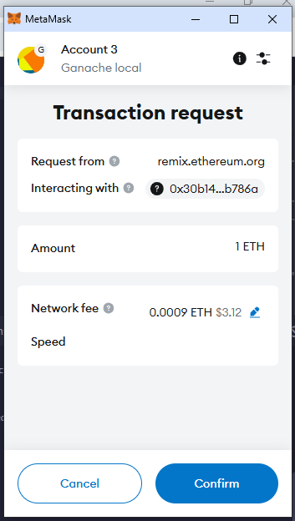

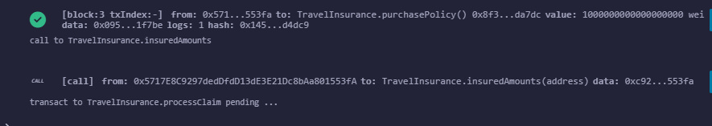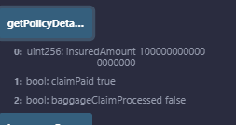The client purchased an insurance policy for 1 ETH. The *insuredAmounts* mapping confirmed that the insured amount was correctly recorded for the client's address.

1. **Processing Flight Delay Claim**

The insurer processed a flight delay claim, and the client received 50% of the insured amount (0.5 ETH). The claim status was updated in the contract, and the client’s account reflected the payout.

1. **Processing Baggage Claim**

Abaggage claim was processed, compensating the client as per the agreed amount. The state of baggageClaimProcessed was updated to reflect the processed claim.**Imagen de la pantalla de un celular con letras
**

# 

# Question 3: Blockchain in Insurance: Privacy, Security, and Compliance Challenges

The adoption of blockchain-based solutions by ReliableFund Insurance offers opportunities to enhance transparency, data security, and compliance with regulation like GDPR. However, it also introduces regulatory and ethical challenges that must be addressed to maintain client trust and privacy.

## Diagram Overview

The diagram outline how blockchain processes, such as Data Validation, Smart Contract Automation, and compliance monitoring, enhance client satisfaction by ensuring privacy, security, and regulatory compliance.

## Table Overview

The table highlights key ethical and regulatory challenges, paired with practical solutions like decentralised oracles, zero-knowledge proofs, and role-based access. These strategies ensure ReliableFund aligns with client expectations and legal requirements.

|  |  |  |  |  |
| --- | --- | --- | --- | --- |
| Aspect | Ethical/Regulatory Challenges | Proposed Strategies | Specific Focus | References |
| Data Privacy | - Conflict between Blockchain immutability and GDPR's *"Right to be Forgotten"*. | - Implement **Zero-Knowledge Proofs** to validate transactions without exposing personal data. | Protect sensitive data and GDPR-compliant. | (EPRS, 2019) GDPR and Blockchain |
|  | - Risk of sensitive data exposure on public blockchains. | - Use **hybrid Blockchain models**: store only encrypted references on-chain. | Enhanced privacy through secure encryption. | (McKinsey, 2024) Risk and Resilience |
| Data Security | - Vulnerabilities in smart contracts and potential attacks on external data oracles. | - Deploy **decentralized oracles** (e.g., Chainlink) and conduct regular security audits. | Secure and reliable data flow. | (Frolov, 2024) Use Cases in Insurance |
|  | - Inefficient private key management compromises client data. | - Introduce **secure key recovery systems** with multi-factor authentication. | Improve user experience and data security. | (Deloitte, 2024) Human Capital Trends |
| Regulatory Compliance | - Challenges in adhering to multiple regulations like GDPR (EU) and CCPA (USA). | - Implement **automated audits** and real-time compliance monitoring systems. | Regulatory transparency and audits. | (EPRS, 2019) GDPR Compliance |
| Transparency vs. Confidentiality | - Excessive transparency could expose critical client or company data. | - Apply **role-based access controls** with permissions for authorized stakeholders only. | Balance between transparency and privacy. | (Blockchain Ethics, 2019) Preprint |
| Digital Inclusion | - Exclusion of users in regions lacking access to digital infrastructure or technology. | - Develop **user-friendly interfaces** and offer digital literacy programs for underserved customers. | Promote accessibility and inclusion. | (Deloitte, 2024) Human Capital Trends |
| Legal Responsibility | - Unclear accountability when smart contracts fail or produce unintended outcomes. | - Define **automated legal clauses** within smart contracts to specify responsibilities clearly. | Ensure shared and clear accountability. | (McKinsey, 2024) Risk and Resilience |
| Fairness and Access | - Risk of monopolization of Blockchain technology by large insurers. | - Promote **interoperability** between platforms and enforce anti-monopoly policies. | Ensure fair and equitable market access. | (Frolov, 2024) Use Cases in Insurance |

# References:

* Javaid, M., Haleem, A., Singh, R. P., Suman, R., & Khan, S. (2022). A review of Blockchain Technology applications for financial services. *BenchCouncil Transactions on Benchmarks, Standards and Evaluations, 2*(100073). https://doi.org/10.1016/j.tbench.2022.100073&#8203;:contentReference[oaicite:22]{index=22}.
* Brophy, R. (2020). Blockchain and insurance: a review for operations and regulation. *Journal of Financial Regulation and Compliance, 28*(2), 215-234. https://doi.org/10.1108/JFRC-09-2018-0127&#8203;:contentReference[oaicite:23]{index=23}.
* Frolov, S., Ivasenko, M., Dykha, M., Shalyhina, I., Hrabar, V., & Fenyves, V. (2024). Interaction between decentralized financial services and the traditional banking system: A comparative analysis. *Banks and Bank Systems, 19*(2), 53-74. https://doi.org/10.21511/bbs.19(2).2024.05&#8203;:contentReference[oaicite:24]{index=24}.
* Ramos, D., & Zanko, G. (2024). A Review of Decentralized Finance as an Application of Increasing Importance of Blockchain Technology. *Mobileyourlife*​.
* Goldin, N. (2024). Toward a financial inclusion agenda for the global majority. *Atlantic Council*. https://www.jstor.org/stable/resrep63302&#8203;:contentReference[oaicite:26]{index=26}.