Lab2
- Install nebula(macOS)
Find more system installation methods and related resources by visiting the official Nebula project repository on GitHub: https://github.com/slackhq/nebula.
This repository provides detailed documentation, installation guides for different operating systems, and configuration examples that help users deploy and manage Nebula efficiently.
brew install nebula
1.1 Install Results
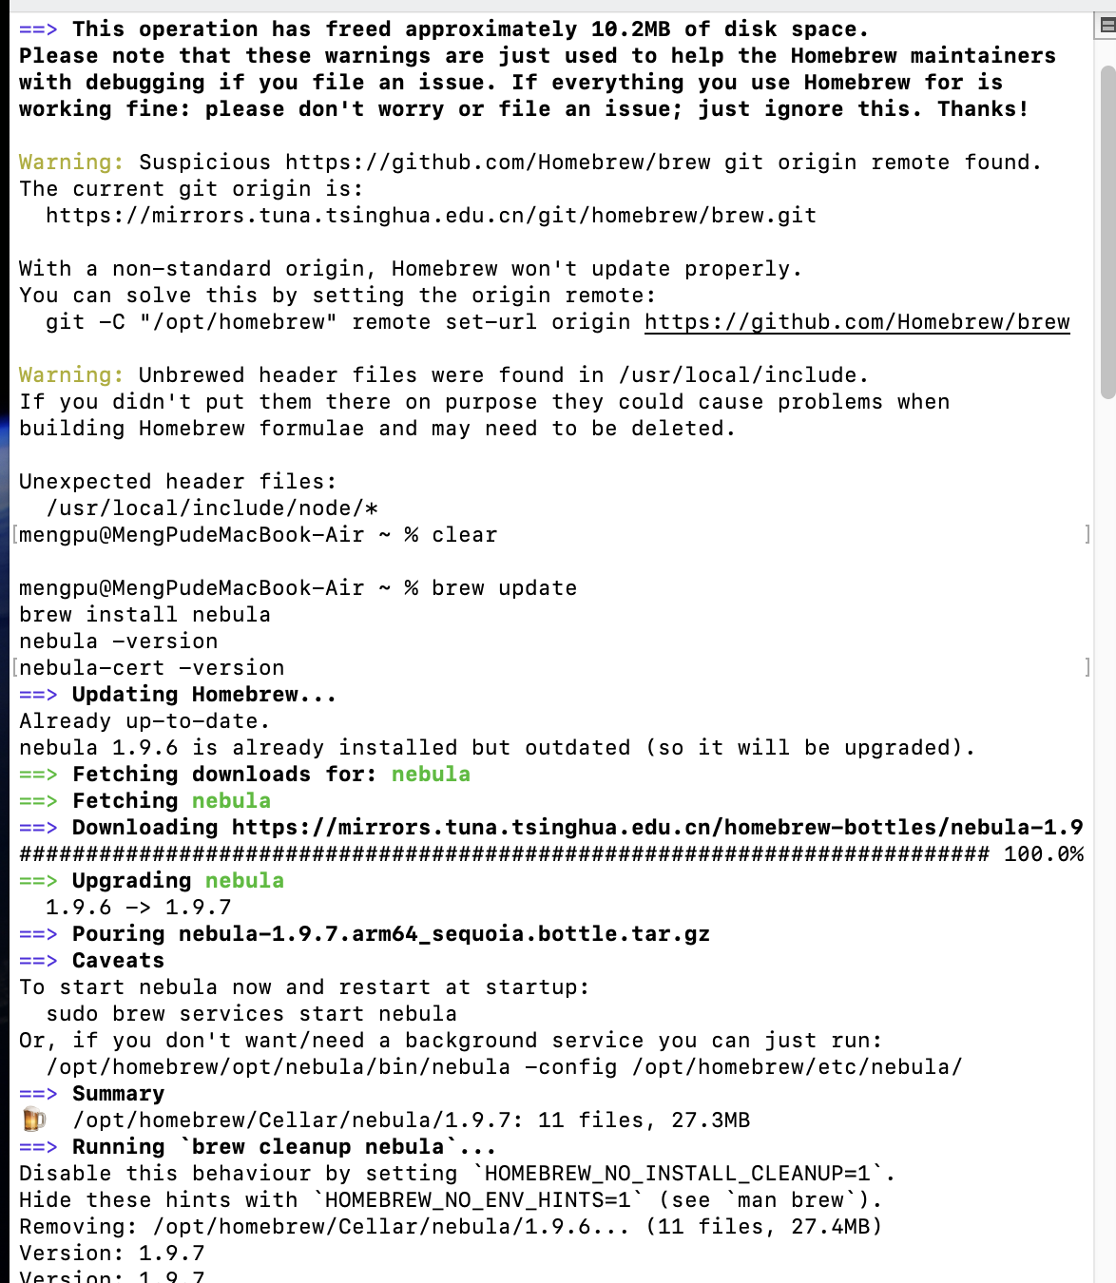

- Configuration and Setup
The client node used the certificate files provided by the instructor: wangzixu.crt and wangzixu.key, both signed by the instructor’s Certificate Authority (ca.crt).
Two configuration files were prepared:
• Lab.2.template.nebula.conf: the template configuration provided by the instructor.
• Lab.2.MBP15.config.yaml: the customized client configuration for the student’s device.
Key changes were made in the client configuration:
1. The PKI section was updated to point to the correct local certificate paths on macOS.
2. The static_host_map was added to connect to the instructor’s Lighthouse (192.168.100.1) through its public IP address 104.243.20.247:554.
3. The lighthouse section set am_lighthouse: false and included the Lighthouse IP in the hosts list.
4. The listen port was modified to 554 to match the Lighthouse configuration.

1.2 Comparison
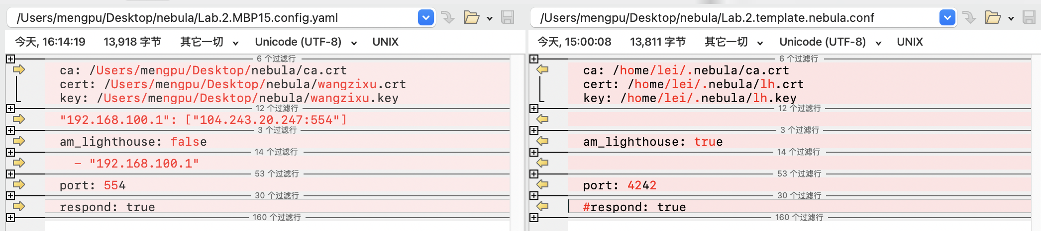

Start with:
sudo nebula -config Lab.2.MBP15.config.yaml

The successful log output confirmed the creation of the virtual network interface and the start of encrypted communication services.
1.3 Started successfully
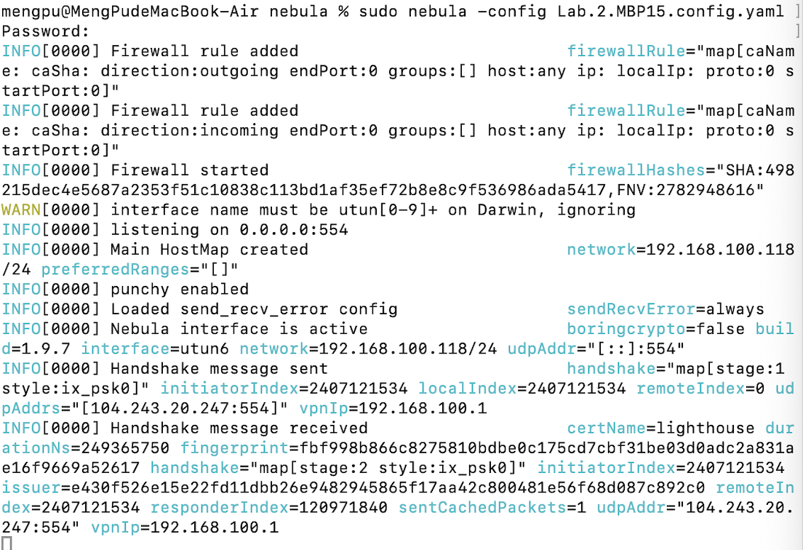

- Results and verification
Once the connection was established, an test was performed to verify connectivity through the Nebula overlay network. The client node executed the command:
ping 192.168.100.1

The result showed multiple successful replies with stable latency, confirming that the encrypted tunnel was properly created and data could pass securely between nodes.
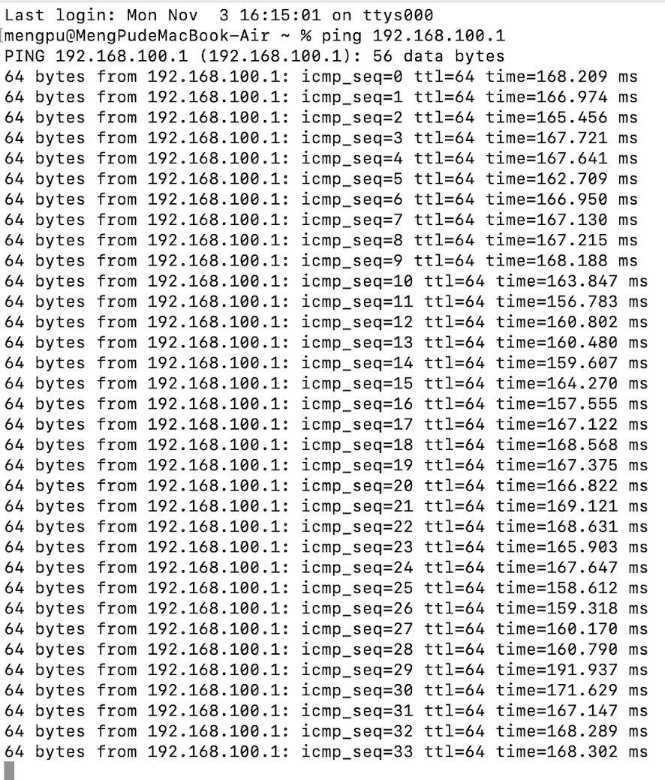
1.4 Results

- Reflection and conclusion
The main issue encountered in this experiment was the failure to clearly distinguish the purpose of each file, which ultimately led to the inability to complete the experiment successfully.
A clearer understanding of the roles of configuration files, certificates, and key files is essential for correctly setting up the environment and ensuring that all components work together as expected.

