Lab 9
All steps follow the instructions. Screenshots are provided as evidence, with brief explanatory notes for each major step.

Knative Serving CRDs Installed
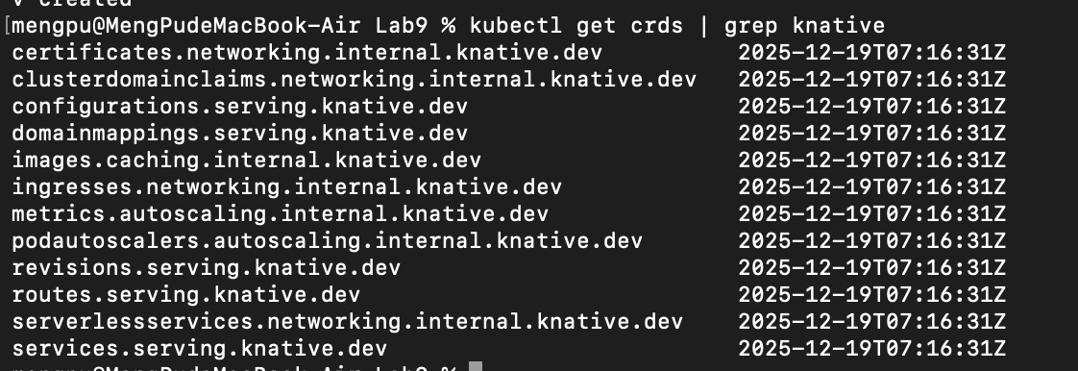
Knative Serving CRDs Installed
This screenshot confirms that all Knative Serving Custom Resource Definitions (CRDs) were successfully created in the Kubernetes cluster.

Knative Serving Core Installation
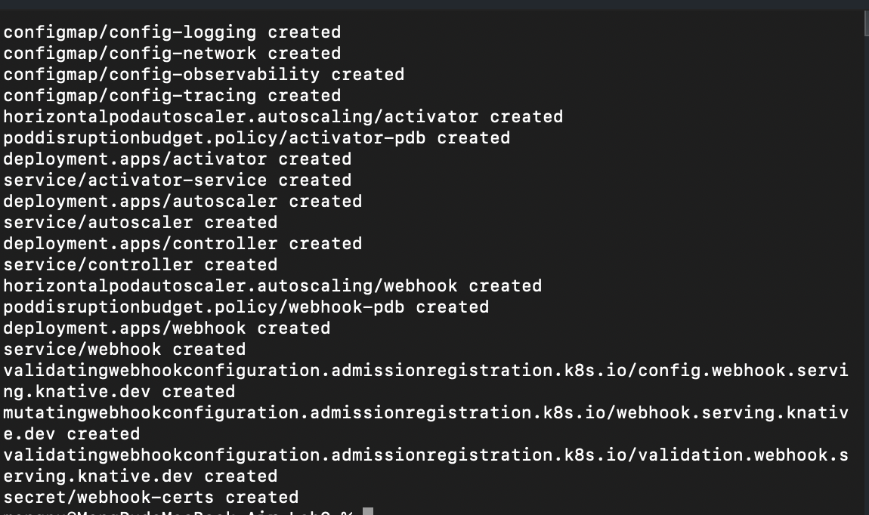
Knative Serving Core Installation
The Knative Serving core components were applied successfully, creating the control plane required to manage Knative services.

Istio Installed
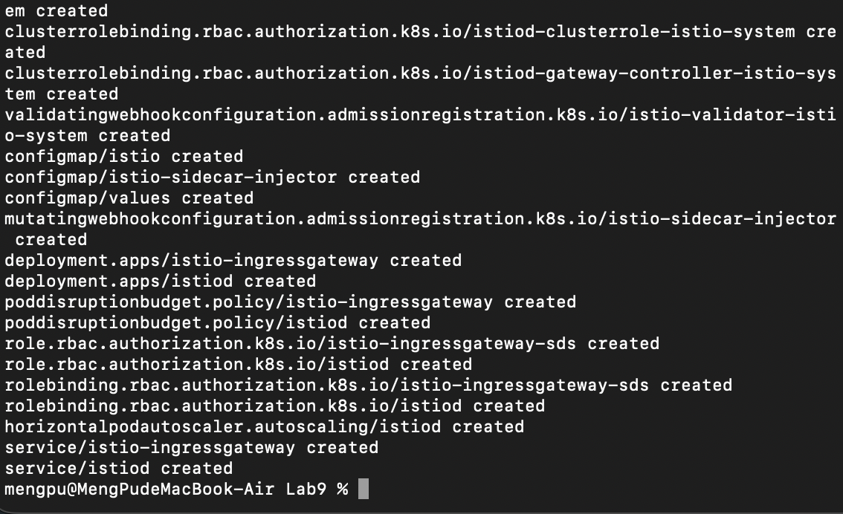
Istio Installed
Istio was installed as the networking layer required by Knative Serving. All Istio components were created successfully.

Istio Ingress Gateway Service
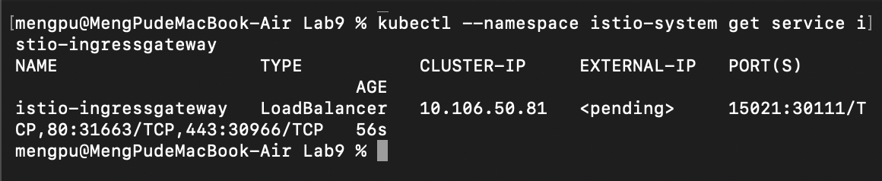
Istio Ingress Gateway Service
The Istio Ingress Gateway service is exposed as a LoadBalancer. The external IP remains pending, which is expected in a local Minikube environment.

Knative net-istio Networking Layer
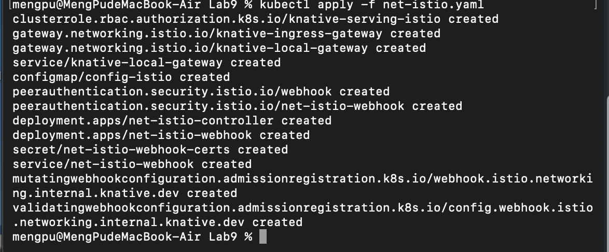
Knative net-istio Networking Layer
The net-istio component was installed to integrate Knative Serving with Istio networking.

Knative Eventing Installed
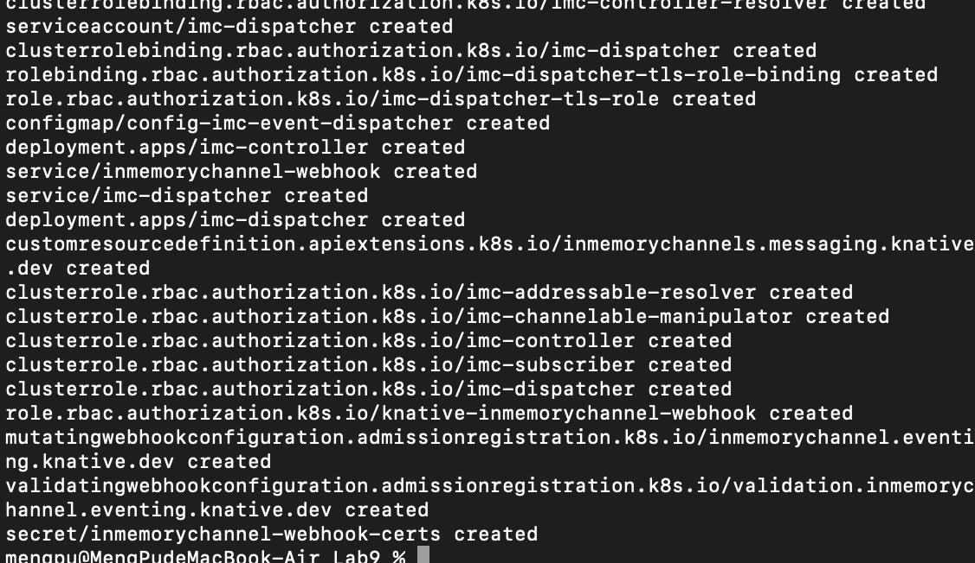
Knative Eventing Installed
Knative Eventing components were successfully created, enabling event-driven architecture support.

Knative Eventing Pods Status
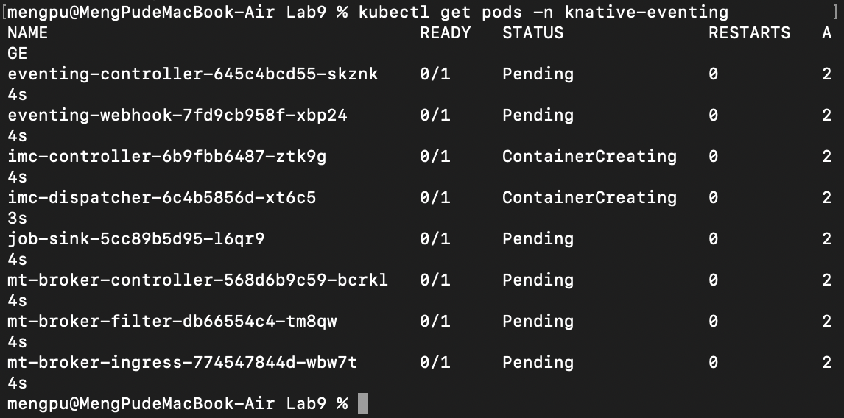
Knative Eventing Pods Status
Some Eventing pods remain in Pending or ContainerCreating state. This behavior is normal in a local Minikube setup and confirms that the Eventing control plane was deployed.

Knative Functions Version Check
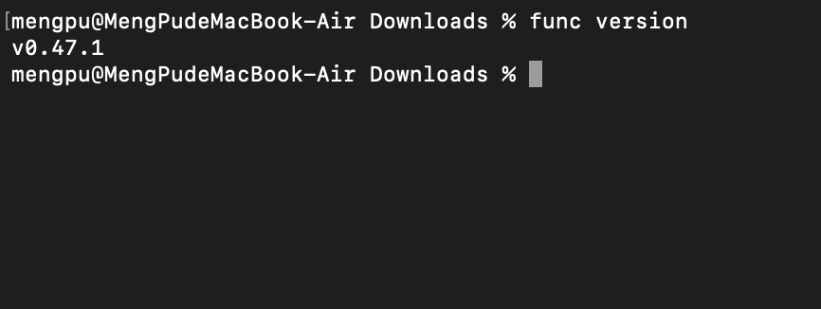
Knative Functions Version Check
The Knative Functions CLI (func) was successfully installed and verified.

Knative Functions Built Using Local Registry
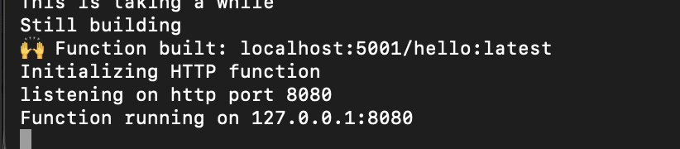
Knative Functions Built Using Local Registry
The function image was built and pushed to a local Docker registry, satisfying the requirement to use a local registry.

Knative Functions Running Locally
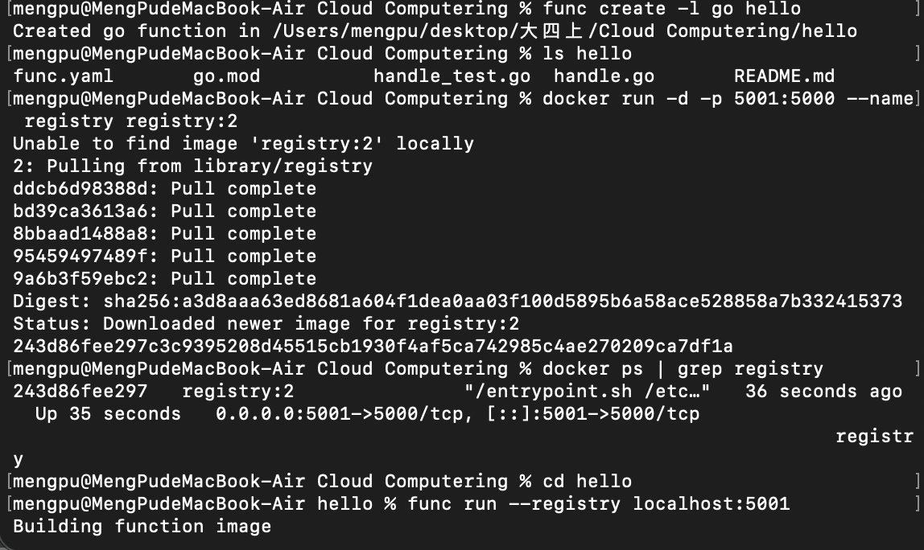
Knative Functions Running Locally
The function is running locally on port 8080 without being deployed to the Knative cluster, in accordance with the instruction to skip function deployment.

Knative Functions Invocation Result
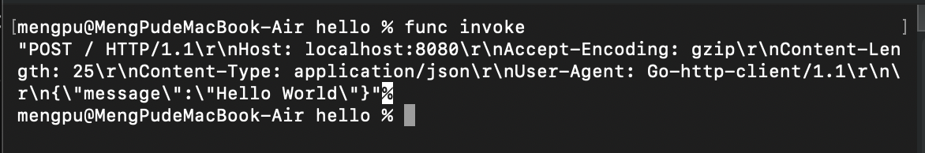
Knative Functions Invocation Result
The function was successfully invoked locally and returned the expected response.

