Lab 6 Report

1. Objectives
This lab follows the official Kubernetes Basics tutorial (https://kubernetes.io/docs/tutorials/kubernetes-basics/). The goal is to understand Kubernetes fundamentals through creating a cluster, deploying applications, exploring pods, exposing services, scaling deployments, performing rolling updates, and cleaning up the environment.

2. Environment Setup
Operating System: macOS Sequoia 15.7.1 (ARM64)
Platform: Minikube running on Docker Desktop (v1.37.0)
Kubernetes Version: v1.29.3
kubectl Version: v1.34.1

3. Procedures and Observations

Step 1 – Create a Cluster
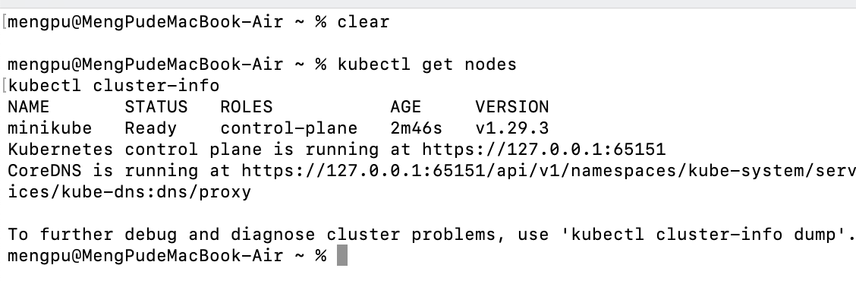
Figure : Checking cluster status using 'kubectl get nodes'.
This command displays the active nodes in the Kubernetes cluster. The output indicates that the 'minikube' node is in the 'Ready' state, meaning the control-plane is successfully initialized.

Step 2 – Deploy an Application
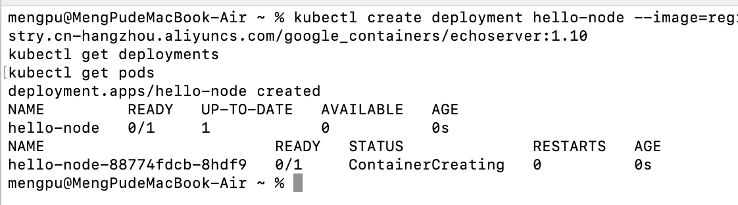
Figure : Deploying the application using the Echo Server image.
This command creates a deployment named 'hello-node' using an Echo Server container image from Alibaba Cloud. The follow-up command 'kubectl get pods' confirms that the Pod has been created and is being initialized.

Step 3 – Explore the Application
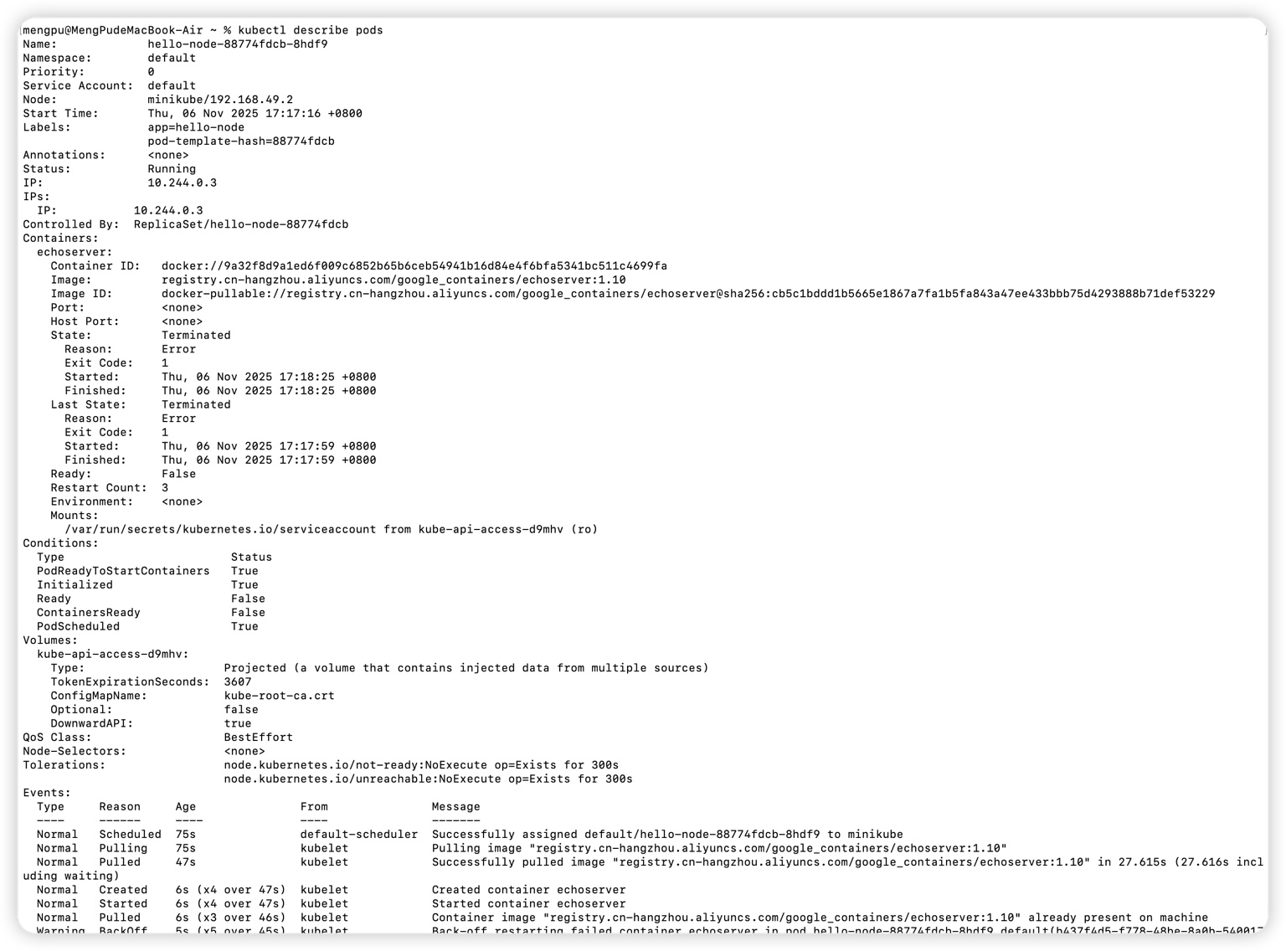
Figure : Describing Pod details using 'kubectl describe pods'.
This command provides detailed information about the Pod, including its labels, node assignment, image source, and events. The output confirms that the Pod was created, scheduled on the node, and initialized correctly.

Step 4 – Expose the Application
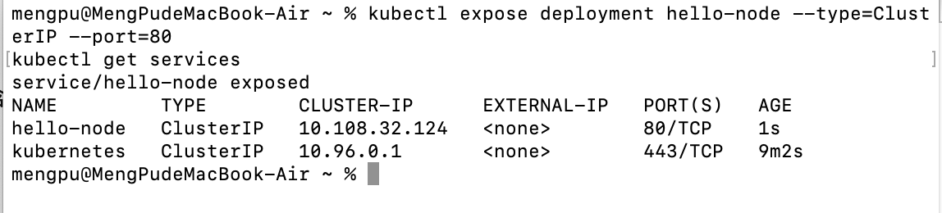
Figure : Exposing the deployment as a ClusterIP service.
The command 'kubectl expose deployment hello-node --type=ClusterIP --port=80' creates a service that exposes the application internally within the Kubernetes cluster on port 80. The output of 'kubectl get services' confirms that the service 'hello-node' was successfully created with a ClusterIP address.
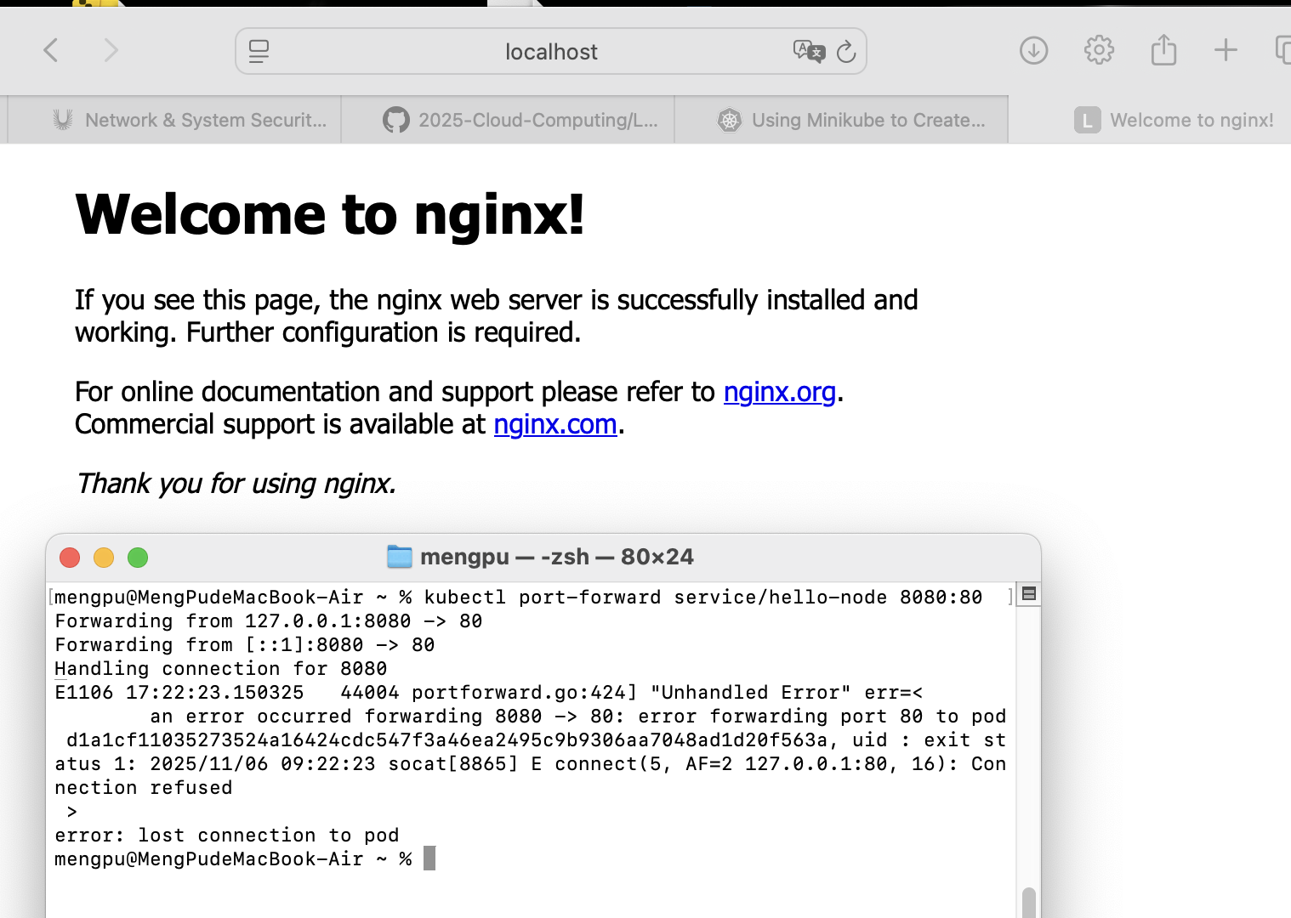
Figure : Successful web access via 'http://localhost:8080'.
The 'Welcome to nginx!' page confirms that the port-forwarding command successfully mapped the service to the local host, allowing access from the browser.

Step 5 – Scale the Application
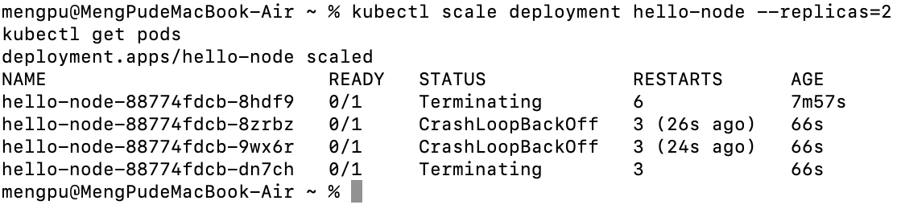
Figure : Scaling up and down the deployment.
Scaling demonstrates Kubernetes’ ability to dynamically manage workloads. The 'kubectl scale' command increased the replicas to 4 and then reduced them to 2, showing horizontal scaling and efficient resource utilization.

Step 6 – Update (Upgrade) the Application
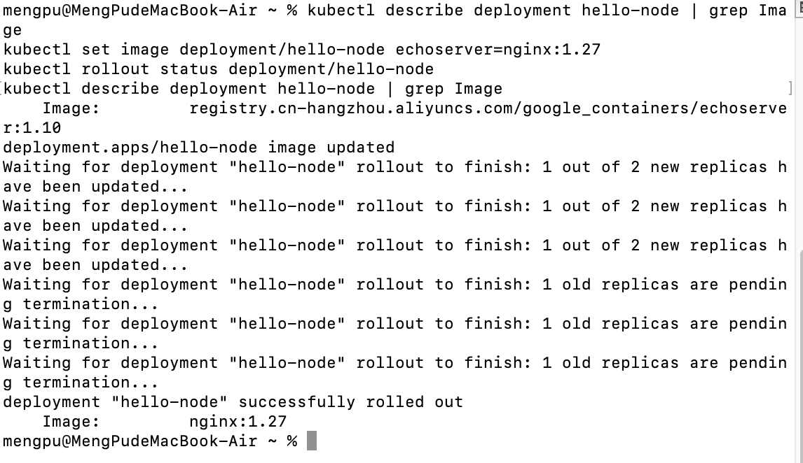
Figure : Performing a rolling update to upgrade the application.
The command 'kubectl set image deployment/hello-node echoserver=nginx:1.27' upgrades the running deployment to a new Nginx version. Kubernetes performs a rolling update, ensuring zero downtime while replacing Pods. The rollout status confirms the upgrade was successful.

Step 7 – Cleanup and Summary
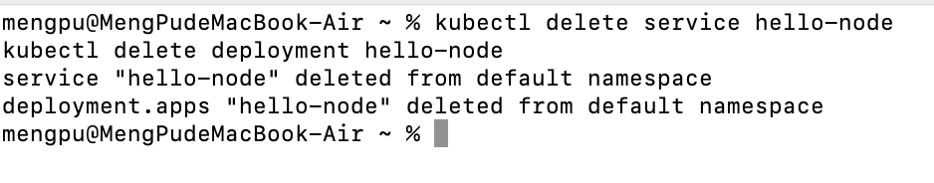
Figure : Cleaning up Kubernetes resources.
The commands 'kubectl delete service hello-node' and 'kubectl delete deployment hello-node' remove all related Kubernetes objects, ensuring the cluster environment is reset and ready for future experiments.
In conclusion, all modules from the Kubernetes Basics tutorial were successfully completed using Minikube. This experiment provided practical experience in managing containerized applications through Kubernetes, covering deployment, scaling, updating, and cleanup processes in a local development environment.

