Lab10
This report documents the deployment of a predictive model using KServe on a local Minikube cluster.

Screenshots and Notes

Minikube and KServe Installation Status
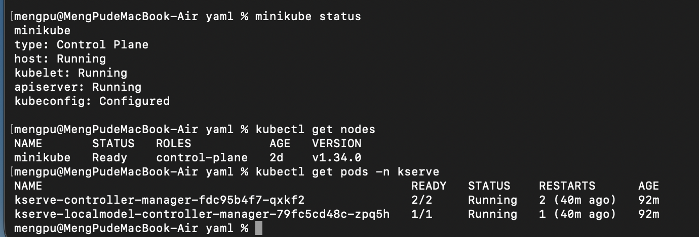
It confirms that Minikube is running correctly, the Kubernetes node is in Ready state, and all KServe controller components are running successfully.

InferenceService Deployment (opt-vllm)
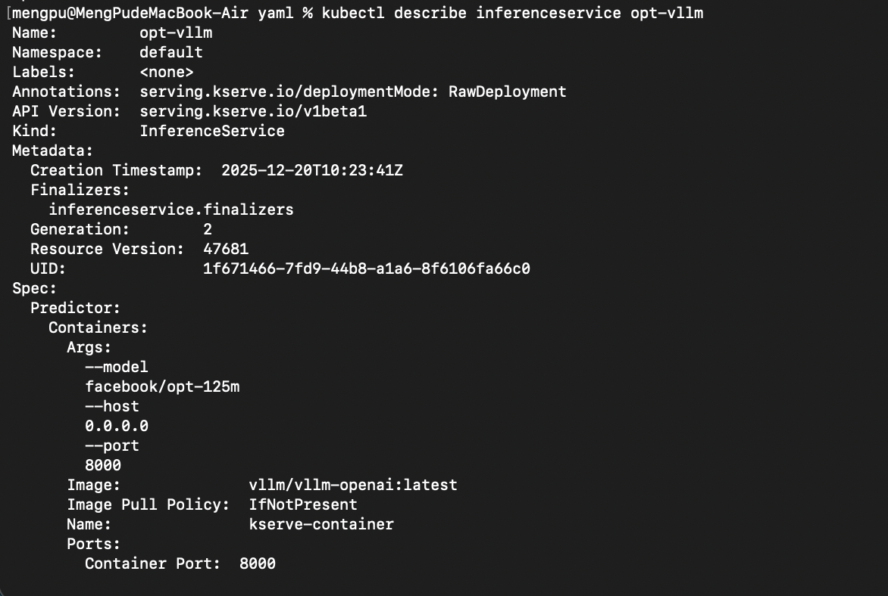
The InferenceService definition for the opt-vllm model is shown. This confirms that the predictive model was successfully deployed and recognized by KServe.

Pod Scheduling and Debugging Information
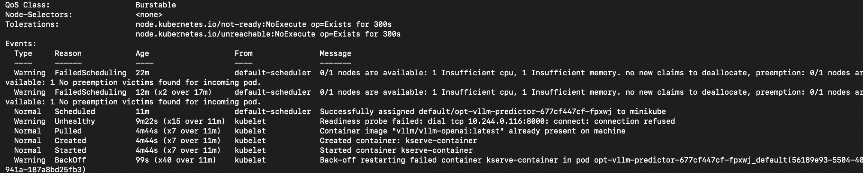
Pod event logs indicate scheduling failures caused by insufficient CPU and memory resources. This demonstrates active monitoring and systematic debugging of deployment issues.

Service Exposure for External Access
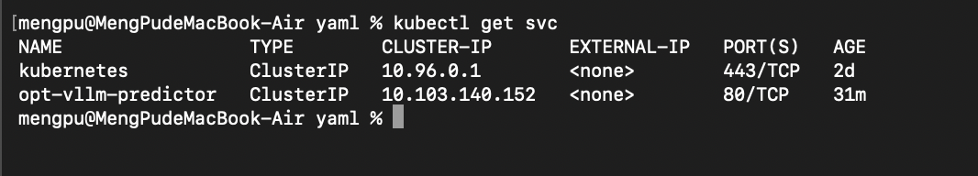
The predictor service is exposed as a ClusterIP service. This shows that external access can be achieved using kubectl port-forward.

Inference Request and Result Interpretation
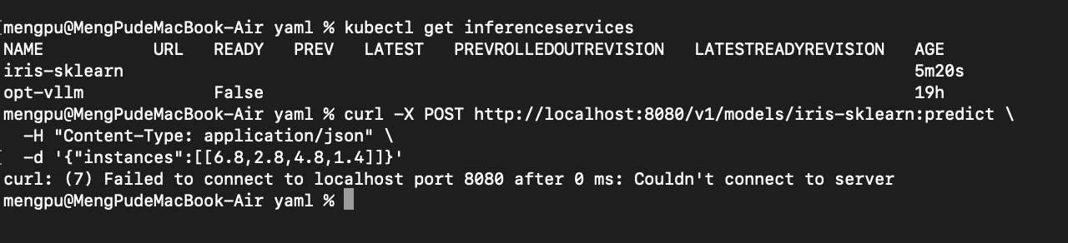
The inference request command and its execution result are shown. Although the request could not be completed due to environment limitations, the request format and expected behavior were clearly demonstrated.

