Lab 3: Building Your Personal Website with GitHub Pages

1. Objective
The purpose of this lab is to create a personal website using GitHub Pages. This task demonstrates how to deploy a static website, apply version control using Git, and enhance the design using Jekyll themes and custom CSS.

2. Experimental Process
Step 1: Repository Setup
A new GitHub repository named '202283910017.github.io' was created to host the personal website. This naming convention allows GitHub Pages to automatically recognize and deploy the repository as a website.
Use Github Desktop to control different versions
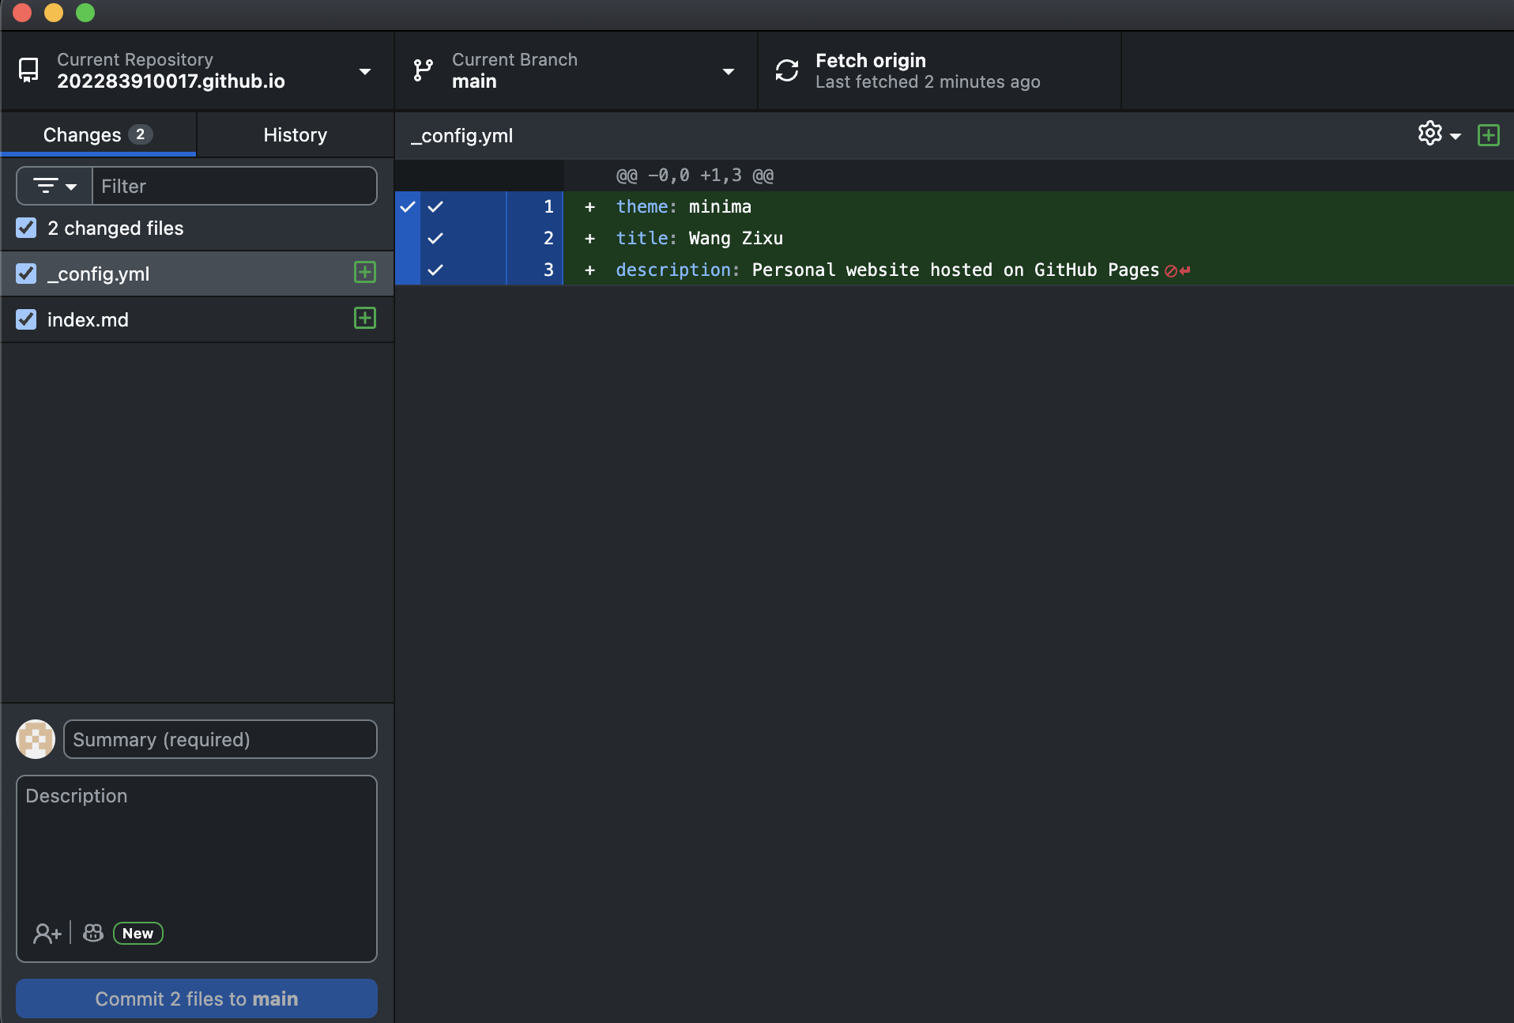
Figure 1. Commit new versions

Step 2: GitHub Pages Configuration
In the repository Settings → Pages, the source was set to 'main branch / root'. GitHub Pages automatically built and deployed the site.
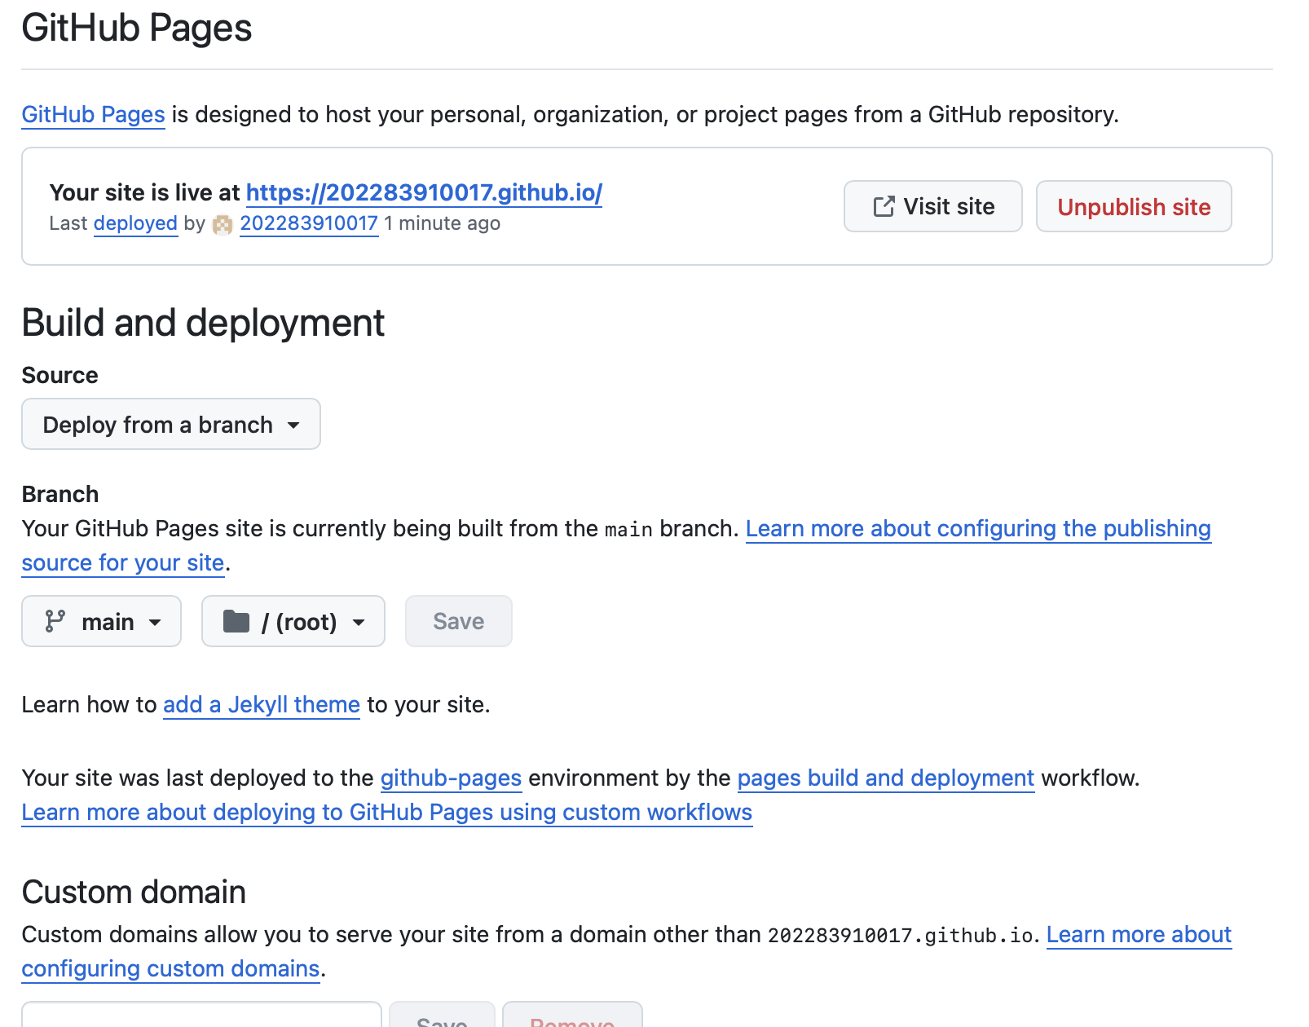
Figure 2. GitHub Pages configuration and successful deployment confirmation.
Step 3: Enabling Jekyll Theme
A configuration file (_config.yml) was added to specify the use of the 'minima' theme. The index.html file was deleted to ensure that Jekyll could render the Markdown-based site correctly.
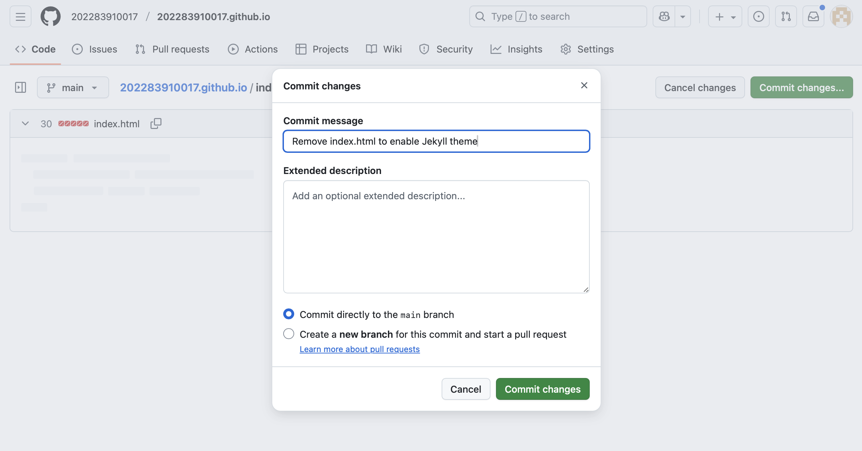
Figure 3. Removing the index.html file to activate Jekyll rendering.
Step 4: Initial HTML Homepage
An initial HTML page titled 'Welcome to My Homepage' was created to verify that GitHub Pages was working correctly.
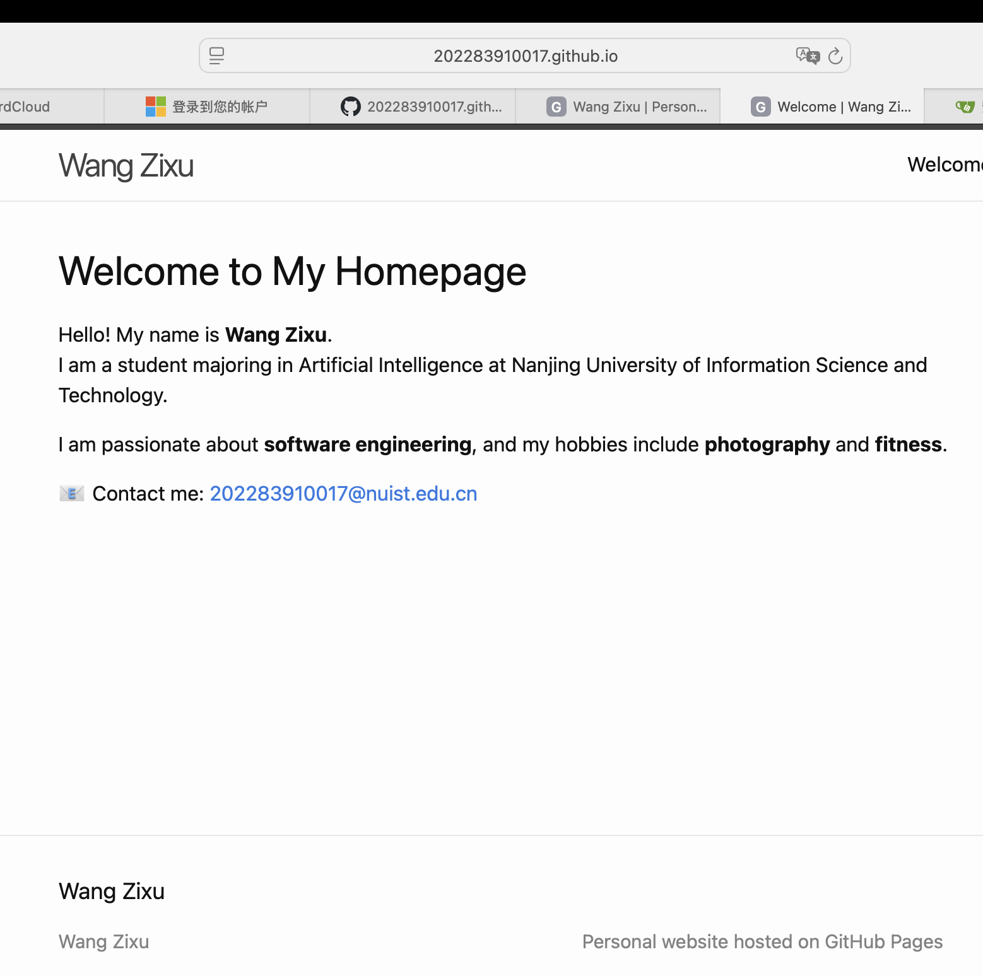
Figure 4. The first HTML version of the homepage before applying the Jekyll theme

Step 5: Website Enhancement with CSS and Structure
Sections such as Education, Skills, and Contact were added in the index.md file. A custom CSS file (assets/css/style.css) was also created to add a gradient background, rounded content cards, and animation effects.
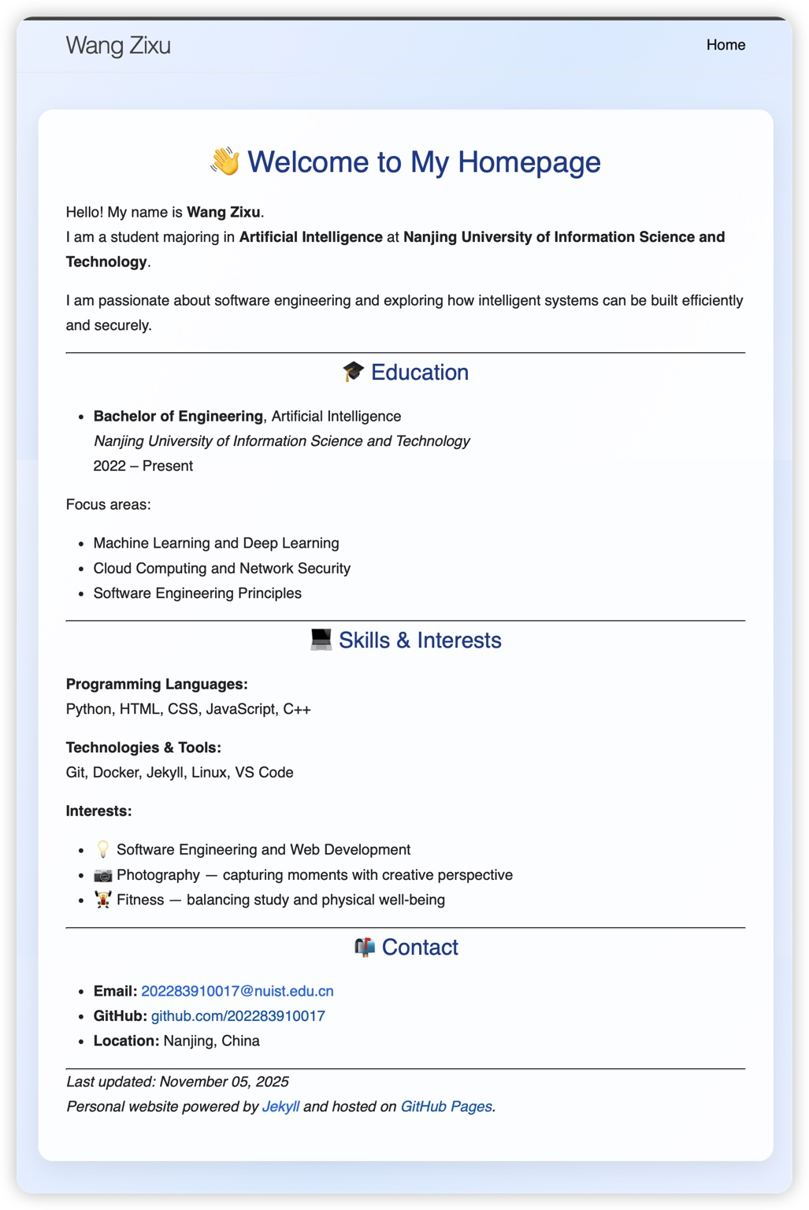
Figure 5. Final version of the personal website with Jekyll theme and custom CSS enhancements.

3. Results and Discussion
The final website was successfully deployed at 'https://202283910017.github.io'. Jekyll rendered the Markdown structure with the Minima theme, including navigation and footer sections.
The visual layout was improved using CSS styling, creating a professional and polished appearance. Version control was clearly demonstrated through multiple commits reflecting progressive website improvements.

4. Conclusion
This lab successfully met all requirements outlined in the GitHub Pages assignment. It demonstrated the deployment of a static website, the use of HTML, Markdown, CSS, and Jekyll for customization, and proper use of Git for version control.
The final website represents a professional and visually appealing online presence suitable for portfolio or academic use.

