EXERCISE 4

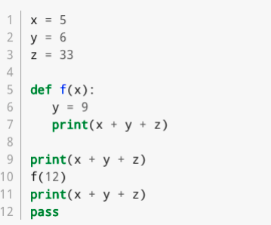

1. What is the output of the program?

* 44
* 54
* 44

1. Which line contains a function header?

* Line 5

1. Which line(s) constitute the main program?

* Lines 1 to 3
* Lines 9 to 12

1. Is there a local variable defined anywhere? If so what is its scope?

* Yes, y = 9 on line 6

1. Does the function f return a value?

* No

1. Does the function f reference any global variables?

* Yes

1. Which lines constitute a function body?

* Line 6
* Line7

1. Are there any arguments used in the program? If so what and where are they? (tricky)

* Yes, 12 on line 10

1. Are there any parameters defined in the program? Explain.

* Yes, x is a parameter defined in the function f and it takes an argument when the function is called.

1. What does the las line do?

* The last line does not do anything. It’s just a placeholder.