Bacterial richness in public tap water and sinks of San Francisco’s public Pit Stop bathrooms are positively correlated with neighborhood income and negatively correlated with population density

Andrae Ladores

May 18, 2022

# Introduction

Throughout the world and including the United States, there are numerous individuals that are deprived of safe and reliable tap water. Cities like Newark, New Jersey and Flint, Michigan are only some examples of the water crisis in the United States (Pace et al. 2022). Possible contaminants in public tap water can lead to instant illnesses, like acute gastroenteritis which produces roughly 16 million cases each year at United States community water systems (Allaire et al. 2018). In Wake County, North Carolina a predominantly Black periurban area has an approximated 114 yearly emergency department visits for acute gastrointestinal illness due to contaminated water service, roughly 22% of those cases can be prevented with adequate community water service (Stillo and MacDonald Gibson 2017). In California, there is a small percentage of public tap water systems that have been found to be in violation at least one point in their time since 2012 (Reese 2018). The United States Environmental Protection Agency dataset was observed for the violations committed by community water systems and 55% of community water systems violated at least one statute under the Safe Drinking Water Act which served over 95 million individuals (Rubin 2013). Additional studies have revealed that water system violations in California transpire in low-income communities, where there are limited resources which makes it difficult to meet the standards which drives the inequitable access to safe tap water (Balazs et al. 2012, Balazs and Ray 2014, McDonald and Jones 2018).

Besides access to safe public water, public restrooms are a necessity as well. They provide service to a mobile population and assists the individuals with greater needs (children, elderly, the homeless, etc.) (Stanwell-Smith 2010). Despite the essentiality of restrooms, they are an optimal place to cultivate the growth and survival of microorganisms due to the humid and warm conditions of a bathroom. A majority of pathogens acquired in some form of health-facility (like a hospital) can survive on inanimate surfaces for weeks or months, possibly serving as a source of transmission unless frequent object/surface disinfections are performed (Kramer et al. 2006, Otter et al. 2013). Cleaning restrooms without the use of disinfectants and only with soaps or detergents can spread viruses and bacterias throughout the area (Abney et al. 2021). In a comprehensive study that sampled specific restroom areas such as handles, toilet faucets, washbasin taps (sinks), soap dispenser bottoms, toilet papers, paper towels, hand dryers, and more found that in a total of 7482 samples, 89.25% were deemed contaminated (Matini et al. 2020). In addition, contamination levels were found to be incredibly high in low-income communities when compared to high-income communities for samples such as soil, bathing water, non-municipal water, surface water, and floodwater (Amin et al. 2019). Public restrooms in high-income locations are also known to display cleaner facilities and conditions compared to the restrooms in low and medium-income areas (Suen et al. 2019).

In this study, I focused on the bacterial richness in public tap water of San Francisco’s public restrooms (Pit Stop bathrooms) and how they vary regarding population density and the average neighborhood income. I proposed two hypotheses: (1) as population density increases, the total bacterial richness of a bathroom will increase and (2) as the average neighborhood income increases, the total bacterial richness will also increase. The study revolves around the use of field collected data across several districts of San Francisco and the use of pre-existing datasets relating to the study of different urban systems. The field collected data consisted of tap water samples of Pit Stop bathrooms along with swab samples of distinct areas on the sink in the same bathrooms. The publicly-available datasets online consisted of information pertaining to San Francisco’s average neighborhood income values and San Francisco census data, obtained from the 2010 Census and 2020 American Community Survey data. Upon analysis of both the collected field data and public data through the use of R (R Core Team 2021), ggplot2 (Wickham 2016), dplyr (Wickham et al. 2022), tidycensus (Walker and Herman 2022), and ggmap (Kahle and Wickham 2013), I found that the relationship between population density and bacterial richness was the opposite than the one I proposed - so, as the average population increased, the total bacterial count actually decreased. This is the same case for the relationship between average income and bacterial richness as well - as the average income level increased, the total colony count increased as well.

# Materials and Methods

## Location and Pit Stop Restrooms

As a class group, we decided which districts of San Francisco we wanted to study based on an official San Francisco district map. We concluded to observing Haight (HA), Marina (MA), Outer Richmond (OR), Civic Center/Tenderloin (CC), Mission (MI), Bayview (BA), and Castro (CA). It’s important to note that I visited BA but upon arriving at the PitStop location, there were no PitStop bathrooms nor public restrooms to sample, so I instead sampled CA’s PitStop bathroom. We used Professor Zimmerman’s R code that randomly plotted points within a neighborhood to determine the exact position we should stop at via bus services.

Pit Stop bathrooms were the main public bathrooms studied and sampled. In neighborhoods where there were two Pit Stop bathrooms in close proximity to the predetermined bus stop, I sampled both bathrooms (B1 & B2), otherwise, I only sampled a single bathroom. San Francisco Public Work’s Pit Stop program supplies the public with safe and sanitized restrooms. Outside or near each unit contains used-needle disposals, animal waste stations, and a regular trash disposal. Inside each restroom contains a hands-free sink, soap, paper towels, toilet, and toilet paper. In addition, each unit gets automatically cleaned after each use and will get manually cleaned by a staff member periodically. Currently, there are 33 Pit Stop locations across 13 neighborhoods. The program utilizes street-cleaning data which determines the placement of each Pit Stops, placing the public restrooms where they are essential (Works 2014). There were some neighborhoods that did not contain a Pit Stop bathroom, in which case, I just found the nearest public restroom, which was often near or in public parks. It’s also important to note that these non Pit Stop restrooms contained bathroom facilities with both Men and Women options. In those cases, I sampled the Men’s side (B2) and I would have my female-identifying peer to assist in collecting my samples for the Women’s side (B1).

## TSA plates

The TSA plates used were prepared using 40g/L of tryptic soy agar and placed into an autoclavable glassware. Then, the addition of distilled and deionized water was added until the desired volume was reached. Once reached, the glasswared was autoclaved at 121°C for 30 minutes on liquid cycle. When it was ready, the product was poured into 100mm petri dishes to cool and stored in a closed bag at 4°C until eventually used.

## Tubes and Swabbing

For the data collection, I used 15mL falcon or centrifuge tubes containing 0.75mL phosphate buffered saline (PBS) 1x pH 7.4 which was autoclaved for 30 minutes at 121°C liquid cycle. Inside a Pit Stop bathroom, I used sterile cotton swabs which I would first dip into the PBS filled centrifuge tubes prior to swabbing three locations on the sink: the area around the spout (s1), the drain (s2), and the handle/arm rest area (s3). I would swab for 3-4 seconds and I would immediately place the swab back into its respective tube. For the negative control (c/control), I simply mimicked the same actions when swabbing the sink, but I simply swabbed the air with the same amount of time. For the water (w), I took an empty centrifuge tube without PBS and took a water sample from the automatic sink. For each Pit Stop unit, I had a total of 5 centrifuge tubes: the 3 sink samples, 1 control sample, and 1 water sample.

## Plating and Counting

Once I returned from the sample sites with my centrifuge tubes, I vortexed each centrifuge tube for 30-40 seconds. After vortexing, each tube sample (except the water sample) is aliquoted onto its respective TSA plate with a value of 0.075mL. The water sample is aliquoted with the same value of 0.075mL onto a TSA plate, but with 3 technical replicates. Per restroom, there are 7 total plates: 3 plates for the sink samples, 3 plates for the water sample, and 1 plate for the control. Once the samples are plated, approximately 7-12 sterilized glass beads are poured into the plates and each plate is shaken for 15-20 seconds or until the sample on the plate has adequately spread across the area. Once each plate has been thoroughly shaken and spread, the plates are incubated at around 37°C for 5 days.

After the incubation period, the plates are taken out for observation. Each plate is carefully observed and recorded for bacterial richness. In addition, I documented the morphotype of each bacteria based on the shape, size, and color, the count of each morphotype on the plate, and the overall total bacterial count present on each plate. After each plate is carefully studied and documented, the plate is properly discarded.

## Public Datasets

The public datasets used in this study were mainly the 2010 American Decennial Census and the 2020 American Community Survey, which can both be obtained from the Census website: <https://www.census.gov>. The 2010 Census data was used to illustrate the average population density throughout San Francisco and the 2020 American Community Survey was used to display the average income data depending on San Francisco’s neighborhood tracts. The 2010 Census data was used instead of the 2020 Census data due to the lack of data available for the 2020 Census dataset at the time. Additionally, I used Analysis Neighborhood and Pit Stop datasets, obtained from <https://datasf.org>, to create the map and neighborhood figures. It is important to note that when using the American Community Survey and Census data, tracts were used instead of neighborhood districts, which should more accurately measure the income and population density data since tracts are smaller than neighborhood districts.

To obtain both average population and income level of San Francisco’s neighborhoods, we were given an R code that analyzes the Analysis Neighborhood data and combined the neighborhood “GEOID” with the Census and American Community Survey’s “GOEID,” providing a list of information that contained both the raw population value and income levels with the respective neighborhoods. To do this, the data on the neighborhood income values on the American Community Survey can be obtained through the use of the package, tidycensus (Walker and Herman 2022). Once that data is obtained, an R function that combines the newly obtained information of the neighborhood income of San Francisco and data on San Francisco’s neighborhoods via Analysis Neighborhood dataset. This resulted in a table consisting of San Francisco’s neighborhoods and each neighborhood’s income. This process was repeated to obtain a table of San Francisco’s neighborhoods and each neighborhood’s (or specifically, tract) population density. However, instead of retrieving the neighborhood income levels from the American Community Survey through tidycenus, the total population value of all races were obtained and then processed the same way as the neighborhood income levels. Using another R function, the raw population and income values were averaged and statistically summarized. From there, I added new columns to my personal dataset and inputted the newly obtained information regarding the neighborhood’s average population and income level to create a synchronized dataset.

# Results

## Microbial Richness

I observed that the overall bacterial richness throughout the sampled bathroom and their neighborhoods (Figure 5) was significantly different with an ANOVA p-value of 2.17E-6; p < 0.05 (Figure 1). Comparing two specific neighborhood’s bacterial richness, Outer Richmond and Civic Center/Tenderloin, with differing average income, I found that the bacterial richness was significantly different between Civic Center/Tenderloin and Outer Richmond area with a t-test p-value of 0.02708; p < 0.05 (Figure 2). From the highest median of bacterial richness to the smallest, San Francisco’s neighborhood ranked the following: Mission, Marina, Castro, Haight, Outer Richmond, and Civic Center/Tenderloin (Figure 1). Furthermore, I observed the relationship between the bacterial richness and the varying sink locations and found that the bacterial richness was not significantly different between the various sink locations (Figure 3; p-value = 0.6912; p < 0.05). Sink location 3 had the highest median, followed by sink location 2, and finally sink location 1 which contained the lowest median value.

## Morphotypes

My barplot to analyze the top morphotype count of the various morphotype identification descriptions and their respective bacterial abundance (Figure 4), found that the morphotype identification, *tiny, taupe*, had the most frequent and abundant morphotype count of 14,032. The second most abundant morphotype, *tiny, yellow*, amounted to a morphotype count of 3,116. That is a 10,916 difference between the most abundant morphotype, *tiny, taupe*, and the second most abundant morphotype, *tiny, yellow*. Furthermore, the morphotypes, *tiny, transparent*, totaled to the value of 2,288 and *small, opaque*, measured to a total of 1728.

## Average Income & Population

The scatterplot to measure the microbial richness along with the average income in San Francisco’s neighborhoods was significantly different with a p-value of 0.006631; p < 0.05 (Figure 6). There was a higher colony count in areas of high average income (Figure 6). Similarly, the relationship between the microbial richness and the average population throughout San Francisco was significant, it had a t-test value of p-value of 3.024E-6; p < 0.05 (Figure 7). There was a higher number of total bacterial colonies in areas of low average population (Figure 7).

# Discussion

This study aimed to provide information regarding the relationship between the bacterial richness of public tap water and public restrooms (Pit Stops) in regards to San Francisco’s average population density and average neighborhood income values. I hypothesized a negative correlation between the average income and bacterial count, so as average income increases, the bacterial richness of such bathrooms would decrease. In actuality, a negative correlation was not observed at all, the regression line displayed a positive relationship between average income and total colony count (Figure 6). Likewise, I hypothesized that there would be a positive correlation between population density and bacterial richness, so as population density increases, the total colony count would increase as well. Again, after analyzing the scatterplot and regression line, the figure/data displayed a negative relationship between total colony count and population density - as the average population increases, the colony count decreases (Figure 7).

## Unexpected Results

I was not expecting the above relationship to be completely opposite of my hypotheses but that is exactly what occurred. There were definitely some unexpected plate results when observing the colony plates after their incubation period. Outer Richmond, which is known to be a relatively high-income neighborhood (with an average income of 143,540.22) and thus, I expected a fairly low bacterial richness since I was thinking that in these high-income neighborhoods, there are better and more frequent cleaning services. But, after observing the plate results for the OR restrooms, there was an incredibly high bacterial count, which drastically changed my results. It was fairly foggy and moist during the day of swabbing the bathrooms of OR and the bathroom was located near a large body of water, which could have certainly altered the plate results. In addition, there were individuals that used the bathrooms prior to collecting our swab samples and that is most likely the reason for the incredibly high colony count. Another unexpected set of colony results were the colony plates for MI. MI is known to be a low-income to medium-income neighborhood (with an average income of 108,616), so I expected the bacterial richness to be fairly abundant. After observing colony plates after the incubation period, there weren’t that many colonies as I anticipated. This was a very peculiar case since there were multiple people ahead in line to use the Pit Stop bathroom. So, it is likely that there would be more colonies on the examined MI plates, but exactly the opposite appeared. I speculate that the elderly person prior to me in line thoroughly disinfected the toilet seat and some other objects before using it themselves, resulting in an overall small colony count.

The relationship between average population density and total colony count is negatively correlated, as the average population increases, the bacterial richness decreases. This was astonishing since places with more human interactions meant more bacterial exchanges, since humans are known to be the primary bacterial vector, serving as a major source of bacteria (Lax et al. 2014, Stephens 2016). Neighborhoods like MI contained the highest value of the average population, yet observed a fairly lower value of total colony count compared to neighborhoods like MA - which actually contains the lowest population density out of all the neighborhoods studied. In fact, MI and MA have similar median values despite MA having significantly lower average population value, differing by a value of 1,148. MA is an intriguing neighborhood that produced surprising results.

MA has both a high average income value and a low average population density value, yet the neighborhood has resulted in one of the most abundant colony counts. This can be due to multiple factors, but some major ones include the bathroom type, weather, and the general area around the location. The bathroom type was not a Pit Stop bathroom, in fact, the MA Pit Stop restroom was not even there to begin with, so we had to settle for a restroom near a park. The weather at the time of sampling MA was foggy and moist, which is optimal for bacterial growth. Lastly, the general vicinity of the bathroom was located near a large body of water and it was right next to an enormous trash dumpster. It is also noteworthy to add that prior to taking samples of the bathroom, there was a homeless person inside the facility and once we were in the middle of our swabbing, a person came in to use the sink as well. I believe that these are the primary reasons for the unexpected results for this specific sampling site.

## Sink Samples

There was no significant difference between bacterial richness and the various samples on the sink (Figure 3). This is possibly due to the many different shapes of the sink I have sampled. The wash basins in Pit Stop restrooms were consistent with one another, but once compared to public park restrooms, they were completely different. The sinks on public restrooms would often change in design and size, making it difficult to swab consistent areas. The sinks in Pit Stop bathrooms are different compared to the traditional sink format - the facilities contain a small narrow spout, a small basin, and a fairly long arm rest or countertop area. Public restrooms like OR contained a different sink format, most notably the size of the arm rest area - it was significantly shorter in length compared to Pit Stop bathrooms. Furthermore, the material used for the Pit Stop bathroom sinks closely resembles mixed concrete that contains a plethora of small bumps and crevices. Restrooms in OR and MA had sinks that were made up of either smooth ceramic or stainless steel. This considerable difference in material is important since rough materials or surfaces, like in Pit Stop restrooms, can result in prolonged and increased bacterial adhesion (Aykent et al. 2010, Gonzalez et al. 2017).

When Pit Stop bathrooms are automatically sanitized or even when the staff member manually cleans the entire facility, the sink is rarely cleaned. When Pit Stop facilities automatically clean themselves after each use, only the toilet and the floor area is washed with water, this is basically what occurs when the staff member physically cleans the facility as well - the employee only hoses the entire restroom down with water. This results in the Pit Stop sink area becoming a great place to accumulate bacteria due to the sink’s rough/uneven layout. Although the boxplot between the total colony count and the sink locations are statistically insignificant, further sampling should be done for Pit Stop facilities to observe if there are actually any significant results.

## Bathroom Concerns

I used the public Pit Stop bathroom website (<https://sfpublicworks.wixsite.com/pitstop>) to carefully depict which neighborhoods would contain Pit Stop bathrooms or not. Unfortunately, there were some neighborhoods on the website that stated a Pit Stop bathroom facility, but when arriving at the location, the Pit Stop bathroom facility was not at the stated location nor anywhere nearby. So, I had to adapt and find the nearest public restroom, often residing near a park. Here are some of the Pit Stop bathrooms that were not actually available but are still stated on the website: Bayview-Hunters Point (both Pit Stop bathrooms), Haight (Buena Vista Ave. and Haight.), and Mission (16th and Mission St.).

I was not able to visit each and every one of the Pit Stop bathrooms stated on their website, but I am sure there are more Pit Stop facilities that are still stated on the site but are not actually there. Despite the misinformation regarding the locations, it is also important to consider the implications that these have on the neighboring communities. The absence of public restrooms promotes public urination and or defecation, which is a public health concern (Moreira et al. 2021). Furthermore, the overall distribution of Pit Stop facilities is towards the Civic Center/Tenderloin and Mission area. Although those places are surely a great way to start placing these public restroom units, there should be additional or more evenly distributed locations, so the Pit Stops are not so tightly packed into two distinct neighborhoods. Sanitation facilities improves the overall public space and is a citizen right, especially to individuals like the homeless, street workers, people with disabilities, women/girls, and transgenders (Heller et al. 2019).

The consistency of sampling on or two bathrooms (B1 or B2) also posed some experimental problems. Pit Stop restrooms are one entire unisex unit and they are only accounted for one entire bathroom in my dataset. I made it a goal to sample two Pit Stop restrooms within each neighborhood, but that would be problematic due to distance, time, or the unavailability of the second Pit Stop facility, so I would simply stick to the single Pit Stop facility sampled. Now, if there were not any Pit Stop restrooms, I would proceed to the nearest public park restroom, like stated previously. These public restrooms were not unisex and often had a “Mens” and “Womens” section, I accounted for each section as their own respective bathroom unit - for example, B1 would be for the Men’s side and B2 would be for the Women’s side. This undoubtedly skewed some results and is more likely the reason why neighborhoods like OR has a similar median value to a neighborhood like CC (Figure 2).

## Future Directions

I was limited with the time and sites sampled and I believe comprehensive studies of solely Pit Stop restrooms need to be taken. The study should consist of the number of times the employee physically cleans the bathroom unit, how long they cleaned it, and how they clean the facility. Moreover, more swabs should be performed throughout the facility, but more importantly, the time the unit gets swabbed should be considered and the swabs should be performed throughout the day or at the very least, more than once. Such a study can possibly look like this: a 6-7 month research period that focuses on two different Pit Stop restrooms each week, with the goal of studying every existing San Francisco Pit Stop facility. Each Pit Stop unit will get swabbed for distinct locations on the sink, floor, and toilet area in the morning and late afternoon/evening. Once finished with swabbing, a quick and simple questionnaire should be given to the employee regarding how many times they have physically cleaned the unit, the duration they cleaned the restroom, and which areas of the bathroom they focus on when cleaning the facility. Once the samples are collected for a Pit Stop restroom, the samples should be either plated or observed under a special instrument, like a microscope and then noted. By paying more attention to the staff’s cleaning regimen and performing more swab samples more than once per Pit Stop unit, a more accurate illustration of the bacterial richness and abundance of San Francisco’s Pit Stop bathroom will be depicted.

Besides bacterial richness, I had plenty of personal data on the bacterial morphotypes (shapes, sizes, and colors) of the colony plates of each bathroom sample. Although my main topic is concentrated on bacterial richness, a separate analysis on bacterial morphotype could have been done to examine the various trends on morphotypes of San Francisco’s public restrooms. Bacterial morphotypes are important since you can observe which common morphotypes are present among the majority of the restrooms. Further research could be done on the bacterial morphotypes themselves that actually identifies what specific bacteria type the morphotype is. Identifying specific bacteria types can distinguish the role that each bacteria has and can even assist finding any harmful bacteria. Each bacteria or maybe the most abundant one can get analyzed for any virulence genes, virulence phenotypes, and antibiotic resistance. These results help visualize the distinct types of bacteria that are in San Francisco’s public restrooms and can even assist in finding patterns for different types of bacterial diseases associated with public restrooms. This would be a great opportunity for future research and can be a gateway to a multitude of studies that not only revolve around the bacterial virulence of San Francisco’s public restrooms, but hopefully expanding the sample location to other places around the world.

My main question revolved around the bacterial richness of public tap water of Pit Stop restrooms. However, as I kept taking water samples of the restrooms and plating the same samples, I was unable to get any significant growth for any of my water samples. This was due to how San Francisco’s water is treated with chloramine, a mixture of chemical compounds made up of chlorine and ammonia that is used to disinfect and clean the solution - essentially removing bacteria. So, when the water samples are plated and cultured there are little to no results. Knowing this, a better experimental design could have been created to focus on San Francisco’s water quality instead of the public restrooms. One possibility could be a research design created to examine the water quality through test strips like pH, to test for pH levels or chlorine strips, to examine chlorine residuals to ensure adequate chlorine levels.

## Conclusion

There is a significant relationship between San Francisco’s average neighborhood income and bacterial richness - as the average neighborhood income increases, bacterial richness increases. The data also displays a correlation between San Francisco’s population density and bacterial richness - as San Francisco’s average population increases, the overall colony count decreases. Additionally, there is a significant relationship throughout the bacterial richness of San Francisco’s various neighborhoods. It was also observed that there is no significant correlation between the bacterial colony count and the different sink samples.

## Statistical Analysis

To analyze the data accumulated throughout the field work, I used boxplots, barplots, map figures, and scatterplots to illustrate my findings using R studio (R Core Team 2021), ggplot2 (Wickham 2016), dplyr (Wickham et al. 2022), ggmap (Kahle and Wickham 2013), and more.

I created boxplot figures to observe the relationship between all the sampled neighborhoods of San Francisco and the bacterial richness. I narrowed the boxplot down to two specific neighborhoods in another figure, OR and CC, to closely inspect the results between two specific neighborhoods. For the morphotype count and morphotype description data in my dataset, I used a barplot to visualize the top ten most abundant morphotypes. I subsetted the morphotype description names and their count, then I took the top ten morphotype count and plotted the results into the barplot, color coded to their respective description as close as possible. The last set of figures I wanted to focus on was the correlation between San Francisco’s average population density and average neighborhood income level, and the bacterial richness. To visualize that relationship, I created two scatter plots depicting the relationship between (1) San Francisco’s average population density and the total colony count, and (2) San Francisco’s average neighborhood income levels and the total colony count. To create all of these figures, I primarily used the ggplot2 (Wickham 2016) package.

To create the sophisticated San Francisco map with my plotted sampling sites, I used the ggmap tool to create a base map by getting an approximate box length via the decimal longitude and latitude coordinates of San Francisco. From there, I used ggmap (Kahle and Wickham 2013) with ggplot2 (Wickham 2016) to input my personal dataset with the respected decimal longitude and latitude coordinates of the bathroom sites I sampled and organized the plot by color (neighborhoods) and plot shapes (Park and Pit Stops).

When statistically analyzing my figures, I used R code through dplyr’s (Wickham et al. 2022) package to calculate the necessary p-value to test for significance. For the boxplot figures created, I ran an ANOVA for the figures that contained three or more categorical variables to test for significance. For the boxplots that contained just two categorical variables, I used an independent t-test to test for significance. In terms of the scatterplots and regression lines, I used a paired t-test to determine significance. For all the statistical analysis to determine significance, I used a level of significance of 0.05.

# Figures and Data Analysis

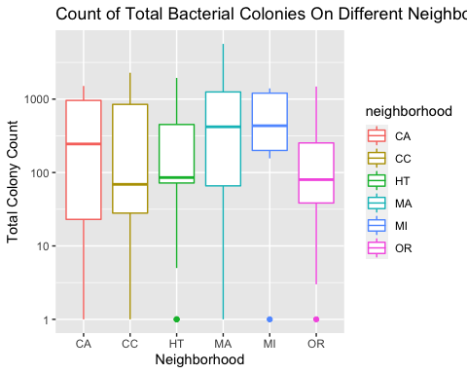

**Figure 1**: The total bacterial colony count was significantly different throughout the various San Francisco neighborhoods (ANOVA p < 0.05).

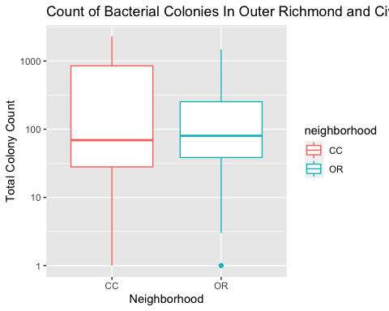

**Figure 2**: The total bacterial colony count was significantly different between Civic Center and Outer Richmond neighborhoods (t-test p < 0.05).

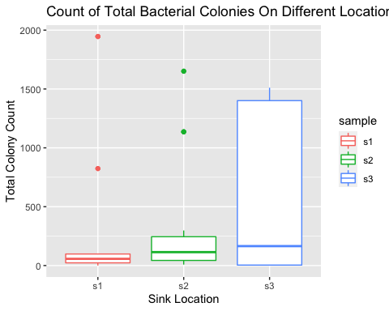

**Figure 3**: The total bacterial colony count was not significantly different between various sink locations (ANOVA p < 0.05).

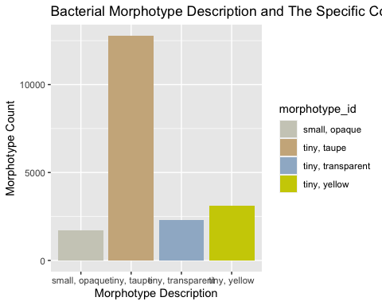

**Figure 4**: Barplot of the top ten morphotype descriptions.

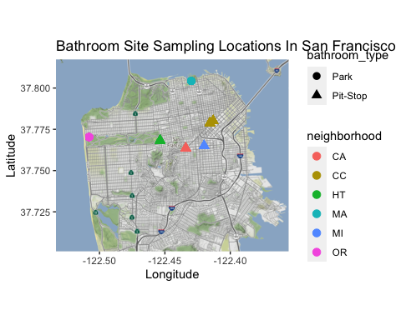

**Figure 5**: Sampled bathroom sites throughout San Francisco’s neighborhoods.

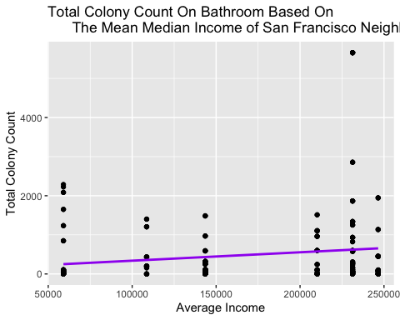

**Figure 6**: The total bacterial colony count was significantly different throughout the varied average income (p < 0.05).

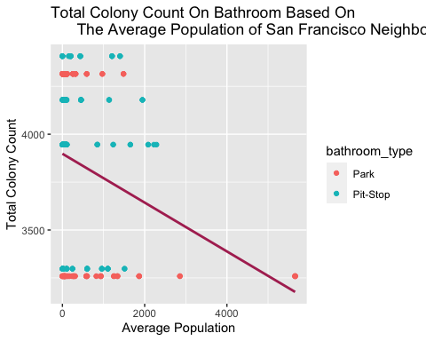

**Figure 7**: The total bacterial colony count was significantly different throughout the average population (p < 0.05).

# Sources Cited

Abney, S. E., K. R. Bright, J. McKinney, M. K. Ijaz, and C. P. Gerba. 2021. Toilet hygiene—review and research needs. Journal of applied microbiology 131:2705–2714.

Allaire, M., H. Wu, and U. Lall. 2018. National trends in drinking water quality violations. Proceedings of the National Academy of Sciences 115:2078–2083.

Amin, N., M. Rahman, S. Raj, S. Ali, J. Green, S. Das, S. Doza, M. H. Mondol, Y. Wang, M. A. Islam, and others. 2019. Quantitative assessment of fecal contamination in multiple environmental sample types in urban communities in dhaka, bangladesh using SaniPath microbial approach. PLoS One 14:e0221193.

Aykent, F., I. Yondem, A. G. Ozyesil, S. K. Gunal, M. C. Avunduk, and S. Ozkan. 2010. Effect of different finishing techniques for restorative materials on surface roughness and bacterial adhesion. The Journal of prosthetic dentistry 103:221–227.

Balazs, C. L., R. Morello-Frosch, A. E. Hubbard, and I. Ray. 2012. Environmental justice implications of arsenic contamination in california’s san joaquin valley: A cross-sectional, cluster-design examining exposure and compliance in community drinking water systems. Environmental Health 11:1–12.

Balazs, C. L., and I. Ray. 2014. [The drinking water disparities framework: On the origins and persistence of inequities in exposure](https://doi.org/10.2105/AJPH.2013.301664). American Journal of Public Health 104:603–611.

Gonzalez, E. A., P. Nandy, A. D. Lucas, and V. M. Hitchins. 2017. Designing for cleanability: The effects of material, surface roughness, and the presence of blood test soil and bacteria on devices. American Journal of Infection Control 45:194–196.

Heller, L., and others. 2019. Human rights to water and sanitation in spheres of life beyond the household with an emphasis on public spaces: Report of the special rapporteur on the human rights to safe drinking water and sanitation.

Kahle, D., and H. Wickham. 2013. [Ggmap: Spatial visualization with ggplot2](https://journal.r-project.org/archive/2013-1/kahle-wickham.pdf). The R Journal 5:144–161.

Kramer, A., I. Schwebke, and G. Kampf. 2006. How long do nosocomial pathogens persist on inanimate surfaces? A systematic review. BMC infectious diseases 6:1–8.

Lax, S., D. P. Smith, J. Hampton-Marcell, S. M. Owens, K. M. Handley, N. M. Scott, S. M. Gibbons, P. Larsen, B. D. Shogan, S. Weiss, and others. 2014. Longitudinal analysis of microbial interaction between humans and the indoor environment. Science 345:1048–1052.

Matini, E., F. Shayeghi, M. E. Vaghar, J. Nematian, S. S. Hosseini, N. Mojri, N. T. Taherabadi, R. Hakimi, N. Ahmadi, N. Badkoubeh, and others. 2020. A survey of public restrooms microbial contamination in tehran city, capital of iran, during 2019. Journal of Family Medicine and Primary Care 9:3131.

McDonald, Y. J., and N. E. Jones. 2018. Drinking water violations and environmental justice in the united states, 2011–2015. American Journal of Public Health 108:1401–1407.

Moreira, F. D., S. Rezende, and F. Passos. 2021. On-street toilets for sanitation access in urban public spaces: A systematic review. Utilities Policy 70:101186.

Otter, J. A., S. Yezli, J. A. G. Salkeld, and G. L. French. 2013. [Evidence that contaminated surfaces contribute to the transmission of hospital pathogens and an overview of strategies to address contaminated surfaces in hospital settings](https://doi.org/10.1016/j.ajic.2012.12.004). American Journal of Infection Control 41:S6–S11.

Pace, C., C. Balazs, K. Bangia, N. Depsky, A. Renteria, R. Morello-Frosch, and L. J. Cushing. 2022. [Inequities in drinking water quality among domestic well communities and community water systems, california, 2011‒2019](https://doi.org/10.2105/AJPH.2021.306561). American Journal of Public Health 112:88–97.

R Core Team. 2021. [R: A language and environment for statistical computing](https://www.R-project.org/). R Foundation for Statistical Computing, Vienna, Austria.

Reese, P. 2018. Does your water district fail to comply with drinking water standards. Sacramento Bee.

Rubin, S. J. 2013. [Evaluating violations of drinking water regulations.](https://search.ebscohost.com/login.aspx?direct=true&AuthType=shib&db=egs&AN=88479096&authtype=shib&site=ehost-live&scope=site&custid=s3818721) Journal: American Water Works Association 105:E137–E147.

Stanwell-Smith, R. 2010. [Public toilets down the drain? Why privies are a public health concern](https://doi.org/10.1016/j.puhe.2010.07.002). Public Health 124:613–616.

Stephens, B. 2016. What have we learned about the microbiomes of indoor environments? MSystems 1:e00083–16.

Stillo, F., and J. MacDonald Gibson. 2017. Exposure to contaminated drinking water and health disparities in north carolina. American Journal of Public Health 107:180–185.

Suen, L. K., G. K. Siu, Y. P. Guo, S. K. Yeung, K. Y. Lo, and M. O’Donoghue. 2019. The public washroom-friend or foe? An observational study of washroom cleanliness combined with microbiological investigation of hand hygiene facilities. Antimicrobial Resistance & Infection Control 8:1–6.

Walker, K., and M. Herman. 2022. [Tidycensus: Load US census boundary and attribute data as ’tidyverse’ and ’sf’-ready data frames](https://CRAN.R-project.org/package=tidycensus).

Wickham, H. 2016. [ggplot2: Elegant graphics for data analysis](https://ggplot2.tidyverse.org). Springer-Verlag New York.

Wickham, H., R. François, L. Henry, and K. Müller. 2022. [Dplyr: A grammar of data manipulation](https://CRAN.R-project.org/package=dplyr).

Works, S. F. P. 2014. San francisco pit stop.