Name :- Chodvadiya Sujal Hasmukhbhai
Roll No:- 2022BCS0187
Course:- CSS 426
Subject :- LAB 7

- GitHub repository link (with Jenkinsfile)
2022bcs0187-sujal/lab-7
- Successful pipeline run (name if the pipeline should be visible)
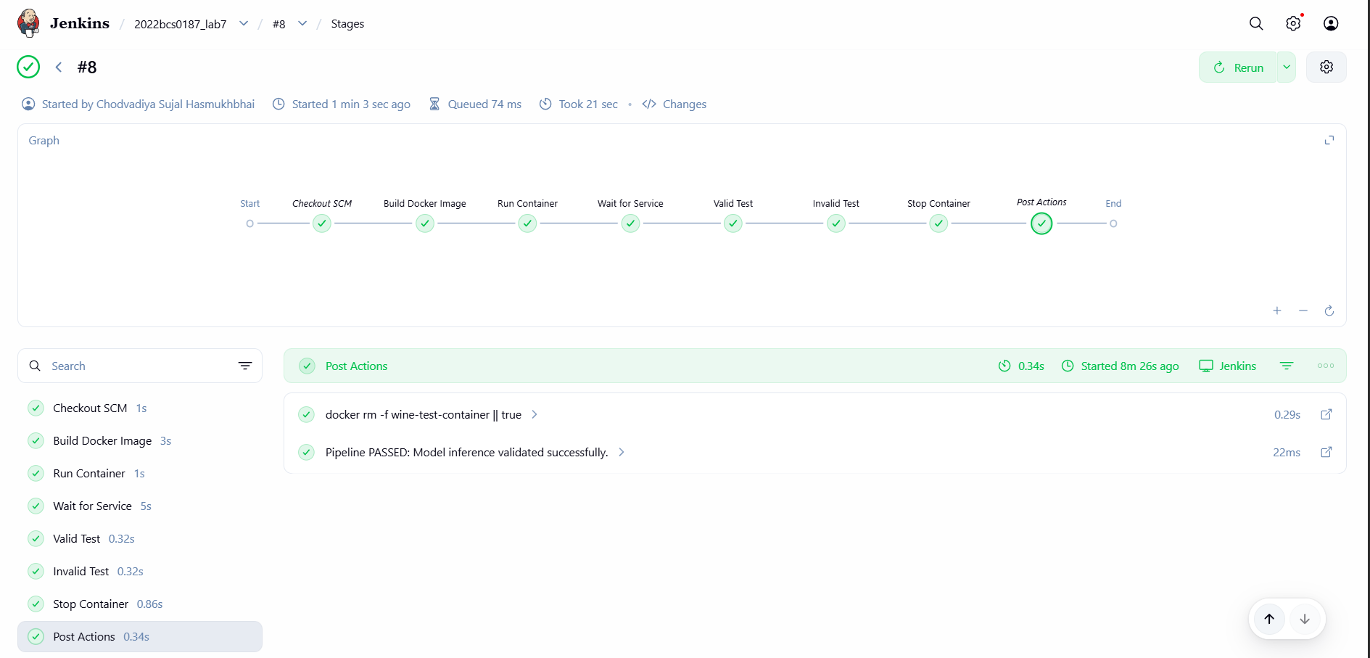
- Failed pipeline run (after induced error)
- Jenkins Console Logs

