|  |  |
| --- | --- |
| Name: Muhammad Boota | EE-272L Digital Systems Design |
| Reg. No.: 2022-EE-134 | Marks Obtained: ____________ |

**Lab Manual**

**Lab 3**

**Combinational Circuits: Structural Modeling Simulation**

**Question No.1**

**(a) Truthtable of the circuit**

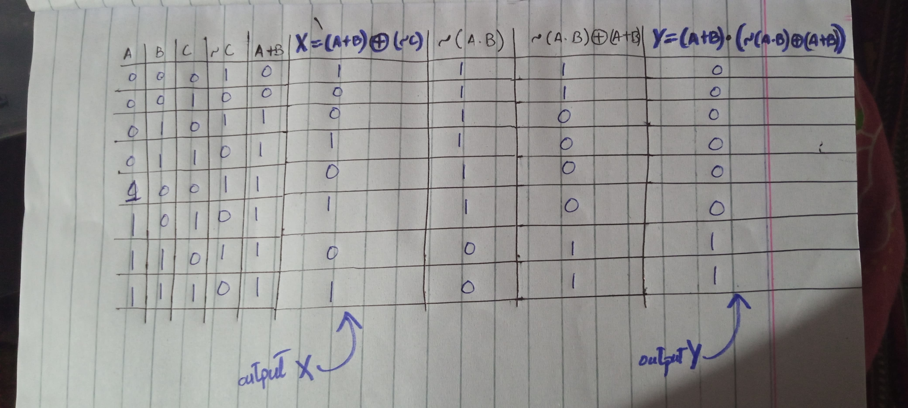

**(b)** **Maximum combinational delay:**



**From Figure path (from c to x) has the maximum combinational delay**

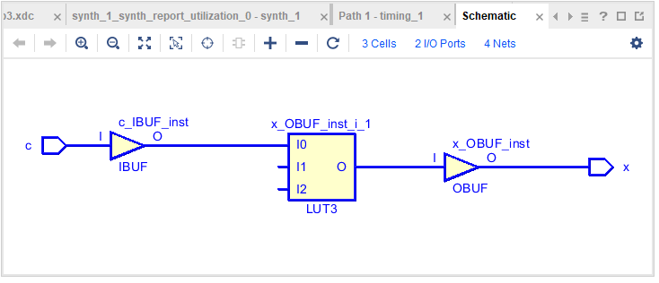

**(c) Resource Utilization:**

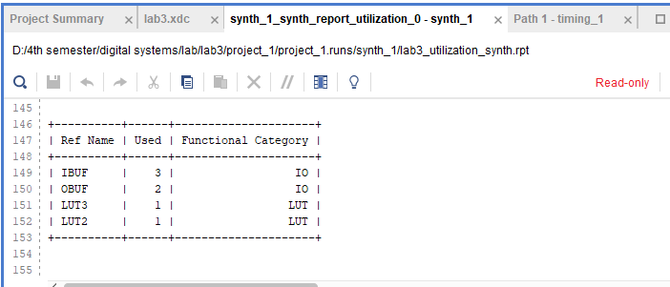

1. **No. of LUTs=2**
2. **No. of IOs=5**