|  |  |
| --- | --- |
| Name: Muhammad Boota | EE-272L Digital Systems Design |
| Reg. No.: 2022-EE-134 | Marks Obtained: ____________ |

**Lab Manual**

**Lab 4**

**Combinational Circuit Design using K-Map**

**Question No.1**

**(a) Truthtable of the circuit**

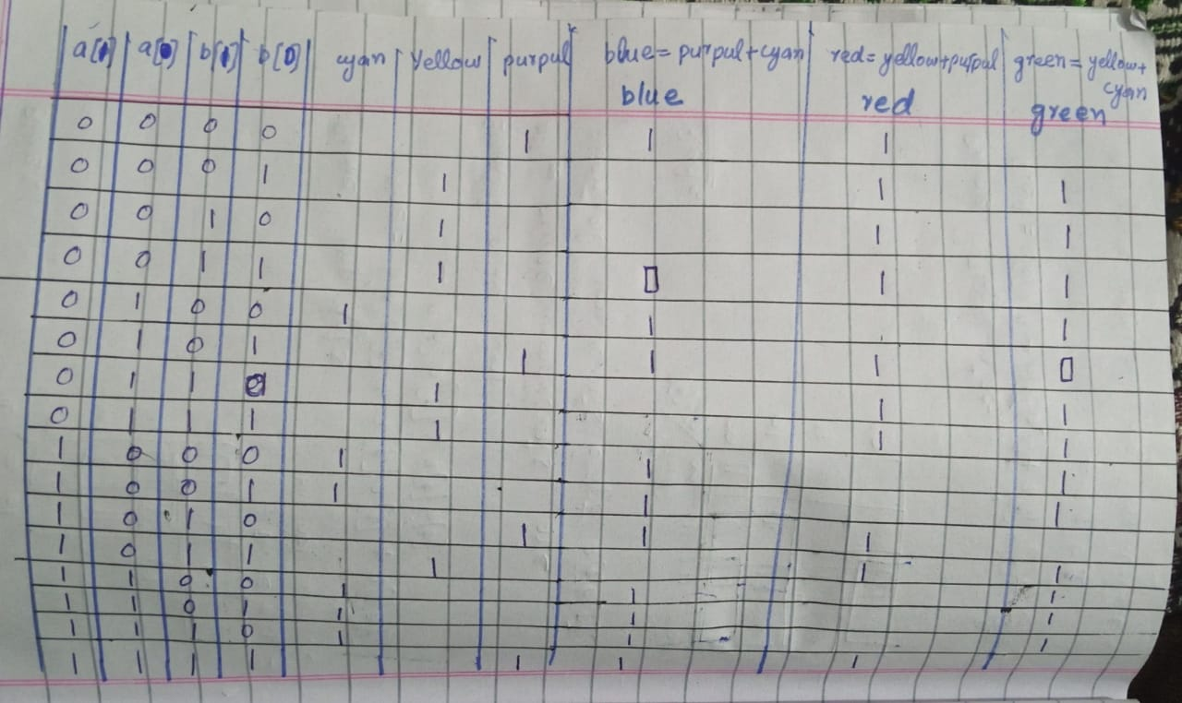

**(****b)K-maps used to minimize the logic**

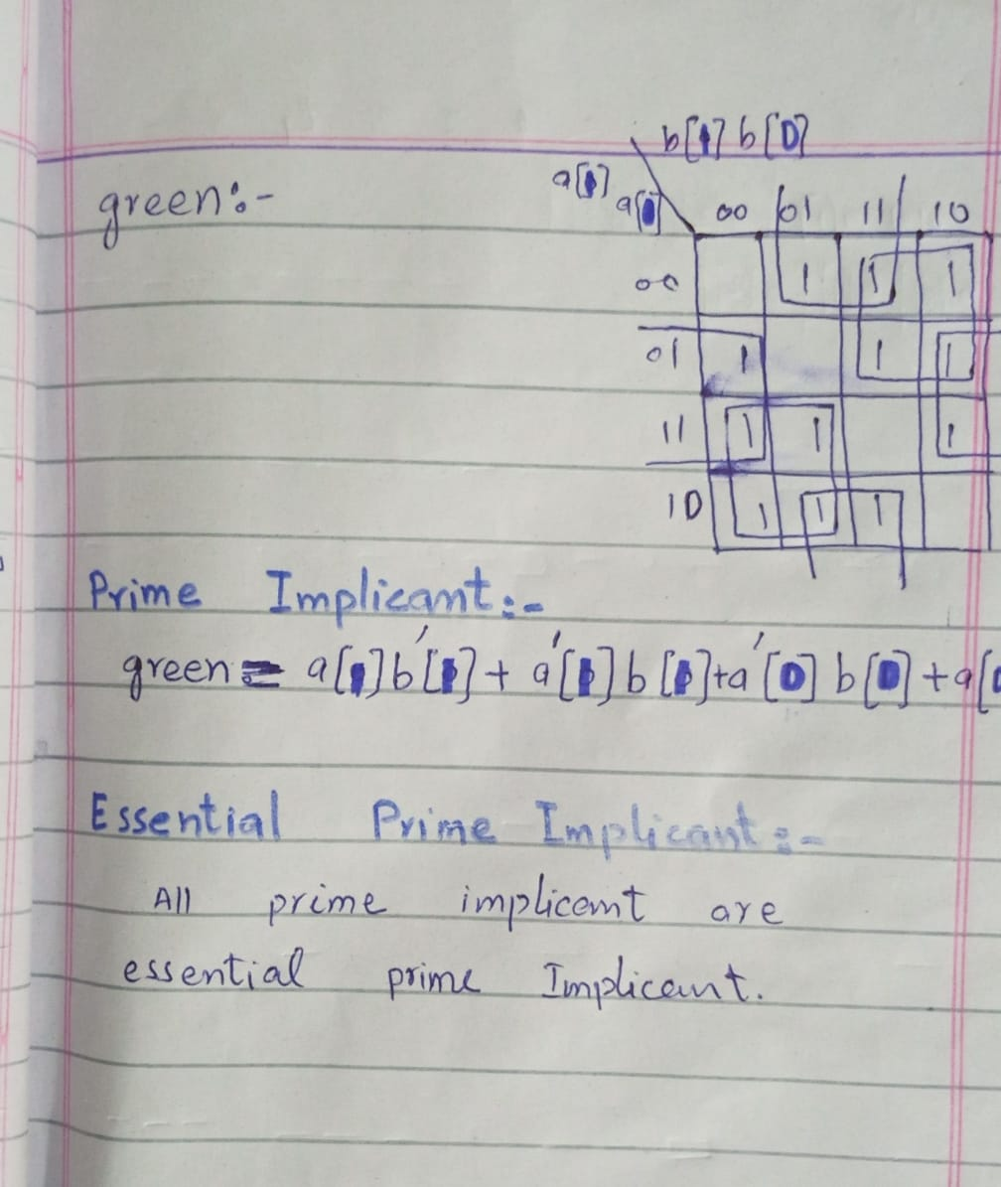

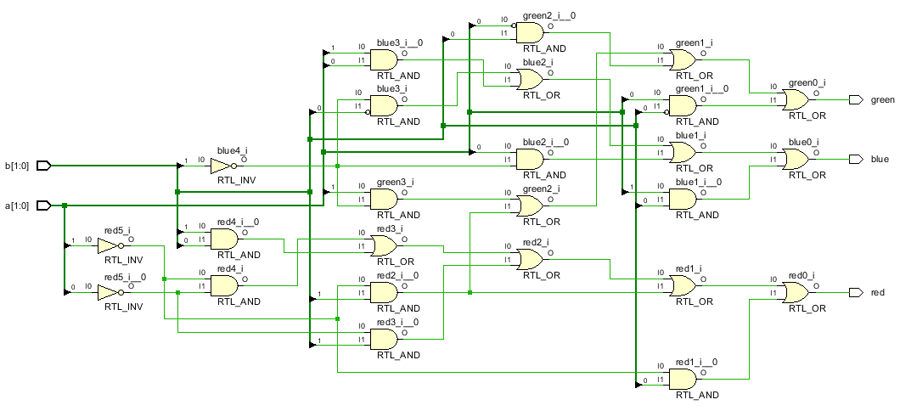**(d) Circuit diagram inferred by the Xilinx Vivado**

**(e)Maximum combinational delay in Synthesis:**

Maximum combinational delay is from a[1](input) to blue(output)

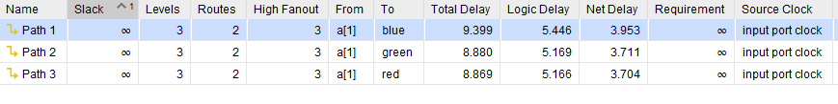 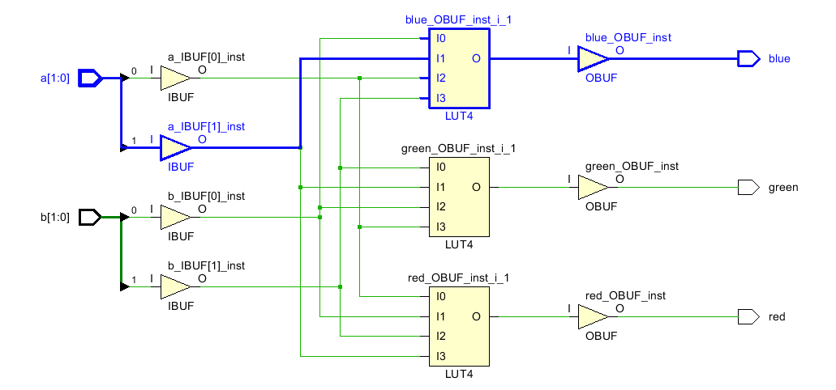

**(f) Resource Utilization**

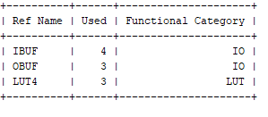

1. **No. of IOs=7**
2. **No. of LUTs=3**

**Question No.2**

1. **Truthtable of the circuit**

**(i)**

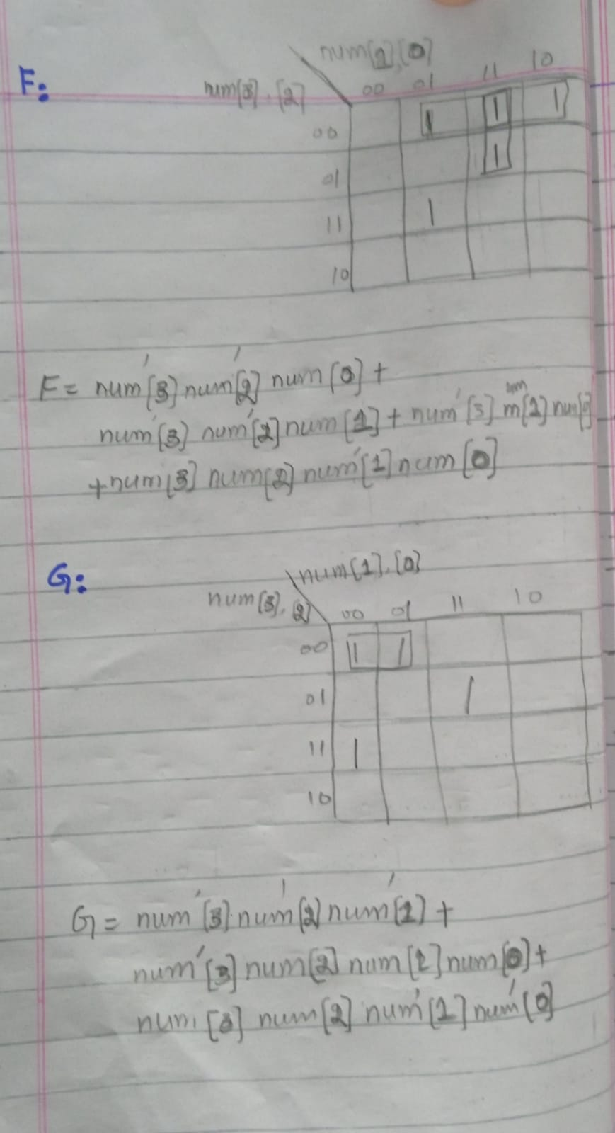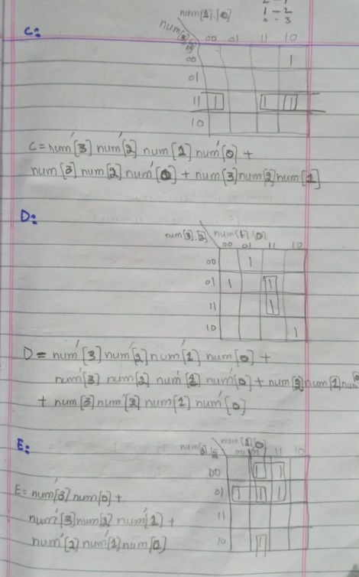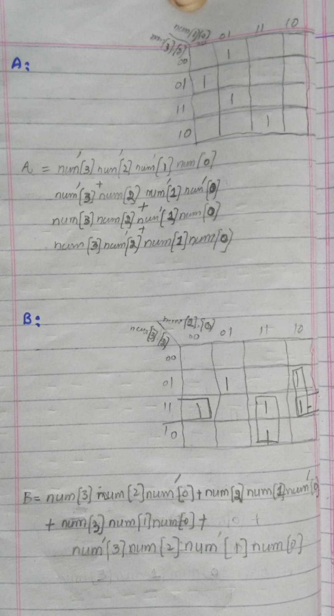**b)K-maps used to minimize the logic**

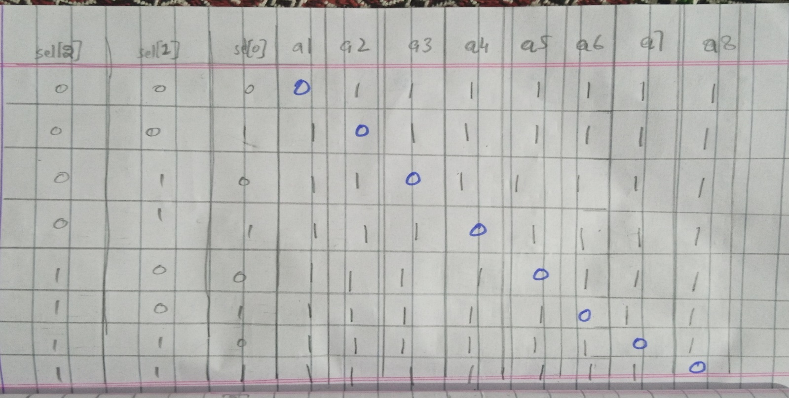**(ii)**

**b) K-maps used to minimize the logic**

