|  |  |
| --- | --- |
| Name: Muhammad Boota | EE-272L Digital Systems Design |
| Reg. No.: 2022-EE-134 | Marks Obtained: ____________ |

**Lab Manual**

**Lab 5**

1. **Truthtable of the circuit**

**(i)**

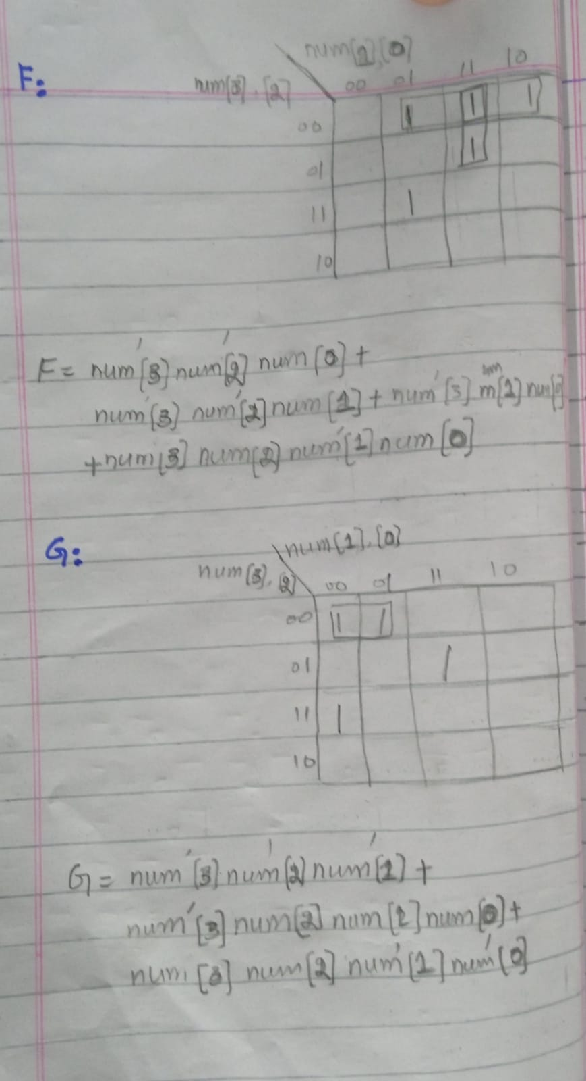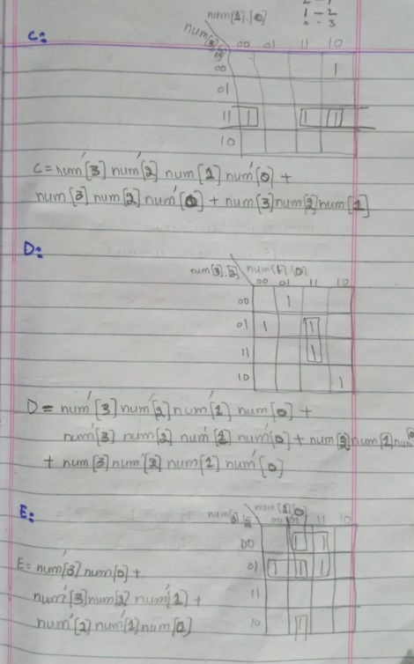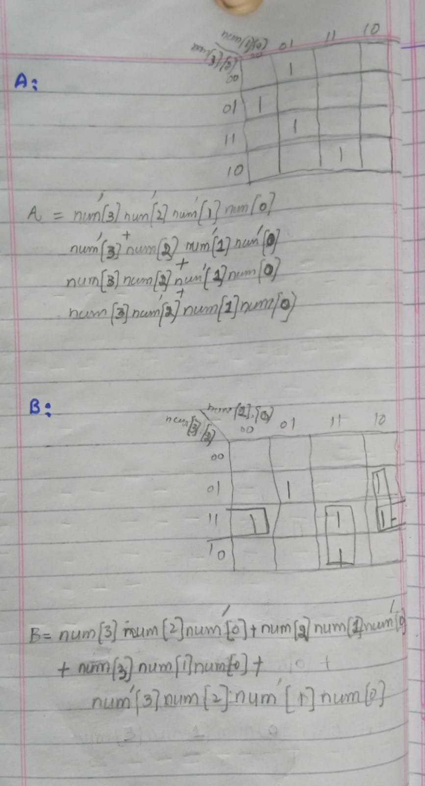**b)K-maps used to minimize the logic**

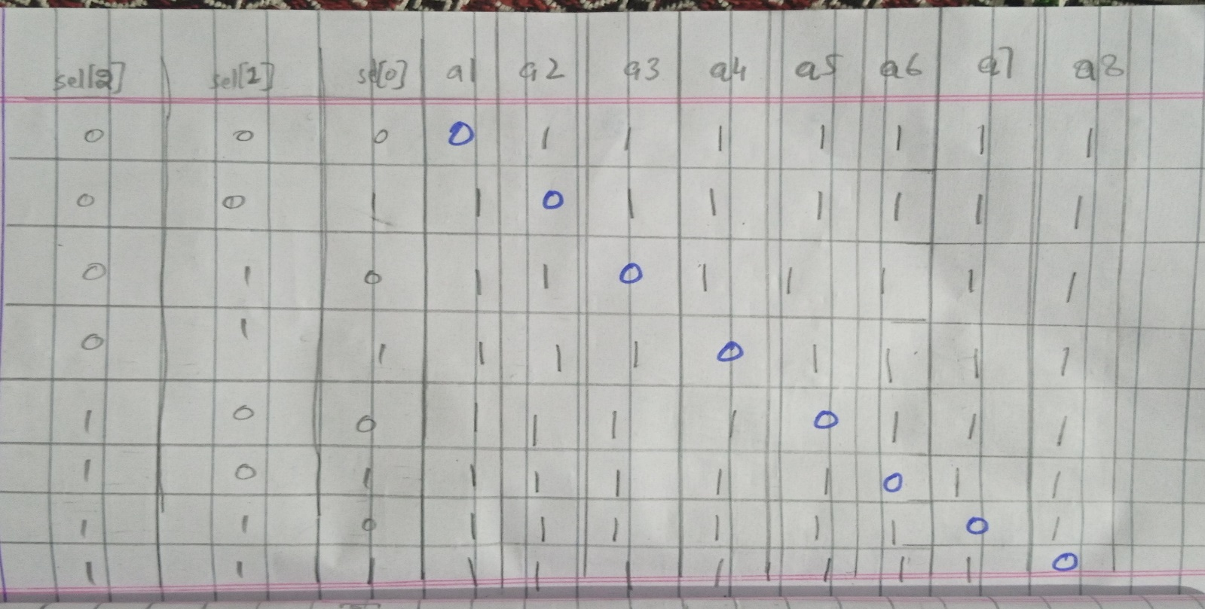**(ii)**

**b) K-maps used to minimize the logic**

