|  |  |  |  |  |  |  |  |  |  |  |  |  |  |  |  |  |
| --- | --- | --- | --- | --- | --- | --- | --- | --- | --- | --- | --- | --- | --- | --- | --- | --- |
| 画面  レイアウト | | | システム名 | | ユースケース名 | | | | | グループ名 | | 承認印 | | 作成日 | | 担当 |
| 図書管理 | | 資料予約 | | | | | B team | |  | | 5/18 | | 森田 |
| ver. | |
| 画面ＩＤ | | | 004-301 | | | | | | | | | | | | | |
| 画面名 | | | 会員Eメール入力（資料予約） | | | | | | | | | | | | | |
| 入力イラスト／入力方法など |  | | | | | | | | | | | | | | | |
| 部品説明 | 入出力項目 | | | | | | 説明 | | | | | | | | | |
| 会員Eメールアドレス | | | | | | 対象となる会員Eメールアドレスを入力するテキストボックス | | | | | | | | | |
|  | | | | | |  | | | | | | | | | |
|  | | | | | |  | | | | | | | | | |
|  | | | | | |  | | | | | | | | | |
|  | | | | | |  | | | | | | | | | |
|  | | | | | |  | | | | | | | | | |
| 操作 | | | | | | | | | | | | | | | | |
| 会員のEメールを入力し確認画面へボタンを押す・・・予約確認画面へ遷移する  Eメールが間違っていたり、入力されていない状態で確認ボタンを押す・・・予約確認エラーページへ移行する | | | | | | | | | | | | | | | | |
| 改定日 | | ／／ | | ／／ | | ／／ | | ／／ | ／／ | | ／／ | | ／／ | | ／／ | |
| 改定者 | |  | |  | |  | |  |  | |  | |  | |  | |

|  |  |  |  |  |  |  |  |  |  |  |  |  |  |  |  |  |
| --- | --- | --- | --- | --- | --- | --- | --- | --- | --- | --- | --- | --- | --- | --- | --- | --- |
| 画面  レイアウト | | | システム名 | | ユースケース名 | | | | | グループ名 | | 承認印 | | 作成日 | | 担当 |
| 図書管理 | | 資料予約 | | | | | B team | |  | | 5/18 | | 森田 |
| ver. | |
| 画面ＩＤ | | | 004-302 | | | | | | | | | | | | | |
| 画面名 | | | 予約確認ページ | | | | | | | | | | | | | |
| 入力イラスト／入力方法など |  | | | | | | | | | | | | | | | |
| 部品説明 | 入出力項目 | | | | | | 説明 | | | | | | | | | |
| 会員名 | | | | | | 資料を予約する会員の登録名が表示される | | | | | | | | | |
| 予約資料 | | | | | | 予約する資料情報が表示される | | | | | | | | | |
|  | | | | | |  | | | | | | | | | |
|  | | | | | |  | | | | | | | | | |
|  | | | | | |  | | | | | | | | | |
|  | | | | | |  | | | | | | | | | |
| 操作 | | | | | | | | | | | | | | | | |
| 予約ボタンを押す…予約完了画面へ遷移 | | | | | | | | | | | | | | | | |
| 改定日 | | ／／ | | ／／ | | ／／ | | ／／ | ／／ | | ／／ | | ／／ | | ／／ | |
| 改定者 | |  | |  | |  | |  |  | |  | |  | |  | |

|  |  |  |  |  |  |  |  |  |  |  |  |  |  |  |  |
| --- | --- | --- | --- | --- | --- | --- | --- | --- | --- | --- | --- | --- | --- | --- | --- |
| 画面  レイアウト | | | システム名 | | ユースケース名 | | | グループ名 | | | 承認印 | | 作成日 | | 担当者 |
| 図書管理 | | 資料予約 | | | B team | | |  | | 5/18 | | 森田 |
| ver. | |
| 画面ＩＤ | | | 004-303 | | | | | | | | | | | | |
| 画面名 | | | 予約完了 | | | | | | | | | | | | |
| 入力イラスト／入力方法など |  | | | | | | | | | | | | | | |
| 部品説明 | 入出力項目 | | | | | | | | 説明 | | | | | | |
|  | | | | | | | |  | | | | | | |
|  | | | | | | | |  | | | | | | |
|  | | | | | | | |  | | | | | | |
|  | | | | | | | |  | | | | | | |
|  | | | | | | | |  | | | | | | |
|  | | | | | | | |  | | | | | | |
| 操作 | | | | | | | | | | | | | | | |
| TOPボタンをクリック…管理者TOPページへ遷移 | | | | | | | | | | | | | | | |
| 改定日 | | ／／ | | ／／ | | ／／ | ／／ | | ／／ | ／／ | | ／／ | | ／／ | |
| 改定者 | |  | |  | |  |  | |  |  | |  | |  | |

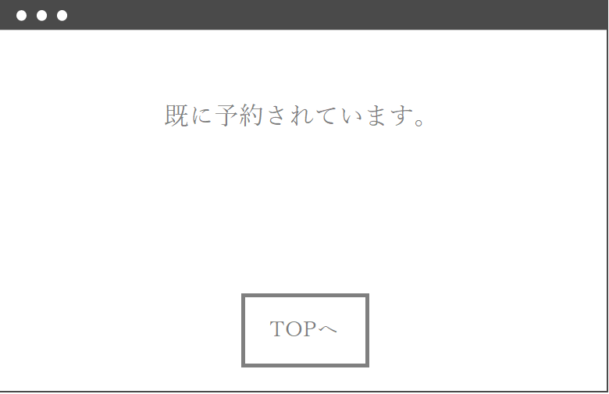

|  |  |  |  |  |  |  |  |  |  |  |  |  |  |  |  |
| --- | --- | --- | --- | --- | --- | --- | --- | --- | --- | --- | --- | --- | --- | --- | --- |
| 画面  レイアウト | | | システム名 | | ユースケース名 | | | グループ名 | | | 承認印 | | 作成日 | | 担当 |
| 図書管理 | | 資料予約 | | | B team | | |  | | ５/18 | | 森田 |
| ver. | |
| 画面ＩＤ | | | 004-304 | | | | | | | | | | | | |
| 画面名 | | | 予約例外 | | | | | | | | | | | | |
| 入力イラスト／入力方法など |  | | | | | | | | | | | | | | |
| 部品説明 | 入出力項目 | | | | | | | | 説明 | | | | | | |
|  | | | | | | | |  | | | | | | |
|  | | | | | | | |  | | | | | | |
|  | | | | | | | |  | | | | | | |
|  | | | | | | | |  | | | | | | |
|  | | | | | | | |  | | | | | | |
|  | | | | | | | |  | | | | | | |
| 操作 | | | | | | | | | | | | | | | |
| TOPボタンをクリック…管理者TOPページへ遷移 | | | | | | | | | | | | | | | |
| 改定日 | | ／／ | | ／／ | | ／／ | ／／ | | ／／ | ／／ | | ／／ | | ／／ | |
| 改定者 | |  | |  | |  |  | |  |  | |  | |  | |

|  |  |  |  |  |  |  |  |  |  |  |  |  |  |  |  |  |
| --- | --- | --- | --- | --- | --- | --- | --- | --- | --- | --- | --- | --- | --- | --- | --- | --- |
| 画面  レイアウト | | | システム名 | | ユースケース名 | | | | | グループ名 | | 承認印 | | 作成日 | | 担当 |
| 図書管理 | | 資料予約 | | | | | B team | |  | | 5/18 | | 森田 |
| ver. | |
| 画面ＩＤ | | | 004-305 | | | | | | | | | | | | | |
| 画面名 | | | 入力例外 | | | | | | | | | | | | | |
| 入力イラスト／入力方法など |  | | | | | | | | | | | | | | | |
| 部品説明 | 入出力項目 | | | | | | 説明 | | | | | | | | | |
|  | | | | | |  | | | | | | | | | |
|  | | | | | |  | | | | | | | | | |
|  | | | | | |  | | | | | | | | | |
|  | | | | | |  | | | | | | | | | |
|  | | | | | |  | | | | | | | | | |
|  | | | | | |  | | | | | | | | | |
| 操作 | | | | | | | | | | | | | | | | |
| TOPボタンをクリック…管理者TOPページへ遷移 | | | | | | | | | | | | | | | | |
| 改定日 | | ／／ | | ／／ | | ／／ | | ／／ | ／／ | | ／／ | | ／／ | | ／／ | |
| 改定者 | |  | |  | |  | |  |  | |  | |  | |  | |