**BIRLA INSTITUTE OF TECHNOLOGY & SCIENCE, PILANI**

**WORK INTEGRATED LEARNING PROGRAMMES**

Course Title: Cross Platform Application Development

Course No(s): SEZG585/SSZG585

Name: TEJAS S

BITS ID: 2022MT93226

Assignment – I

*Assignment Title:*

Flutter App with Back4App Integration

*Assignment Description:*

In this assignment, you will create a Flutter app that connects to Back4App, a Backend-as-a-Service (BaaS) platform, to manage tasks. You will be responsible for setting up the Back4App backend, creating the Flutter app, and implementing the necessary functionality to interact with the backend.

*GitHub URL:*

[***https://github.com/2022mt93226/Assignmet-Flutter-App-with-Back4App-Integration***](https://github.com/2022mt93226/Assignmet-Flutter-App-with-Back4App-Integration)

**Assignment Steps:**

***Step 1****: Set Up Back4App*

*Sign up for a Back4App account (if not already done).*

*Create a new Back4App app.*

*Create a class in Back4App named Task with columns title (String) and description (String).*

>> Opened a new Back4App Account with my email ID

>> I've created a new app on Back4App named "Flutter App" and defined a class called "Task" within it. This "Task" class is designed with columns for "title" (string type) and "description" (string type).

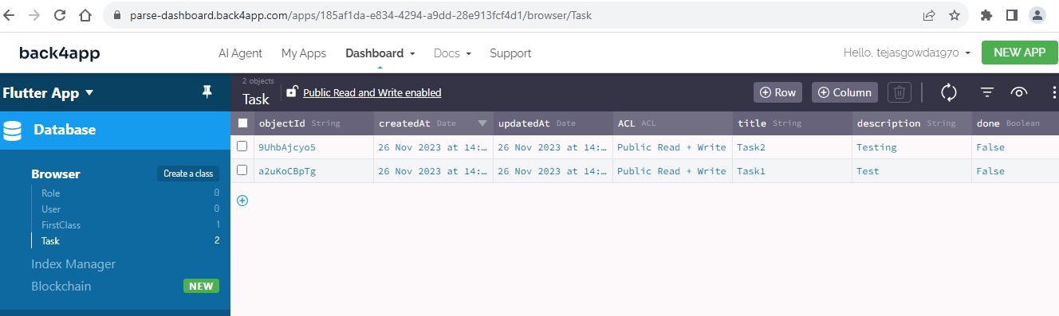

***Step 2:*** *Flutter Setup*

*Create a new Flutter project.*

*Add the required dependencies to your pubspec.yaml file.*

*Initialize the Parse SDK in your Flutter app.*

>> created a new flutter project by name – flutter_project

***flutter create <project_name>***

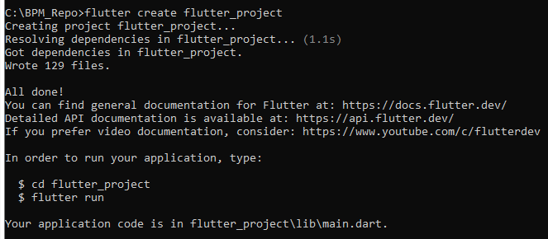

>> Added the required dependencies in pubspec.yaml file

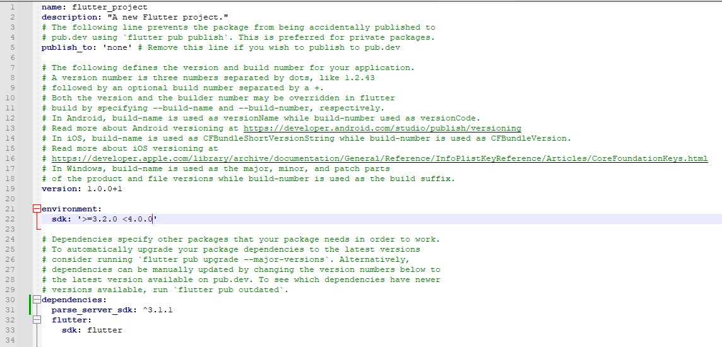

>> Ensured the system has the necessary tools and dependencies to run Flutter apps by running the below command

***flutter doctor***

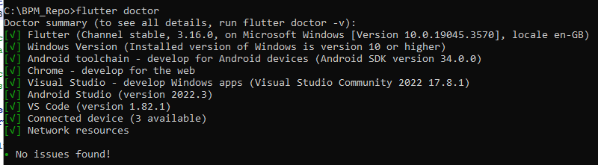

**>>** Installed dependencies listed in the pubsec.yaml file by running the below command

***flutter pub get***

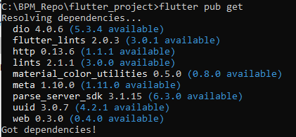

**>>** Started the Parse SDK by running the below command

***flutter run***

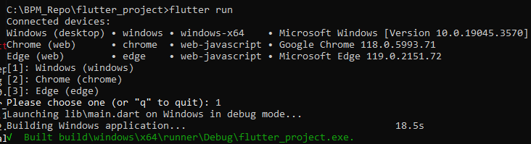

***Step 3:*** *Task List*

*Create a screen in your Flutter app to display a list of tasks.*

*Implement a function to fetch tasks from Back4App using the Back4App API.*

*Display the tasks in a list view with titles and descriptions.*

>> Created a screen to display the list of tasks

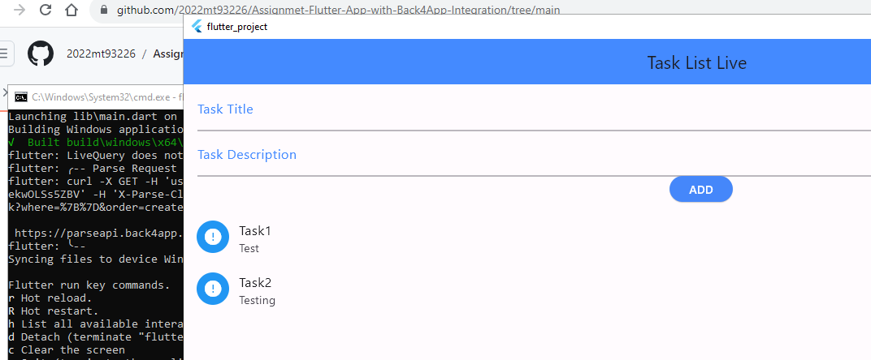

>> Function to fetch tasks from Back4App

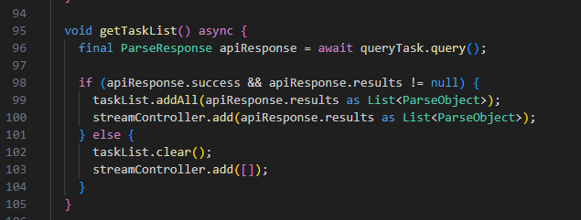

>>Tasks in a list view with titles and descriptions

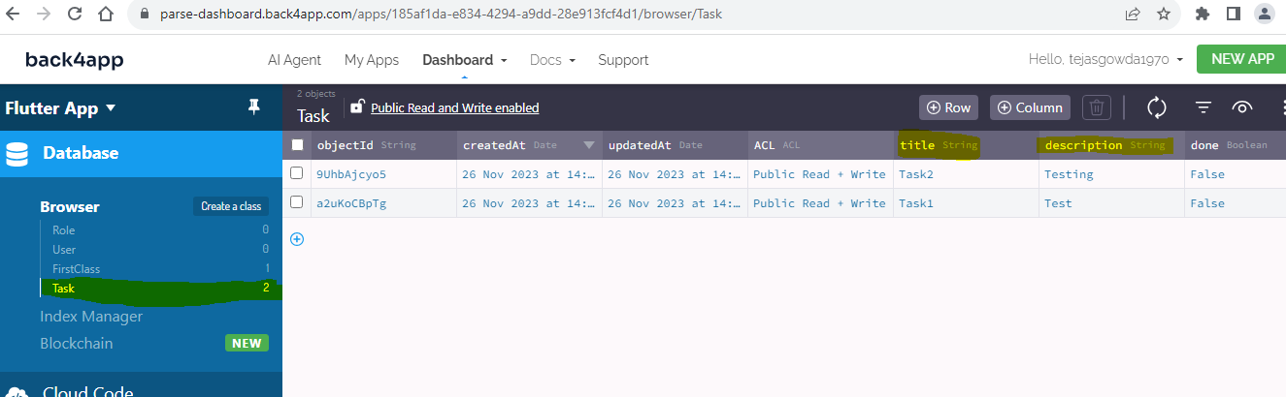

***Step 4:*** *Task Creation (10 points)*

*Create a screen for adding new tasks.*

*Implement functionality to create and save tasks to Back4App.*

*Verify that newly created tasks appear in the task list****.***

>> Created a screen for adding new tasks

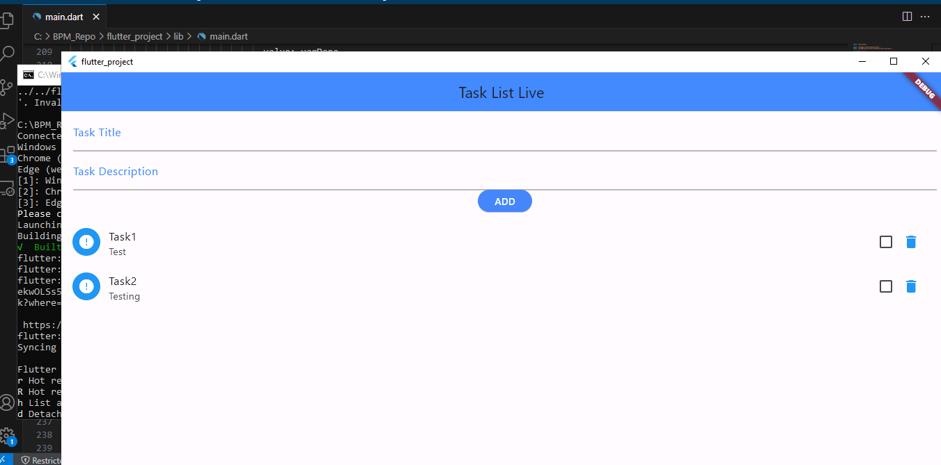

>> Function to create and save tasks

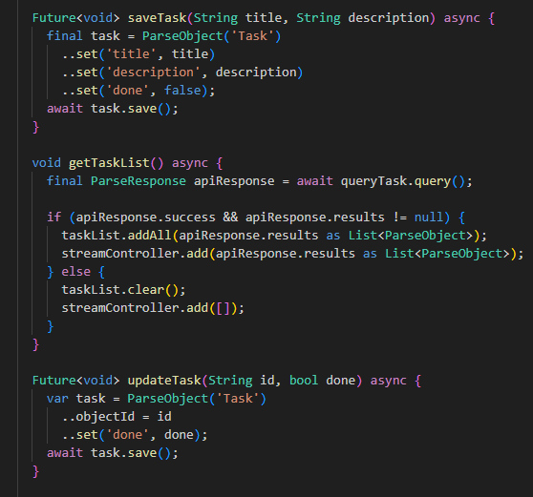

>> Verified adding of task 3 into the task list

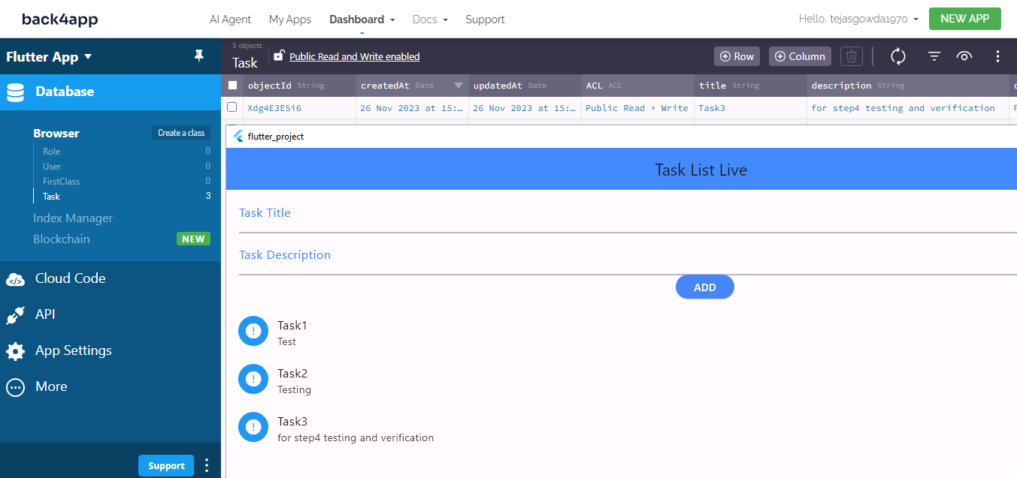

***Step 5:*** *Task Details*

*Add a feature to view task details when a task is tapped in the task list.*

*Display the title and description of the selected task.*

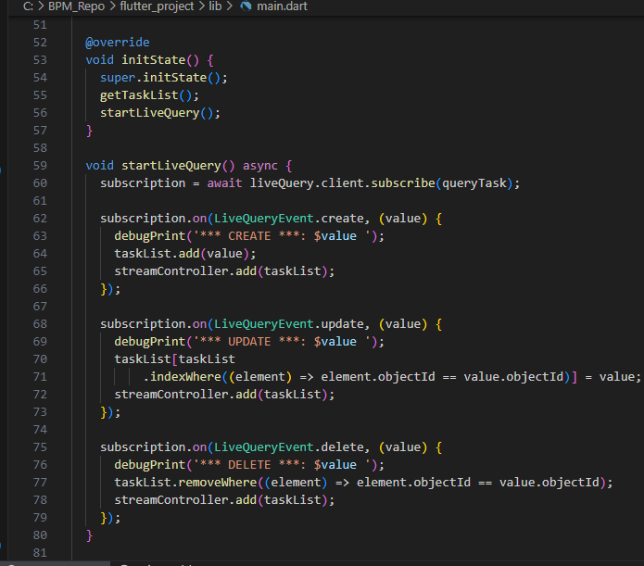



***Step 6:*** *Bonus Features*

*Add a feature to edit and update existing tasks.*

*Implement a feature for task deletion.*

*Add any additional features or enhancements you like.*

>> Function to update tasks

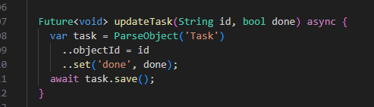

>> Function to delete tasks

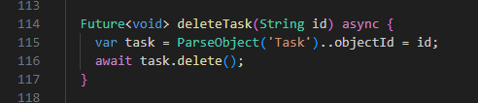

>> Additional Features

