CSE475 Machine Learning – Task 1 Report
Data EDA and Related Work on the BUSI-WHU Breast Ultrasound Dataset
Group | Group08
Members | Maharun Nesa Tanni (2023-1-60-190); Kh. Tania Akter Tamanna (2023-2-60-070)
Track | Track 3 – CNN + Attention
Dataset | BUSI-WHU Breast Cancer Ultrasound Image Dataset (Mendeley Data, DOI 10.17632/k6cpmwybk3.3, CC BY 4.0)
Repository | [GitHub repository link]

1. Dataset and problem
BUSI-WHU was collected at Renmin Hospital of Wuhan University (Dec 2020 – Dec 2022) and approved by the hospital ethics committee (WDRY2022-K217). Each image contains a breast tumour with an expert pixel-level mask, and the patient file gives the benign/malignant label, patient index, pixel-per-cm scale and tumour measurements. We treat it as a binary image-classification problem (benign vs malignant), with the masks used to check that the attention model looks at the lesion.
Item | Value (from our notebook)
Total images / patients | 927 images, 816 patients (patient_index in the patient file)
Classes | Benign 560 (60.4%), malignant 367 (39.6%); ratio 1.53 : 1
Format / colour | BMP, 8-bit grayscale (mode L) for all 927 images
Masks | 927 / 927 matched, none empty
Image size | Width 243–2400 px (median 433); height 233–1947 px (median 401)
Physical scale | 57–480 pixel/cm (median 98), four scale groups (40–80: 234, 80–120: 255, 120–160: 209, 160–200: 229 images)
Missing labels / exact duplicates | 0 / 0
Problem type | Binary classification (+ tumour segmentation masks available)

2. Exploratory data analysis (A–G)

A. Summary
The table in Section 1 is our summary table. The dataset is small (927 images), single-channel, and every image has a usable mask and label. One patient can have several images, which matters for splitting (Section 3).

B. Class balance
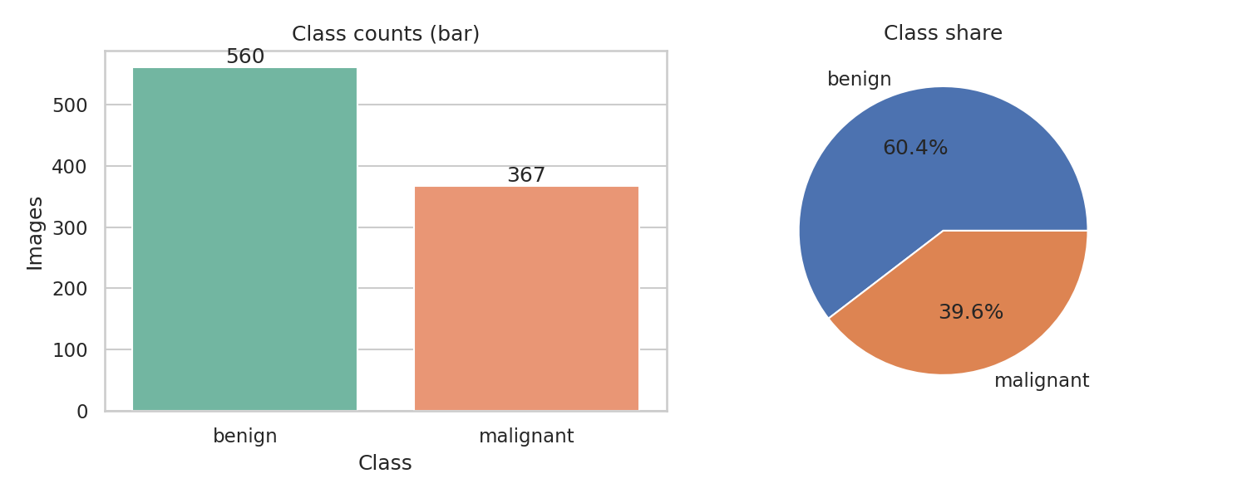
Figure 1. Class counts (bar) and class share (pie).
Reading: benign is the larger class (560 vs 367). The imbalance is moderate (1.53 : 1), so a model that always predicts benign would already get 60.4% accuracy. We therefore report macro-F1, per-class recall, ROC-AUC and PR-AUC, and use stratified splits with class weights.

C. Labelled sample grid
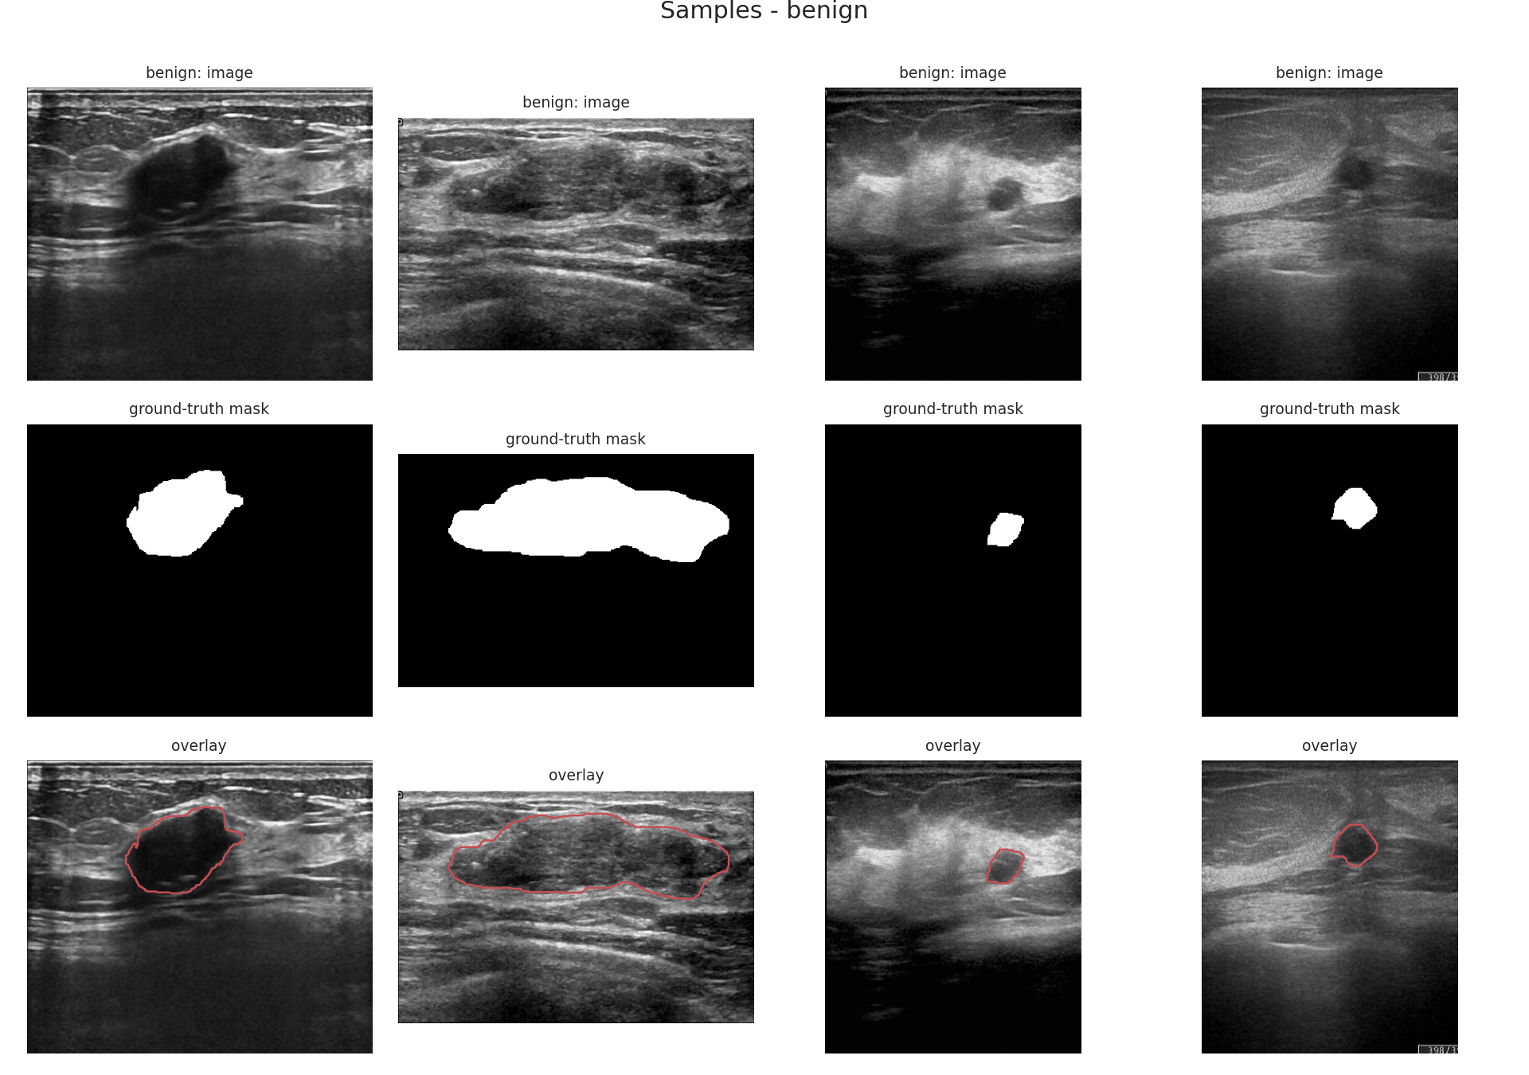
Figure 2. Benign samples: image, ground-truth mask, overlay.
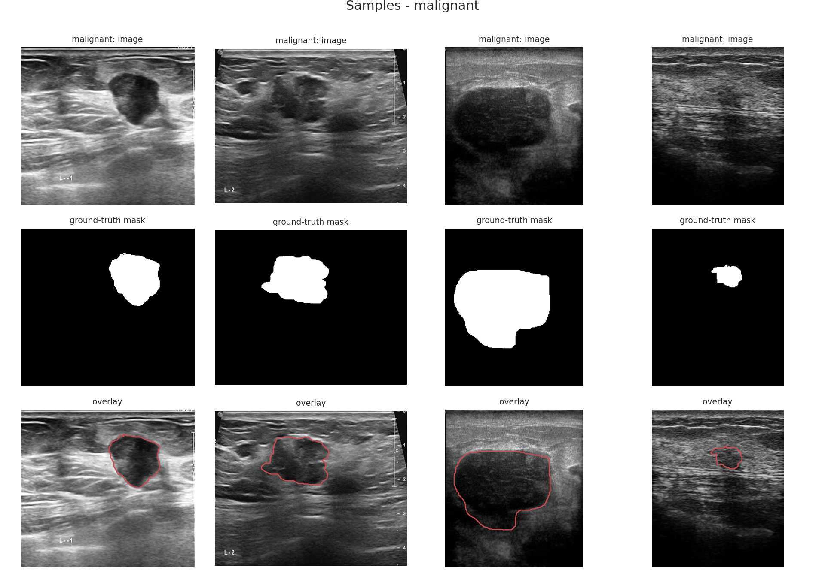
Figure 3. Malignant samples: image, ground-truth mask, overlay.
Reading: the masks follow the dark lesion well. Benign lesions in the grid are mostly smoother and rounder; malignant ones are larger with more irregular borders. The border is not always clear, because speckle noise and shadowing make some benign and malignant cases look alike, so a visual rule alone will not separate the classes.

D. Size and resolution
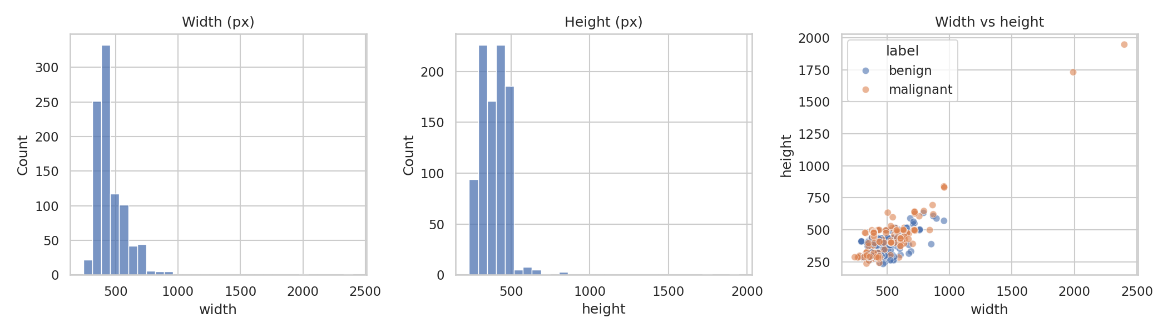
Figure 4. Width, height and width-vs-height of all images.
Reading: most images are around 430 × 400 px, but sizes vary a lot (aspect ratio 0.68–2.2) and two malignant images (10014-3 and 10014-4) are far larger (about 2000–2400 px wide). The pixel-per-cm scale also varies from 57 to 480, so the same pixel size means different physical sizes. We will resize with padding to a fixed input (e.g. 224 × 224) to keep the tumour shape, and note that size in pixels is not a clean cue.

E. Pixel and colour statistics
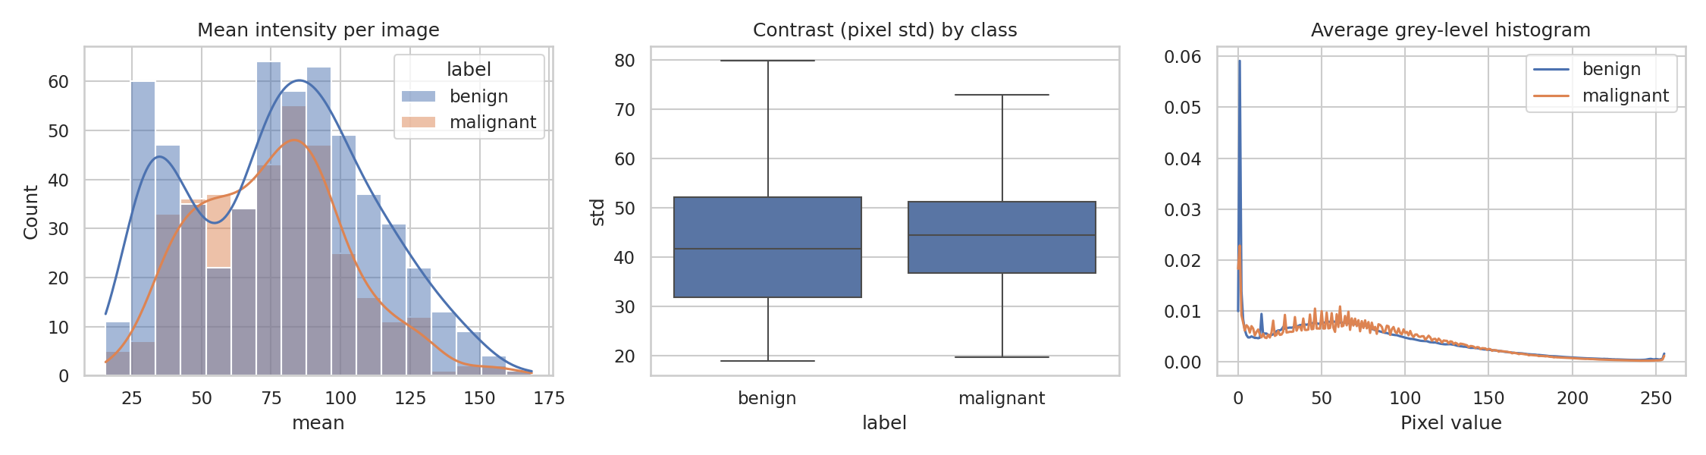
Figure 5. Mean intensity, contrast by class and average grey-level histogram.
Reading: all images are grayscale (R = G = B). Mean intensity is 77 ± 31 (range 15.6–168.7) and contrast (pixel std) is 43.5 ± 12. The mean-intensity histogram has two peaks, because 52 images are very dark (mean < 30). The grey-level histogram has a large spike at 0 from black borders and shadows. Benign and malignant have almost the same intensity (mean 78.0 vs 75.6) and contrast (43.2 vs 44.0), so brightness does not separate the classes. We will normalise each image and use mild brightness/contrast augmentation.

F. Image quality
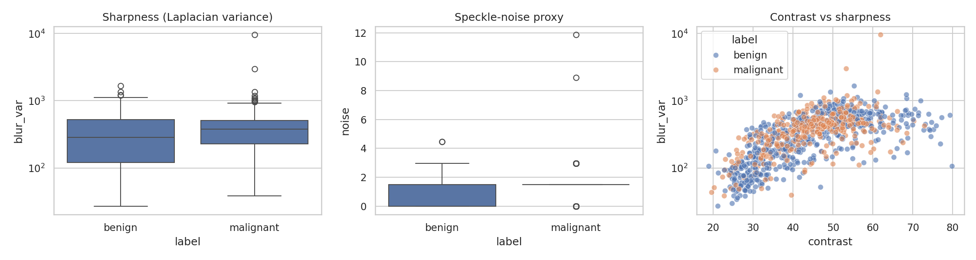
Figure 6. Sharpness, speckle-noise proxy and contrast vs sharpness.
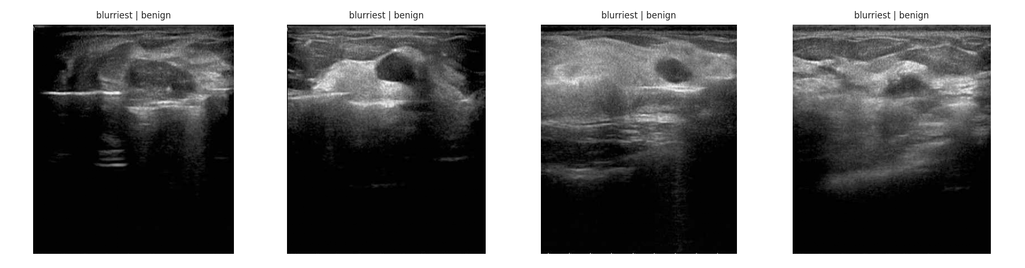
Figure 7. The four blurriest images (all benign, dark and low contrast).
Reading: sharpness (Laplacian variance) has median 341 (range 27–9570) and rises with contrast (corr. 0.68 on log scale). The noise proxy is low (mean 1.25) with two outliers near 9 and 12. The blurriest images are dark and low contrast, but they still show a visible lesion, so we keep them rather than delete them. We found no exact duplicates (MD5). Seven images share a coarse 8×8 average hash, but they belong to different patients and look different, so we treat them as coincidences and still group by patient when splitting.

G. Interactive plots
The notebook contains Plotly plots (brightness vs contrast, width by class, sharpness by class, resolution map) with hover on image name, to find outliers such as the very dark images and the two very large images. They also confirm that the two classes overlap heavily on simple image statistics.

Mask and tumour analysis
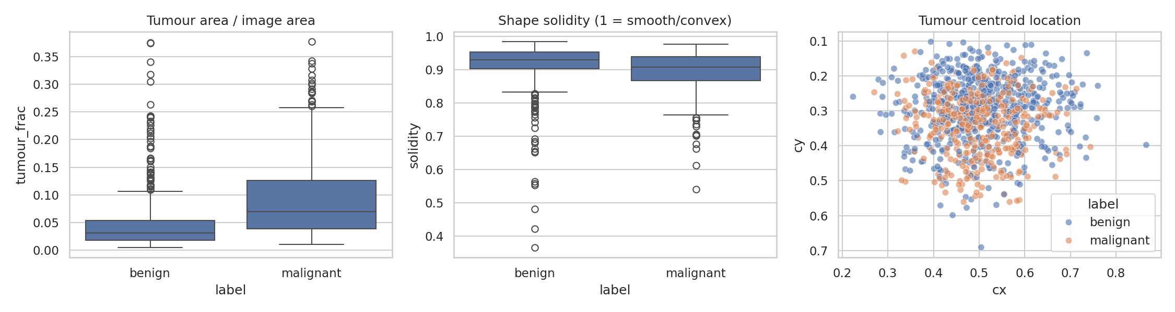
Figure 8. Tumour area fraction, shape solidity and centroid location.
Reading: malignant tumours are larger (median area fraction 0.070 vs 0.032; median area 1.25 cm² vs 0.56 cm²) and slightly less convex (median solidity 0.907 vs 0.930). Tumours sit mostly near the centre and upper part of the image (mean centroid x = 0.50, y = 0.31) for both classes, so position gives no shortcut. 89 masks have more than one region and 48 have solidity below 0.8 (very irregular), which matters when we build region graphs. Tumour size is a strong cue, so a model could learn size alone; the ablation in Task 3 should check this.
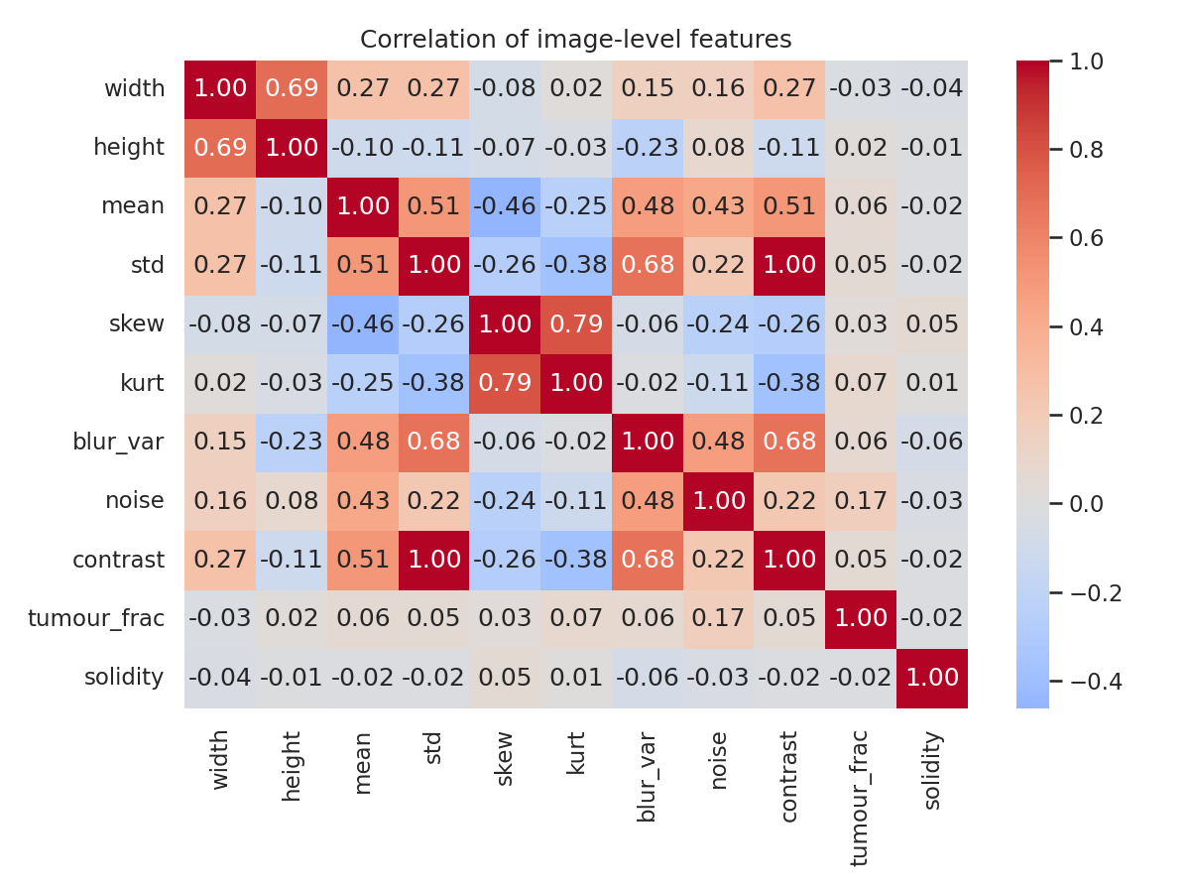
Figure 9. Correlation of image-level features.
Reading: std and contrast are identical (r = 1.00), skew and kurtosis move together (0.79), width and height correlate (0.69), and sharpness follows contrast (0.68). Tumour area and solidity are almost unrelated to intensity features, so mask-based shape features add new information.

3. Data-integrity plan (rule 6.2)
- Split by patient. 778 patients have one image and 38 patients have 2–9 images (149 images in total). No patient has mixed labels. We will use StratifiedGroupKFold / GroupShuffleSplit with patient_index so one patient never appears in both train and test.
- Fit normalisation and any augmentation statistics only on the training data after the split.
- Do not use file names, patient index or the xlsx tumour measurements as model inputs (they leak size and label information).
- Judge by macro-F1 and per-class recall, not accuracy.

4. Related work and research gap
We reviewed five recent open-access papers (the full table with all required columns is in related_work/Group08_BUSIWHU_related_work_table.pdf, and the PDFs are in related_work/papers/).
Paper | Year / venue | Dataset | Method | Relation / limit
Node-based GCN with SLIC for breast US classification (Trang et al.) | 2024, IEEE Access | BUSI, BUS-BRA | SLIC superpixel graph + GCN | Graph-based classification reference; whole-image superpixels
Malignancy pattern analysis with clinical features and GCN (Montaha et al.) | 2024, Digital Health | Breast US sets | Feature-node graph + GCN / GAT | Graph of markers, not image regions
HyFormer-Net: CNN–Transformer with multi-scale fusion (Rahman) | 2025, arXiv | BUSI | EfficientNet-B3 + Swin + attention gates | Attention ablation + Grad-CAM; preprint, no BUSI-WHU
Hybrid Attention Network for breast tumour segmentation (Aslam et al.) | 2025, arXiv | BUSI, UDIAT | DenseNet121 + spatial / self / semantic attention | Attention ablation + Friedman test; segmentation only
DDTransUNet: dual-branch, dual-attention Transformer + CNN (Zhang et al.) | 2024, Frontiers in Physiology | TN3K, CAMUS and one more US set | Swin + CNN, spatial + channel attention, cross-attention fusion | Spatial vs channel attention reference; not breast-specific
Also reviewed (abstract level, paywalled): DSATNet (Medical Physics 2025) and DFLNet (Digital Signal Processing 2025) use BUSI-WHU, for segmentation only.
Research gap. (1) The BUSI-WHU papers we found (DSATNet, DFLNet) do segmentation only; we found none that benchmark benign-vs-malignant classification on BUSI-WHU. (2) Graph methods for breast ultrasound use other datasets and whole-image superpixel (Trang et al.) or hand-made feature graphs (Montaha et al.), not graphs built from tumour regions. (3) Patient-grouped evaluation, 5-fold CV with a significance test, and explainability are rarely reported together: only Aslam et al. test significance and only HyFormer-Net uses Grad-CAM.
Our contribution. A patient-grouped, leakage-free comparison of CNN baselines and our proposed CNN with an attention module (Track 3) on BUSI-WHU, with ablation (with / without attention, channel vs spatial), 5-fold CV, a significance test and XAI (Grad-CAM and LIME).

5. Conclusion and plan for Task 2
- BUSI-WHU is a clean, grayscale ultrasound dataset with complete masks and labels, moderately imbalanced (60/40), with varied size, scale and brightness.
- Main risks are patient leakage (38 patients with several images), tumour-size shortcut and the pixel-scale variation; we handle them with patient-grouped stratified folds, macro-F1 and a size ablation.
- Task 2: CNN baselines (Simple CNN, ResNet50, DenseNet121, EfficientNet-B0), then our own CNN with an attention module (e.g. SE / CBAM), with precision, recall, F1, confusion matrix, ROC and PR curves.

References
[1] Dataset: BUSI_WHU, Mendeley Data, V3, doi:10.17632/k6cpmwybk3.3, 2025.
[2] Trang et al., Node-based graph convolutional network with SLIC method for breast cancer ultrasound images classification, IEEE Access, vol. 12, 2024, doi:10.1109/ACCESS.2024.3488188.
[3] Montaha et al., Malignancy pattern analysis of breast ultrasound images using clinical features and a graph convolutional network, Digital Health, 2024.
[4] Rahman, HyFormer-Net: A synergistic CNN-Transformer with interpretable multi-scale fusion for breast lesion segmentation and classification in ultrasound images, arXiv:2511.01013, 2025.
[5] Aslam, Naveed and Ahmed, Hybrid attention network for accurate breast tumor segmentation in ultrasound images, arXiv:2506.16592, 2025.
[6] Zhang et al., A dual-branch and dual attention transformer and CNN hybrid network for ultrasound image segmentation, Frontiers in Physiology, vol. 15, 2024, doi:10.3389/fphys.2024.1432987.
[7] DSATNet, Dual branch segment anything model-transformer fusion network for accurate breast ultrasound image segmentation, Medical Physics, 2025 (abstract level).
[8] DFLNet, Disentangled feature learning network for breast cancer ultrasound image segmentation, Digital Signal Processing, 2025 (abstract level).

