KIDS’ THURSDAYS
at the Fabyan Villa Museum
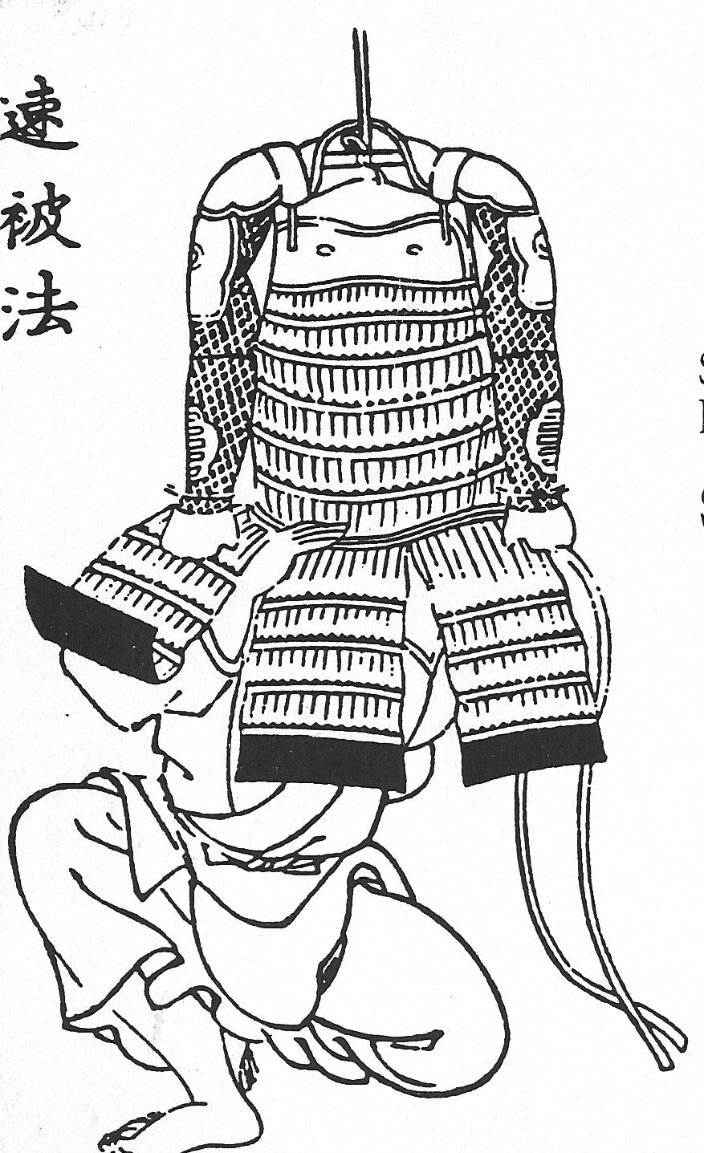
1:00-4:00pm

Every Thursday June-August
Self-guided Mystery Tour
Special Programs on these dates:

June 28th: MAKING AND BREAKING CODES
July 12th: MYSTERIES: THE MUMMY& MORE
July 26th: THEN & NOW--life a century ago
August 2nd: JAPANESE CULTURE FOR KIDS
- Ages 5 – 12 only
- Program begins at 2:00 p.m.
- Program participation fee-$3.00 each

The Fabyan Villa Museum and Japanese Garden are located
in the Fabyan Forest Preserve
--Rte. 31 Geneva, IL
Operated by
Preservation Partners
of the Fox Valley.
Find more info at:
630/377-6424
www.ppfv.org

Operated by
Preservation Partners
of the Fox Valley.
Find more info at:
630/377-6424
www.ppfv.org

KIDS’ THURSDAYS
at the Fabyan Villa Museum
1:00-4:00pm

Every Thursday June-August
Self-guided Mystery Tour
Special Programs on these dates:

June 28th: MAKING AND BREAKING CODES
July 12th: MYSTERIES: THE MUMMY& MORE
July 26th: THEN & NOW--life a century ago
August 2nd: JAPANESE CULTURE FOR KIDS
- Ages 5 – 12 only
- Program begins at 2:00 p.m.
- Program participation fee-$3.00 each

The Fabyan Villa Museum and Japanese Garden are located
in the Fabyan Forest Preserve
--Rte. 31 Geneva, IL

KIDS’ THURSDAYS
at the Fabyan Villa Museum
1:00-4:00pm

Every Thursday June-August
Self-guided Mystery Tour
Special Programs on these dates:

June 28th: MAKING AND BREAKING CODES
July 12th: MYSTERIES: THE MUMMY& MORE
July 26th: THEN & NOW--life a century ago
August 2nd: JAPANESE CULTURE FOR KIDS
- Ages 5 – 12 only
- Program begins at 2:00 p.m.
- Program participation fee-$3.00 each

The Fabyan Villa Museum and Japanese Garden are located
in the Fabyan Forest Preserve
--Rte. 31 Geneva, IL
Operated by
Preservation Partners
of the Fox Valley.
Find more info at:
630/377-6424
www.ppfv.org

Operated by
Preservation Partners
of the Fox Valley.
Find more info at:
630/377-6424
www.ppfv.org

KIDS’ THURSDAYS
at the Fabyan Villa Museum
1:00-4:00pm

Every Thursday June-August
Self-guided Mystery Tour
Special Programs on these dates:

June 28th: MAKING AND BREAKING CODES
July 12th: MYSTERIES: THE MUMMY& MORE
July 28th: THEN & NOW--life a century ago
August 2nd: JAPANESE CULTURE FOR KIDS
- Ages 5 – 12 only
- Program begins at 2:00 p.m.
- Program participation fee-$3.00 each

The Fabyan Villa Museum and Japanese Garden are located
in the Fabyan Forest Preserve
--Rte. 31 Geneva, IL

