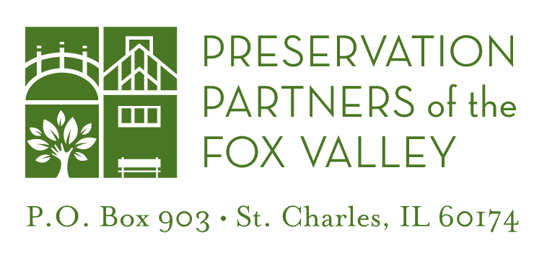

**Agenda**

Wednesday, May 1, 2019

1:00 PM

At the Durant House Museum – Leroy Oaks Forest Preserve

1. Introductions
2. Liquor Licensing for Farm-To-Table event at Durant House
3. Site
   1. Landscaping
   2. Tree removal
   3. Branches on roof
   4. General planting plans for Summer 2019
4. New Durant Garden
   1. Location
   2. Water access
5. Air Conditioner at Sholes
   1. Timing
   2. Unit type, details
6. Mice Management
7. Temperature Monitoring
8. Building Maintenance
   1. Coordination and funding
   2. Proposed projects
9. Signage
   1. Sholes sign update
   2. Wayfinding
10. Future Meetings
11. Miscellaneous