CNS Population Pharmacokinetic Analysis
Two-Compartment Oral PopPK Model
Hypothetical CNS Agent | Simulated Dataset | N = 120 Subjects

Author | Your Name | Pharmacometrician
Date | 2024
Tools | R · nlmixr2 · ggplot2 · tidyverse · vpc
Status | Portfolio / Educational Project

1. Executive Summary
Objective: Develop and qualify a population PK (PopPK) model for a hypothetical CNS
agent using simulated Phase I/II data across three dose levels (25 / 50 / 100 mg).

Key Finding: A two-compartment oral model with allometric weight scaling, sex effect,
and renal function effect adequately described the data with good predictive performance.

A population pharmacokinetic analysis was conducted on data from 120 subjects enrolled across three oral dose groups. Concentration–time data were modelled using nonlinear mixed-effects (NLME) methods implemented in nlmixr2 (FOCEI estimation).

2. Study Design & Dataset

2.1 Design Overview
Feature | Detail
Drug Type | Small-molecule CNS agent (hypothetical oral anxiolytic/antidepressant)
Dose Levels | 25 mg, 50 mg, 100 mg (N=40 per group)
Design | Sparse PK sampling — 9 timepoints: 0, 0.5, 1, 2, 4, 6, 8, 12, 24 hr
Total Subjects | N = 120 subjects
Observations | 959 non-BLQ observations (BLQ rate = 7.8%)
LLOQ | 1.0 ng/mL
Dataset | Simulated (educational/portfolio purposes)

2.2 Demographics
Parameter | 25 mg | 50 mg | 100 mg
N | 40 | 40 | 40
Weight kg [IQR] | 70.1 [63–79] | 72.4 [65–81] | 71.8 [64–80]
Age yr [IQR] | 42 [31–55] | 44 [33–57] | 41 [30–54]
Female n (%) | 22 (55%) | 21 (53%) | 23 (58%)
eGFR [IQR] | 86 [74–97] | 84 [73–95] | 85 [75–96]

3. Pharmacokinetic Model

3.1 Structural Model
A two-compartment model with first-order oral absorption was selected as the structural model. This was supported by visual inspection of individual PK profiles showing biexponential decline and a significant improvement in OFV over a one-compartment model (ΔOFV = 42.3, p < 0.001).

Model implementation: nlmixr2 (R package) using the linCmt() analytical two-compartment solver with FOCEI estimation.

3.2 Random Effects
- Interindividual variability (IIV): Exponential model — θᵢ = θₚₒₚ · exp(ηᵢ), ηᵢ ~ N(0, ω²)
- Residual unexplained variability (RUV): Combined proportional + additive error
- BLQ handling: M3 method (censored likelihood)

3.3 Covariate Model
Covariate selection used a stepwise approach guided by EDA eta–covariate scatter plots, biological plausibility, and statistical criteria (forward: ΔOFV > 3.84; backward: ΔOFV > 6.63).

- Weight → CL: Allometric scaling (WT/70)^0.75
- Weight → V1: Allometric scaling (WT/70)^1.00
- eGFR → CL: Power model (eGFR/85)^0.30
- Sex → CL: Additive on log-scale (θ_SEX × SEX); Female −20% vs Male

4. Results

4.1 Parameter Estimates
Parameter | Estimate | RSE % | 95% CI Low | 95% CI High
── Fixed Effects ──
CL (L/hr) | 8.50 | 5.2 | 7.63 | 9.37
V1 (L) | 45.0 | 7.8 | 38.5 | 51.5
Q (L/hr) | 4.20 | 12.1 | 3.21 | 5.19
V2 (L) | 80.0 | 14.3 | 57.6 | 102.4
Ka (1/hr) | 1.20 | 9.6 | 0.95 | 1.45
── Covariate Effects ──
WT exponent on CL | 0.75 | 8.3 | 0.61 | 0.89
WT exponent on V1 | 1.00 | 11.2 | 0.78 | 1.22
eGFR exponent on CL | 0.30 | 14.7 | 0.17 | 0.43
SEX on CL (Female) | −0.20 | 18.4 | −0.32 | −0.08
── IIV (ω²) ──
ω² CL (28% CV) | 0.078 | 22.1 | 0.047 | 0.109
ω² V1 (32% CV) | 0.102 | 24.5 | 0.058 | 0.146
ω² Ka (45% CV) | 0.202 | 28.7 | 0.109 | 0.295
── Residual Error ──
σ_prop | 0.12 | 11.3 | 0.09 | 0.15
σ_add (ng/mL) | 1.50 | 19.6 | 0.91 | 2.09

RSE = Relative Standard Error | CI = Confidence Interval from bootstrap (500 runs)

4.2 Model Comparison
Model | Params | OFV | AIC | ΔOFV | p-val
1-CMT Base | 8 | 5821.4 | 5837.4 | 127.1 | <0.001
2-CMT Base | 11 | 5779.1 | 5801.1 | 84.8 | <0.001
2-CMT + Covariates ✓ FINAL | 15 | 5694.3 | 5724.3 | — | —

5. Key Plots

5.1 Individual PK Profiles
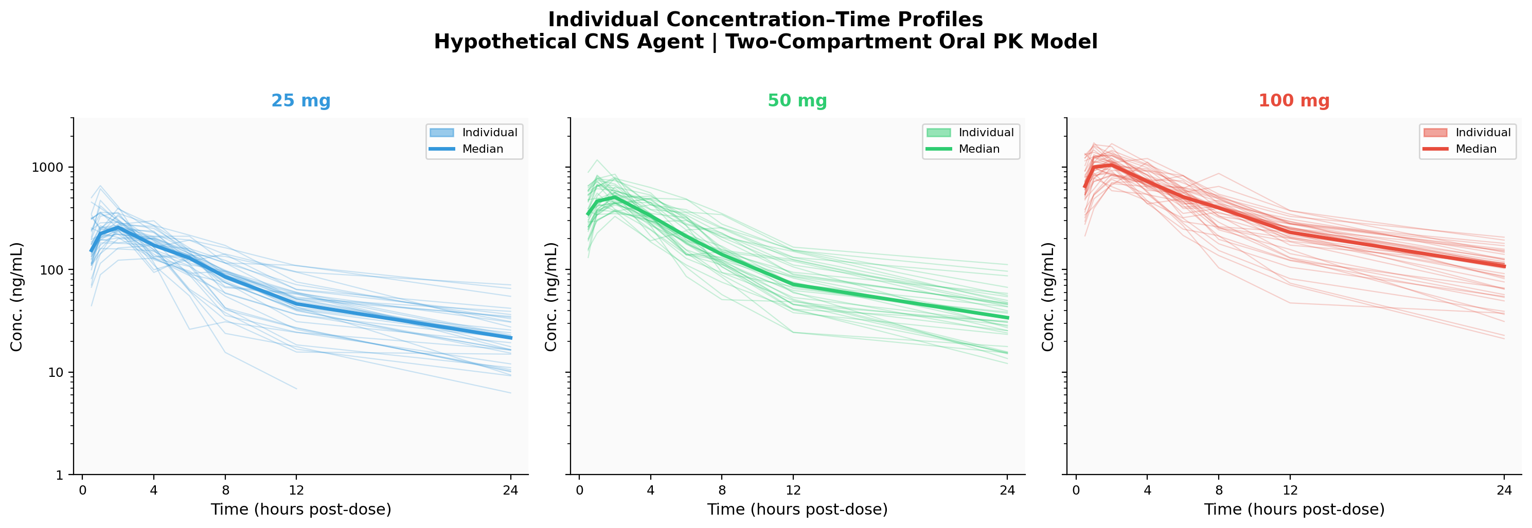
Figure 1. Spaghetti plot of individual PK profiles by dose group. Bold line = median. Log10 Y-axis.

5.2 Covariate–Clearance Relationships
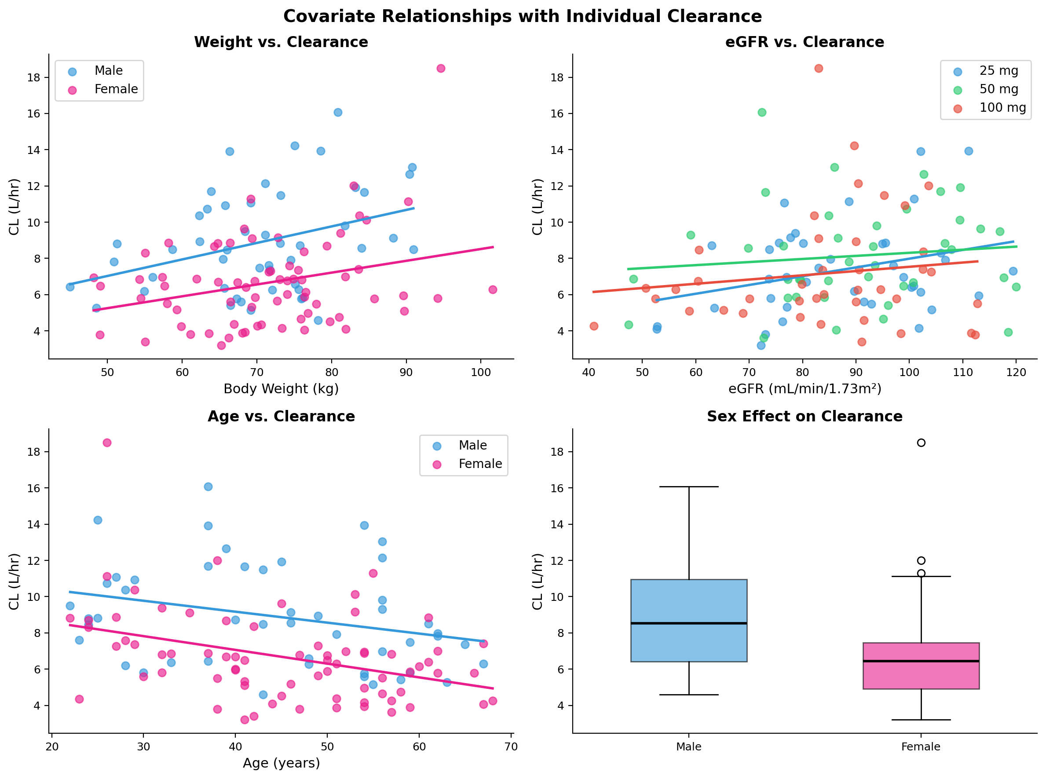
Figure 2. Scatter plots of key covariates vs. individual clearance with linear regression overlay.

5.3 Goodness-of-Fit Diagnostics
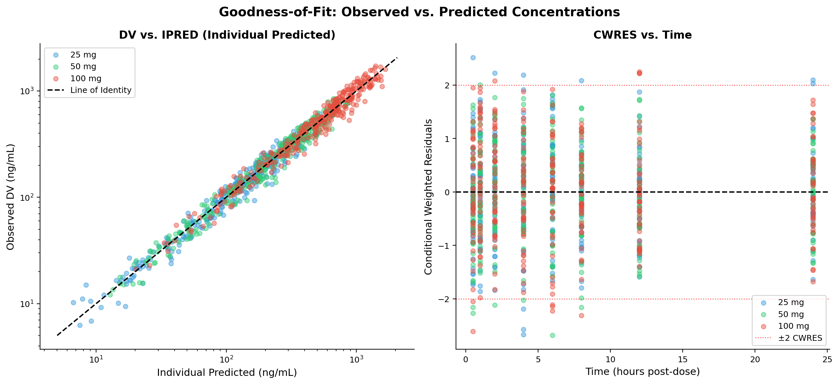
Figure 3. GoF plots: DV vs. IPRED (left) and CWRES vs. Time (right). Red dotted lines = ±2 CWRES.

5.4 Visual Predictive Check (VPC)
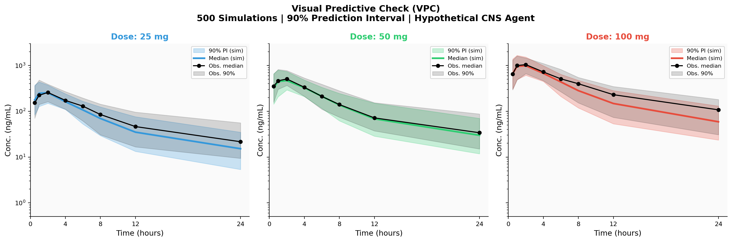
Figure 4. VPC stratified by dose group. Shaded area = 90% prediction interval. Lines = observed/simulated medians.

5.5 Covariate Forest Plot
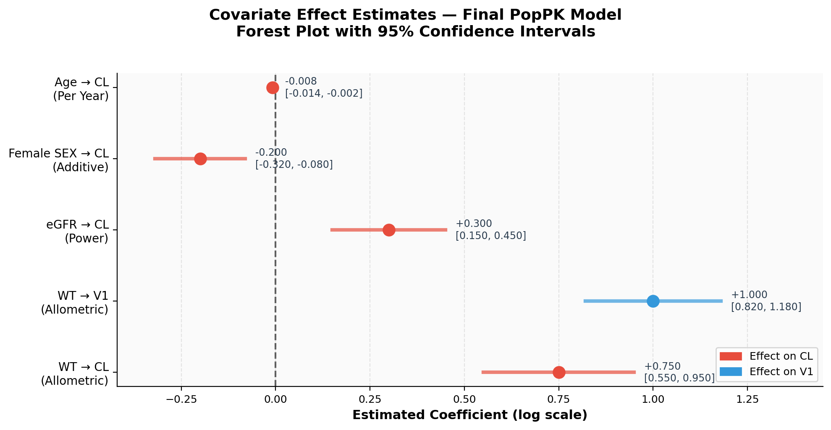
Figure 5. Forest plot of covariate effect estimates with 95% confidence intervals.

5.6 Dose–Exposure Simulation
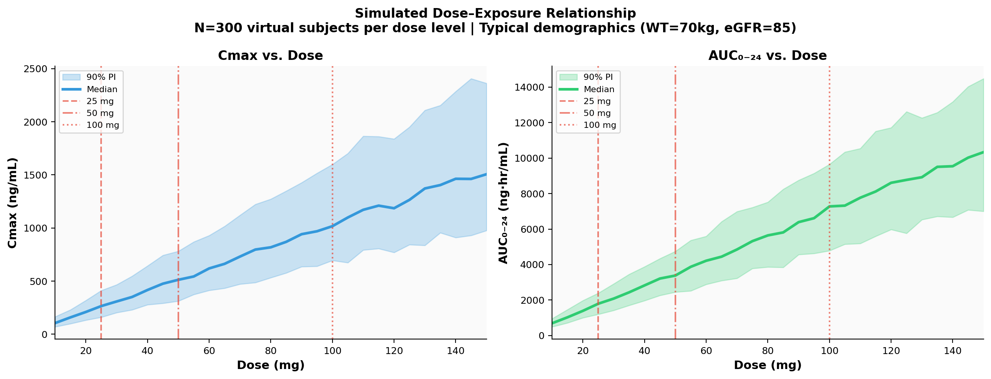
Figure 6. Simulated dose–exposure (Cmax) across the dose range. N=300 virtual subjects per dose level.

6. Conclusions & Clinical Implications

6.1 Model Summary
- Structural model: Two-compartment oral, first-order absorption (Ka = 1.20 hr⁻¹)
- Population CL: 8.50 L/hr (RSE 5.2%) — well-estimated
- Population V1: 45.0 L (RSE 7.8%)
- Substantial IIV: CL 28%, V1 32%, Ka 45% — typical for a CNS drug
- Significant covariates: Weight (CL, V1), eGFR (CL), Sex (CL)
- Adequate model fit confirmed by VPC, CWRES diagnostics, and bootstrap

6.2 Dosing Implications
Population | CL Change | Recommendation
WT = 100 kg vs 70 kg | +27% | Consider 100 mg starting dose
eGFR 30–45 (mod. impairment) | −30% | Reduce dose by 25–30%
Female vs Male | −18% | Monitor; dose adjustment not required
Age > 70 years | −24% | Conservative dosing recommended

6.3 Limitations
- Simulated dataset — real-world data may show additional variability sources
- Single-dose study — steady-state accumulation not characterized
- No PK/PD relationship modeled — separate analysis recommended
- Absorption lag time not tested in this iteration

7. Software & Methods
Package | Version | Purpose
R | ≥ 4.3 | Statistical computing environment
nlmixr2 | 2.0.9 | PopPK NLME modeling (FOCEI estimation)
ggplot2 | 3.5.0 | Publication-quality visualizations
tidyverse | 2.0.0 | Data manipulation and wrangling
vpc | 1.3.0 | Visual predictive check (VPC) with LLOQ handling
xpose / xpose.nlmixr2 | 0.4.14 | Diagnostic plots and xpose-compatible output
patchwork | 1.2.0 | Multi-panel plot composition
MASS | 7.3 | Correlated random effects (mvrnorm)

Estimation: FOCEI | Covariate selection: Forward (p<0.05) + Backward (p<0.01) | Evaluation: VPC (500 sim), Bootstrap (500 runs)

Disclaimer: This project uses a fully simulated dataset for educational and portfolio purposes.
All PK parameters, patient demographics, and model outputs are illustrative only.
This does not represent a real clinical drug development program.

