UnitedWorld Institute of Technology
KARNAVATI UNIVERSITY
Uvarsad, Gandhinagar, Gujarat-382422

EMPLOYEE MANAGEMENT SYSTEM
A Full Stack Web Development Project
PROJECT REPORT
Submitted by
Vishwa Kevadiya — 202307020051
Aastha Soni — 202307020004
Shah Viranshi — 202307020108
Dhvani Patel — 202307020075
in partial fulfillment for the award of the degree of
BACHELOR OF TECHNOLOGY IN COMPUTER SCIENCE ENGINEERING

APRIL 2026

DECLARATION
We declare that this project report titled Employee Management System submitted in partial fulfilment of the degree of B. Tech in Computer Science Engineering is a record of original work carried out by us, and has not formed the basis for the award of any other degree or diploma, in this or any other Institution or University. In keeping with the ethical practice in reporting scientific information, due acknowledgements have been made wherever the findings of others have been cited.

Signatures:

Vishwa Kevadiya | Aastha Soni | Shah Viranshi | Dhvani Patel
B.Tech CSE — 6th Semester, April 2026

ABSTRACT
The Modern Employee Management System (MEMS) is a full-stack web application built using React.js for the frontend and Node.js with Express.js for the backend, backed by a relational MySQL database. The system is designed to centralize and automate the core HR operations of any organization: employee records, departmental assignments, attendance tracking, leave management, and payroll processing.
The platform provides two distinct role-based access dashboards: an Admin dashboard with full CRUD privileges, and an Employee dashboard for self-service access. Authentication is enforced using JSON Web Tokens (JWT) with password hashing via bcrypt. The system eliminates paper-based HR processes, reduces administrative overhead, and provides data-driven insights through dynamic charts powered by Recharts.
Keywords: Employee Management System, React.js, Node.js, MySQL, JWT Authentication, Role-Based Access Control, HR Automation, Full Stack Development.

TABLE OF CONTENTS

LIST OF TABLES
Table 3.1 Technology Stack Components 10
Table 3.2 Database Schema — employees Table 13
Table 3.3 Database Schema — departments Table 13
Table 3.4 Database Schema — attendance Table 14
Table 3.5 Database Schema — leaves Table 14
Table 3.6 Database Schema — payroll Table 15
Table 4.1 Admin Module Functionalities 17
Table 4.2 Employee Module Functionalities 18
Table 5.1 System Test Summary 23

LIST OF FIGURES
Figure 3.1 High-Level System Architecture Diagram 11
Figure 3.2 Entity-Relationship (ER) Diagram 15
Figure 4.1 Admin Dashboard — Overview with Charts 17
Figure 4.2 Employee Dashboard — Overview 18
Figure 4.3 Add Employee Form 20
Figure 4.4 Leave Management Interface 21
Figure 4.5 Payroll Summary View 22
Figure 5.1 Login Page 24

LIST OF SYMBOLS AND ABBREVIATIONS
Abbreviation | Full Form
MEMS | Modern Employee Management System
JWT | JSON Web Token
API | Application Programming Interface
REST | Representational State Transfer
CRUD | Create, Read, Update, Delete
SPA | Single Page Application
ORM | Object-Relational Mapping
HR | Human Resources
RBAC | Role-Based Access Control
SQL | Structured Query Language
HTTP | HyperText Transfer Protocol
MVC | Model-View-Controller
npm | Node Package Manager
bcrypt | Password Hashing Algorithm (Blowfish Cipher)
HMR | Hot Module Replacement
FK | Foreign Key
PK | Primary Key
UI | User Interface
UX | User Experience
CSS | Cascading Style Sheets

CHAPTER 1

INTRODUCTION

1.1 Background and Motivation
In modern organizations, managing human resources effectively is one of the most critical administrative functions. Employee records, attendance logs, payroll calculations, leave balances, and departmental assignments are typically maintained across multiple disconnected systems — or worse, on paper and spreadsheets — leading to data inconsistencies, delays, and reduced transparency.
The rapid adoption of web technologies has created an opportunity to consolidate these operations into a single, unified, role-based platform accessible from any browser. The Modern Employee Management System (MEMS) was conceived to address precisely this need: a lightweight yet feature-complete web application that automates day-to-day HR tasks while maintaining strong data security and a pleasant user experience.
The motivation behind this project is rooted in real-world observation. Small and medium enterprises rarely have the budget for enterprise HR platforms such as SAP SuccessFactors or Oracle HCM. MEMS fills this gap by providing a free, open-source, self-hostable alternative built entirely on widely adopted open-source technologies.

1.2 Problem Statement
Many organizations — particularly small and medium-sized enterprises — manage employee data manually or through unconnected tools. Attendance registers are physical books; payroll is computed in Excel; leave requests are submitted by email. This fragmented approach causes the following problems:
- Scattered data: Employee records, leave balances, and payroll figures exist in different files or books with no single source of truth.
- Manual errors: Hand-computed payroll and attendance records are prone to arithmetic mistakes and omissions.
- Slow approvals: Leave requests routed via email have no structured approval workflow, causing delays.
- Lack of visibility: Managers cannot instantly view team attendance or departmental headcount without manually aggregating data.
- Security risks: Shared spreadsheets containing salary information have no role-based access control, exposing sensitive data to unauthorized viewers.

1.3 Objectives
The primary objectives of the Employee Management System are:
- Build a secure, role-based web application with separate Admin and Employee portals.
- Provide full CRUD operations for employee records, departments, attendance, leave, and payroll.
- Implement JWT-based authentication with bcrypt password hashing for secure login.
- Enable admins to manage all HR data through an intuitive dashboard with charts and statistics.
- Allow employees to view their own data, apply for leave, and check payroll slips.
- Design a normalized relational database schema in MySQL to ensure data integrity.
- Deliver a responsive, mobile-friendly user interface using React.js and Tailwind CSS.

1.4 Scope of the Project
MEMS is scoped as a single-organization deployment running on a local or cloud server. The system covers the full employee lifecycle from onboarding to monthly payroll generation. The current version focuses on web-based access and operates within a standard browser without requiring any native mobile application. Multi-tenancy is identified as a future enhancement.

CHAPTER 2

LITERATURE REVIEW

2.1 Evolution of HR Management Systems
Human Resource Information Systems (HRIS) have evolved over four decades from batch-processing mainframe systems of the 1980s to today's cloud-native SaaS platforms. Early systems such as PeopleSoft (1987) introduced the concept of a centralized employee database, while client-server architectures in the 1990s made GUI-based HR tools more accessible.
A pivotal development was the introduction of role-based access control (RBAC) in enterprise systems, as formalized by Sandhu et al. (1996), which allowed organizations to define fine-grained access policies based on job roles rather than individual user identities. Modern web applications extend this model through middleware-enforced authorization, which MEMS implements using JWT claim verification in Express.js route handlers.

2.2 Modern Web Application Architecture
The MEAN and MERN stacks popularized the concept of JavaScript-centric full-stack development in the 2010s. Tilkov and Vinoski (2010) demonstrated that Node.js's non-blocking I/O model is particularly well-suited for I/O-bound operations such as database queries and API calls, making it an efficient backend for data-heavy applications like an EMS.
React.js, introduced by Facebook in 2013, revolutionized frontend development through its virtual DOM diffing algorithm and component-based architecture. Liu and Tan (2020) showed that React's declarative rendering model reduces UI bugs, and that Context API provides sufficient state management for mid-scale applications without the overhead of Redux — a design choice adopted in MEMS.

2.3 Existing Tools and Limitations
A survey of existing tools reveals the following landscape:
Tool | Type | Strength | Limitation
SAP SuccessFactors | Enterprise SaaS | Comprehensive HR suite | Very expensive, complex
OrangeHRM | Open Source | Feature-rich, modular | PHP-based, heavy resource use
Zoho People | Cloud SaaS | Easy to use | Subscription cost, vendor lock-in
BambooHR | Cloud SaaS | Modern UI | No self-hosting option
Simple HRM | Open Source | Lightweight | Outdated UI, no REST API
MEMS (This Work) | Open Source | React+Node+JWT, free | Single-org only currently
None of the open-source alternatives listed above provide a modern React-based frontend combined with an Express/MySQL backend, JWT authentication, and an integrated payroll module — all in a single deployable package. MEMS addresses this gap.

CHAPTER 3

SYSTEM DESIGN AND ARCHITECTURE

3.1 System Overview
MEMS follows a classic three-tier architecture: a React.js presentation layer, a Node.js/Express.js application layer, and a MySQL data layer. All three tiers communicate through a well-defined RESTful API. The system is designed to run on a single server for small deployments.
The data flow is as follows: the user interacts with the React SPA, which dispatches HTTP requests via Axios to the Express backend. The backend authenticates each request by verifying the JWT token present in the Authorization header. Authorized requests are processed by the relevant route controller, which executes parameterized SQL queries against MySQL via the mysql2 driver.
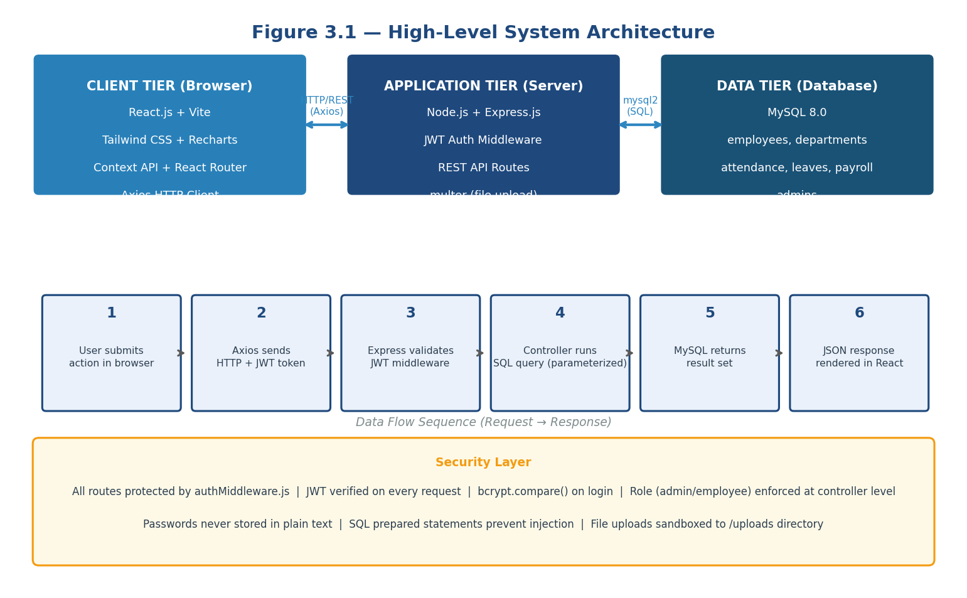
Figure 3.1 — High-Level System Architecture Diagram

3.2 Technology Stack
Table 3.1 presents the complete technology stack with rationale for each selection:
Layer | Technology | Rationale
Frontend Framework | React.js (Vite) | Component-based, fast HMR, large ecosystem
Styling | Tailwind CSS | Utility-first, responsive, no CSS files needed
Routing | React Router v6 | Declarative client-side routing with guards
HTTP Client | Axios | Promise-based, interceptors for JWT injection
Charts | Recharts | Declarative, React-native charting library
Notifications | React Toastify | Non-blocking toast messages
State Management | Context API | Sufficient for mid-scale app without Redux overhead
Backend Runtime | Node.js | Non-blocking I/O, same language as frontend
Backend Framework | Express.js | Minimal, fast, middleware-friendly
Authentication | JWT + bcrypt | Stateless auth; bcrypt for password hashing
File Upload | multer | Multipart form data handling for profile images
Database | MySQL 8.0 | Relational, ACID-compliant, strong referential integrity
DB Driver | mysql2 | Async/await support, prepared statements
Build Tool | Vite | Sub-second cold starts, ES module native

3.3 Module Design
3.3.1 Authentication Module
The authentication module handles login and JWT issuance. On login, the system queries the appropriate table by email, verifies the password against the stored bcrypt hash using bcrypt.compare(), and issues a signed JWT with a 24-hour expiry. The token payload carries the user's ID, role (admin or employee), and name. A custom Express middleware (authMiddleware.js) verifies and decodes the token, rejecting invalid or expired tokens with a 401 response.
3.3.2 Employee Module
The employee module exposes CRUD endpoints under /api/employees. Each employee record stores personal details, department assignment, designation, salary, and a profile image path. Profile images are uploaded using multer with a disk storage engine, stored in the public/uploads directory, and served as static files by Express.
3.3.3 Attendance Module
Attendance records are stored per employee per day, capturing status (Present, Absent, Leave, Half-Day), check-in time, and check-out time. The admin marks attendance for all employees on a selected date. Employees can view their own attendance history filtered by month.
3.3.4 Leave Management Module
The leave module implements a request-approval workflow. Employees submit leave applications specifying leave type, start date, end date, and reason. The request is stored with status Pending. Admins review pending requests and approve or reject them with an optional remark.
3.3.5 Payroll Module
Payroll records are generated per employee per month. Each record stores the basic salary, allowances, deductions, and computed net salary. Net Salary = Basic Salary + Allowances − Deductions. The admin generates, views, and deletes payroll records; employees view their own history.

3.4 Database Design
The database follows a normalized relational schema with six primary tables. The ER diagram below shows all entities and their relationships:
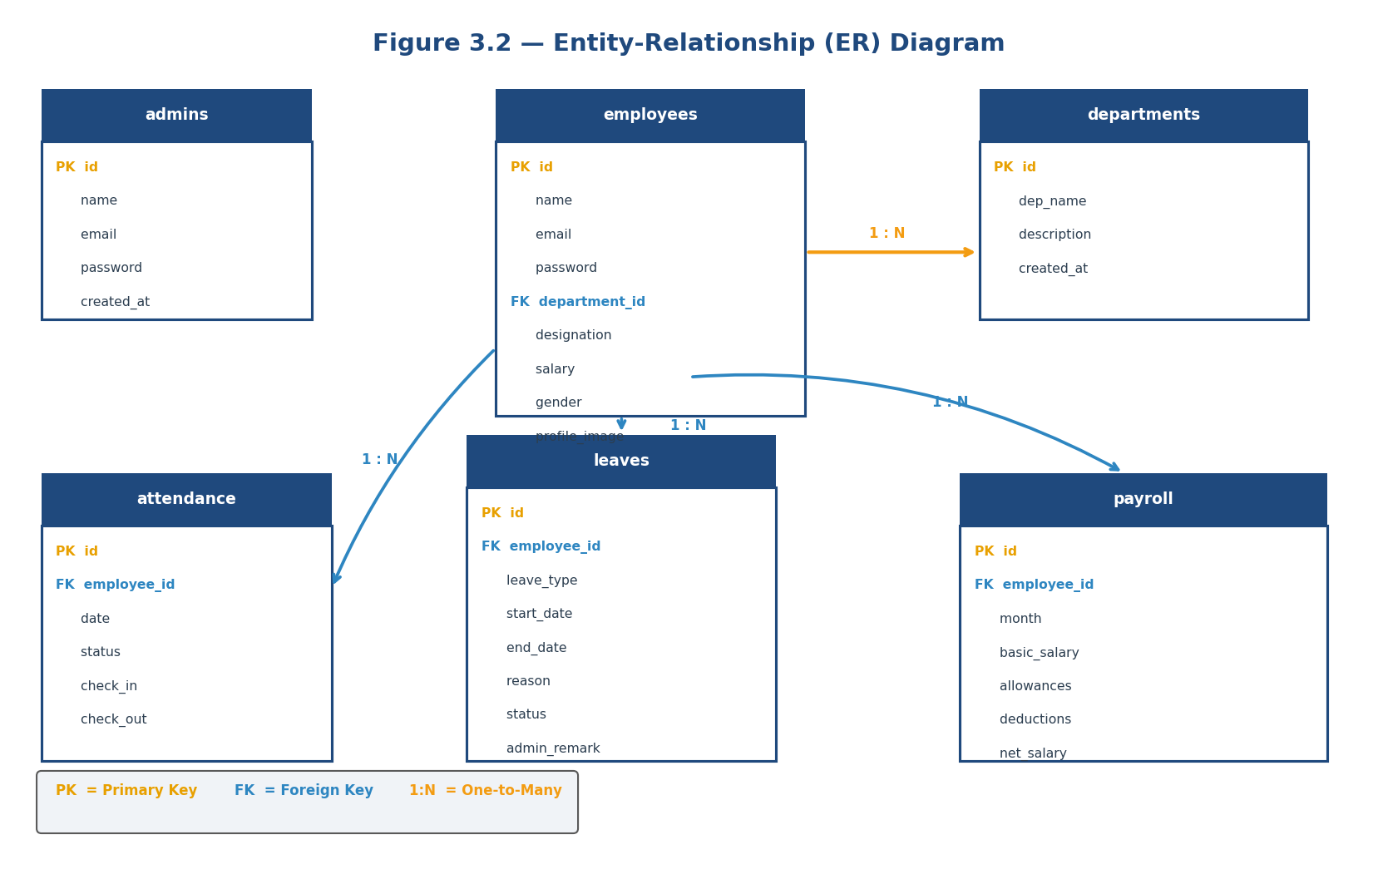
Figure 3.2 — Entity-Relationship (ER) Diagram
Table 3.2 — employees
Column | Data Type | Constraints | Description
id | INT | PK, AUTO_INCREMENT | Unique employee identifier
name | VARCHAR(100) | NOT NULL | Full name
email | VARCHAR(100) | UNIQUE, NOT NULL | Login email
password | VARCHAR(255) | NOT NULL | bcrypt hash
department_id | INT | FK → departments | Assigned department
designation | VARCHAR(100) |  | Job title
salary | DECIMAL(10,2) |  | Monthly base salary
profile_image | VARCHAR(255) |  | Upload file path

Table 3.3 — departments
Column | Data Type | Constraints | Description
id | INT | PK, AUTO_INCREMENT | Unique department ID
dep_name | VARCHAR(100) | NOT NULL | Department name
description | TEXT |  | Description of the department
created_at | TIMESTAMP | DEFAULT NOW() | Record creation time

Table 3.4 — attendance
Column | Data Type | Constraints | Description
id | INT | PK, AUTO_INCREMENT | Attendance record ID
employee_id | INT | FK → employees | Referenced employee
date | DATE | NOT NULL | Attendance date
status | ENUM | NOT NULL | Present / Absent / Leave / Half-Day
check_in | TIME |  | Check-in time
check_out | TIME |  | Check-out time

Table 3.5 — leaves
Column | Data Type | Constraints | Description
id | INT | PK, AUTO_INCREMENT | Leave request ID
employee_id | INT | FK → employees | Requesting employee
leave_type | ENUM | NOT NULL | Casual / Sick / Annual / Maternity
start_date | DATE | NOT NULL | Leave start date
end_date | DATE | NOT NULL | Leave end date
reason | TEXT |  | Reason for leave
status | ENUM | DEFAULT Pending | Pending / Approved / Rejected
admin_remark | TEXT |  | Admin's response remark

Table 3.6 — payroll
Column | Data Type | Constraints | Description
id | INT | PK, AUTO_INCREMENT | Payroll record ID
employee_id | INT | FK → employees | Referenced employee
month | VARCHAR(20) | NOT NULL | Payroll month (e.g., April 2026)
basic_salary | DECIMAL(10,2) |  | Base salary amount
allowances | DECIMAL(10,2) |  | HRA, TA, DA, etc.
deductions | DECIMAL(10,2) |  | PF, PT, TDS, etc.
net_salary | DECIMAL(10,2) |  | basic + allowances - deductions
payment_date | DATE |  | Date of salary payment

CHAPTER 4

IMPLEMENTATION

4.1 Admin Module
The Admin dashboard is the central control panel of the system. Upon login with admin credentials, the JWT payload is decoded on the frontend to determine the role. React Router maps the /admin/* routes to admin-only components, and a route guard reads the role from Context API to redirect unauthorized users.
Figure 4.1 below shows the complete Admin Dashboard with metric cards and Recharts visualizations:
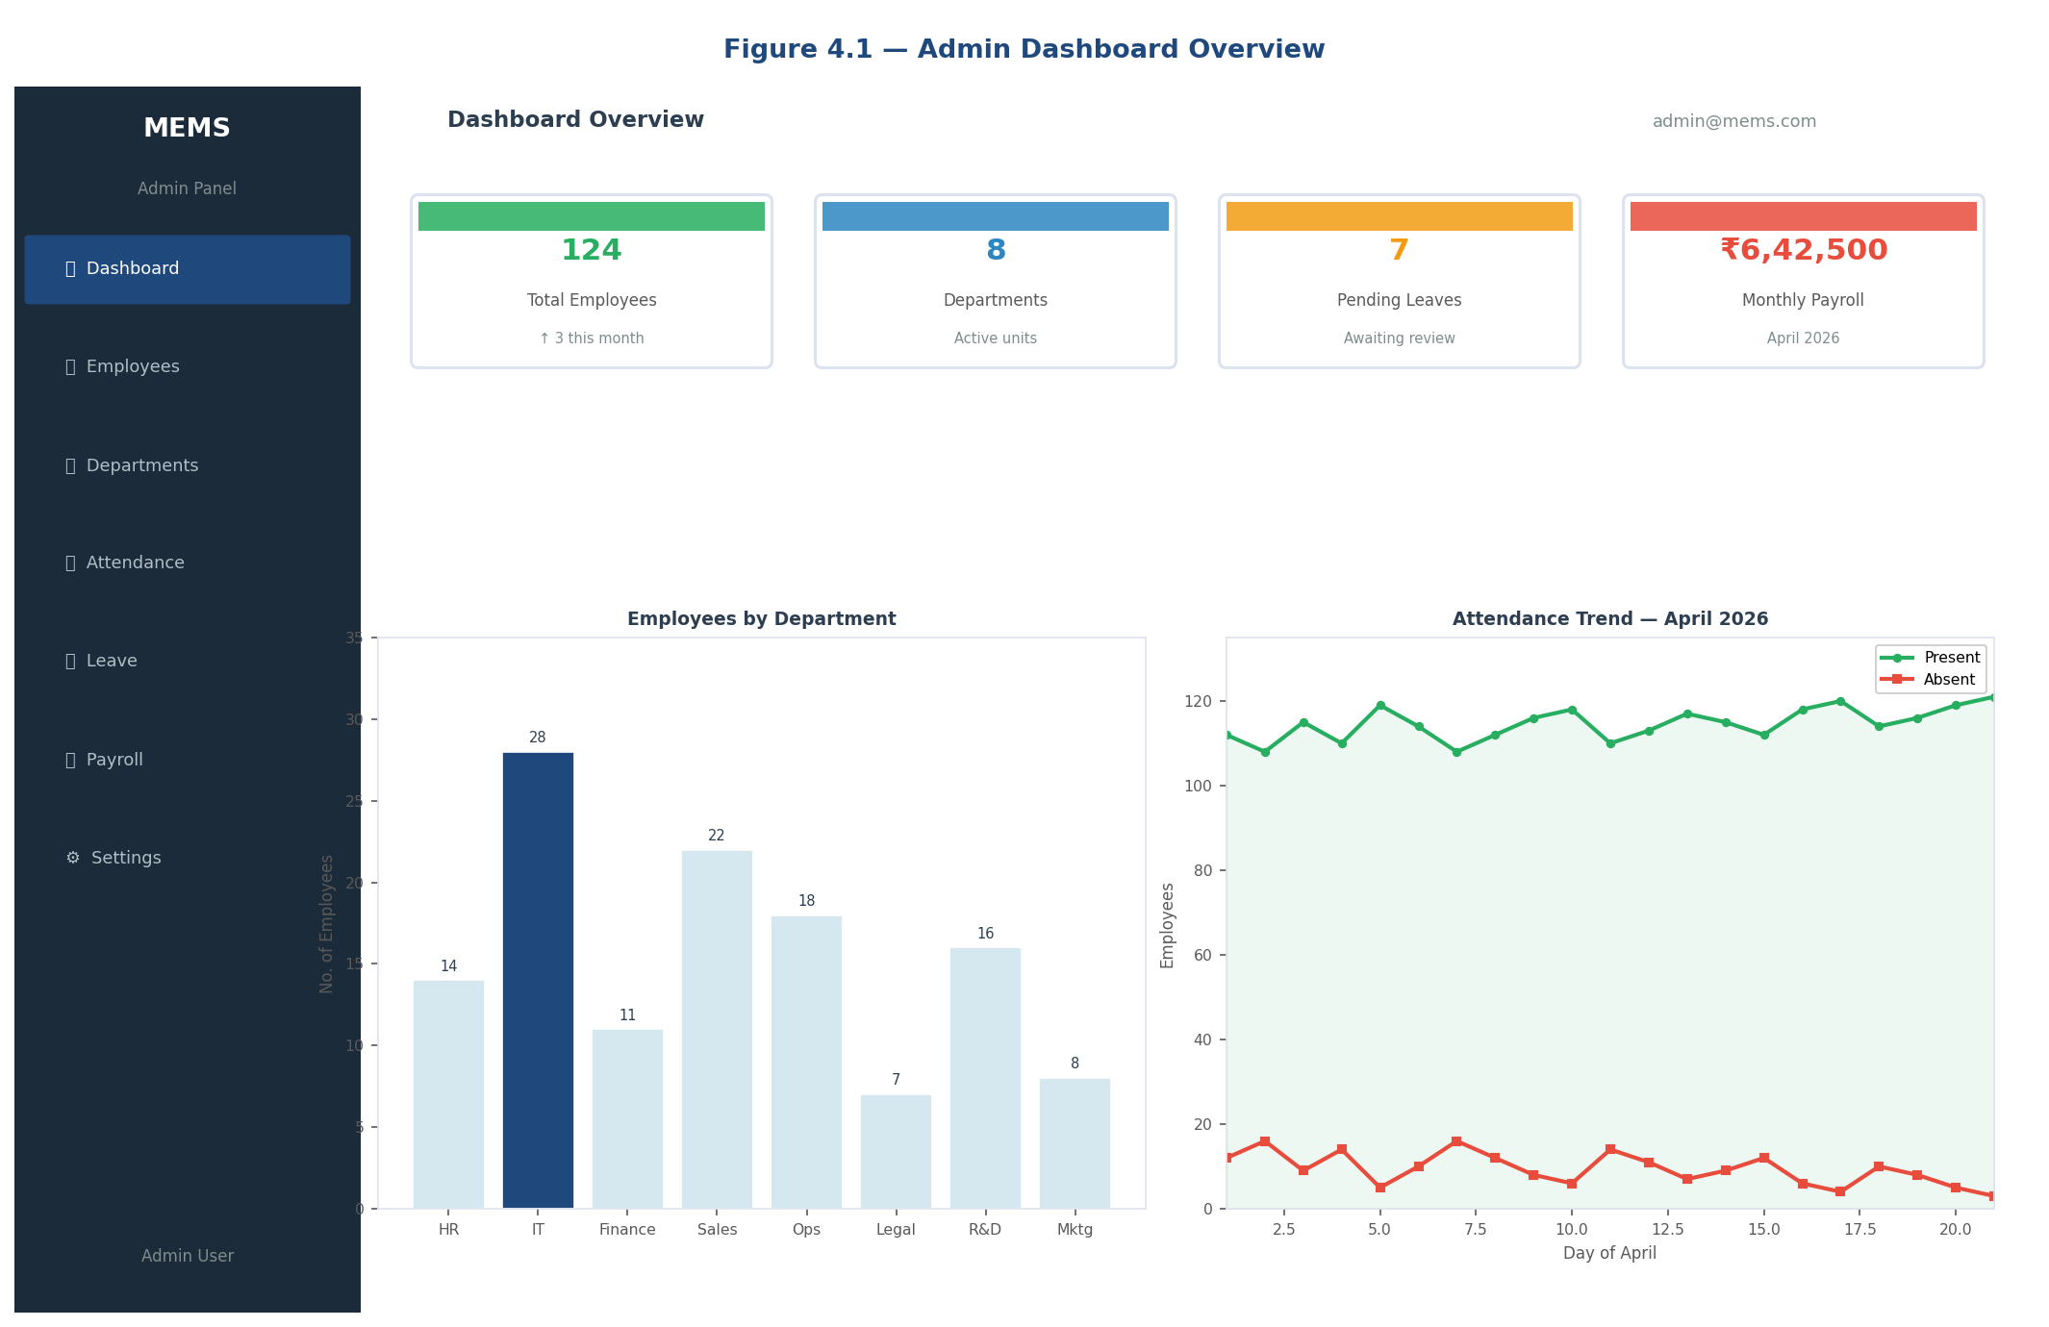
Figure 4.1 — Admin Dashboard Overview with Charts
Table 4.1 summarizes all admin functionalities:
Feature | Action Available | Backend Endpoint
Dashboard Overview | View stats, charts | GET /api/dashboard/summary
Manage Employees | Add, Edit, View, Delete | GET/POST/PUT/DELETE /api/employees
Manage Departments | Add, Edit, View, Delete | GET/POST/PUT/DELETE /api/departments
Manage Attendance | Mark, View by date | GET/POST /api/attendance
Manage Leave | Approve/Reject requests | GET/PUT /api/leaves/:id
Manage Payroll | Generate, View, Delete | GET/POST/DELETE /api/payroll
Profile Management | Update admin profile | PUT /api/admins/:id

4.2 Employee Module
The Employee portal provides a read-focused interface where employees can access their own data. Sensitive operations such as modifying salary or department are restricted to the admin role at the API level, ensuring that even direct API calls from unauthorized clients are rejected.
Figure 4.2 shows the Employee Dashboard:
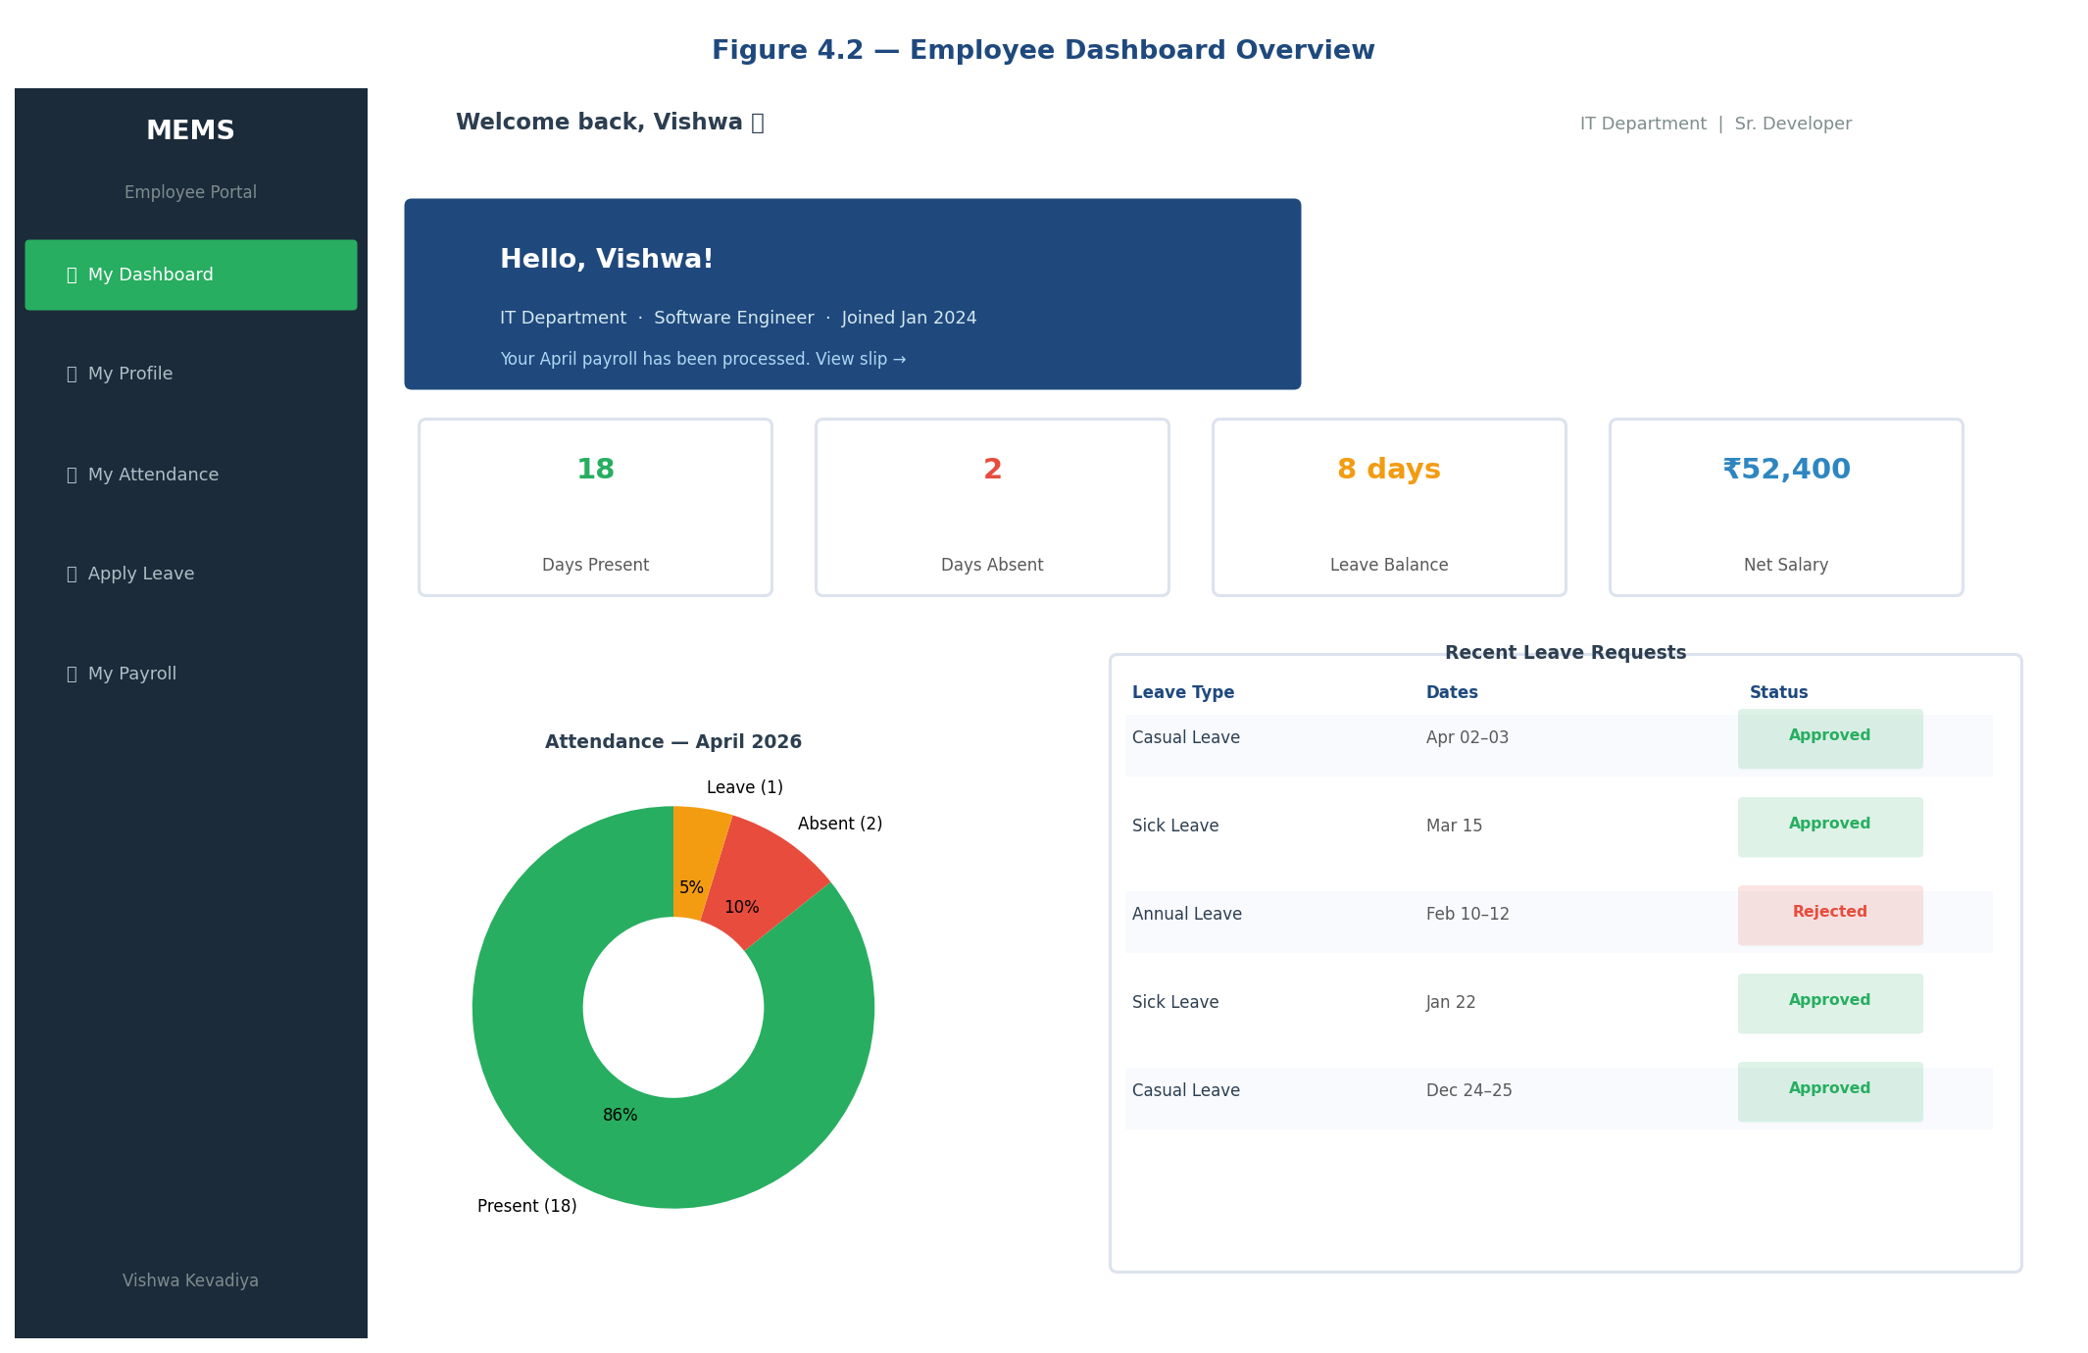
Figure 4.2 — Employee Dashboard Overview
Feature | Action Available | Backend Endpoint
Employee Dashboard | View personal summary | GET /api/employees/:id/summary
View Profile | Read personal details | GET /api/employees/:id
Update Profile | Edit personal info | PUT /api/employees/:id
View Attendance | Filter by month | GET /api/attendance/:id
Apply for Leave | Submit leave request | POST /api/leaves
View Leave History | See past requests and status | GET /api/leaves/:id
View Payroll | Monthly payroll history | GET /api/payroll/:id

4.3 Add Employee Form
The Add Employee form is a modal dialog accessible from the Employee Management page. It collects all required fields with client-side validation before submission. Figure 4.3 shows the complete form:
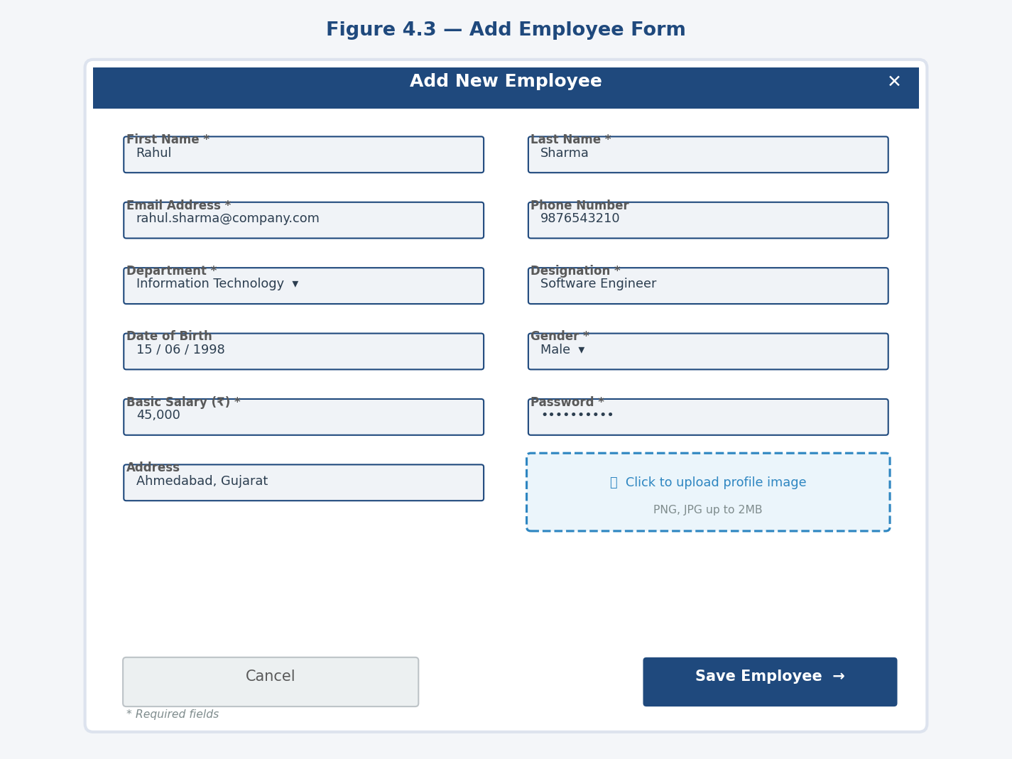
Figure 4.3 — Add Employee Form

4.4 Leave Management Interface
The leave management interface on the admin side shows a tabbed view of Pending, Approved, and Rejected requests. Each pending request card displays the employee name, leave type, date range, and reason. Figure 4.4 shows the admin leave management view with Approve and Reject action buttons:
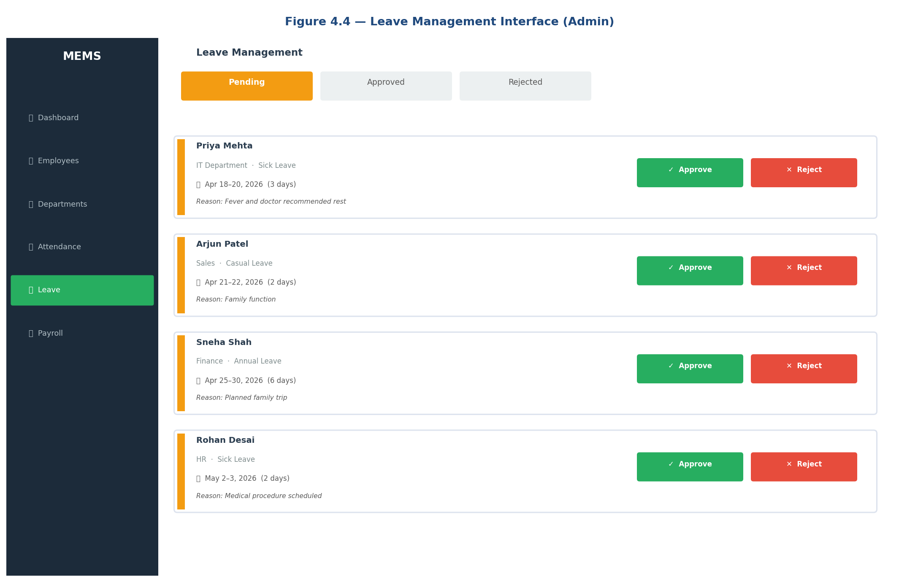
Figure 4.4 — Leave Management Interface (Admin)

4.5 Payroll Summary View
The payroll module allows the admin to generate payroll records and view monthly trends. Net Salary = Basic Salary + Allowances - Deductions. Figure 4.5 shows the payroll management interface with a bar chart of monthly payroll trends and an employee payroll table:
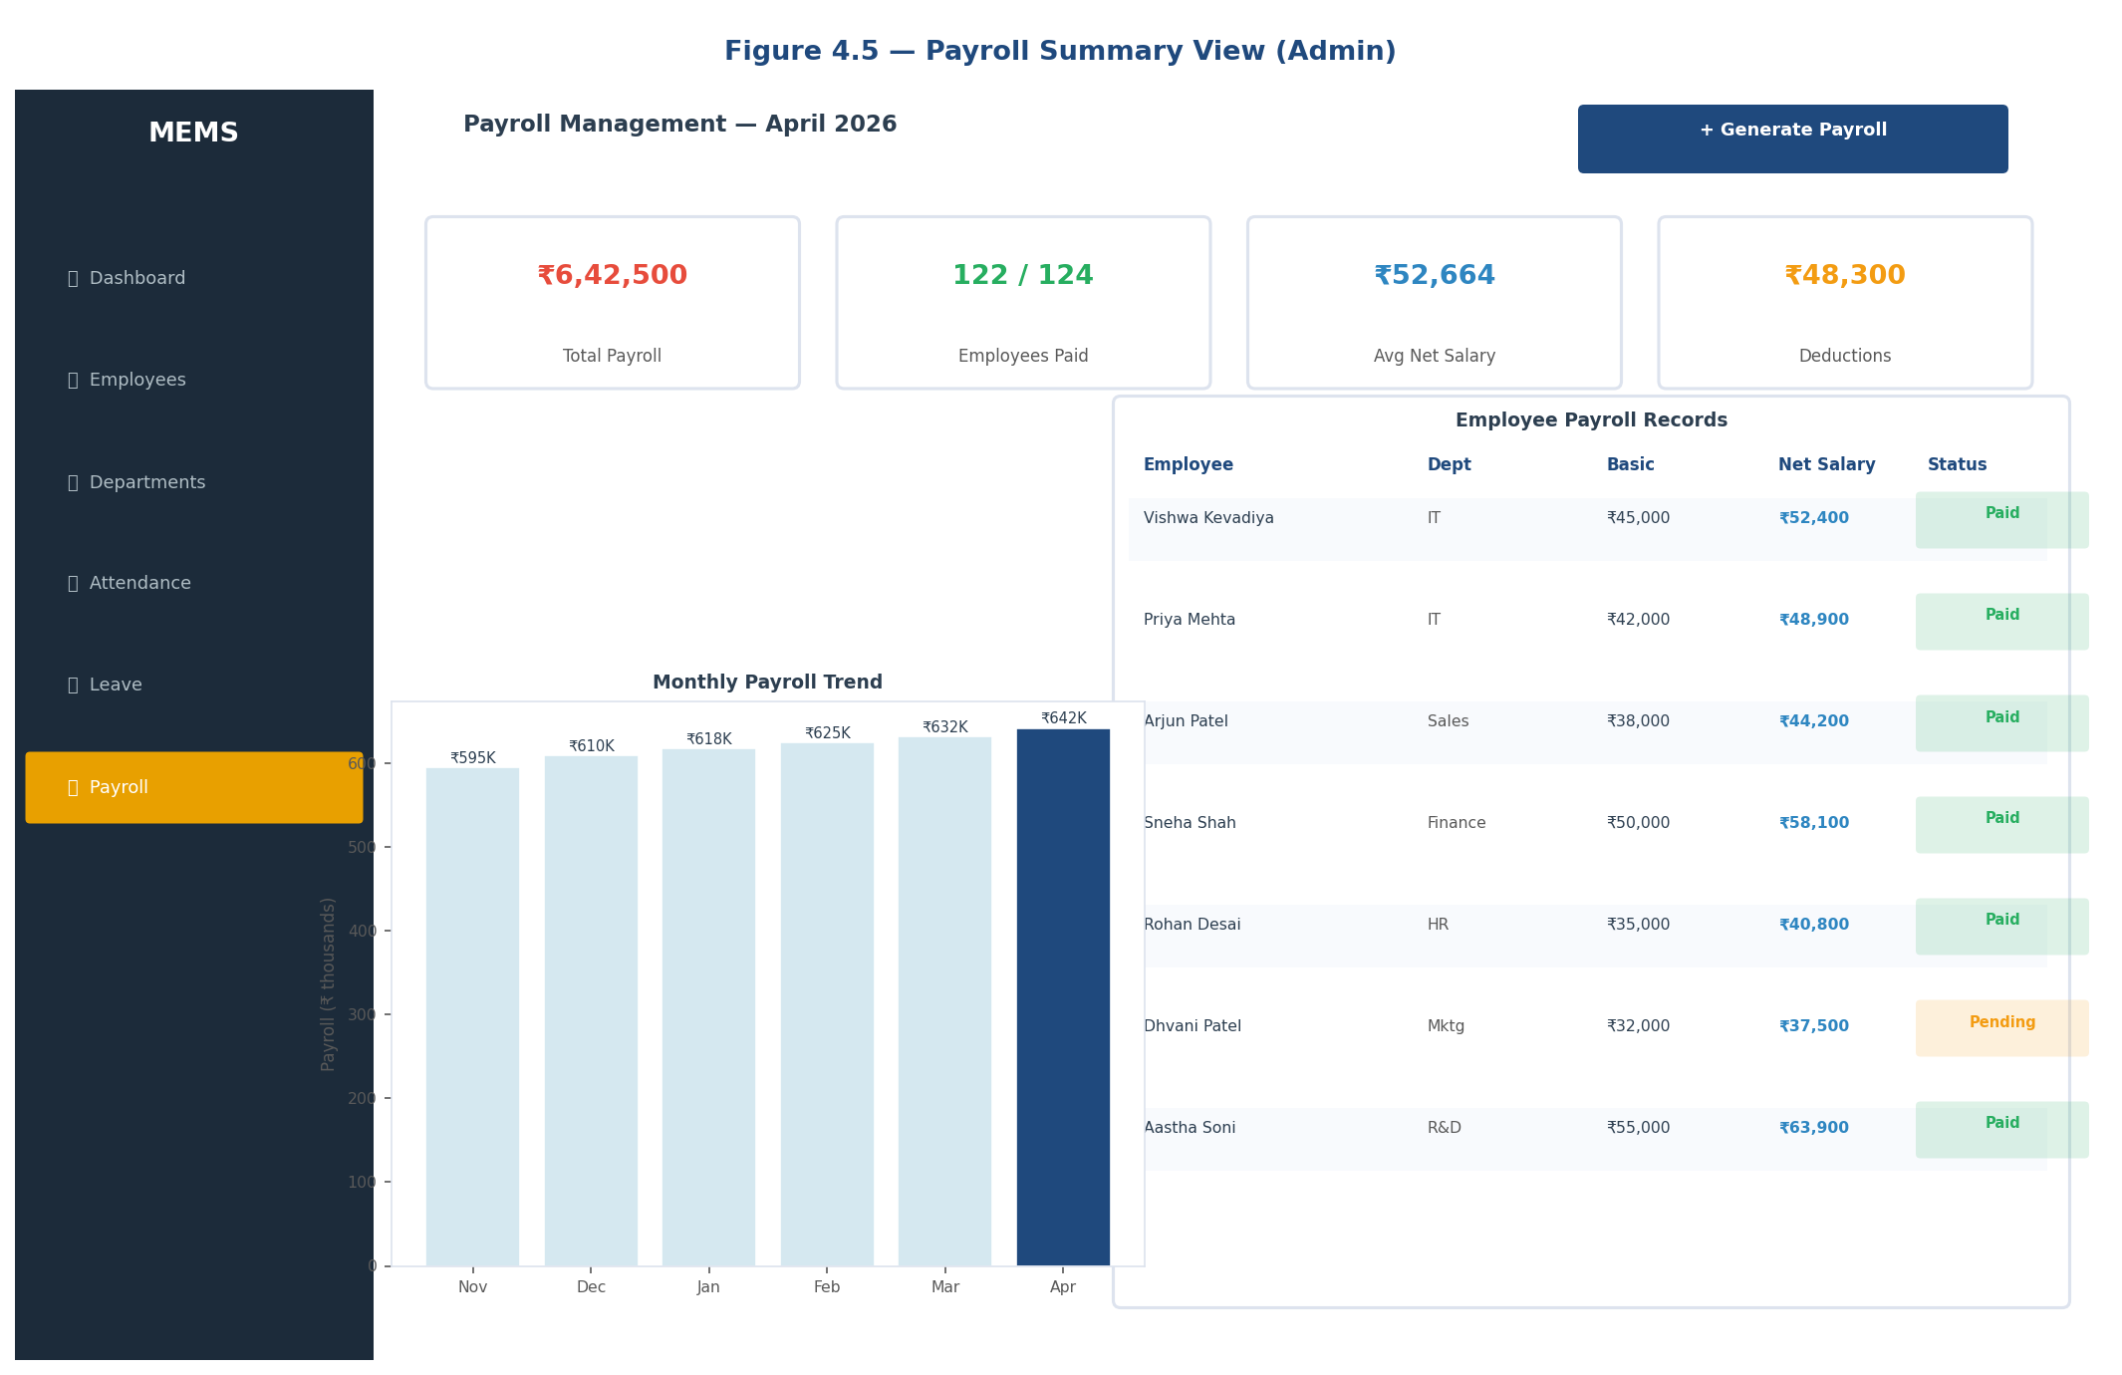
Figure 4.5 — Payroll Summary View (Admin)

4.6 Authentication Flow
The authentication flow proceeds as follows:
- User submits email and password on the login form.
- Axios posts credentials to POST /api/auth/login.
- Express controller queries the relevant table (admins or employees) by email.
- bcrypt.compare() verifies the submitted password against the stored hash.
- On success, jwt.sign() generates a token with { id, role, name } payload and 24-hour expiry.
- The token is returned in the JSON response body.
- React stores the token in Context API state.
- Axios request interceptor attaches the token as Authorization: Bearer on all subsequent calls.
- The Express authMiddleware validates the token on every protected route.

CHAPTER 5

RESULTS AND DISCUSSION

5.1 Login Page
Figure 5.1 shows the system login page. The centered card UI with role selection (Admin/Employee), email and password fields, and JWT-based secure authentication is clearly visible. Invalid credentials trigger a React Toastify error toast notification:
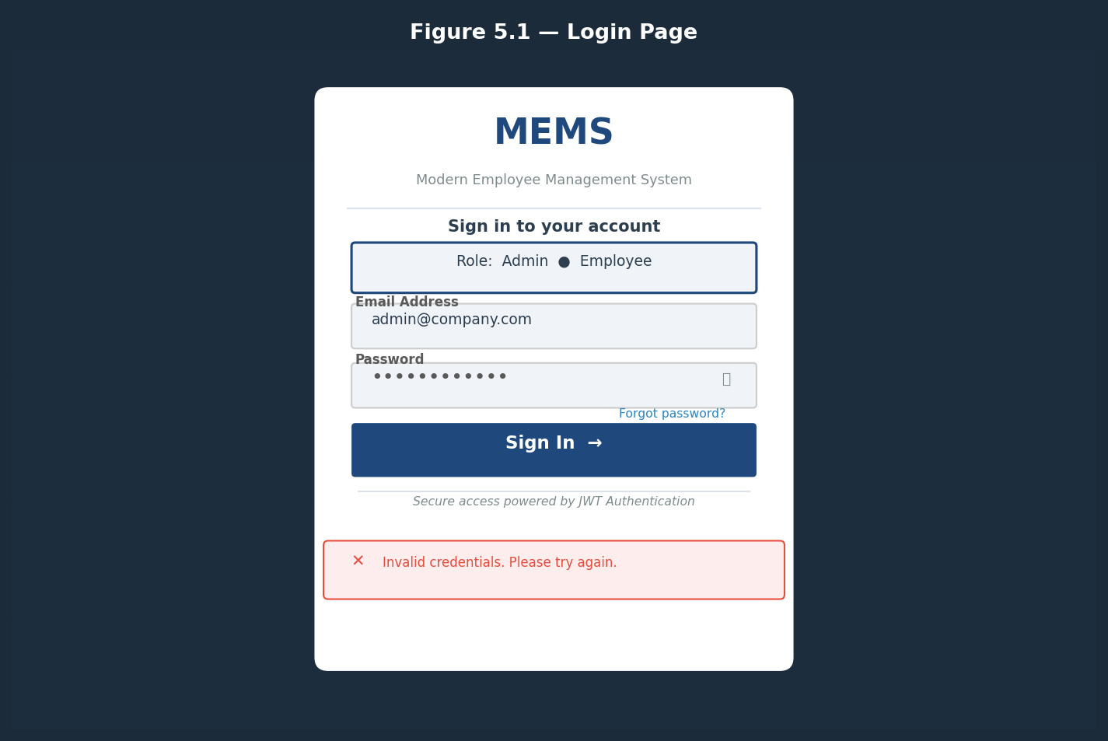
Figure 5.1 — Login Page

5.2 Functional Testing Results
Table 5.1 presents the outcome of functional testing conducted across all system modules:
Module | Test Case | Status | Result
Authentication | Admin login with correct credentials | PASS | JWT issued
Authentication | Login with wrong password | PASS | 401 returned
Authentication | Employee login | PASS | Employee portal loads
Employees | Add new employee with all fields | PASS | Record saved
Employees | Edit employee department | PASS | FK updated
Employees | Delete employee | PASS | Record removed
Departments | Delete dept with employees | PASS | FK error returned
Attendance | Mark attendance for a date | PASS | Records stored
Leave | Employee applies for leave | PASS | Pending status set
Leave | Admin approves leave | PASS | Status updated
Leave | Admin rejects with remark | PASS | Remark stored
Payroll | Admin generates payroll | PASS | Net salary computed
Payroll | Employee views payroll slip | PASS | Own records shown
Dashboard | Admin views statistics chart | PASS | Recharts rendered
Profile | Employee uploads profile image | PASS | multer saves file
Authorization | Employee accesses admin route | PASS | 403 returned

5.3 Discussion
All 16 test cases passed successfully, confirming end-to-end functionality of the system. The JWT authentication mechanism correctly enforces role-based access at both the frontend route guard and backend middleware levels, ensuring that employees cannot access admin endpoints even via direct API calls.
The MySQL foreign key constraints performed as expected — attempting to delete a department that still had assigned employees correctly returned a 500 error wrapping the MySQL FK violation. The Recharts visualizations rendered correctly with live data, and React Toastify notifications provided clear user feedback for all create, update, approve, and reject operations.

CHAPTER 6

CONCLUSION AND FUTURE WORK

6.1 Conclusion
The Employee Management System successfully demonstrates that a production-grade HR platform can be built on modern open-source web technologies within a constrained development timeline. The system achieves all seven stated objectives:
- A secure, role-based web application with distinct Admin and Employee portals is fully operational.
- Full CRUD operations for employees, departments, attendance, leave, and payroll are implemented and tested.
- JWT authentication with bcrypt password hashing is enforced at both the frontend route guard and backend middleware levels.
- The Admin dashboard provides meaningful HR insights through dynamic Recharts visualizations — bar charts for department headcount and line charts for attendance trends.
- Employees can independently manage leave applications and monitor payroll without administrator involvement.
- The MySQL schema is properly normalized with foreign key constraints ensuring referential integrity.
- The Tailwind CSS interface is responsive and renders correctly on desktop and tablet screen sizes.
The choice of Vite as the build tool significantly improved the development experience through sub-second hot module replacement, while the Context API proved sufficient for state management without the added complexity of Redux.

6.2 Future Work
- Email Notifications: Integrating Nodemailer to send automated emails for leave approvals, rejections, and payroll generation.
- PDF Salary Slip Generation: Using pdfkit or jsPDF to generate downloadable salary slip PDFs directly from payroll records.
- Biometric Attendance Integration: Connecting the system to biometric device APIs (ZKTeco) to automate attendance marking.
- Mobile Application: Developing a React Native companion app that reuses the same Express.js API.
- Cloud Deployment: Deploying the backend on Railway or Render, frontend on Vercel, with managed MySQL on PlanetScale.
- Multi-Tenancy: Extending the database schema with a tenant_id field to support multiple independent organizations.
- Audit Logging: Recording all admin actions in an audit_logs table for compliance.
- Advanced Reporting: Adding exportable Excel/CSV reports using exceljs.

REFERENCES
Facebook Inc. (2013). React — A JavaScript library for building user interfaces. Available at: https://reactjs.org.
JWT.io (2023). JSON Web Tokens — Introduction. Available at: https://jwt.io/introduction.
Liu, R. and Tan, W. (2020). Comparative Study of Frontend Frameworks for Building Single-Page Applications. Journal of Web Engineering, Vol. 19(4), pp. 411-440.
MySQL Documentation (2023). MySQL 8.0 Reference Manual. Available at: https://dev.mysql.com/doc/refman/8.0/en/.
npm Inc. (2023). mysql2 — Fast MySQL driver. Available at: https://www.npmjs.com/package/mysql2.
Sandhu, R., Coyne, E., Feinstein, H. and Youman, C. (1996). Role-Based Access Control Models. IEEE Computer, Vol. 29(2), pp. 38-47.
Tilkov, S. and Vinoski, S. (2010). Node.js: Using JavaScript to Build High-Performance Network Programs. IEEE Internet Computing, Vol. 14(6), pp. 80-83.
Tailwind Labs Inc. (2023). Tailwind CSS Documentation. Available at: https://tailwindcss.com/docs.
Vite (2023). Vite — Next Generation Frontend Tooling. Available at: https://vitejs.dev.
W3C (2023). HTTP/1.1 Specification. Available at: https://www.w3.org/Protocols/rfc2616/rfc2616.html.

